Application migration and modernization

Hands-on lab

July 2018

Information in this document, including URL and other Internet Web site references, is subject to change without notice. Unless otherwise noted, the example companies, organizations, products, domain names, e-mail addresses, logos, people, places, and events depicted herein are fictitious, and no association with any real company, organization, product, domain name, e-mail address, logo, person, place or event is intended or should be inferred. Complying with all applicable copyright laws is the responsibility of the user. Without limiting the rights under copyright, no part of this document may be reproduced, stored in or introduced into a retrieval system, or transmitted in any form or by any means (electronic, mechanical, photocopying, recording, or otherwise), or for any purpose, without the express written permission of Microsoft Corporation.

Microsoft may have patents, patent applications, trademarks, copyrights, or other intellectual property rights covering subject matter in this document. Except as expressly provided in any written license agreement from Microsoft, the furnishing of this document does not give you any license to these patents, trademarks, copyrights, or other intellectual property.

The names of manufacturers, products, or URLs are provided for informational purposes only and Microsoft makes no representations and warranties, either expressed, implied, or statutory, regarding these manufacturers or the use of the products with any Microsoft technologies. The inclusion of a manufacturer or product does not imply endorsement of Microsoft of the manufacturer or product. Links may be provided to third party sites. Such sites are not under the control of Microsoft and Microsoft is not responsible for the contents of any linked site or any link contained in a linked site, or any changes or updates to such sites. Microsoft is not responsible for webcasting or any other form of transmission received from any linked site. Microsoft is providing these links to you only as a convenience, and the inclusion of any link does not imply endorsement of Microsoft of the site or the products contained therein.

© 2018 Microsoft Corporation. All rights reserved.

Microsoft and the trademarks listed at <https://www.microsoft.com/en-us/legal/intellectualproperty/Trademarks/Usage/General.aspx> are trademarks of the Microsoft group of companies. All other trademarks are property of their respective owners.

Contents

[Application migration and modernization hands-on lab 1](#_Toc519766888)

[Abstract and learning objectives 1](#_Toc519766889)

[Overview 1](#_Toc519766890)

[Requirements 2](#_Toc519766891)

[Before the hands-on lab 3](#_Toc519766892)

[Task 1: Set up the environment 3](#_Toc519766893)

[Help references 3](#_Toc519766894)

[Task 2: Validate you can connect to the Development Environment 9](#_Toc519766895)

[Exercise 1: Migration to Azure 12](#_Toc519766896)

[Prerequisites 12](#_Toc519766897)

[Help references 12](#_Toc519766898)

[Task 1: Migration Tool to Lift and Shift Application to PaaS 13](#_Toc519766899)

[Task 2: Install the Microsoft Web Platform Installer 16](#_Toc519766900)

[Task 3: Run the Azure App Service Migration Assistant 20](#_Toc519766901)

[Task 4: Validate Application Migration 31](#_Toc519766902)

[Task 5: Create Azure API Management 35](#_Toc519766903)

[Exercise 2: Implementing DevOps Continuous Integration / Continuous Deployment (CI/CD) 37](#_Toc519766904)

[Help references 37](#_Toc519766905)

[Prerequisites 37](#_Toc519766906)

[Task 1: Add a new project to VSTS and upload the code 38](#_Toc519766907)

[Task 2: Upload Code to Git Repository in VSTS 41](#_Toc519766908)

[Task 3: Use Deployment Center to create CI/CD 44](#_Toc519766909)

[Task 3 (Alternative): Use VSTS to create CI/CD 53](#_Toc519766910)

[Exercise 3: Detect, Diagnose, Monitor Application Performance with Application Insights 74](#_Toc519766911)

[Help references 74](#_Toc519766912)

[Prerequisites 74](#_Toc519766913)

[Task 1: Create an Application Insights Instance 75](#_Toc519766914)

[Task 2: Update your Web Application to use Application Insights 78](#_Toc519766915)

[Task 3: Update your application to provide more telemetry 86](#_Toc519766916)

[Task 4: Implement the Custom Event Telemetry Provider 92](#_Toc519766917)

[Task 5: Push your code to production 92](#_Toc519766918)

[Task 5: Review the data 96](#_Toc519766919)

[Task 6: Web Test 97](#_Toc519766920)

[Exercise 4: Optimize and Protect Azure Web Application 101](#_Toc519766921)

[Help references 101](#_Toc519766922)

[Prerequisites 101](#_Toc519766923)

[Task 1: Configure Backups 101](#_Toc519766924)

[Task 2: Configure Storage Account for Backups 102](#_Toc519766925)

[Task 3: Schedule Backup 104](#_Toc519766926)

[Task 4: Backup Database 105](#_Toc519766927)

[Task 5: Viewing Health by Reviewing the Response Time and Errors 106](#_Toc519766928)

[Task 6: Setting Alerts 108](#_Toc519766929)

[Task 7: Configuration App Diagnostics 109](#_Toc519766930)

[Task 8: Viewing Application CPU/Memory 111](#_Toc519766931)

[Task 9: Viewing Disk space 111](#_Toc519766932)

[Task 10: Configuring Auto Scale Up 111](#_Toc519766933)

[Task 11: Creating an Auto Scaling Out 113](#_Toc519766934)

[Task 12: Prepare for scaling in another region 114](#_Toc519766935)

[Task 13: Viewing Resource Health and History 116](#_Toc519766936)

[Task 14: View Auto Scale Run History 117](#_Toc519766937)

[Task 15: Setting up auto scaling notifications 117](#_Toc519766938)

[Exercise 5: Optimize and Secure Azure SQL Database 119](#_Toc519766939)

[Help references 119](#_Toc519766940)

[Prerequisites 119](#_Toc519766941)

[Task 1: Resource Locking 119](#_Toc519766942)

[Task 2: Enable Transparent Data Encryption 121](#_Toc519766943)

[Task 3: Scale Up Database Performance 122](#_Toc519766944)

[Task 4: Configure Firewall and virtual networks 124](#_Toc519766945)

[Task 5: Threat Detection and Vulnerability Assessment 124](#_Toc519766946)

[Task 6: Turn on SQL Server Auditing 125](#_Toc519766947)

[Task 7: Automatic Tuning 126](#_Toc519766948)

[Task 8: Enable Database Diagnostics 126](#_Toc519766949)

[Task 9: Configure Long-term backup retention for database 127](#_Toc519766950)

[Exercise 6: Optimize Entire Web Application Performance with Content Distributed Network (CDN) 128](#_Toc519766951)

[Help references 129](#_Toc519766952)

[Prerequisites 129](#_Toc519766953)

[Task 1: Configure CDN for the whole web application 129](#_Toc519766954)

[Task 2: Configure Caching Rules 131](#_Toc519766955)

[Task 3: Improve performance by adding compression 132](#_Toc519766956)

[Exercise 7: Optimize Partial Web Application Performance with Content Distributed Network (CDN) 134](#_Toc519766957)

[Prerequisites 134](#_Toc519766958)

[Task 1: Create a Resource Group & Storage Account 134](#_Toc519766959)

[Task 2: Provision 137](#_Toc519766960)

[Task 3: Add a CDN Endpoint 140](#_Toc519766961)

[Task 4: Copy images to storage account 140](#_Toc519766962)

[Task 5: Integrate into web application 145](#_Toc519766963)

[Task 6: Explore Enhancements 148](#_Toc519766964)

[Exercise 8: Increase Application / Database Performance with Redis Cache 149](#_Toc519766965)

[Help references 149](#_Toc519766966)

[Prerequisites 149](#_Toc519766967)

[Task 1: Provisioning the Redis Cache Service 149](#_Toc519766968)

[Task 2: Improve Session Performance 151](#_Toc519766969)

[Task 4: Speed Up Output and Reduce Memory Footprint 154](#_Toc519766970)

[Task 5: Reducing database utilization 154](#_Toc519766971)

[Exercise 9: Improve Quality & Performance of Search with Azure Search 157](#_Toc519766972)

[Help references 157](#_Toc519766973)

[Prerequisites 157](#_Toc519766974)

[Task 1: Create Azure Search Service 157](#_Toc519766975)

[Task 2: Configure Azure Search 161](#_Toc519766976)

[Task 3: Integrate search into application 166](#_Toc519766977)

[Task 4: Verify Search Results 170](#_Toc519766978)

[Task 5: Commit & Sync Code 170](#_Toc519766979)

[Exercise 10: Accelerate development and take advantage of serverless using Azure Functions 171](#_Toc519766980)

[Help references 171](#_Toc519766981)

[Prerequisites 171](#_Toc519766982)

[Task 1: Refactor 171](#_Toc519766983)

[Task 2: Modernize 175](#_Toc519766984)

[Task 3: Integrate 184](#_Toc519766985)

[Task 4: Publish the Service 186](#_Toc519766986)

[Task 5: Configure Function Database Connection 190](#_Toc519766987)

[Task 5: Configure Function Application Insights 193](#_Toc519766988)

[Task 6: Modify App Service CI/CD Task 195](#_Toc519766989)

[Exercise 11: Monetize your data and services, and open new channels to customers using Azure API Management 195](#_Toc519766990)

[Help references 195](#_Toc519766991)

[Prerequisites 195](#_Toc519766992)

[Task 1: Set up new a new API in the Azure Portal 195](#_Toc519766993)

[Task 3: Enable Application Insights 203](#_Toc519766994)

[Task 4: Explore the API Management (APIM) Developer Portal 204](#_Toc519766995)

[After the hands-on workshop 207](#_Toc519766996)

[Task 1: Delete the Resource Group in which you placed your Azure resources. 207](#_Toc519766997)

Application migration and modernization hands-on lab

## Abstract and learning objectives

Modernize legacy on-premises applications and infrastructure by leveraging several cloud services, while adding a mix of web services.

Learning Objectives:

* Use Azure App Services
* Implement DevOps with Continuous integration/delivery/deployment with VSTS
* Detect, Diagnose, Monitor Application Performance with Application Insights
* Optimize & Protect Azure Web Application
* Optimize & Secure Azure SQL Database
* Optimize Entire Web Application Performance with Content Distributed Network (CDN)
* Optimize Partial Web Application Performance with Content Distributed Network (CDN)
* Increase Application / Database Performance with Redis Cache
* Use Search to make content full text searchable
* Accelerate development and take advantage of serverless using Azure Functions
* Monetize your data and services, and open new channels to customers using Azure API Management

## Overview

The App Modernization hands-on lab is an exercise that will challenge you to implement an end-to-end migration and modernization scenario using a supplied sample that is based on Microsoft Azure App Services and related services. The scenario will include implementing compute, storage, security, and search, using various components of Microsoft Azure. The hands-on lab can be implemented on your own, but it is highly recommended to pair up with other members at the lab to model a real-world experience and to allow each member to share their expertise for the overall solution.

## Requirements

1. Microsoft Azure subscription (non-Microsoft subscription)
2. **Global Administrator role** for Azure AD within your subscription
3. Local machine with Remote Desktop installed

## Before the hands-on lab

Duration: 30 minutes

In this exercise, you will set up your environment for use for the rest of the exercises. This will involve downloading the assets from the repository and deploying them to Azure. We will use your workstation to set up the environment and connect to Virtual Machines via Remote Desktop.

#### Task 1: Set up the environment

###### Tasks to complete

1. Deployed the environment template to Azure
2. Migrate the on-premises SQL database to Azure

###### Exit criteria

* Initiate the environment deploy from the repository
* Verify the website runs in Azure (IaaS)
* Note the URLs of the provisioned web for future reference
* Save the database connection string for later

#### Help references

|  |  |
| --- | --- |
| Azure Templates | <https://azure.microsoft.com/en-us/resources/templates/> |
| PowerShell Gallery | <http://www.powershellgallery.com/> |

Open your browser to [https://aka.ms/appmodernization](https://aka.ms/appmodernization%20)

Click on the "Deploy to Azure" button

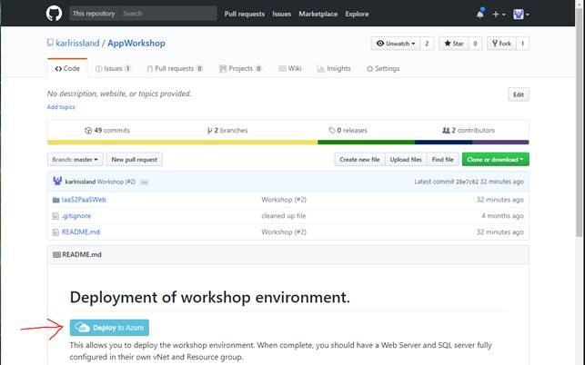

This will take you to the Azure portal.  If prompted, log into your subscription.

The portal will read the template and prompt you for parameters;

* Pick your subscription
* Create a new resource group (e.g. AppMigrationAndModernization)
* Enter the Admin User Name and Admin User Password for your VMs or leave the default settings.

**Default Settings**

Admin User Name: sysadmin  
Admin User Password: Password$123

db Login Name: workshopServiceAcc  
db User Name: workshopServiceAcc  
db User Password: P2ssw0rd

Database Name: partsUnlimitedDB

**Note**: if you don't have a Visual Studio Enterprise License, please select the community edition for the Dev Workstation OS Version.

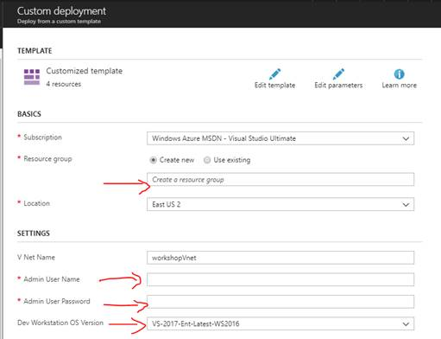

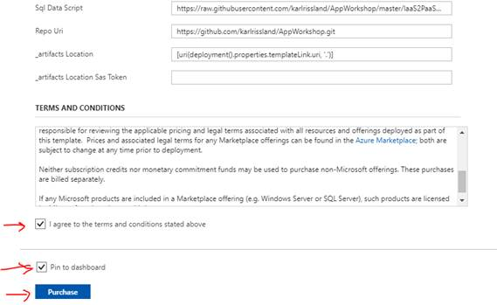

**Note:** Do not modify the values for \_artifacts Location or \_artifacts Location SAS Token.

When done, check the “I agree to terms…”, check pin to Dashboard, and click the **Purchase** button

After you click **Purchase** you will be taken to the dashboard and you will see a "Deploying Template" Tile.

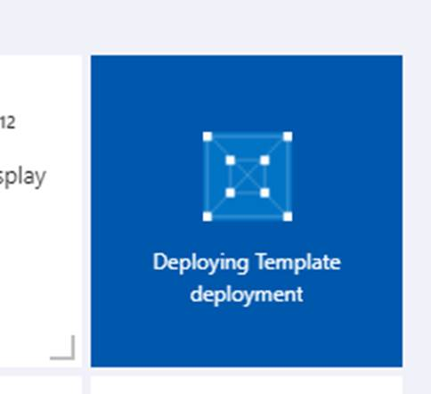

Clicking on the tile will show you deployment information and status.  This shows all the parameters that were used as part of your deployment, and at the bottom of the blade, will show you the deployment status:

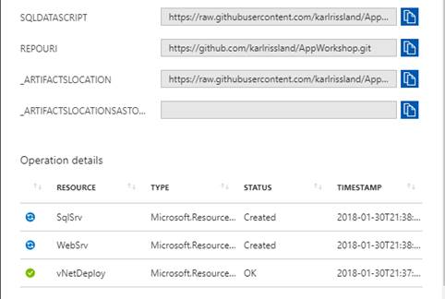

Refreshing the blade will update the deployment status.  The deployment will first create the vNet, then the web and SQL servers in parallel, and finally create the developer workstation and deploy the app.  The entire process should take between 18 and 25 minutes.

You can navigate away from this page and review the resource group.  In the top right of the resource group, you will also see deployment information.

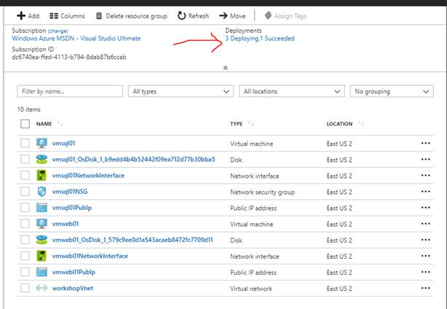

Clicking this link will take you to the list of completed and active deployments

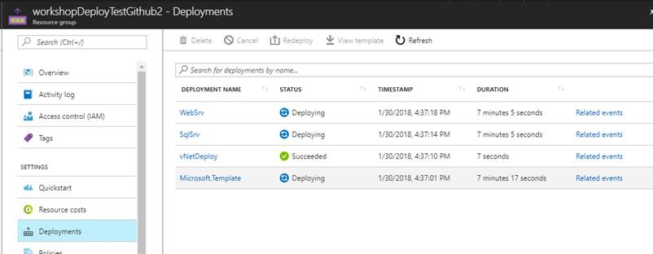

Once the deployment is complete, review the vmweb01 configuration to find the public URL.  Copy the URL, open a browser, and paste and go to verify that everything worked correctly.

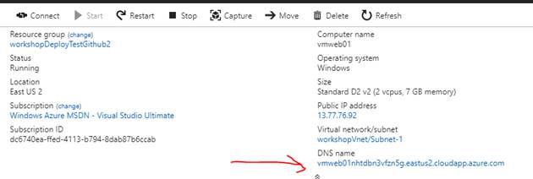

You should see the Parts Unlimited web site launch like below.

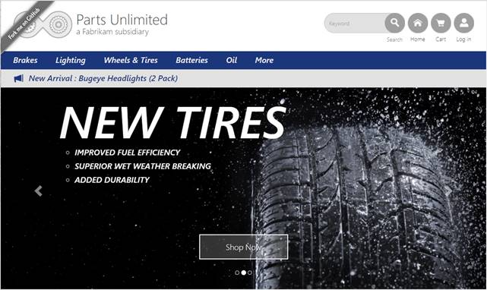

#### Task 2: Validate you can connect to the Development Environment

Now that the environment is set up, we need to make sure we can connect to the development environment where we will be doing the exercises for this workshop.

###### Tasks to complete

1. Verify connectivity to the development virtual machine
2. Sign in to Visual Studio

###### Exit criteria

* If needed, install Visual Studio Community in development virtual machine

Remote into the vmdev01 using the User Name and Password used when creating the environment.

**Note**:

Default Admin: sysadmin

Default Password: Password$123

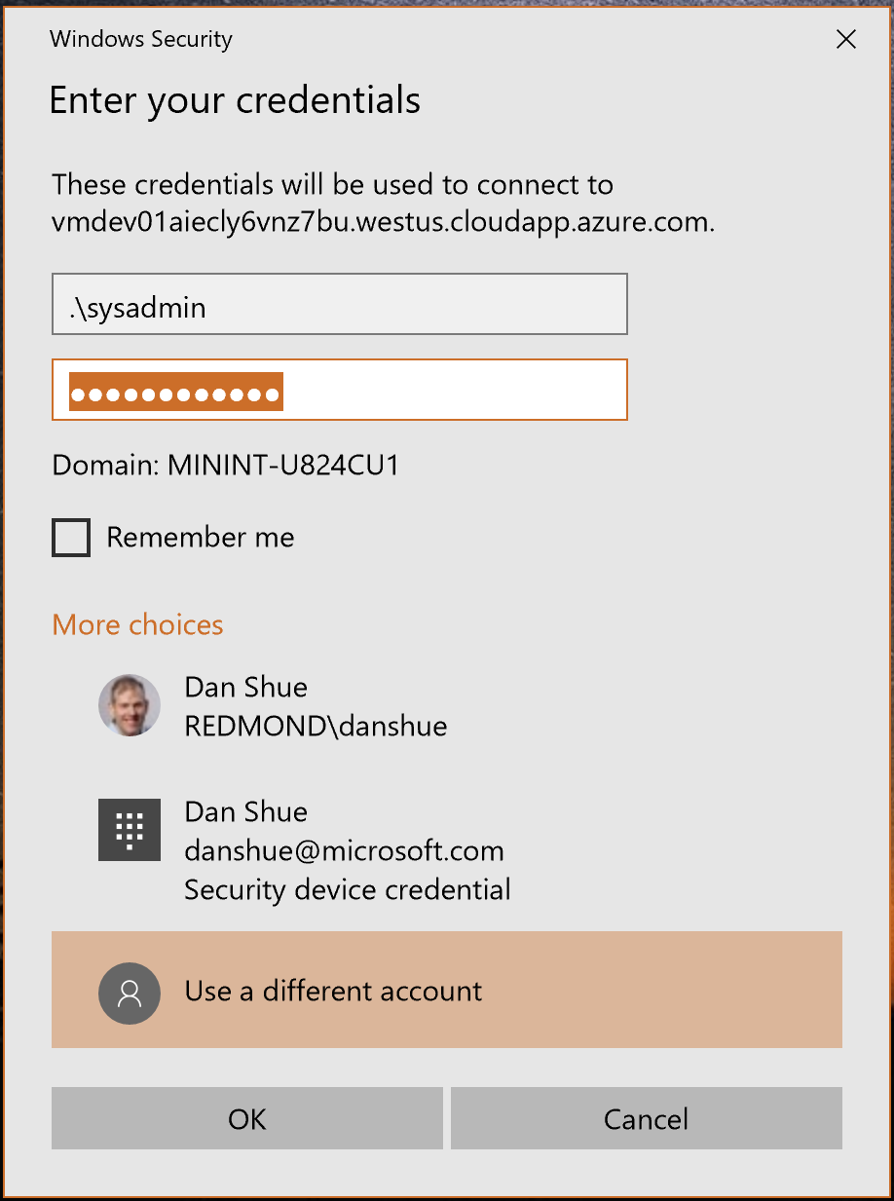

* Launch and Configure Visual Studio

**Note:**

If you don't have Visual Studio Enterprise, you should have deployed the community edition.

TODO: ADD STEPS for COMMUNITY EDITION & Chrome

Click **“Sign In”**. Type your Microsoft Account or Corporate Account, whichever account name you use for your Visual Studio Subscription (MSDN).

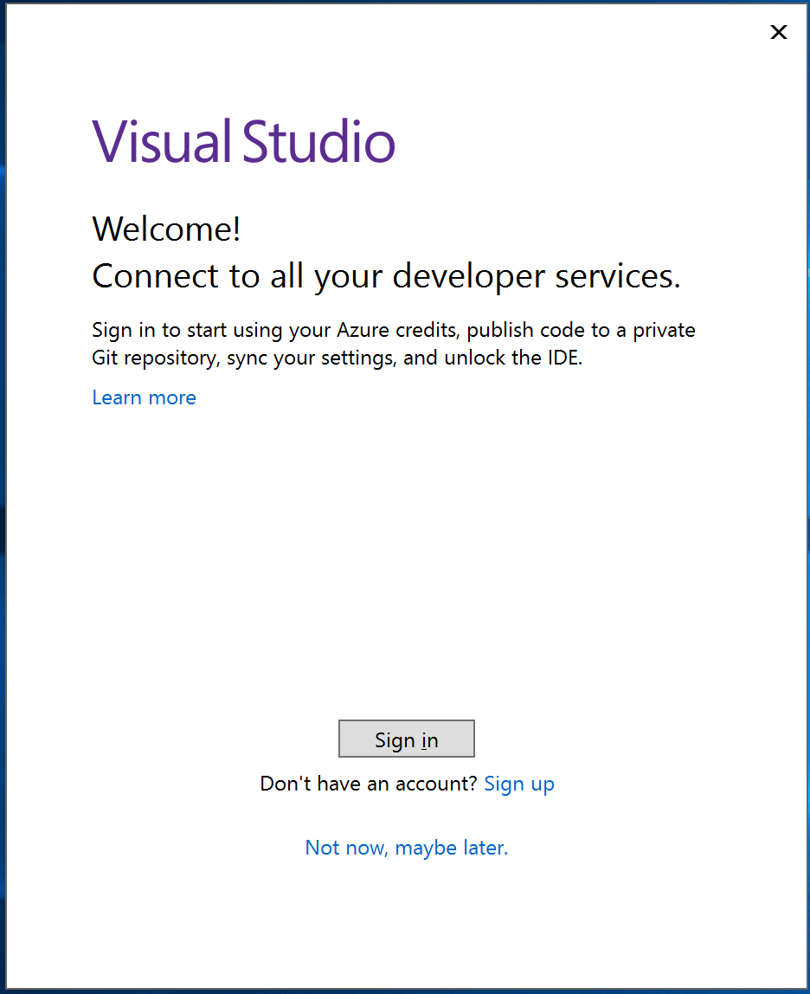

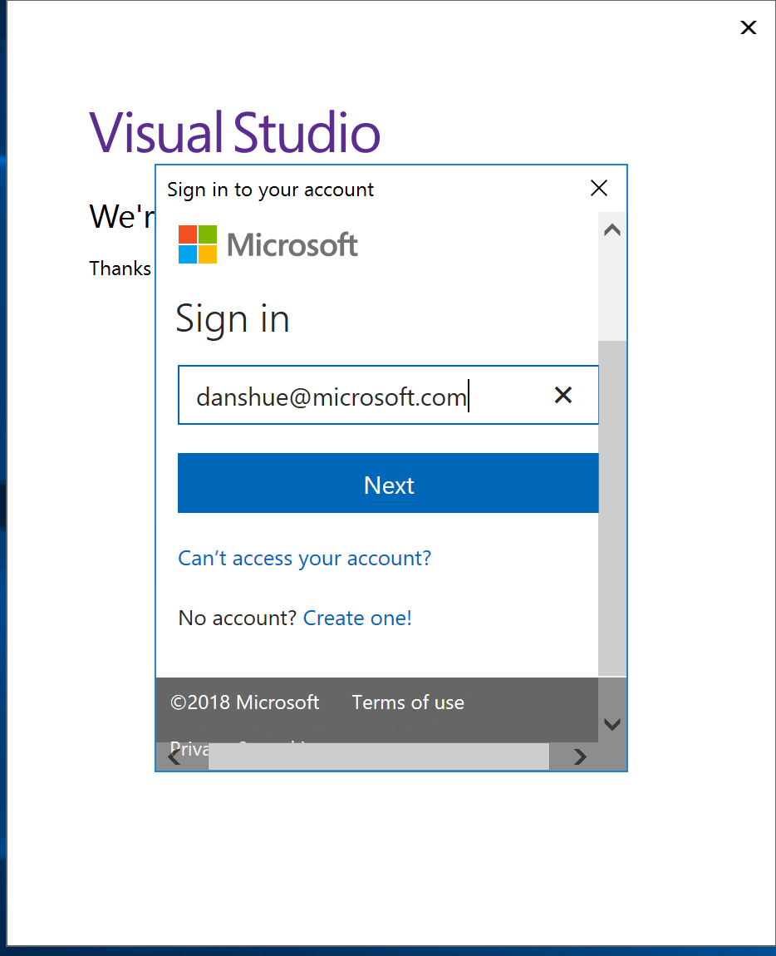

* Open the Solution which is located at C:\Source\AppWorkshop\IaaS2PaaSWeb\IaaS2PaaSWeb.sln

Write the values defined during the setup:

Web Site URL: \_\_\_\_\_\_\_\_\_\_\_\_\_\_\_\_\_\_\_\_\_\_\_\_\_\_\_\_\_\_\_\_

VM User Name: \_\_\_\_\_\_\_\_\_\_\_\_\_\_\_\_\_\_\_\_\_\_\_\_\_\_\_\_\_\_\_\_

VM User Name Password: \_\_\_\_\_\_\_\_\_\_\_\_\_\_\_\_\_\_\_\_\_\_\_\_\_\_\_\_\_\_\_\_

While this is just the initial setup process, note that everything has been automated using a combination of Azure Resource Management Templates, PowerShell, and PowerShell DSC. This technique can be used to support a DevOps process even if you are deploying to IaaS based environments.

## Exercise 1: Migration to Azure

Duration: 30 minutes

Parts Unlimited is in the auto part business. They typically sell via a brick and mortar store but have invested in a small e-commerce presence to augment those stores. They have seen an uptick in use from customers and have been getting some complaints about the speed of the site and requests for additional features and functionality.

Parts Unlimited would like to expand and improve their ecommerce presence, experiment with new features and business strategies to help grow the business. However, they are not interested in sinking large sums of money into hardware and the management of that hardware. They want to quickly spin something up to see how it works, scale it if it does, and deprovision it if it doesn’t. They also want more flexibility in how they scale their solutions given the seasonal nature of what they do.

Currently, Parts Unlimited consists of an ASP.NET 4.5.1 website running on Microsoft Windows 2016 and SQL database running on Microsoft SQL 2016. You need to migrate that application to a Microsoft Azure App Service Web Site and a Microsoft SQL Azure Database.

With the website migrated, you immediately gain new capabilities that you can use to improve your site and accelerate business value:

* Deployment Slots
* Testing in Production
* Scale up / Scale out
* Authentication Support for Azure AD, Facebook, twitter, etc.
* Diagnostic Tools
* Security Center
* No OS to manage or patch
* Etc.

These features setup Parts Unlimited for future enhancement and scale without having to plan for and manage infrastructure.

#### Prerequisites

To complete this task, you should have provisioned the Parts Unlimited IaaS environment. This is used to simulate the on premises environment and provide a developer workstation for you to work in complete with source control. The website should be running in your Azure Subscription to complete this section.

#### Help references

|  |  |
| --- | --- |
| App Service Overview | <https://docs.microsoft.com/en-us/azure/app-service/app-service-web-overview> |
| Migration to Azure | <https://www.migratetoazure.net/> |
| Azure SQL Database | <https://docs.microsoft.com/en-us/azure/sql-database/> |

#### Task 1: Migration Tool to Lift and Shift Application to PaaS

In this exercise, you will use migration tool to lift and shift application to PaaS. The migration tool can be found at <http://www.migratetoazure.net/>. You will need to install the following components using Microsoft Web Platform Installer (already installed in the machine, available for download at [https://www.microsoft.com/web/downloads/platform.aspx](https://www.microsoft.com/web/downloads/platform.aspx%20)

* SQL Server Shared Management Objects and
* SQL Server Data-Tier Application Framework (DACFx)

###### Tasks to complete

1. Install the web platform installer
2. Run the Azure App Service Migration Assistant
   * Create an Azure App Service instance
   * Migrate the app from the on-premise web server to Azure App Service
   * Migrate the on-premises SQL database to Azure
3. Verify the web application has been migrated

###### Exit criteria

* Azure App Service instances should be created with the application
* Note the URLs of the provisioned web for future reference
* Save the new database connection string for later

From your freshly created environment.

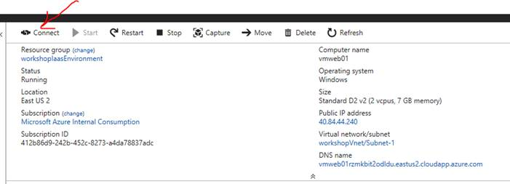

* Remote into the vmweb01 using the User Name and Password used when creating the environment.

**Note**:

Default Admin: sysadmin

Default Password: Password$123



Verify the identity of the virtual machine and click YES to continue.

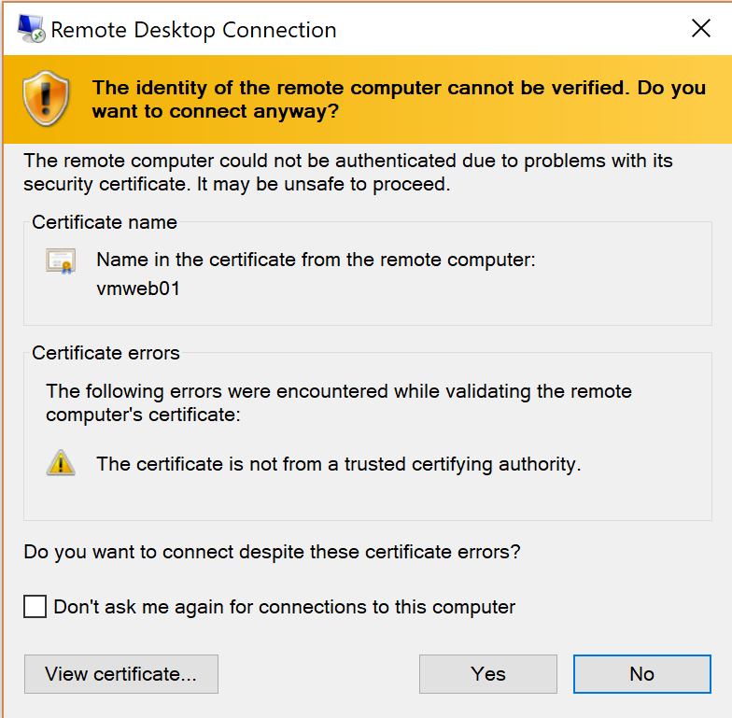

When you first connect, Server Manager will open.  To make is simpler to browse the web, let's turn off IE Enhanced Security.

Click on Local Server.  You will see an option for IE Enhanced Security, click it

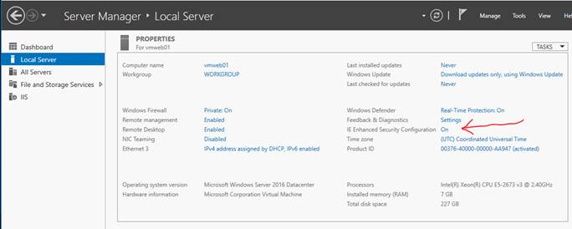

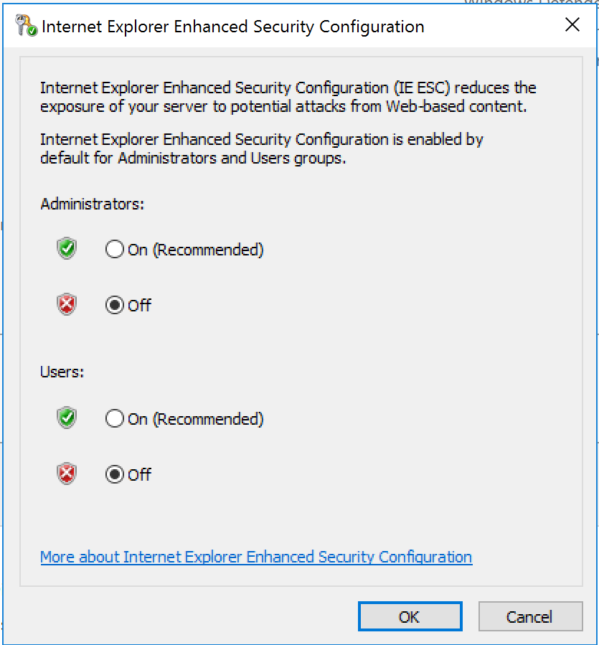

This will toggle the setting to off.  Once done, close Server Manager.

Click the Start Button and see if you have the “Microsoft Web Platform Installer” on your system. If you don’t, follow the steps below to install.

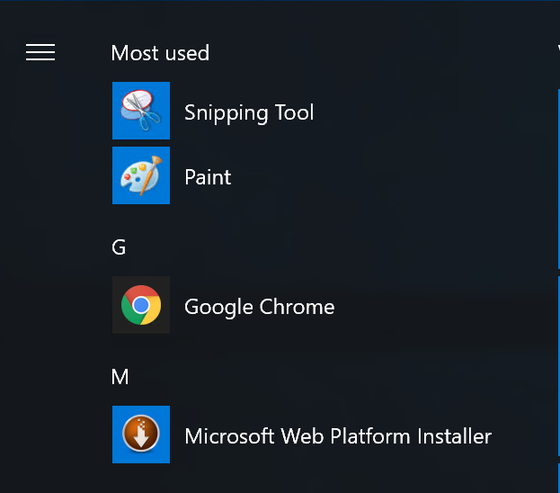

#### Task 2: Install the Microsoft Web Platform Installer

Open a browser and navigate to <https://www.microsoft.com/web/downloads/platform.aspx> and click the **Install this extension** button.

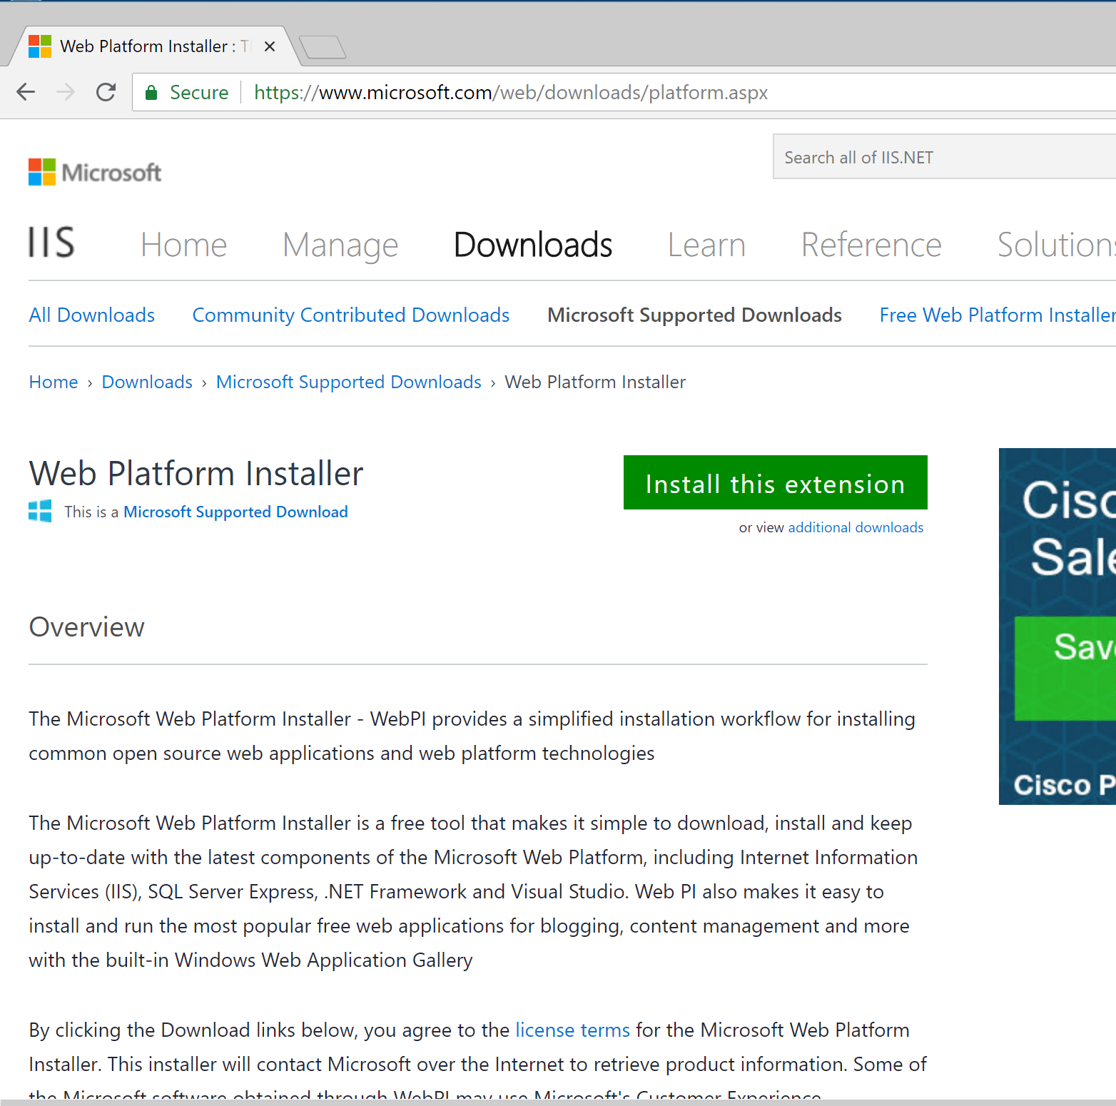

 After the Web Platform Installer is done downloading, Run the MSI package and accept all the default values:

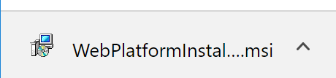

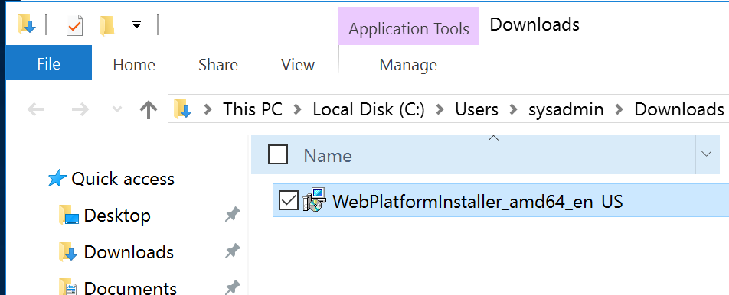

Run the Web Platform from the start menu. Once Web Platform is open, search for and select to install SQL Shared Management Objects and SQL Server Data-Tier Application Framework.

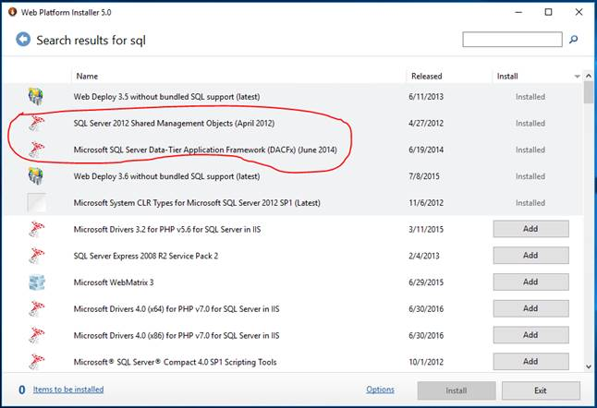

Once you’ve “Add” those packages to your install, Accept the prerequisites and continue with the installation.

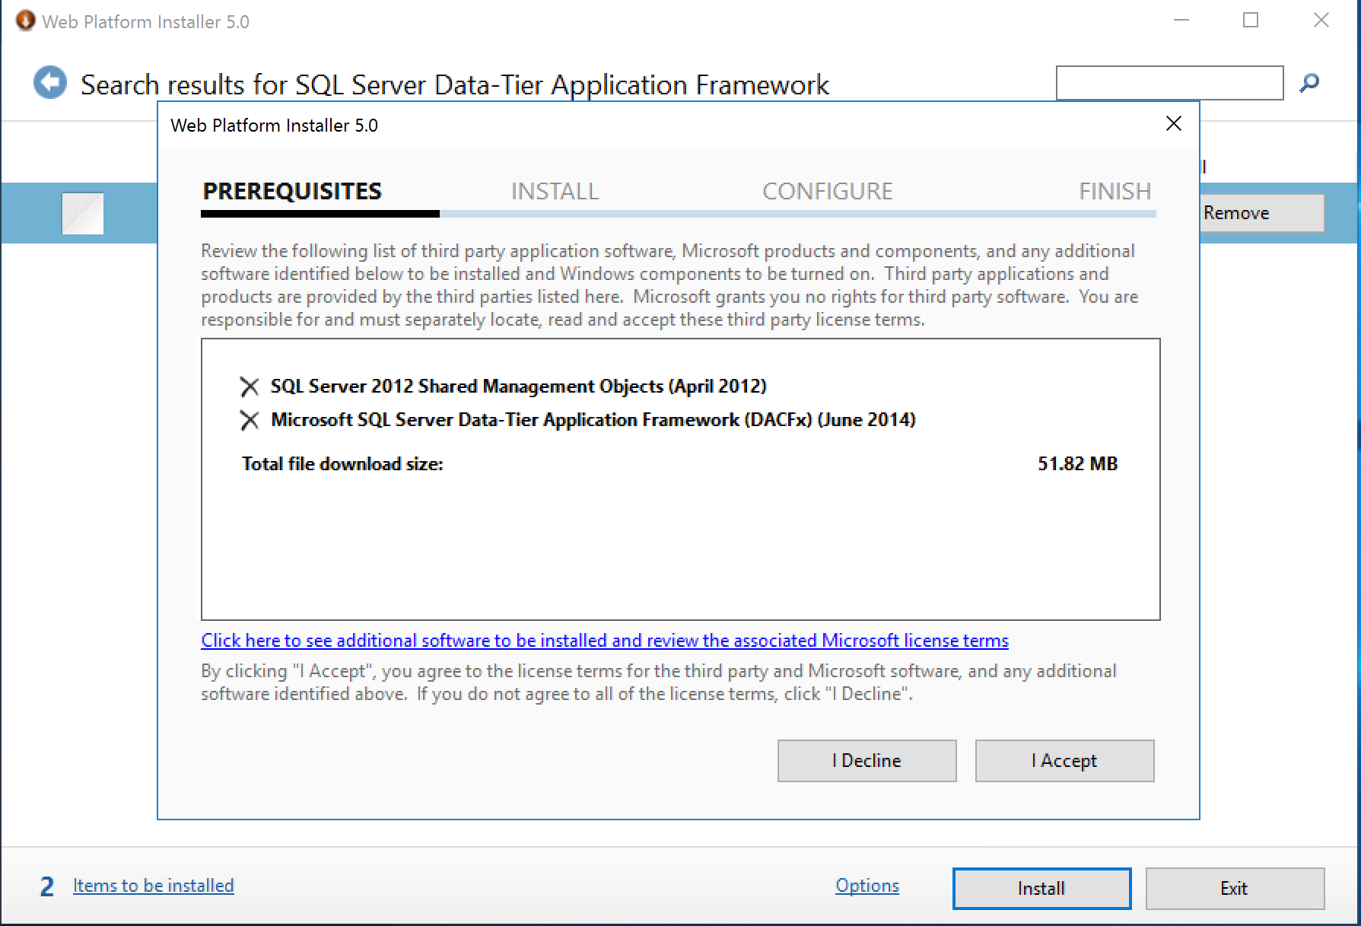

When done, click Finish

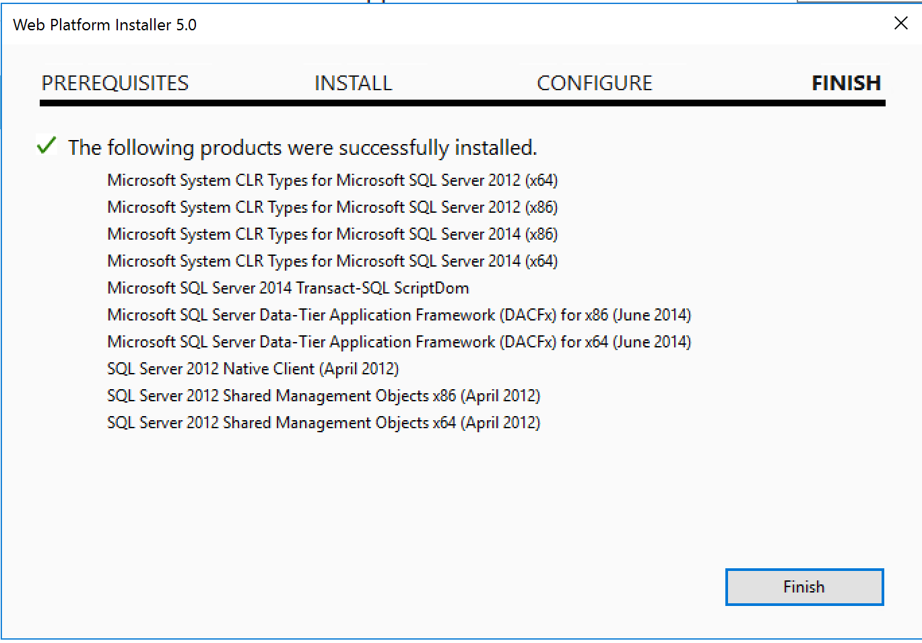

Exit the installer

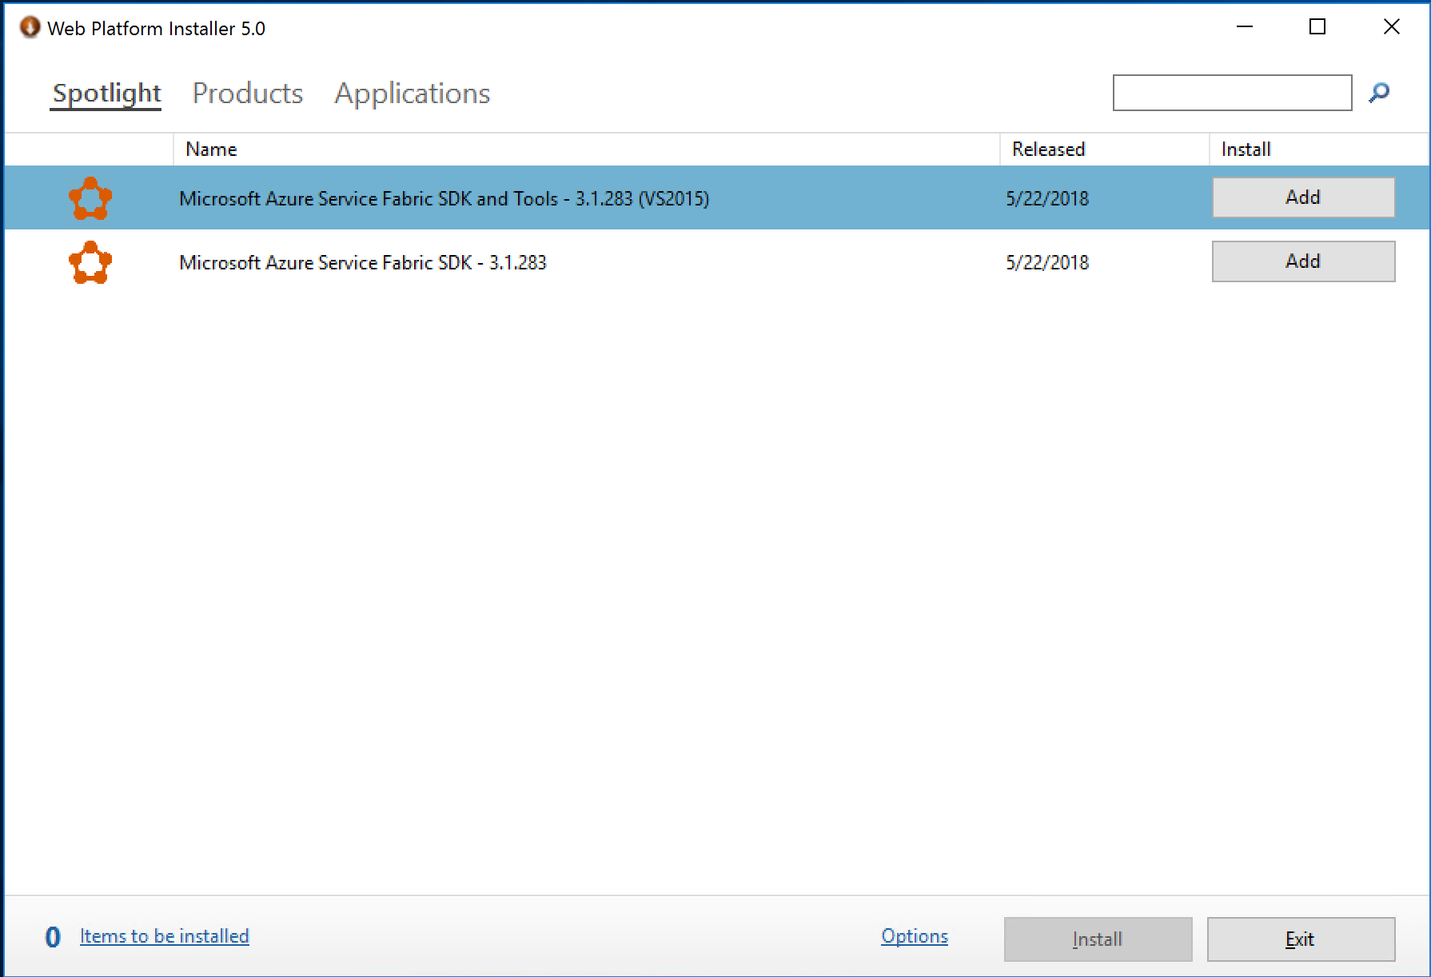

#### Task 3: Run the Azure App Service Migration Assistant

Open a browser and navigate to the migration tool site <http://www.migratetoazure.net/>

You will be presented with several options.  Windows Migration Tools, Linux Migration Tools, Assessments, etc.  Click Windows Tool.

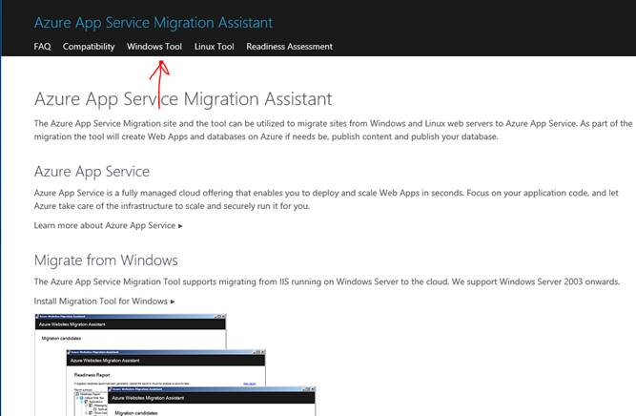

**Note**: If you do not see the Windows Tools and only see the menu (see below) expand the Browser Window.

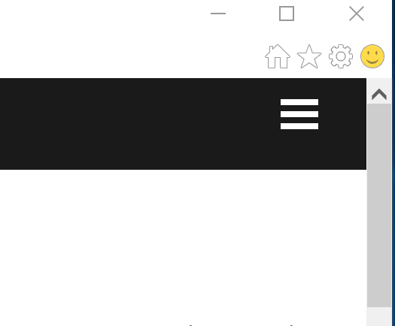

Choose to install the tool

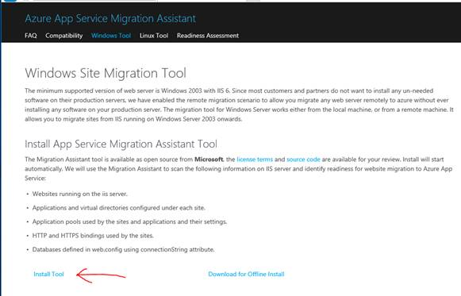

You will be presented with a security warning, click install to continue.

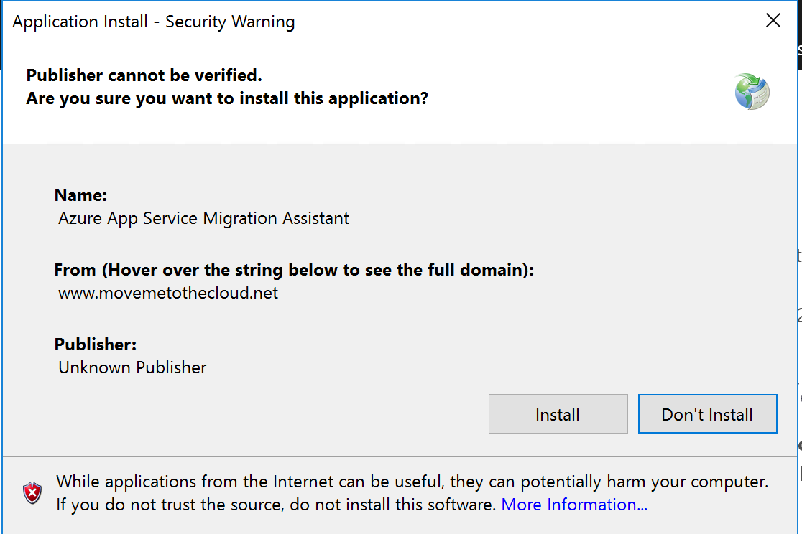

You will then be asked to run the file, click Run to continue.

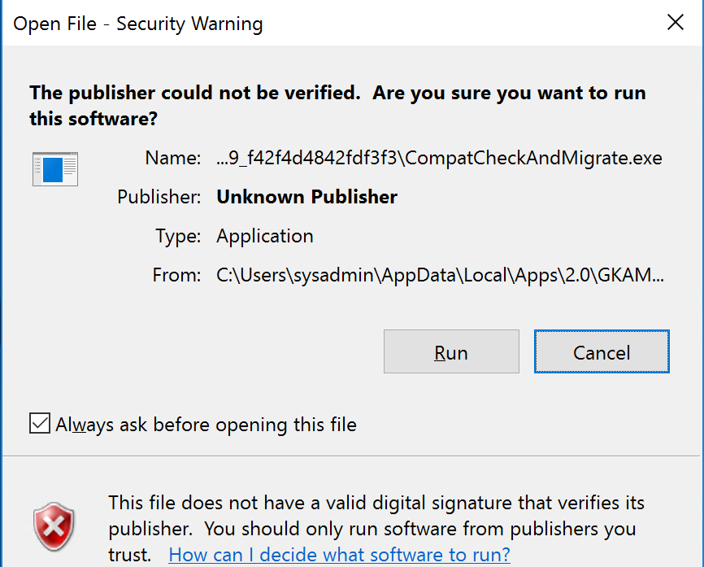

Choose the first option, migrate sites and databases on the local server to Azure and click continue

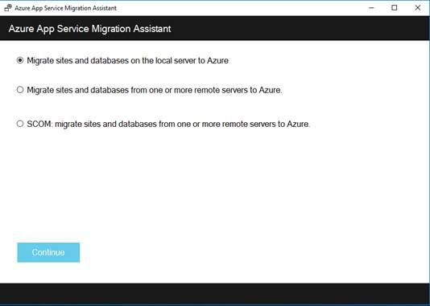

The tool will quickly scan your IIS server to pick up any websites that are migration candidates and the corresponding connection strings.  You can select what you want to migrate, then click next.

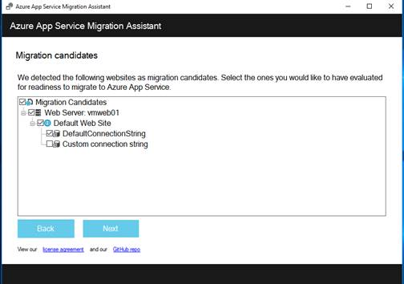

You will be presented with a Readiness Report.  You can upload this for analysis or save for later.

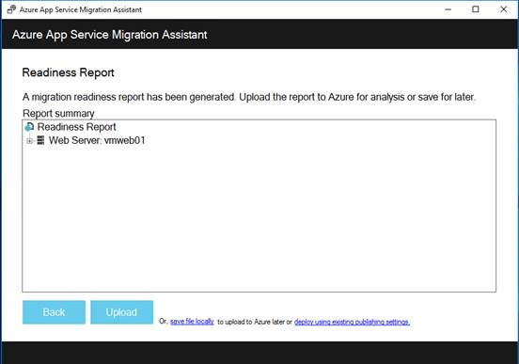

Click **Upload** to check if your site is ready to be migrated.  Your results should be like the following:

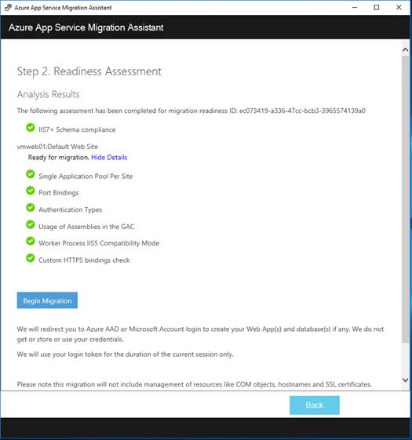

If everything looks good, click Begin Migration.

You will first be asked to authenticate against an Azure subscription

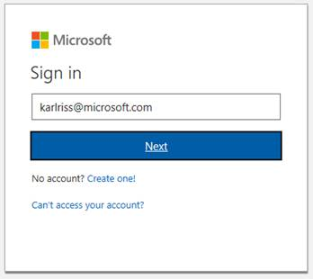

Once signed in, you will be asked for the Tenant, Subscription, and Location to use for the migration.  Make your selections and click Start Migration

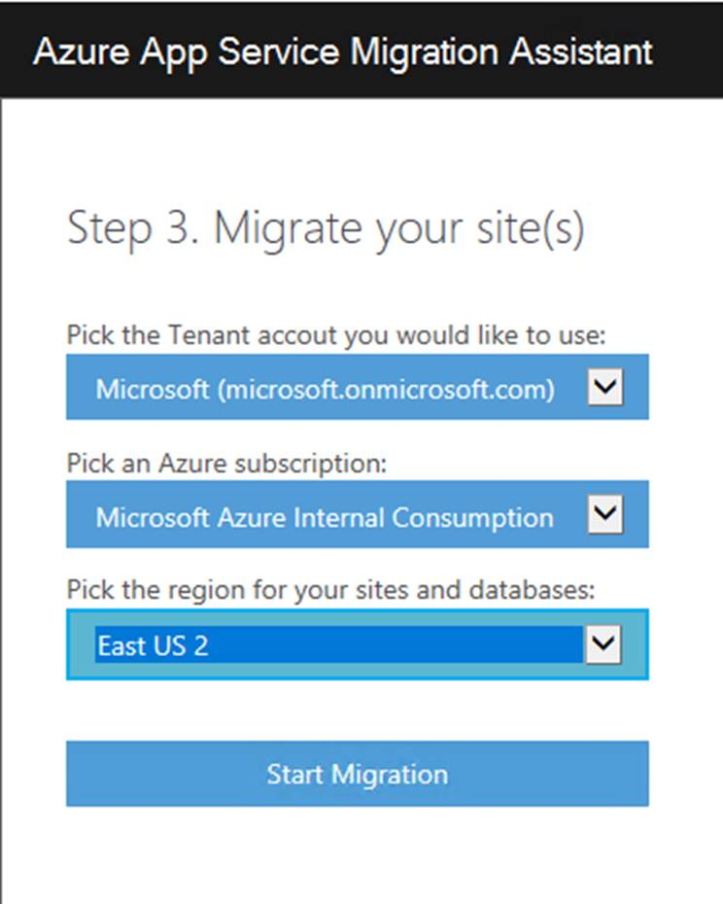

In this step, the tool will ask you to use an existing Azure SQL Server or create a new one, select the websites to migrate, as well as other configuration details.

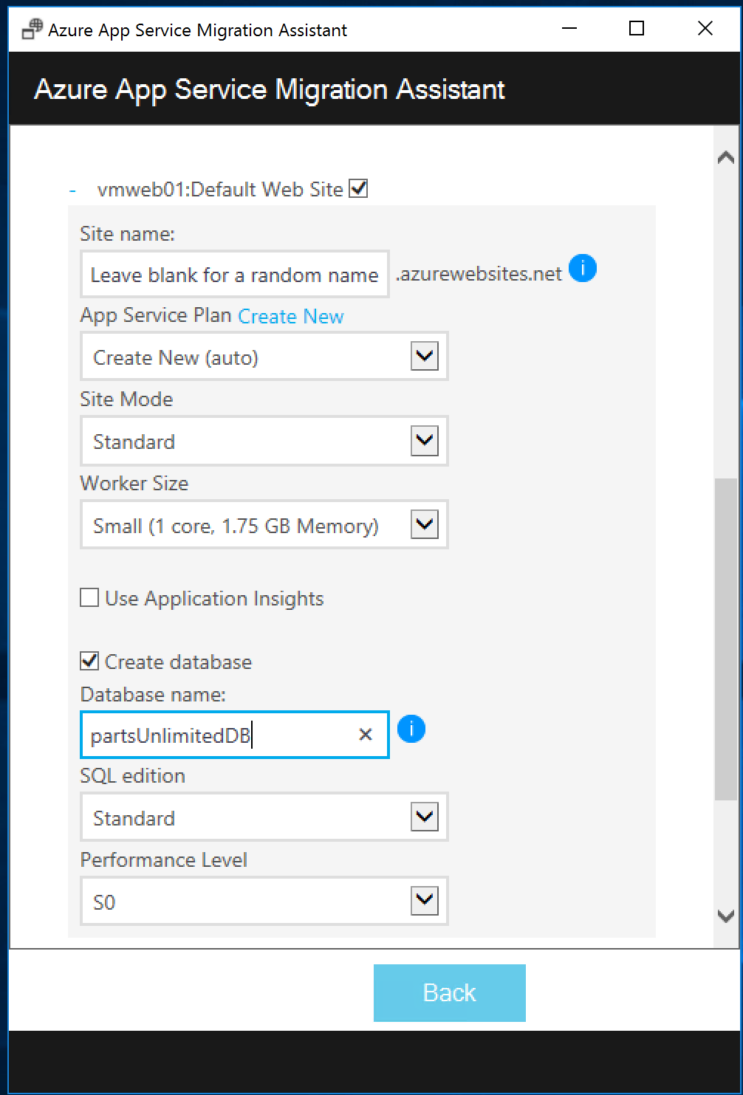 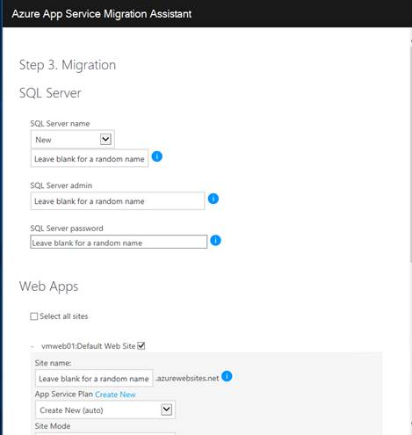

**Note**: Use the admin user and password that you used for the server and Use the same name for the database that you used when you created the environment

**Default Settings**:

Default DB Login Name: workshopServiceAcc

Default DB User Name: workshopServiceAcc

Default DB User Password: P2ssw0rd

Default Database Name: partsUnlimitedDB

When done, click the **Create**.

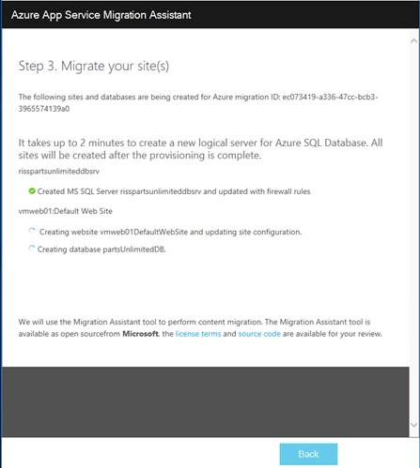

After a few minutes, your web app, SQL database server, and database are created and ready to go.

The final step is to publish the content.  Click the Begin Publish button.

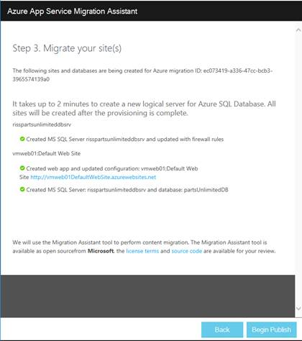

#### Task 4: Validate Application Migration

After a few minutes, your site and content will be ready to go.  Click the link to view your site.

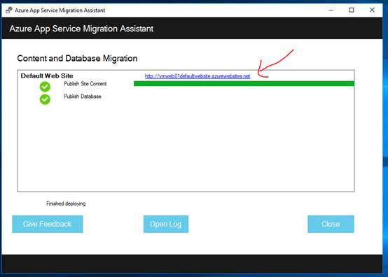

Ask yourself: How did the web site connect to the database? Did the migration tool modify the Web.Config file with the new database? We’ll answer that below.

Go back to the Azure portal and look at the Resource Groups.  You will see a new Resource Group called "Server-Migration-<location>.

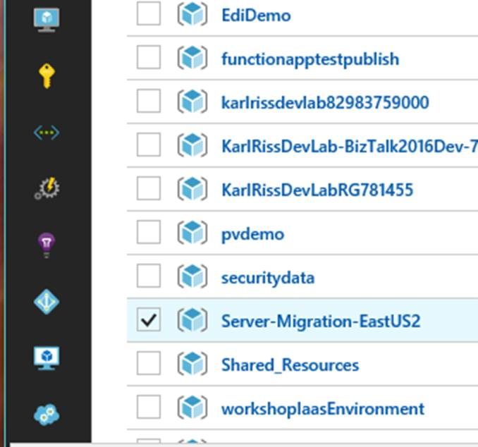

Navigate into the resource group to inspect the services that were created.

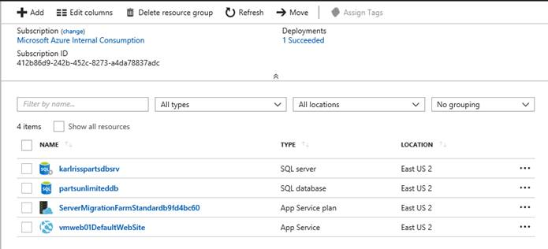

You should have 4 items

* SQL Server
* SQL Database
* App Service Plan
* App Service

Click the web app and then click app settings so we can have a look at what was created

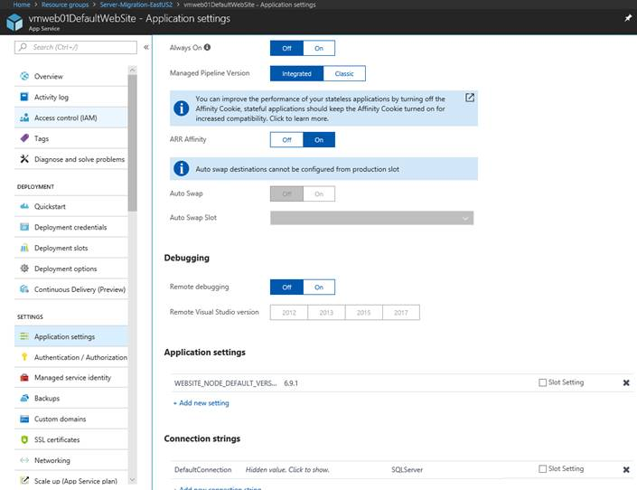

Notice there are lots of options, we will be discussing them throughout this workshop.  However, note the connection string.  The App Service will override application settings defined in your Web.Config, making it easy to manage and secure.

Go back to the resource group and click on the App Service Plan.  The app service plan defines the infrastructure your app is hosted on.  Scale Up defines the instance size you are running on and scale out defines the number of instances.

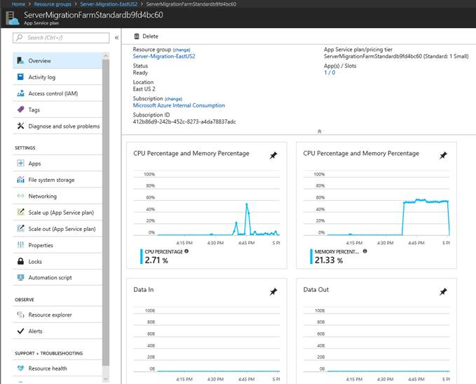

#### Task 5: Create Azure API Management

Since the creation of the Azure API Management takes a little bit to provision, we will configure it now. In the Azure Portal, create a new instance of API Management:

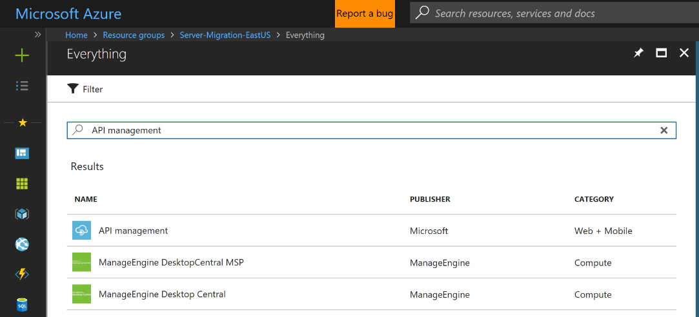

Type in the name (e.g. use the same name as your web application), choose the region that’s the same as the web application that is already deployed, then type in the organization name, and then type your email address. When you’re all done, click **Create.** Provisioning this resource can take up to 1 hour.

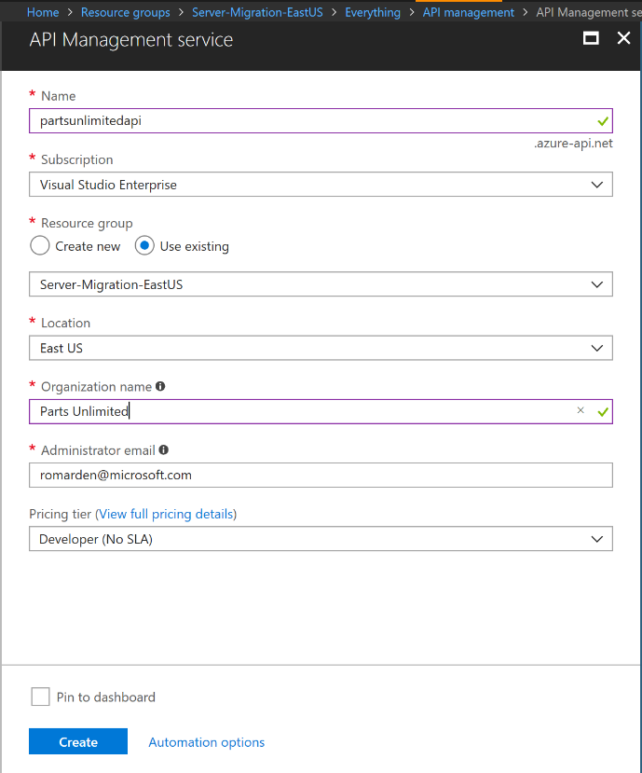

## Exercise 2: Implementing DevOps Continuous Integration / Continuous Deployment (CI/CD)

Duration: 45 minutes

Parts Unlimited wants to improve their deployment process to enable more agility. Currently, Parts Unlimited has a very manual deployment process. Developers document the install steps and operations performs the deployment. This process worked when they pushed code only a few times a year. However, the goal is to rapidly deliver value in days as opposed to months.

Currently, there is no automated deployment process. Visual Studio Team Services has been chosen as the ALM/DevOps platform moving forward. You will implement a CI/CD process from Team Services to Azure. Once the CI/CD process is in place you can quickly deploy changes to production with full traceability. The automation not only shortens your delivery time, it also dramatically improves the repeatability. Additionally, you can add unit testing, automated UI testing, Load Testing, Manual Testing, approval processes, etc. to ensure you do not sacrifice quality for speed.

#### Help references

|  |  |
| --- | --- |
| Visual Studio Team Service | <https://www.visualstudio.com/team-services/> |
| Visual Studio Team Services CI/CD | <https://docs.microsoft.com/en-us/azure/virtual-machines/windows/tutorial-vsts-iis-cicd> |
| Visual Studio Team Services Creation | <https://docs.microsoft.com/en-us/vsts/accounts/create-account-msa-or-work-student?view=vsts> |

#### Prerequisites

To complete this task, you should have provisioned the Parts Unlimited IaaS and PaaS environments (Exercise 1). You will use the Developer Workstation deployed as part of the IaaS environment for your development work.  
  
You must also have a Visual Studio Team Services Account and be able to create new projects within that account. If you don’t, you will need to setup a new Account.

#### Task 1: Add a new project to VSTS and upload the code

* Create Team Services Project and upload code
* Use Quick DevOps capabilities out of portal
* verify build/release process
* Add deployment slots
* Update release to use deployment slots
* Verify release

You can find the URL with a wizard which will help you setup a CI/CD process here; [https://azure.microsoft.com/en-us/try/devops/](mhtml:file://C:\Users\danshue\Desktop\Workshop\AppMigrationAndModernizationWorkshopPresenter.mht!https://azure.microsoft.com/en-us/try/devops/). For this next section you will need access to a visual studio team services subscription.  These are free for up to 5 people and are included with an MSDN subscription.

**Note**: Setup VSTS with the same user account you use to log into the Azure Portal.  If you do not, the CI/CD wizard will not find your subscription automatically!

If you don't already have a subscription, go to; [www.visualstudio.com](http://www.visualstudio.com), then click get started for free under the Visual Studio Team Services option.

Once you have a VSTS subscription setup, log into your tenant and create a new project

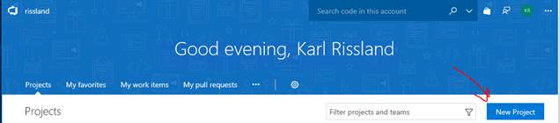

Give your project a name, make sure you have Git as your version control system, and click create

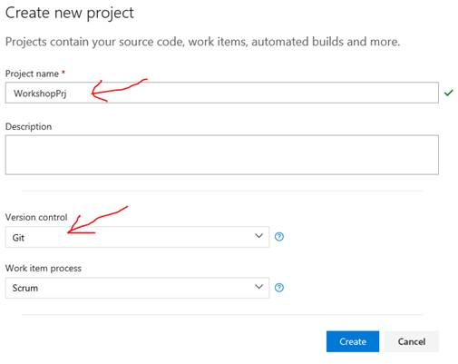

In a few moments you will have a new project provisioned for you.  You are now ready to upload code.

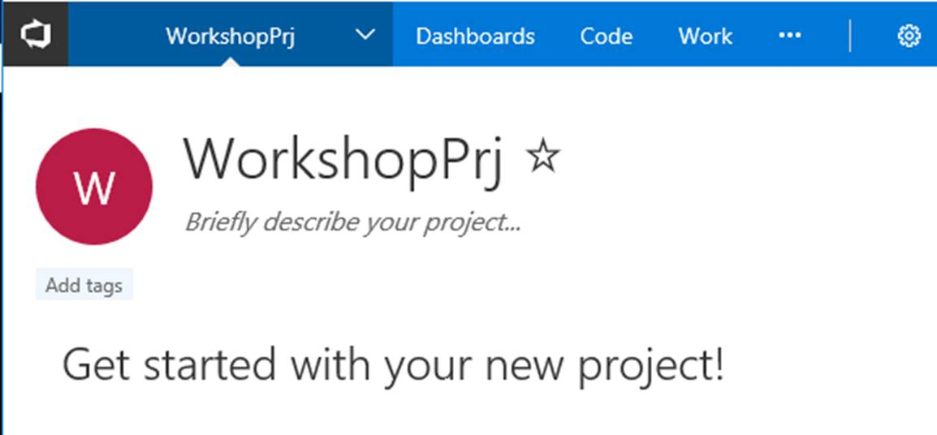

Next, we are going to change the origin of our Git repo and push an it to VSTS.  If not already visible, you can navigate to the Code Section of VSTS where you will be presented with the commands (with some small changes) to push the code to the repo.  This will be specific to your VSTS subscription and your project name so type in what VSTS shows you.  For example:

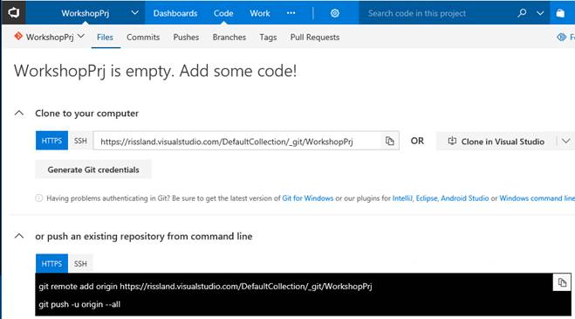

Git remote

Remote into the vmdev01 using the User Name and Password used when creating the environment.

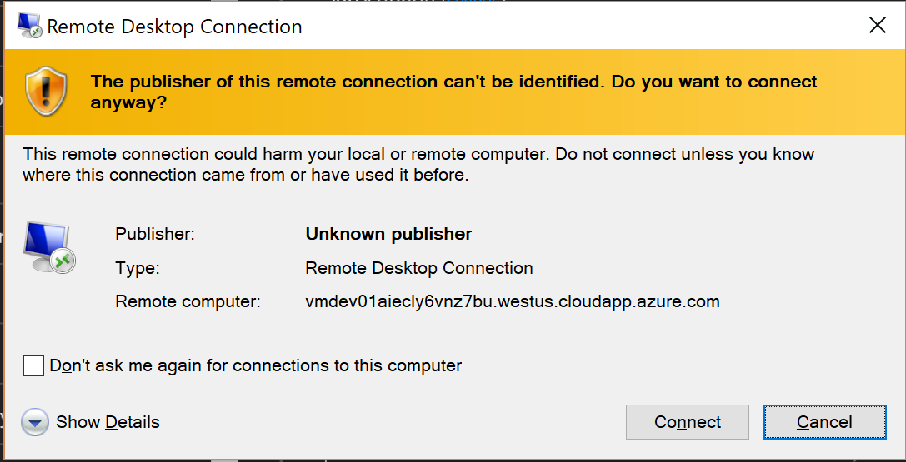

**Note**:

Default Admin: sysadmin

Default Password: Password$123



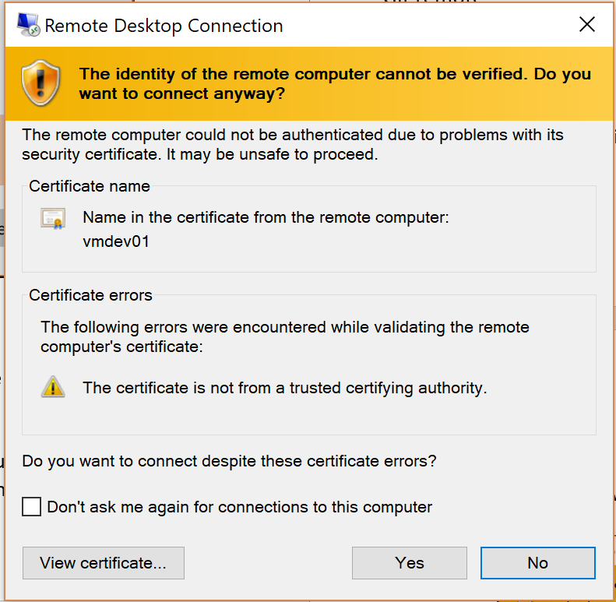

#### Task 2: Upload Code to Git Repository in VSTS

Open a command prompt

Navigate to c:\Source\AppWorkshop

The command VSTS is suggesting is git remote add origin……

We are going to use git **remote set-url origin….** Instead.

Grab your URL from your newly created VSTS Project

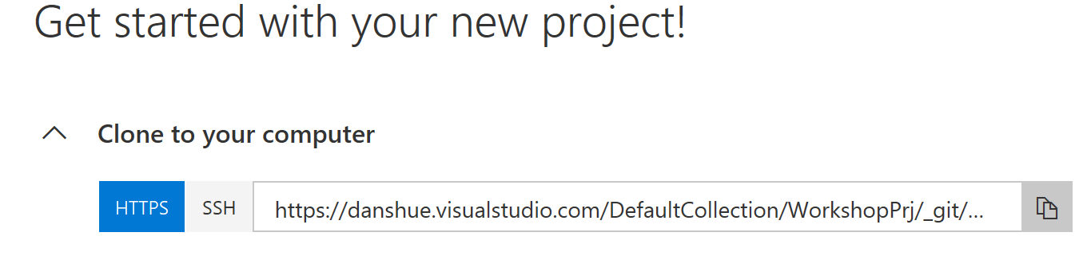

The command will look like git remote set-url origin **https://rissland……**..

Type in the command and hit enter to change the origin from GitHub to VSTS

Next, execute **git push -u origin --all**

You’ll be prompted for your credentials.

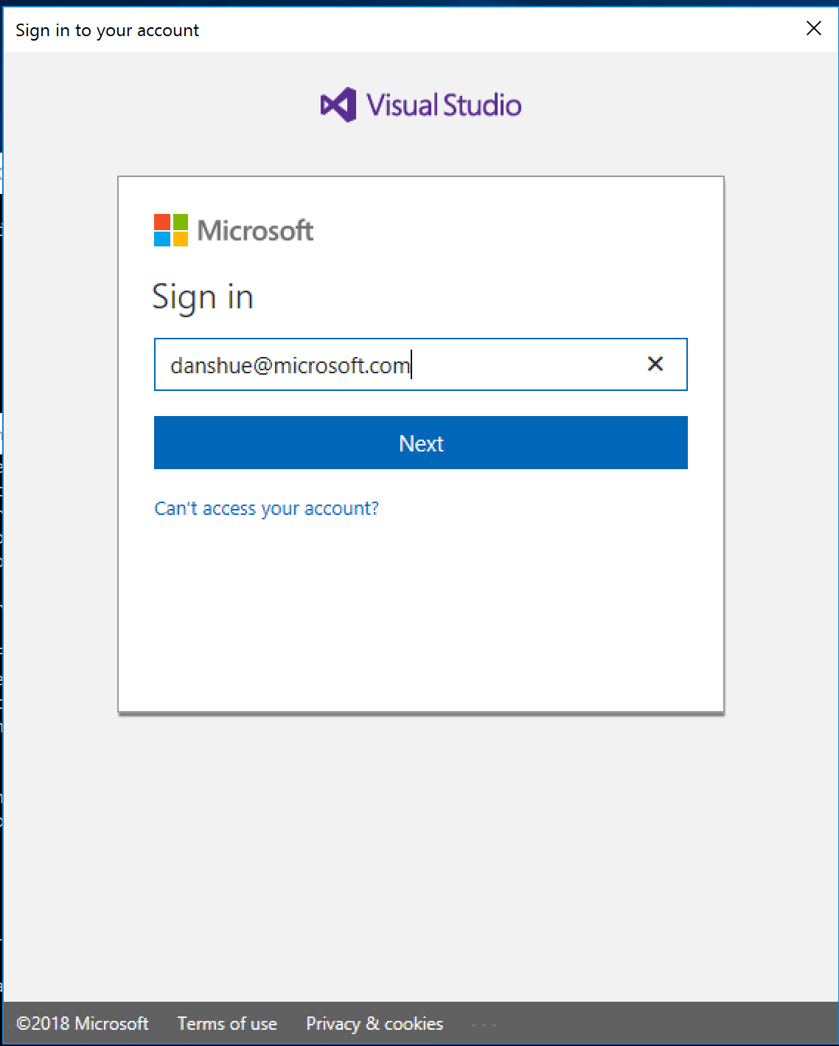

After you have entered your credentials, your commit will be pushed to VSTS

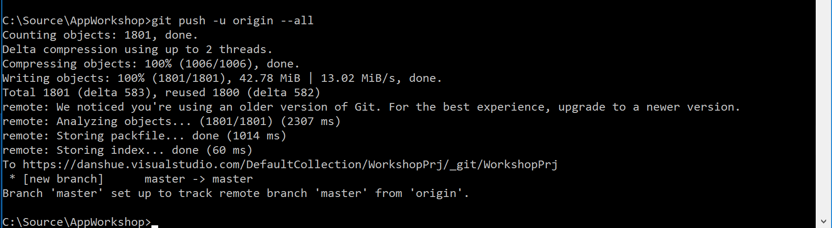

Once you entered the commands, refresh the browser.  You should now see the workshop code in your VSTS repository.

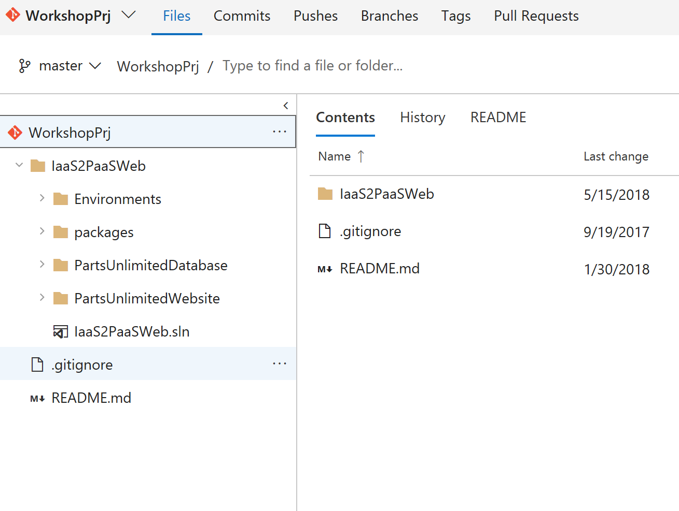

#### Task 3: Use Deployment Center to create CI/CD

Go back to the Azure portal and open the Azure App Service Web Site you created when you used the Migration Tool. It will be in the Server-Migration-XXXX Resource Group.

You will want to pick the "Deployment Center (Preview)”

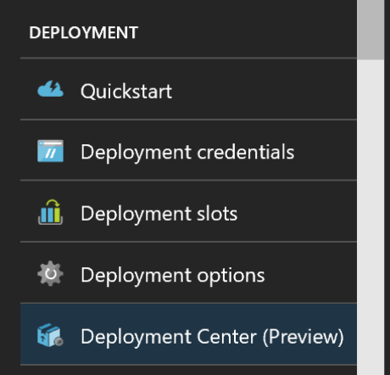

Next, you will see an overview page, click VSTS

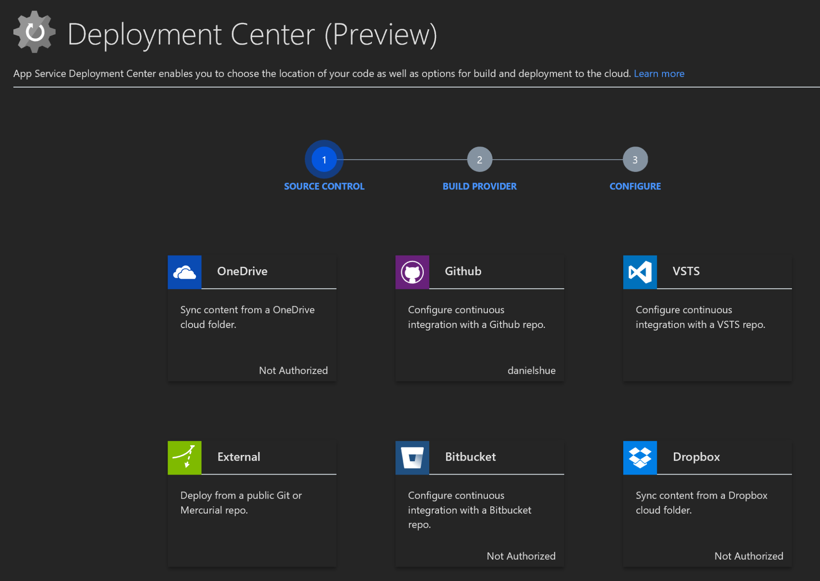

Next, you’ll have a choice of Build Providers, App Service Kudu build server or VSTS Continuous Delivery.

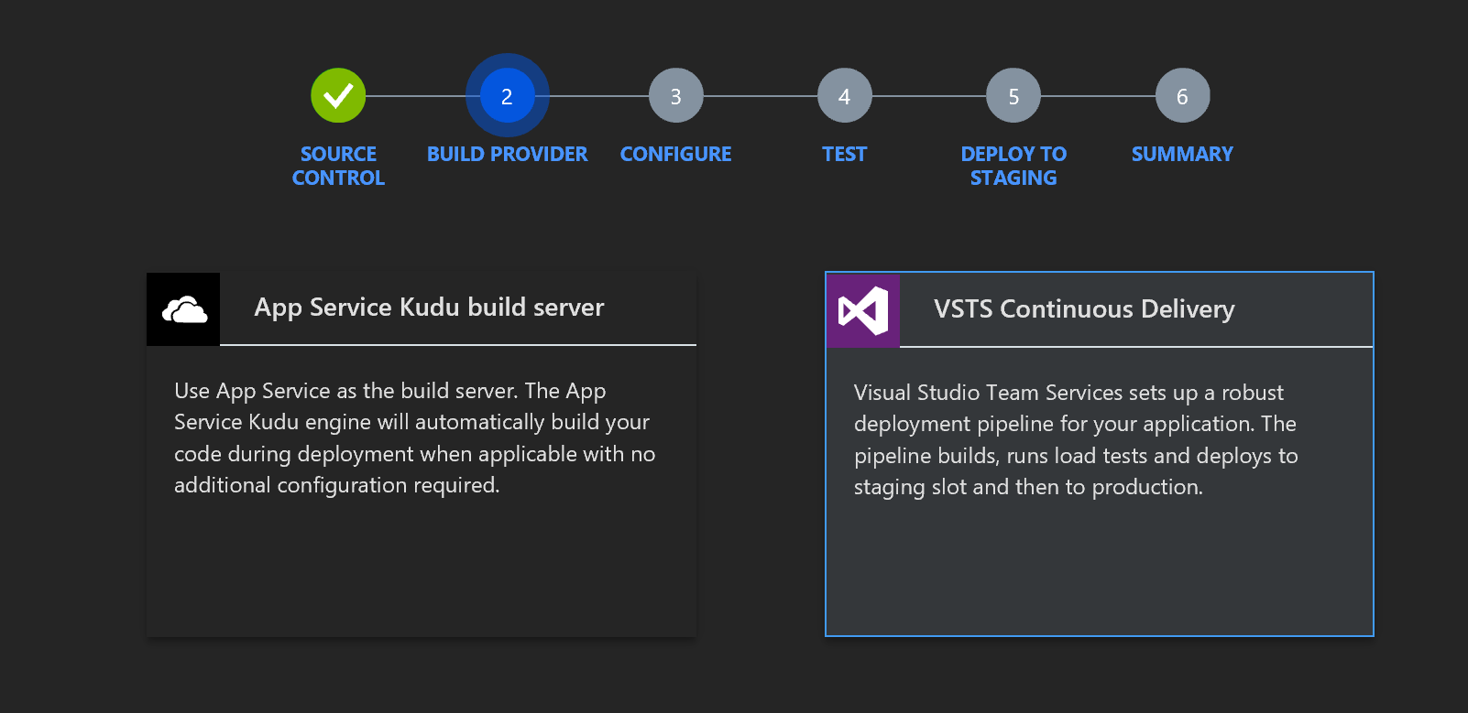

 Click on **VSTS Continuous Delivery**

Configure where the source code is located and which Web Application Framework to use for your Build

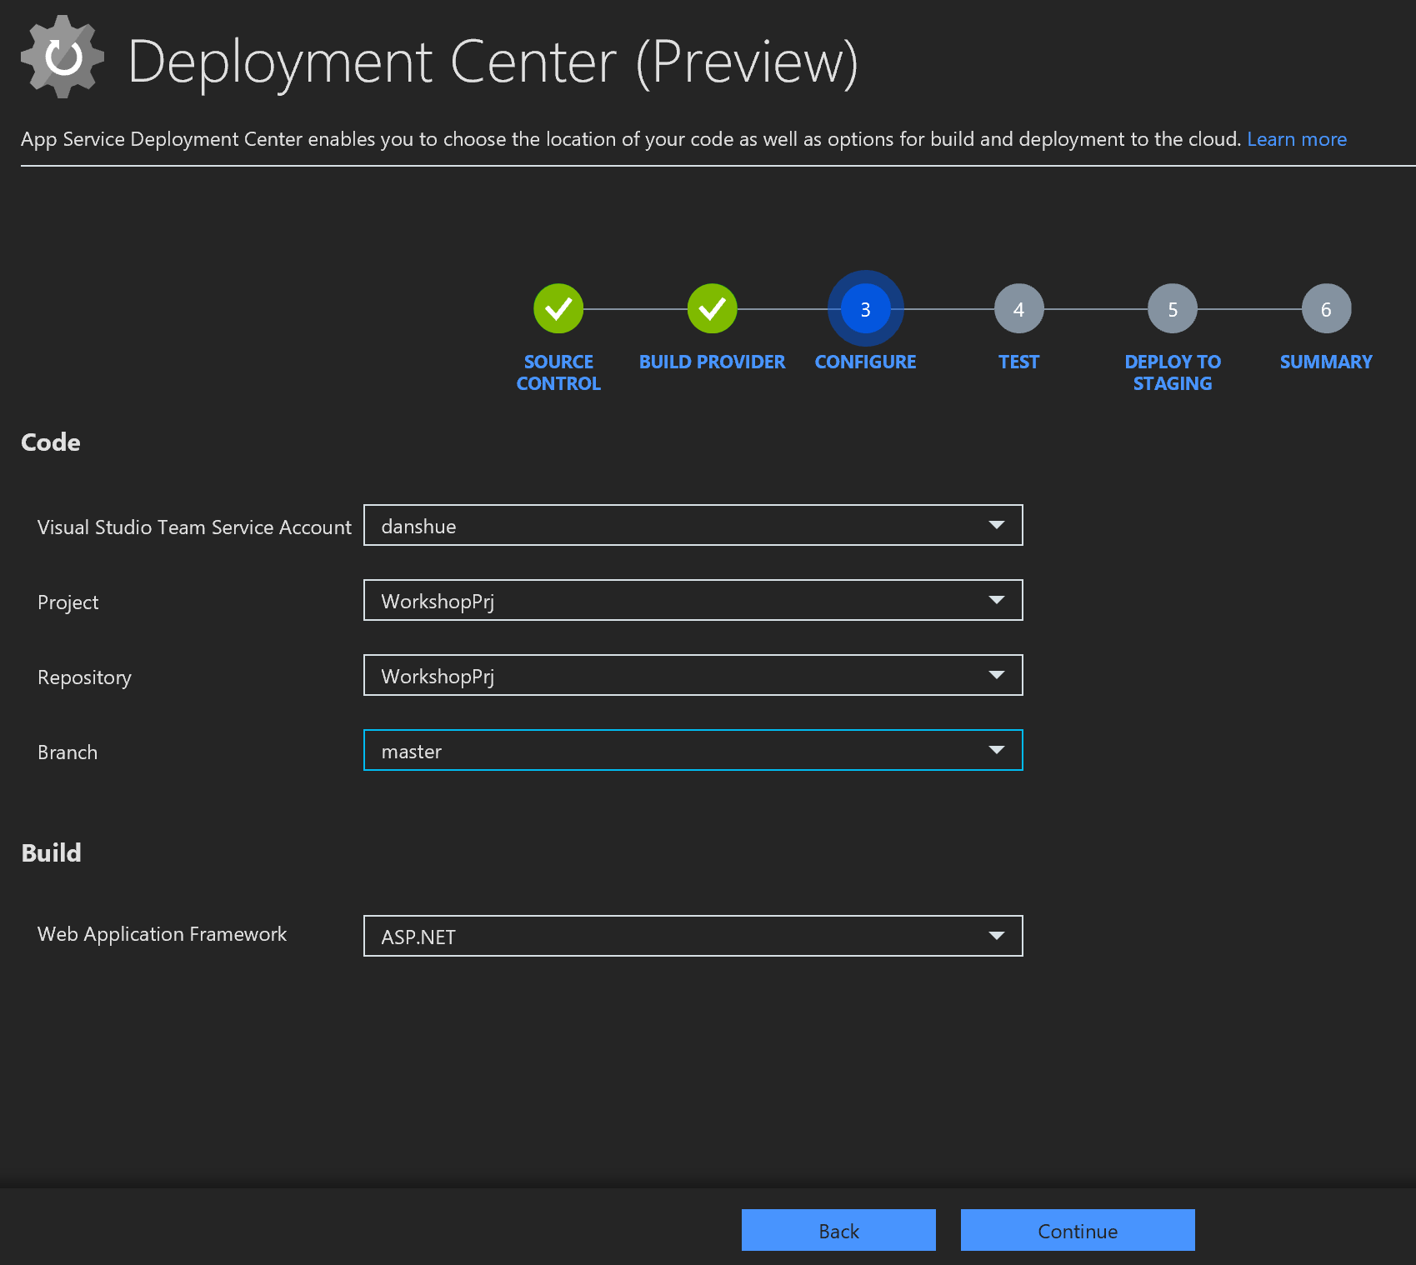

**Note**:

If you don't click on each dropdown, the OK button won't enable.

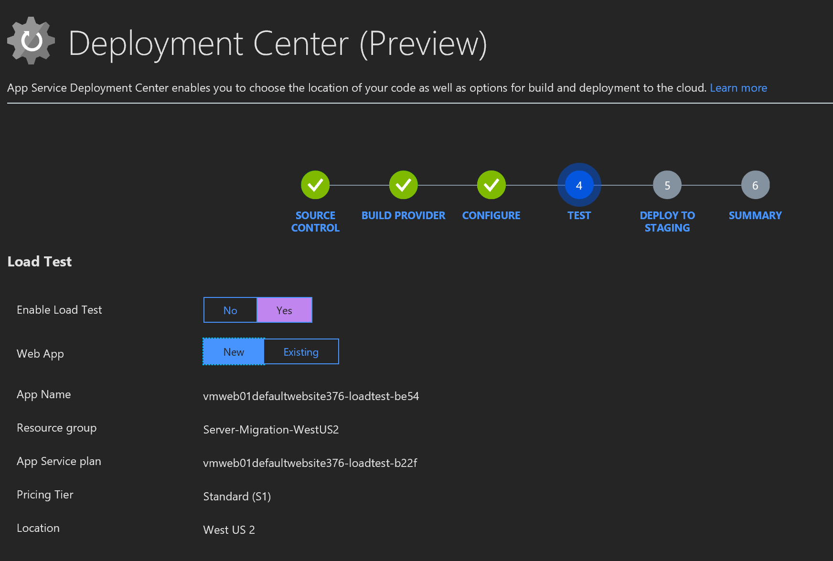

While you can setup Load Testing here, we are going to leave this option set to On change leave the default values.

Web apps have a feature called deployment slots.  This helps you deploy to a test environment prior to going to production.  We are going to click Yes and let the wizard set this up for us.

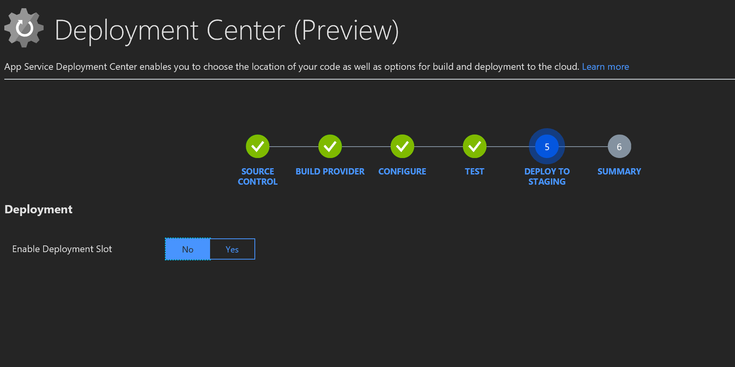

Click yes, choose to create a **New** Deployment Slot, and name the slot 'Staging'

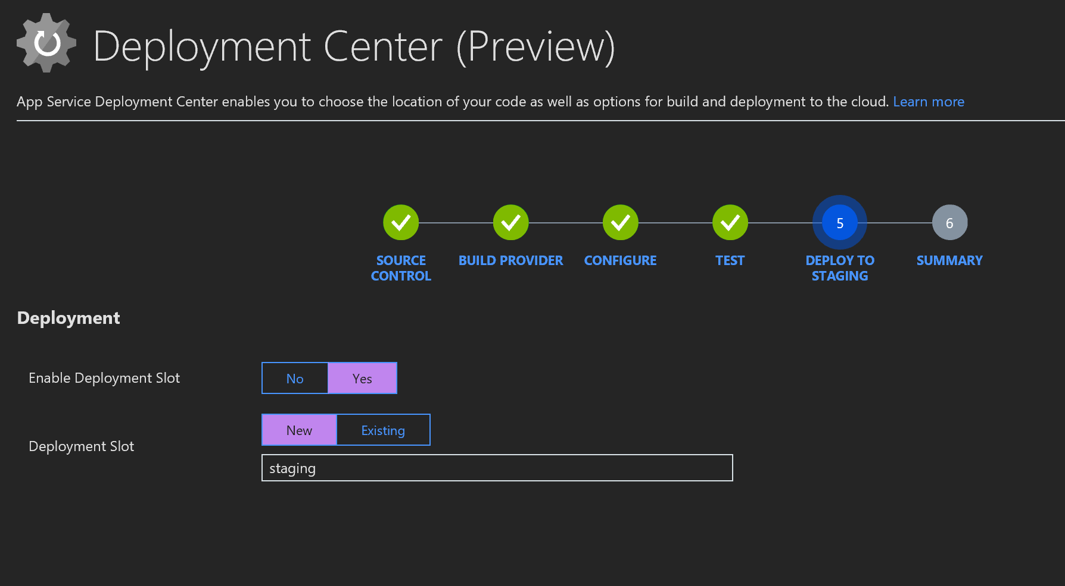

Click Continue

You should see a summary like the following:

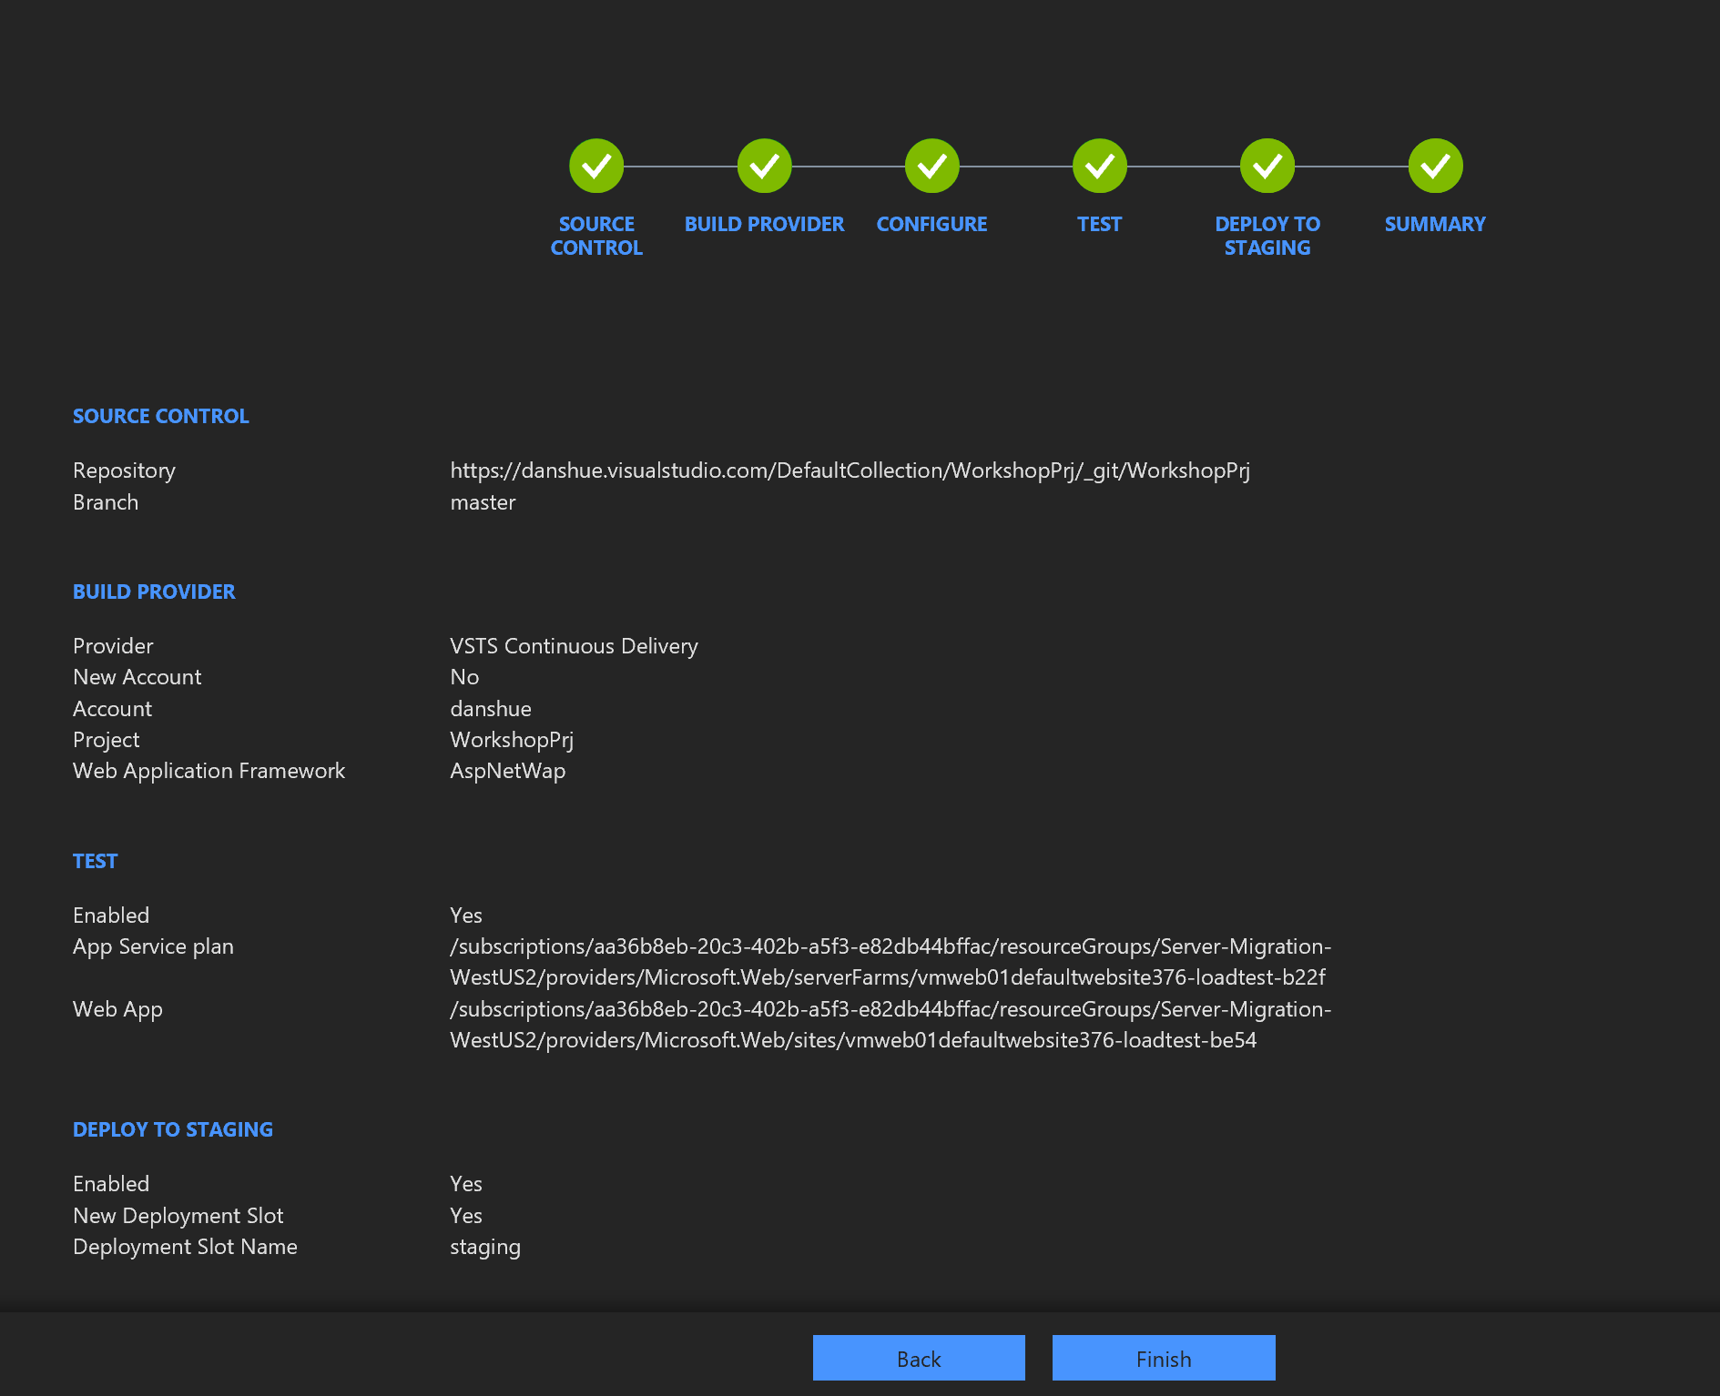

Verify the configuration and then click **Finish**.

The service will trigger a Build in VSTS, create a new Web Application for Test environment and create a new staging Slot.

This process may take a few minutes. When its complete, you’ll see a summary screen like the following:

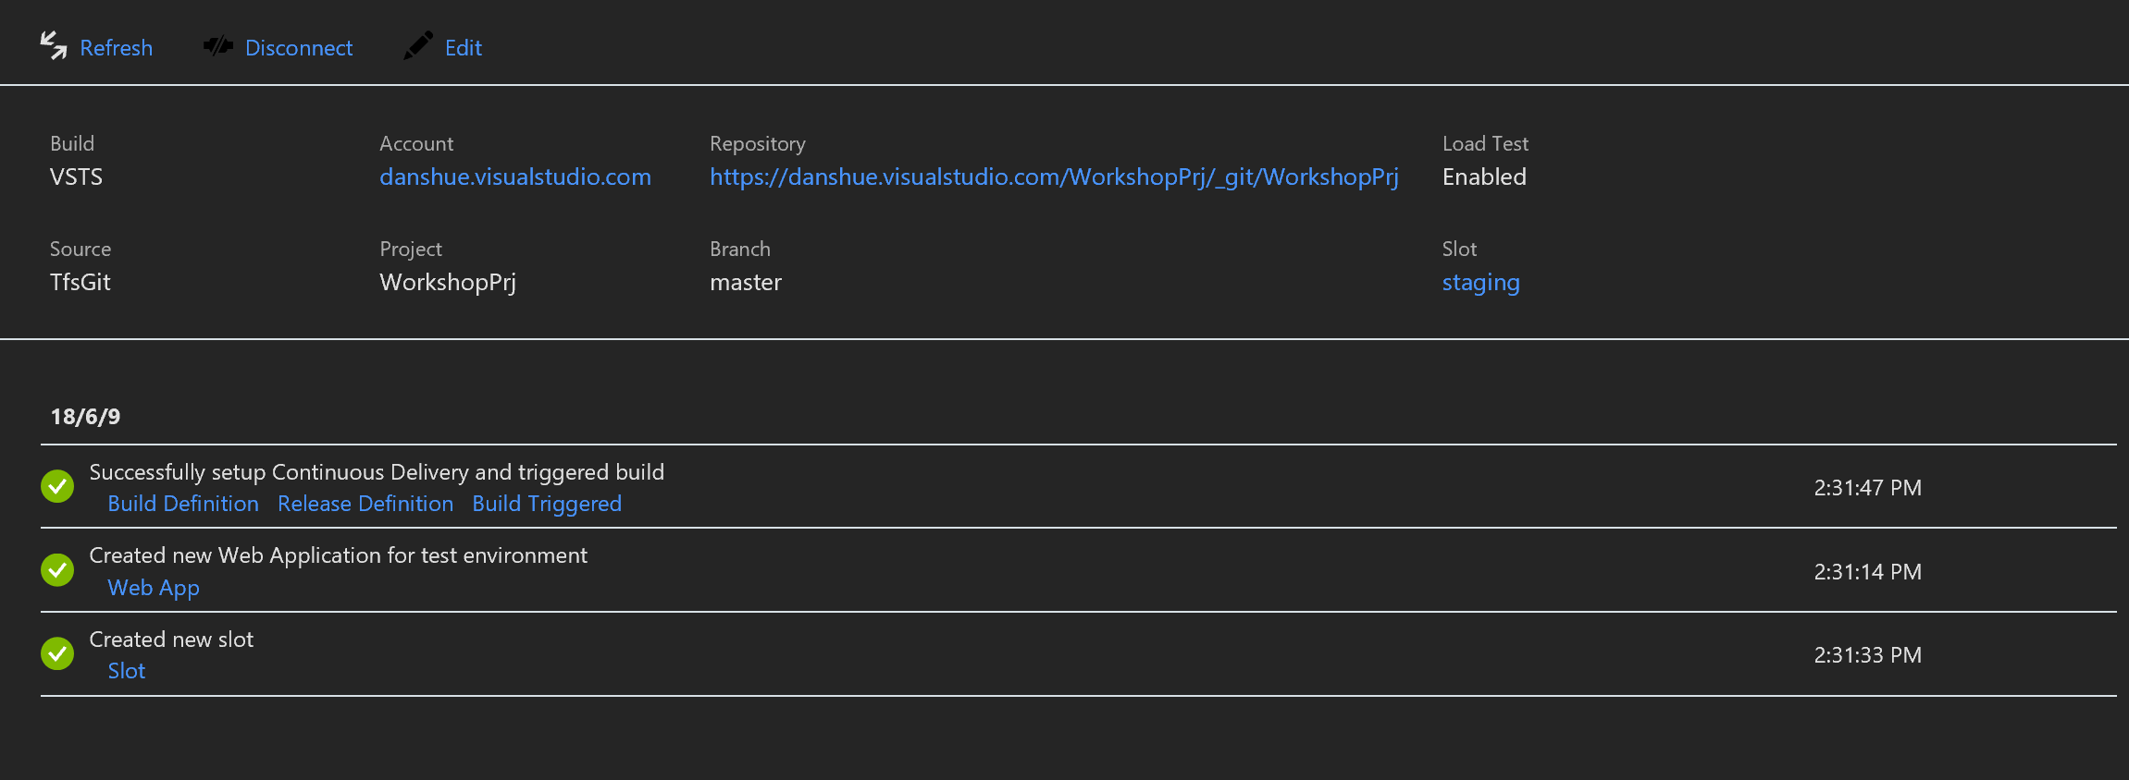

Going back to VSTS, click on Build and Release, then click on Builds.  You should see the build definition that was generated for you.

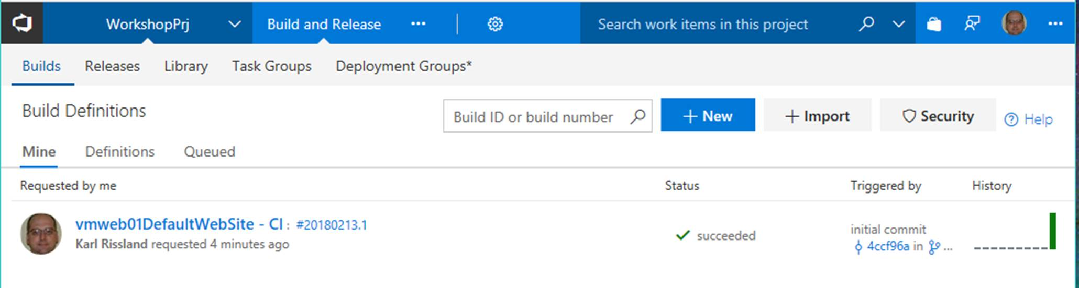

Next, click on the Releases tab to see the release that was generated for you.

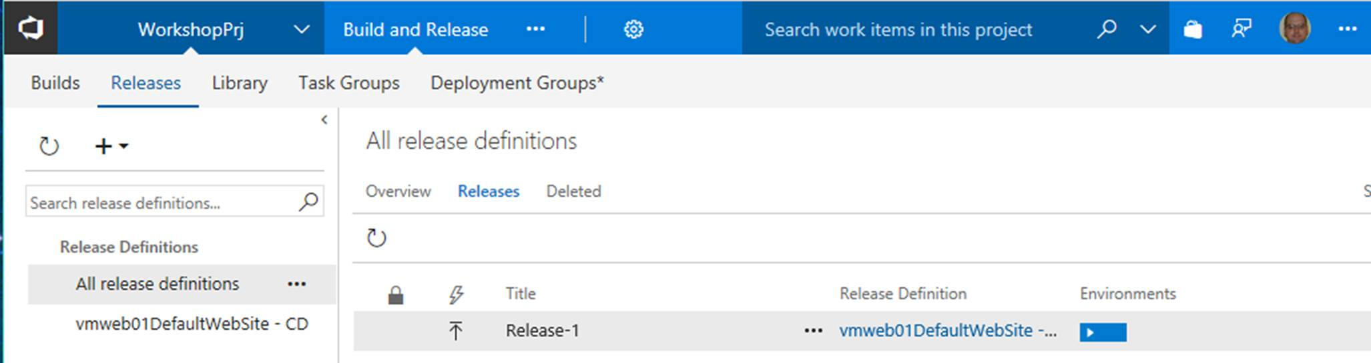

After a little time, the release should complete.

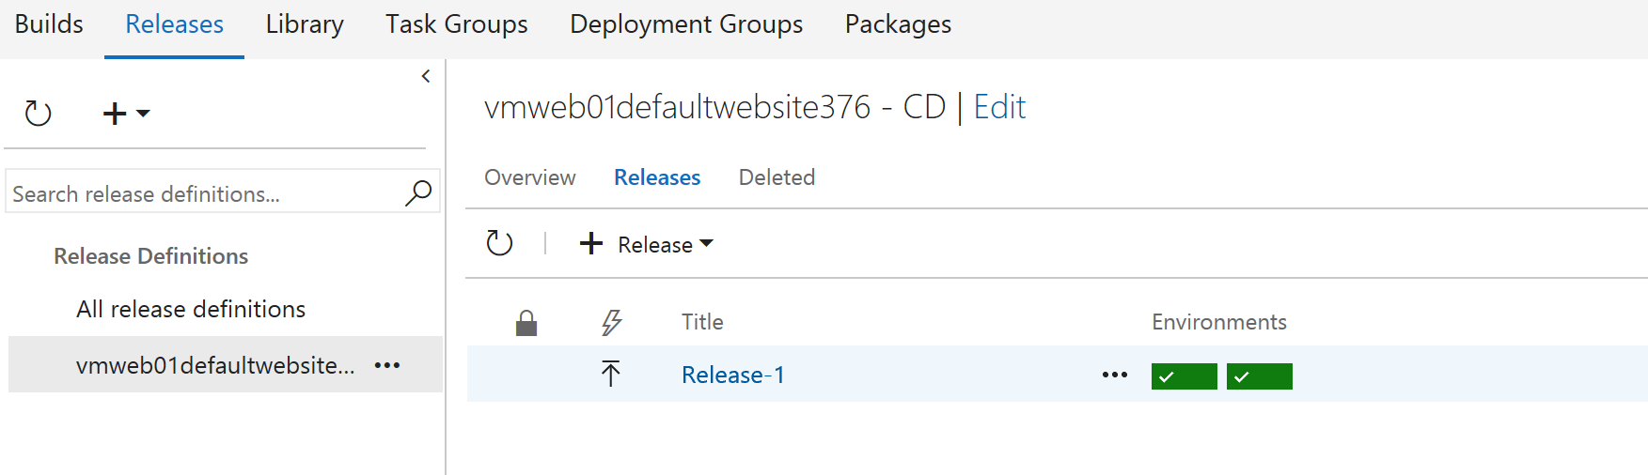

**Note**:

Looks like there is a bug in the migration tool.  It doesn't property put the connection string in the app settings correctly. Remember how we fixed this before?

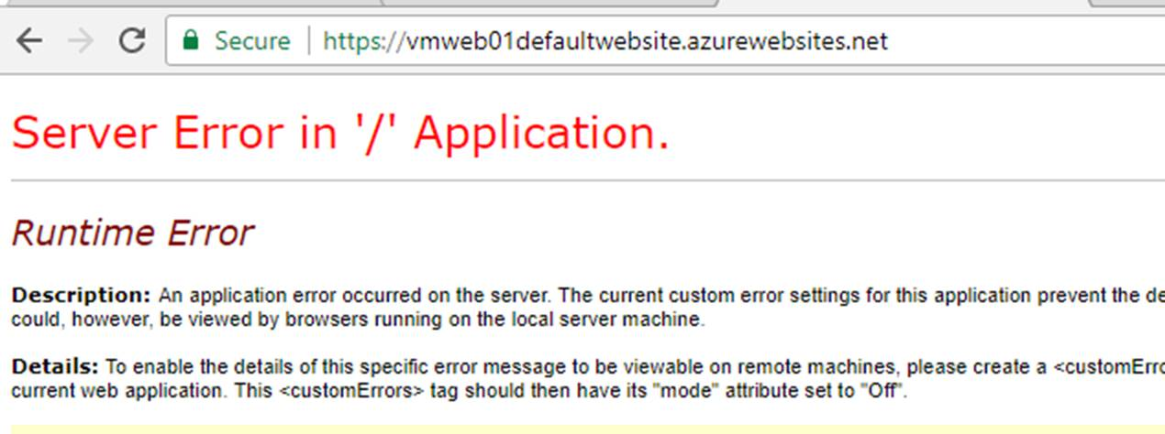

**Note**: This is an opportunity to see how you can troubleshoot the environment using Kudu, diagnostics, deployment slots, etc. Navigation with your web browser to https://[webname].scm.azurewebsites.net.

To Avoid the error……….

Note that the name of the connection string is "DefaultConnectionString", which we captured before starting the CI/CD pipeline creation.

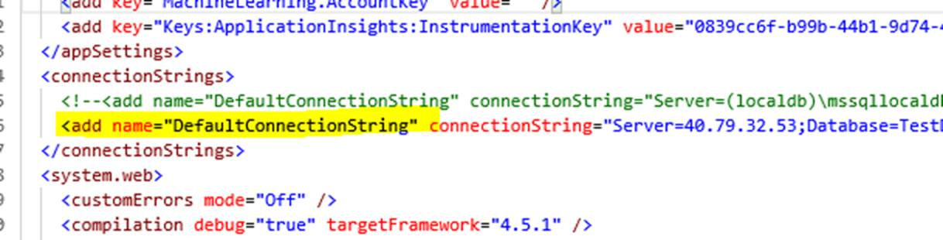

When the migration tools moved the application, it doesn't correctly add the connection string name.  Note that the connection string is simply "DefaultConnection"

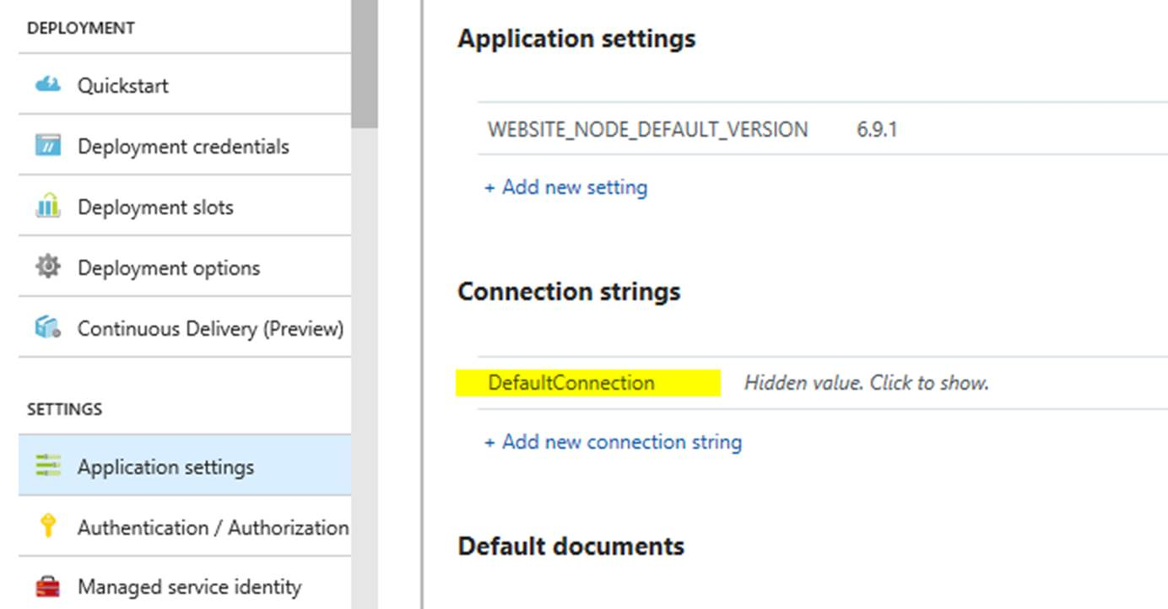

To avoid an error, simply edit the connection string name in both the production website and the staging slot to read "DefaultConnectionString" and save your settings. For the Database, use **SQLAzure**.

**Note**:

If you’re using VSTS, consider managing ConnectionString values in Release using the appropriate task.

#### Task 3 (Alternative): Use VSTS to create CI/CD

Go back to the Azure portal and open the Azure App Service Web Site you created when you used the Migration Tool. It will be in the Server-Migration-XXXX Resource Group.

**Part A - Setup A Deployment Slot**

Open the Server-Migration-\*\*\*\* resource group and click on the web application

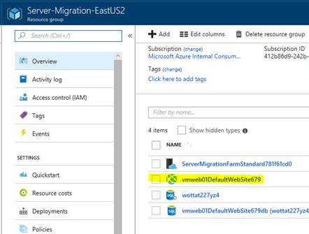

In the web application, click on Deployment Slots

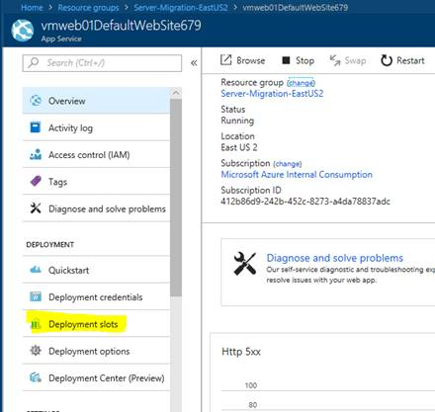

At this time, there are no deployment slots configured for your website.  A deployment slot is used to setup a staging environment for your application, so you can test new changes easily prior to rolling them to production.

Click the Add Slot option to add a new deployment slot.

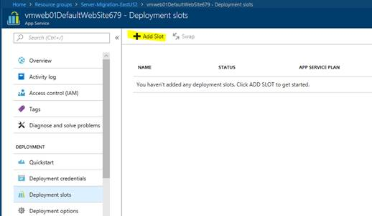

On the "Add a Slot" dialog, name the slot "staging" and choose the configuration source as the current production slot, then click ok.

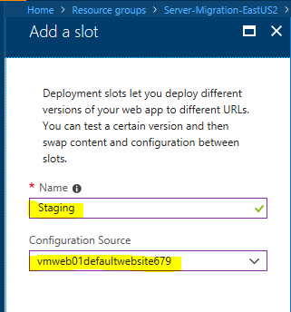

When done, you should have a new deployment slot named "staging".

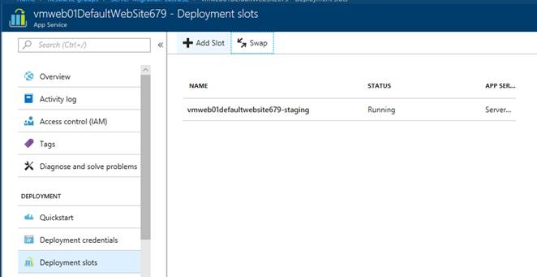

**Part B - Setup CI/CD**

Open your new Team Services Account \*\*\*\*.VisualStudio.Com and view the "Overview".  You should be presented with summary information about your project with a very prominent "Set up Build" Button….. Click it.

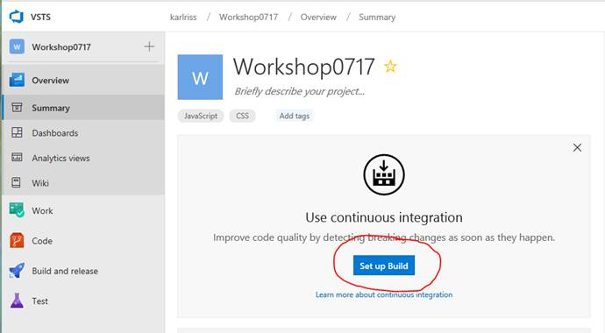

The Next Dialog will ask you to choose where your source code is, your project, repository, and branch.  These options should be defaulted to the correct values.  Click continue.

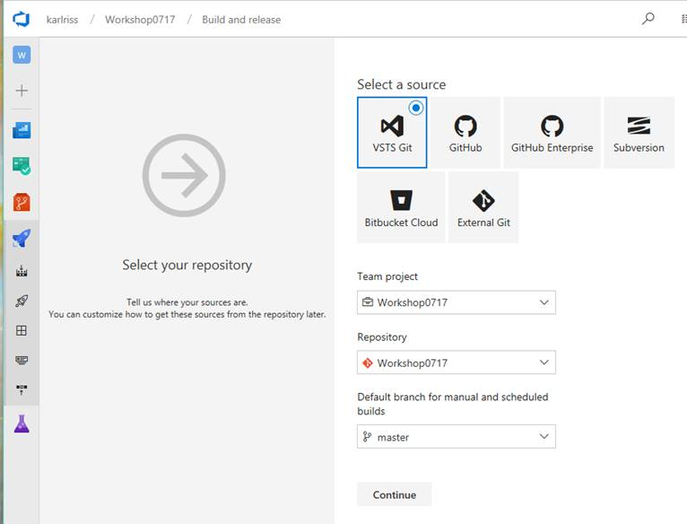

The next dialog will present you with a few canned build templates.  Select the Azure Web App for ASP.NET template and click Apply.

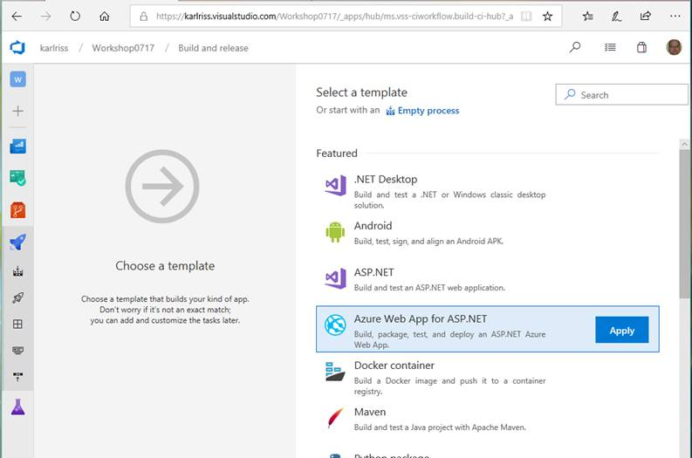

Next, you will be shown the build process with some options that need to be configured.  First, in the "Azure Subscription" drop down, pick the Azure subscription which is hosting your migrated web application and then click the "Authorize" button.

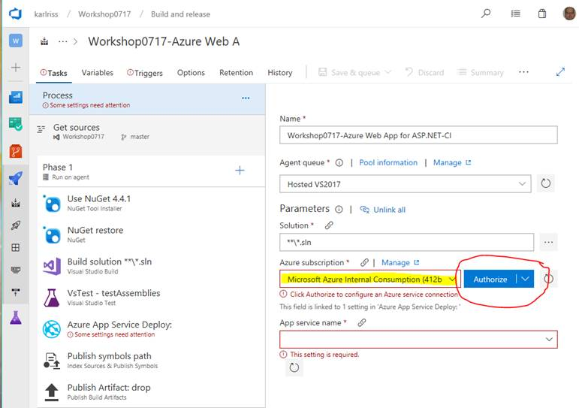

**Note:** It is assumed that you are using the same login for your VSTS account and your azure subscription.  If this is not the case, the Azure subscription may not be shown in the drop down and you will need to manually add it to VSTS.  If this is the case, simply ask your instructor or proctor to assist you.  Should take no more than a few minutes to setup.

Once the subscription has been Authorized, VSTS is able to enumerate the App Services in your subscription and populate the drop down.  Simply pick the App Service you wish to deploy to.

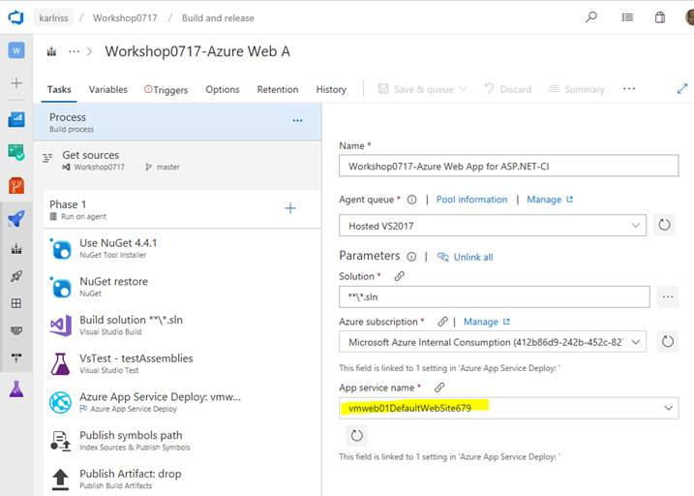

One last setting.  Notice that the "Triggers" tab is showing an error.  Click the triggers tab and select your master branch.

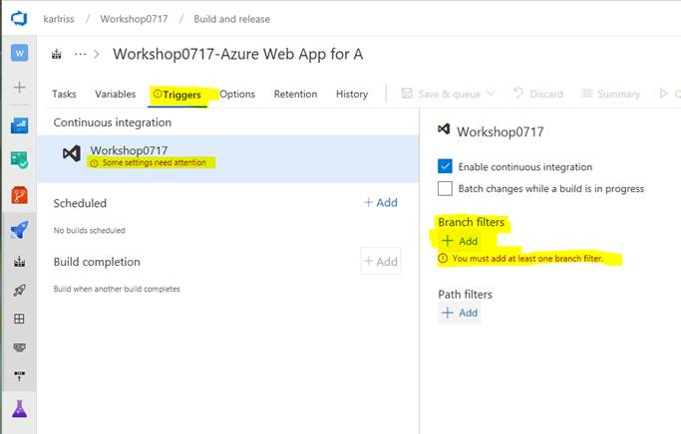

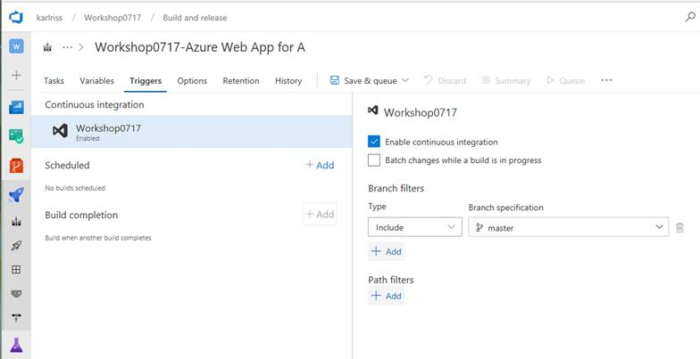

Lastly, save and queue your build to verify it works correctly.

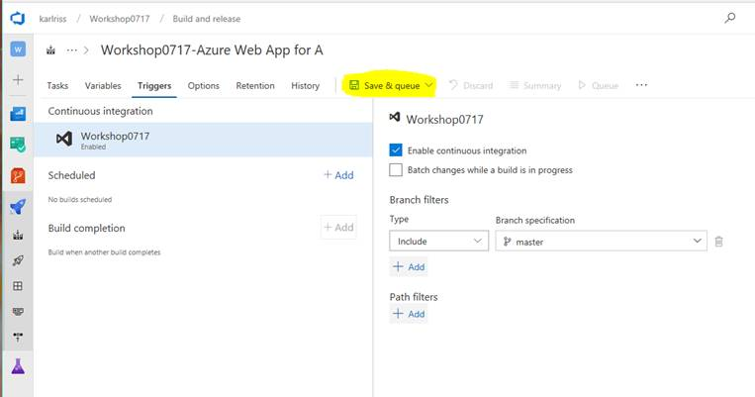

Add a comment to note the changes made to the build definition and click the "Save & Queue" button.

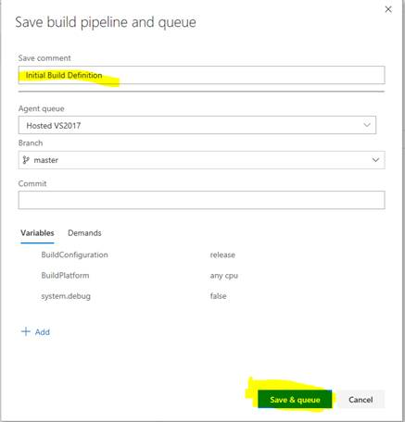

You will see that the build was successfully saved and a new build has been queued.  Click the new build link so you can watch the progress.

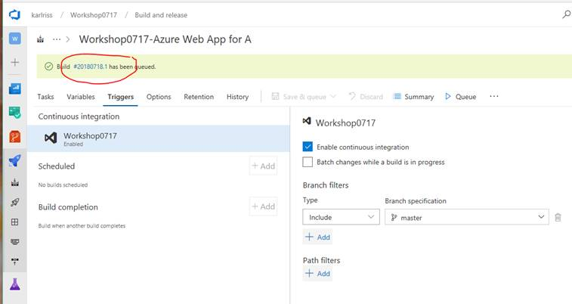

Clicking on the "Logs" tab will let you review detailed, real time, build information.

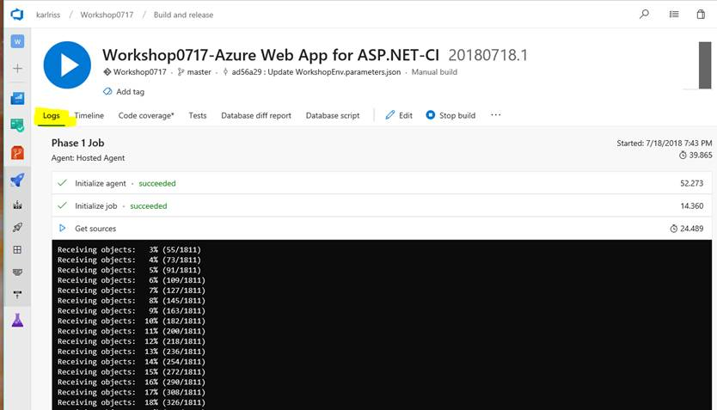

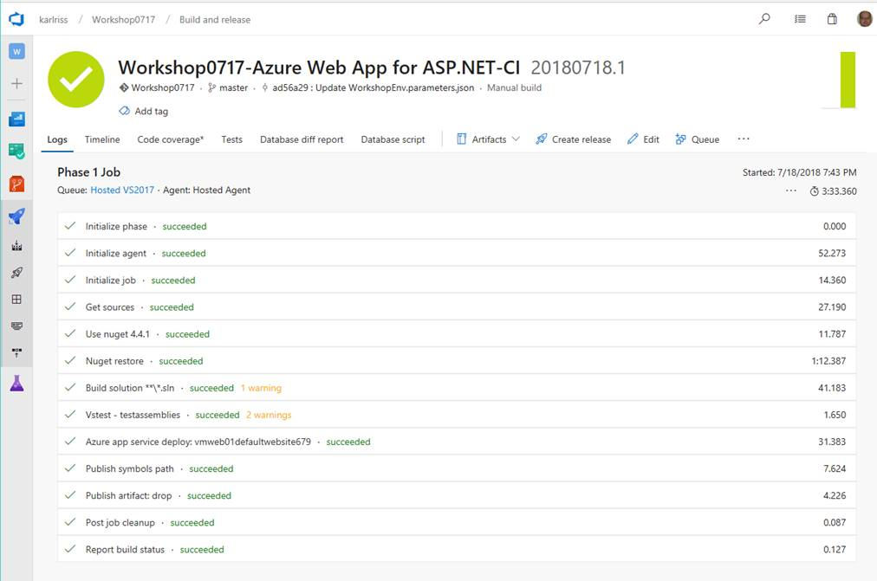

**Part C - Leverage the Deployment Slot and implementing a Release**

While we are deploying our application as part of a build, it may be a better option to leave the creation of artifacts to the build and move deployment of said artifacts to a release.  To quickly create a new release, click the "Create Release" option.

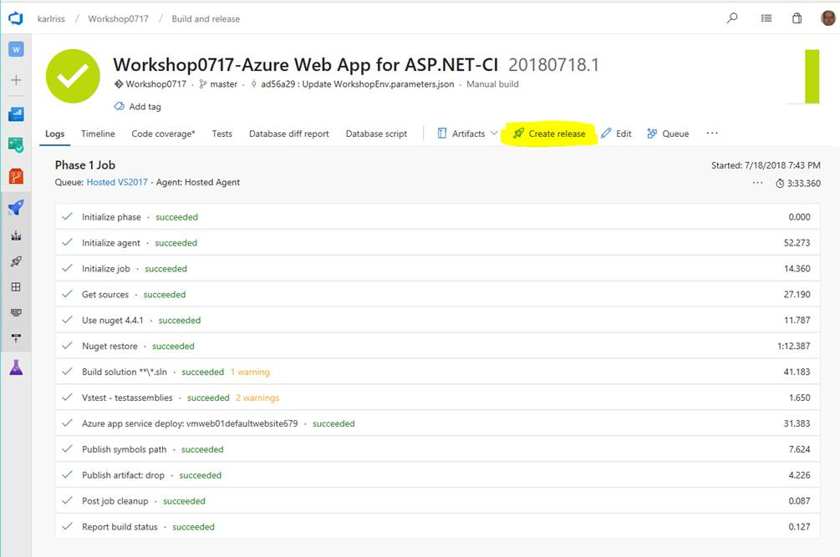

Just like when creating a new build, you are presented with a selection of templates to use as your starting point.  Select the "Azure App Service Deployment" template and click "Apply".

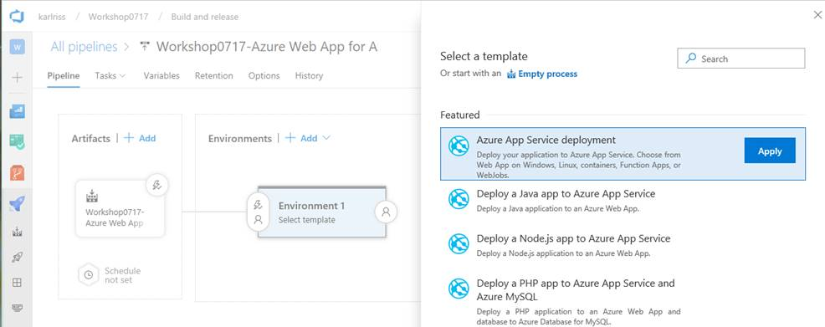

Just like the build, we need to configure the task to deploy to our Website.  Click the error showing for "1 phase, 1 task" to get started.

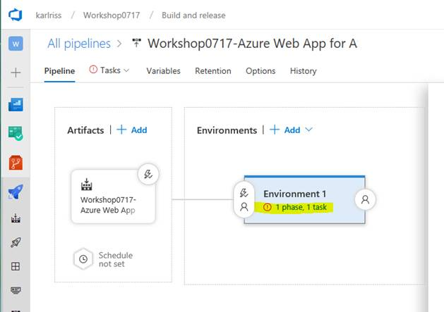

Next you are shown options to configure the subscription, app type, and app service name.  These should all be available in the drop downs.

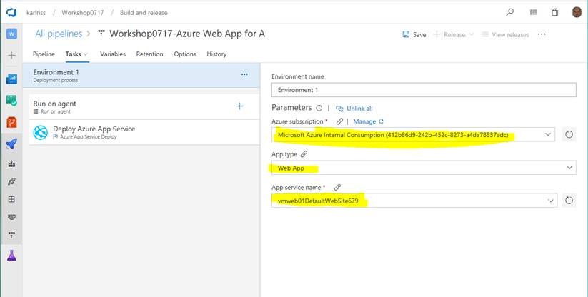

Almost done, we just want to make a couple of additional modifications to take advantage of the deployment slot we configured earlier.

Click the "Deploy Azure App Service" task so we get access to all the configuration options.  We will want to check the "Deploy to Slot" check box, pick the resource group, then select the "staging" slot that we configured earlier.

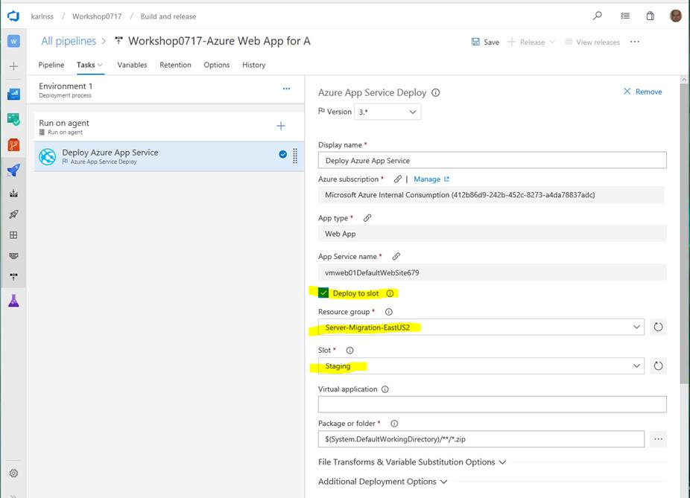

At this point, the release will simply deploy to our staging slot and nothing will be changed in production until we swap production with staging.  We can do this as part of our release by adding another task.

Click on the "+" to add a new task.  Search for "Swap" and add the "Azure App Service Manage" task to your release process.

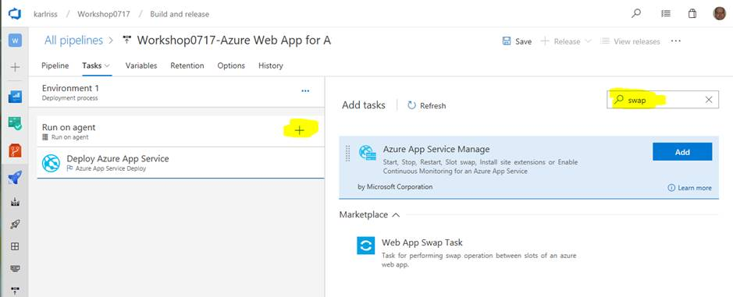

Once added it will need a little configuration.

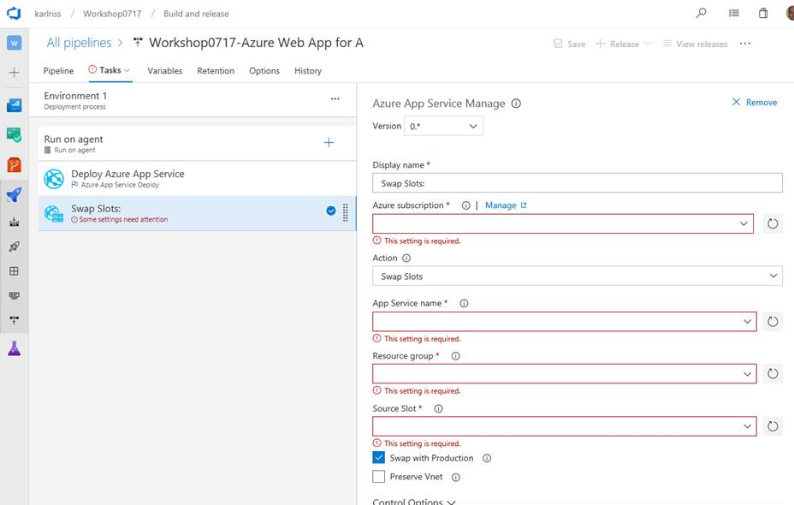

You will want to select your subscription, pick the app service, pick the resource group, and pick the source slot.  Finally click "Save"

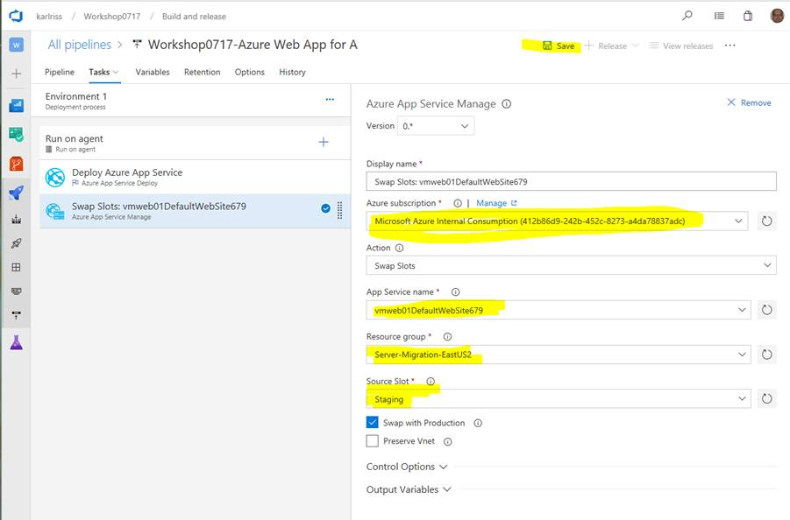

Lastly, we need to clean up the build definition a little since deployment is now handled by the release.  Go back and edit the build definition.

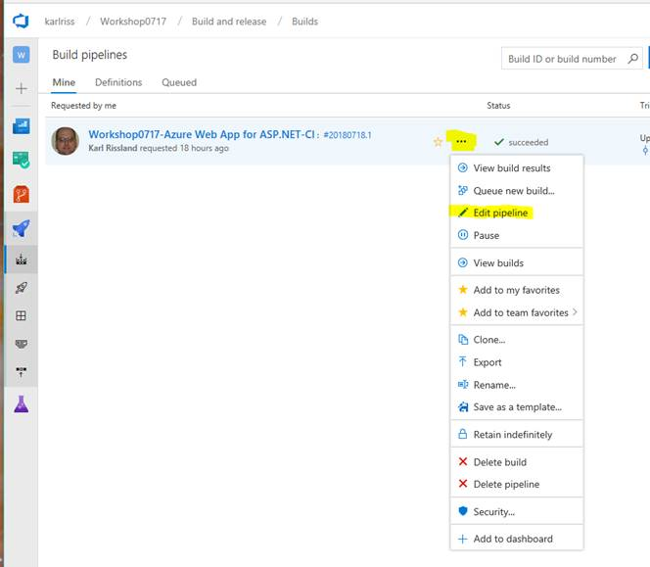

Select the "Azure App Service Deploy" task and remove it.

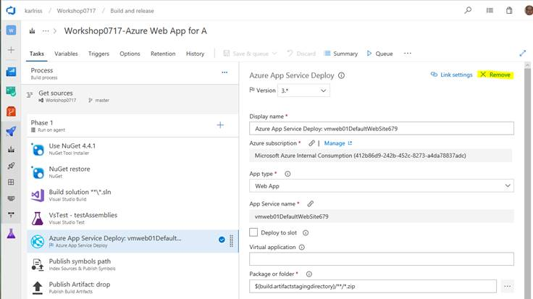

The CI/CD pipeline is complete.  Queue a new build and follow the build/release to verify it works correctly.  Follow the build process and then follow the release process.

Note: While we are moving the deployment capabilities to the release and using deployment slots, we did not create multiple environments to save time.  If you like, you could create a new environment in the release and move the "Swap Slots" task to the second environment and add approval processes.

## Exercise 3: Detect, Diagnose, Monitor Application Performance with Application Insights

Duration: 45 minutes

Parts Unlimited understands that bad experiences online will quickly drive a customer to your competitor. With that in mind, they want to gain better visibility into issues customers are experiencing while using their site.

In addition to gaining better insights into the sites health, they are also interested in better understanding how customers are using the site and the sites effectiveness.

As there is no instrumentation on the site today, they have decided to add Application Insights telemetry.

Timely actionable telemetry is an important aspect of any modern application. Actionable information is a vital component of any DevOps practice.

* Add Application Insights to the web app
* Modify the code to instrument the app
* Test locally to verify the app works
* Push the changes to kick off a release
* Test that the production application works
* Review App Insights Data

#### Help references

|  |  |
| --- | --- |
| Azure Application Insights | <https://docs.microsoft.com/en-us/azure/application-insights/app-insights-overview> |

#### Prerequisites

To complete this task, you should have provisioned the Parts Unlimited IaaS and PaaS environments (Exercise 1). You will use the Developer Workstation deployed as part of the IaaS environment for your development work.  
  
You must also have a Visual Studio Team Services Account and be able to create new projects within that account. If you don’t, you will need to setup a new Account.

#### Task 1: Create an Application Insights Instance

Go to the resource group created by the migration tool.  You should see your application services.

Click on the Application Insights Menu Item to create a new instance

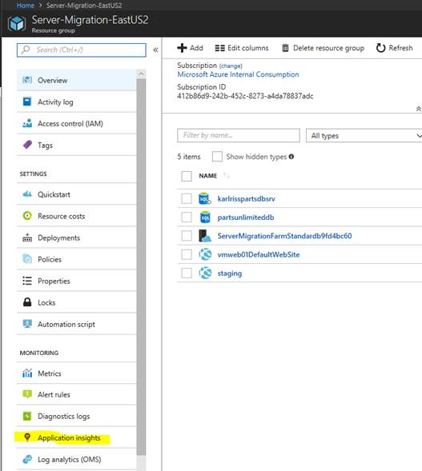

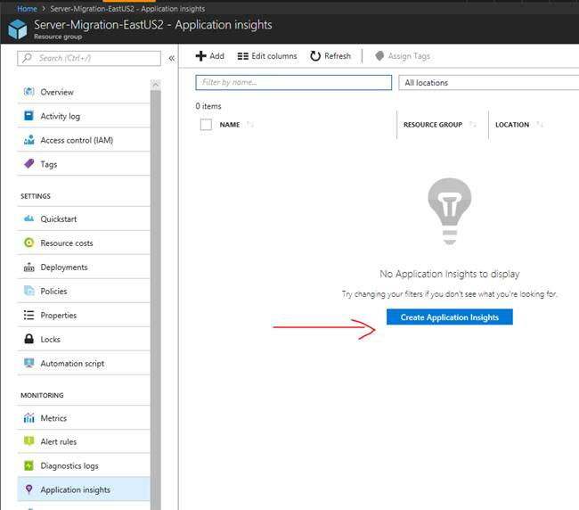

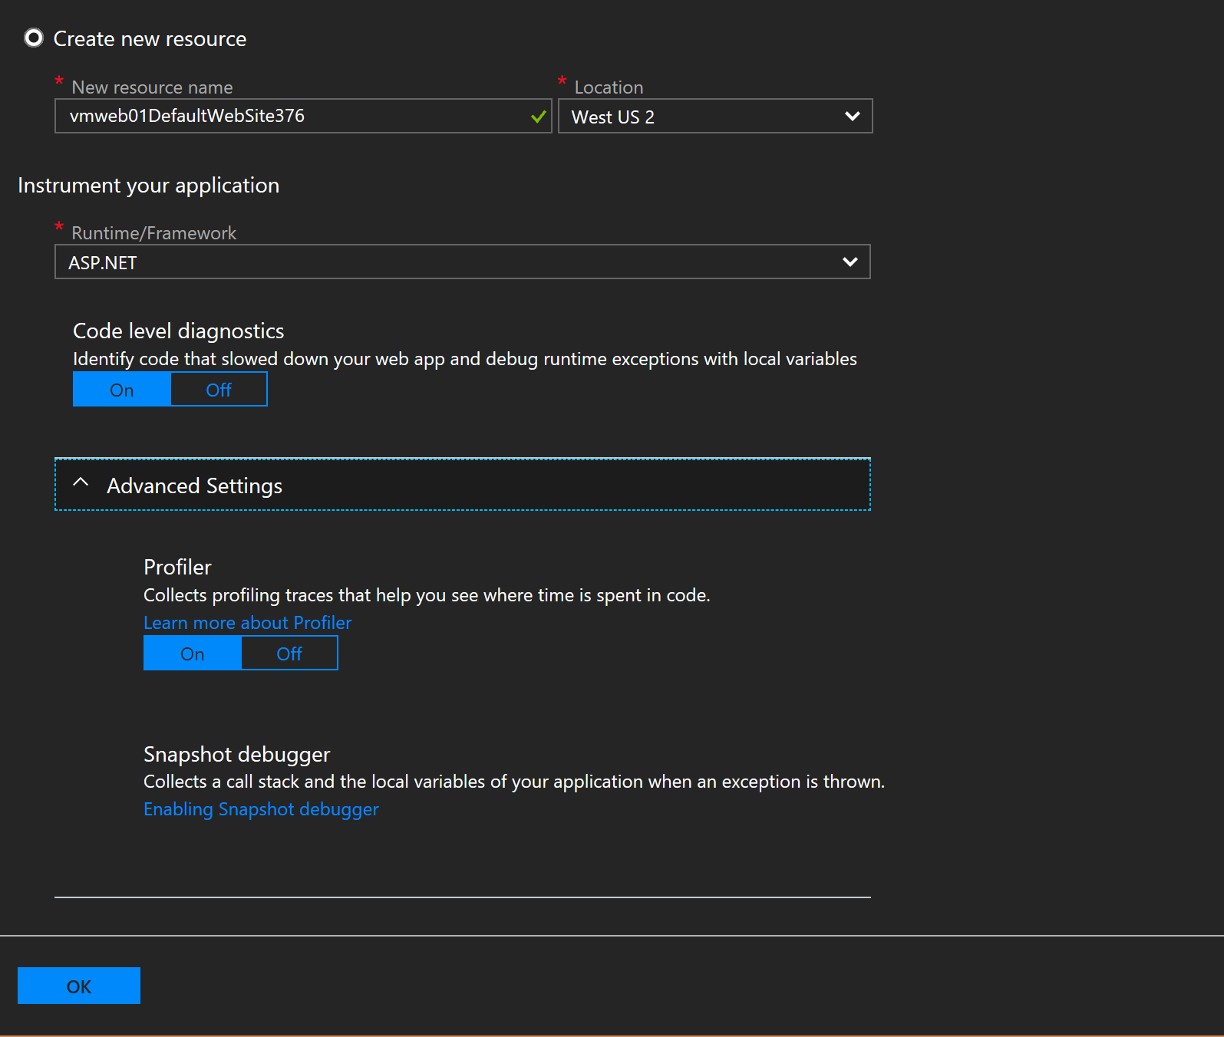

Enter a name for the Azure Application Insights instance and choose the region where it should be deployed. Choose the runtime/framework your application is using. In this case, choose ASP.NET. Click OK to create.

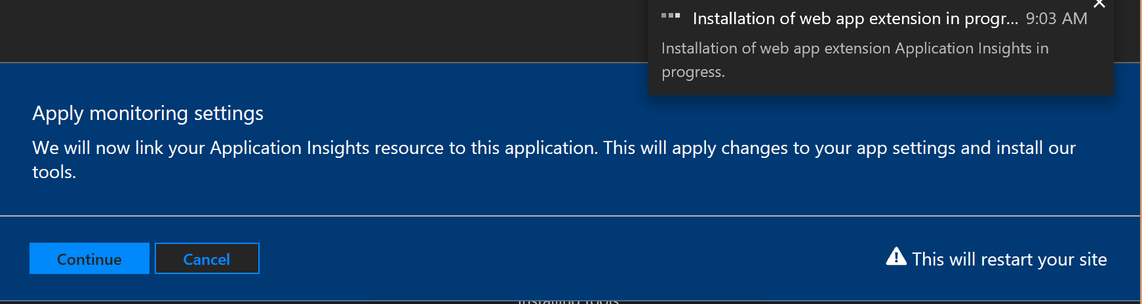

At the top of the pane, you’ll see a notice telling you the application will modify your Application Settings and will restart your site.

Deployment should only take a few moments.

When deployment is finished, go back to your resource group.  You should now see your App Insights Instance

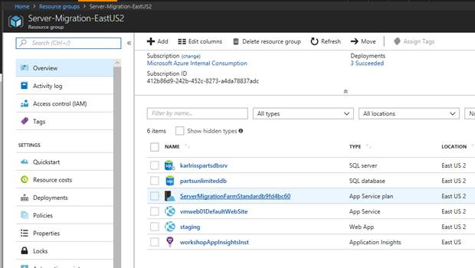

#### Task 2: Update your Web Application to use Application Insights

Remote into the vmdev01 using the User Name and Password used when creating the environment.



**Note**:

Default Admin: sysadmin

Default Password: Password$123





On your developer workstation, open the solution.

Right click on the web application and choose to add Application Insights telemetry

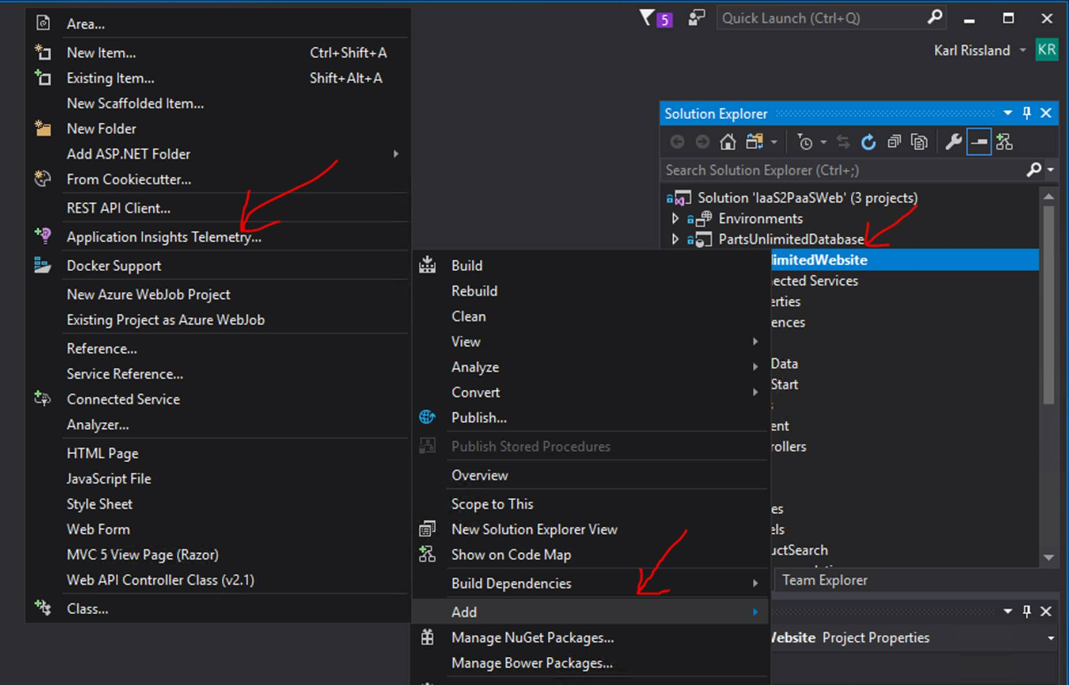

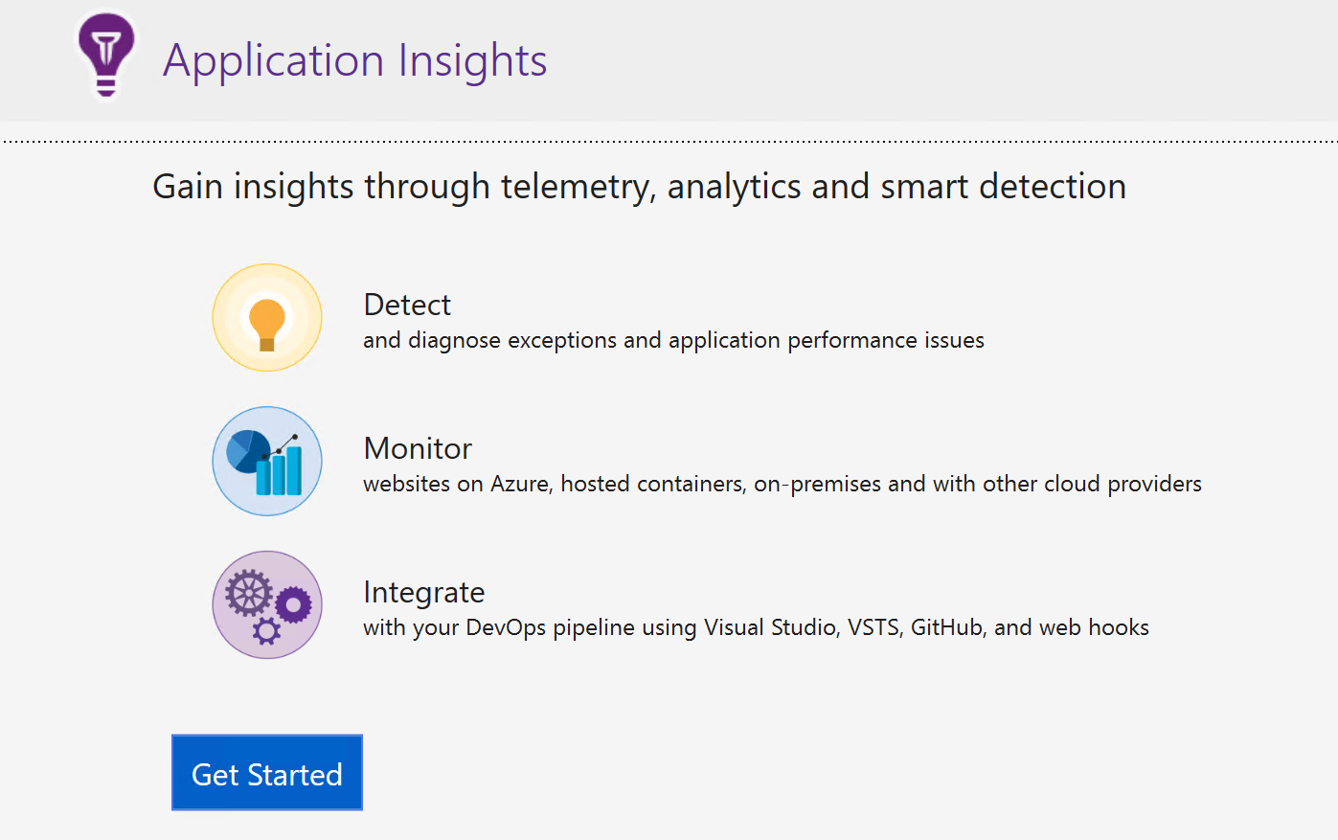

You will be presented with a dialog, click **Get Started** to continue.

This will bring up the Registration Dialog.

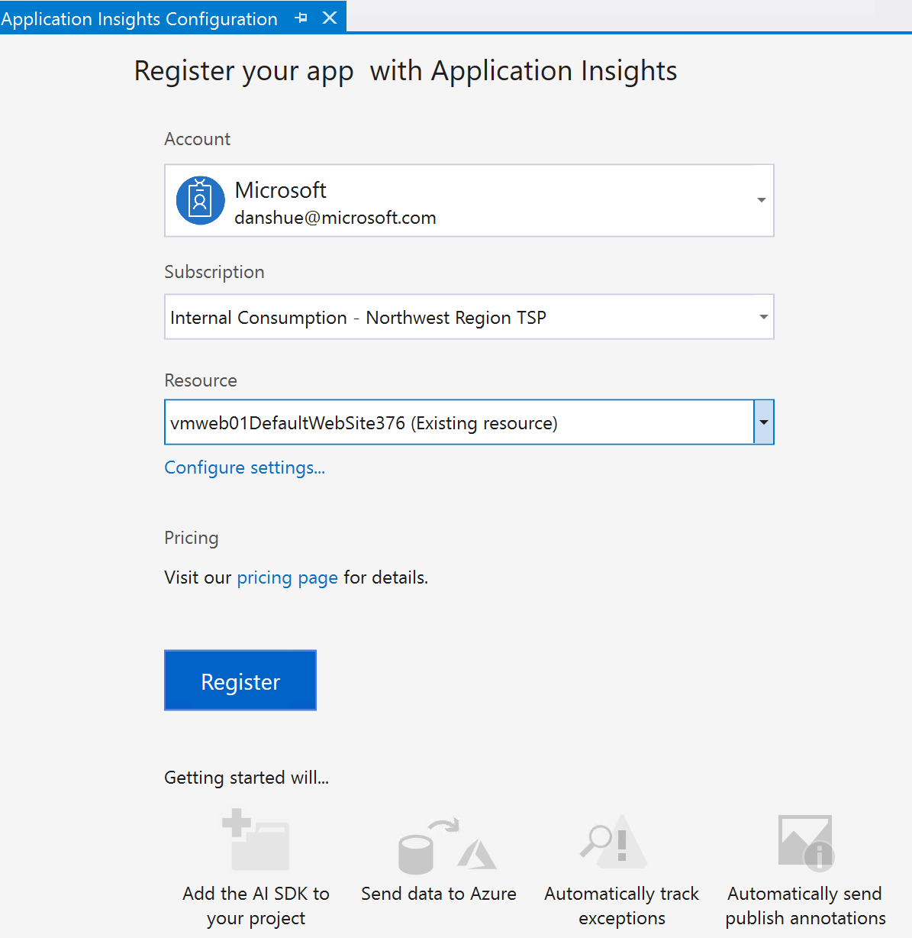

You will want to select your subscription and select the Application Insights resource we just created and click **Register**

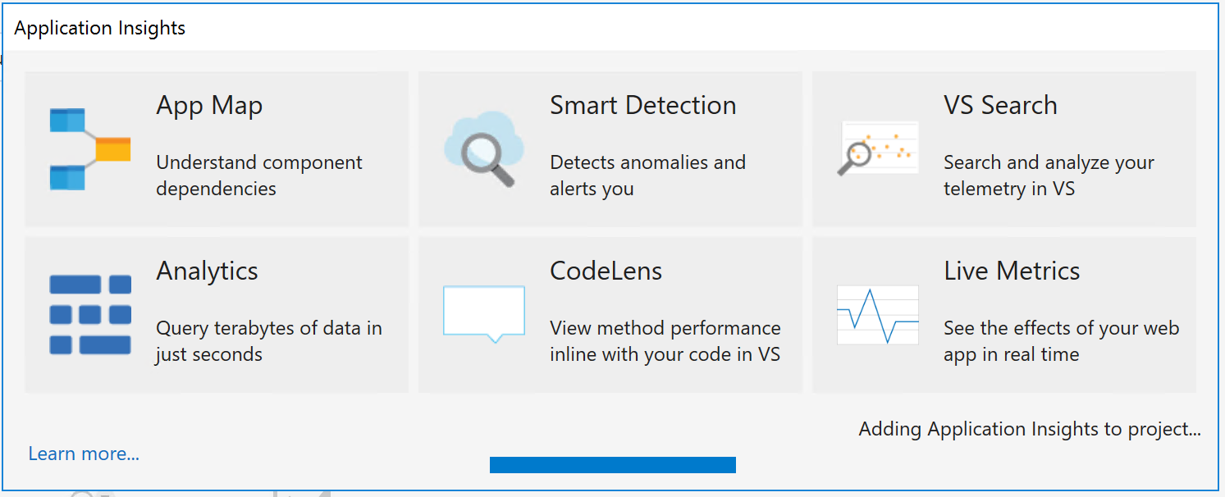

In a few moments, your application will be instrumented and registered.

Lastly, we will enable trace collection.  Simply click the "**Collect traces from System.Diagnostics**" to enable.

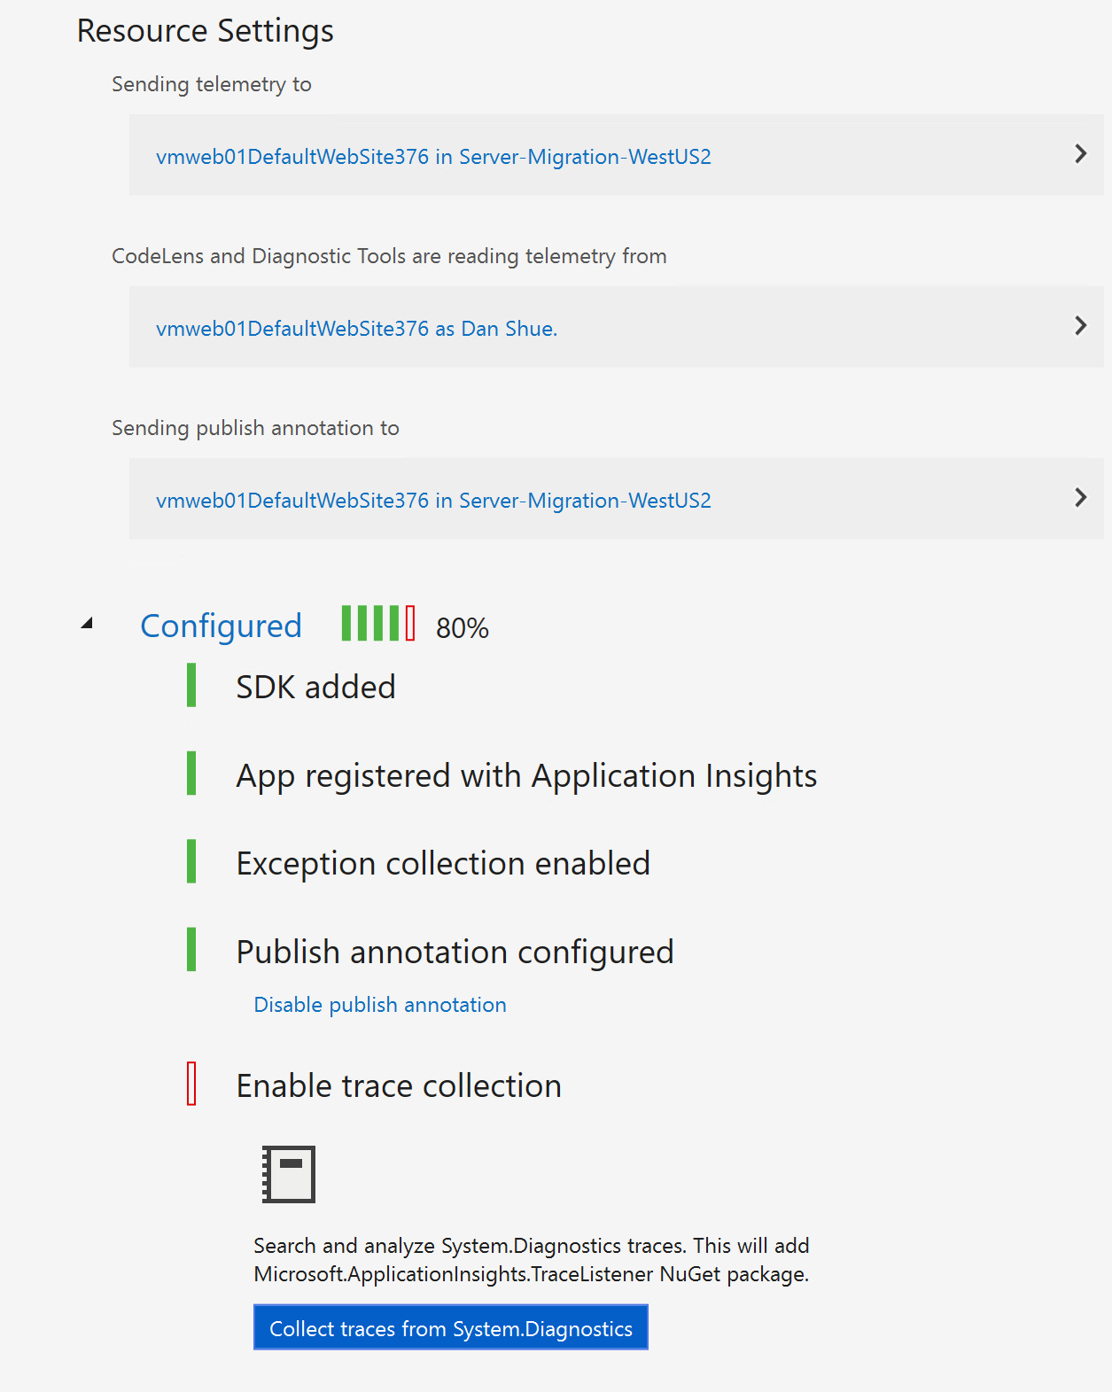

This should leave you 100% configured

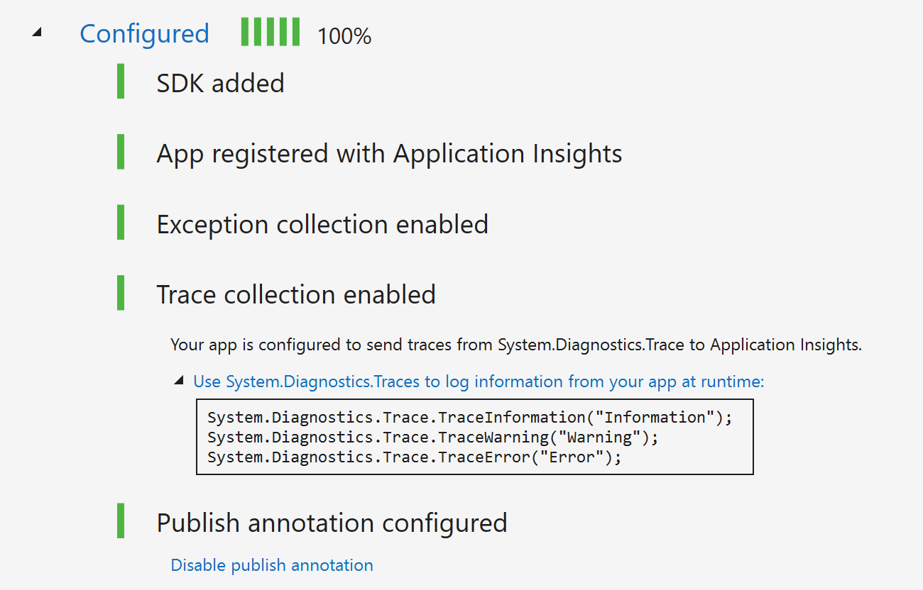

We need to update a package, so right click on the project in visual studio and select "Manage NuGet Packages.."

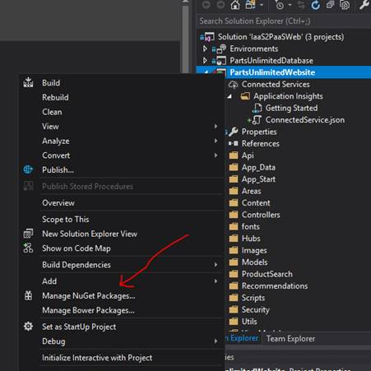

There are a lot of packages that need to be updated, but we are only going to update one package.

We are looking for System.Diagnostics.DiagnosticSource.  Select that package and click the update button.

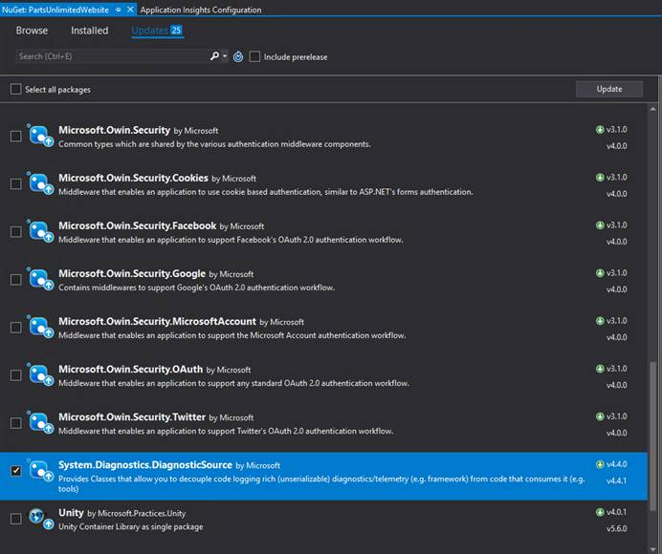

Before checking in our code, we are going to want to test the application locally.  To do this, verify that your connection string is pointed to localDB.

<add name="DefaultConnectionString" connectionString="Server=(localdb)\mssqllocaldb;Database=PartsUnlimitedWebsite;Integrated Security=True;" providerName="System.Data.SqlClient" />

Open the **WebConfig** file, uncomment the localDB connection string and comment out the connection string pointing to a server and then save the file.

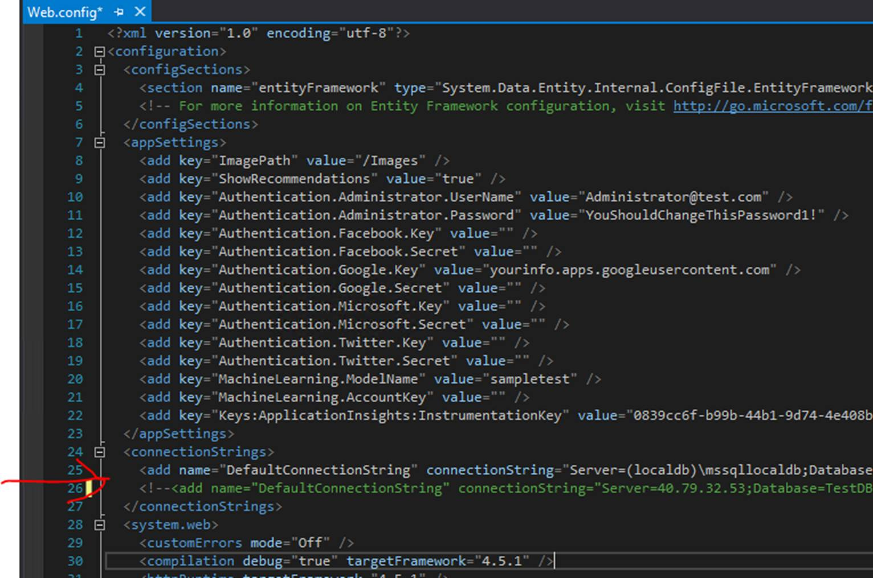

Run your web application and verify everything runs correctly.

**Note:** You want to move the instrumentation key to the Web.Config.  This lets you override the key in production and easily use multiple keys.  This blog has a nice post on how to do that; [https://blogs.msdn.microsoft.com/devops/2015/01/07/application-insights-support-for-multiple-environments-stamps-and-app-versions/](mhtml:file://C:\Users\danshue\Desktop\Workshop\AppMigrationAndModernizationWorkshopPresenter.mht!https://blogs.msdn.microsoft.com/devops/2015/01/07/application-insights-support-for-multiple-environments-stamps-and-app-versions/)

#### Task 3: Update your application to provide more telemetry

Azure Application Insights gives you a lot of information without doing anything else.  However, we want a little more, so we are going to make some changes.

Open the \_Layout.cshtml file located in the views\shared folder.

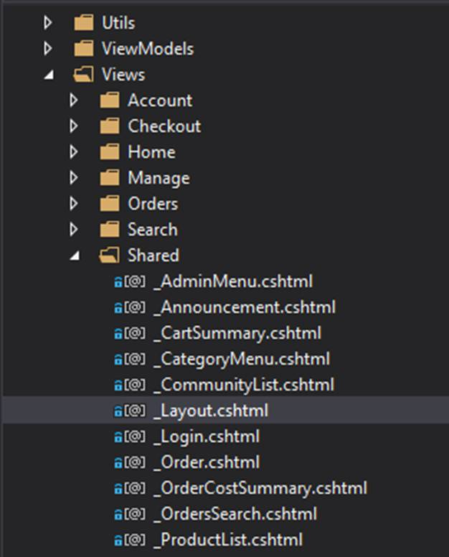

There is a section commented out that will send telemetry from the web page.  We are going to replace this code with code we get from the app insights portal.

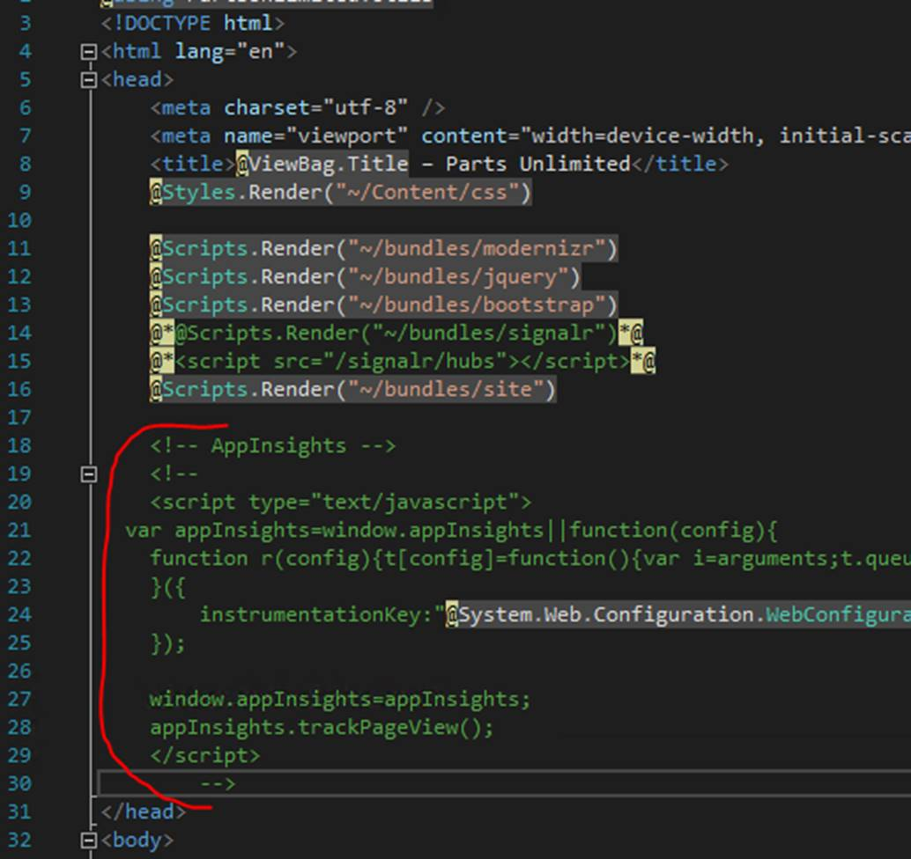

Next, go to Azure, open your resource group, then open Application Insights.

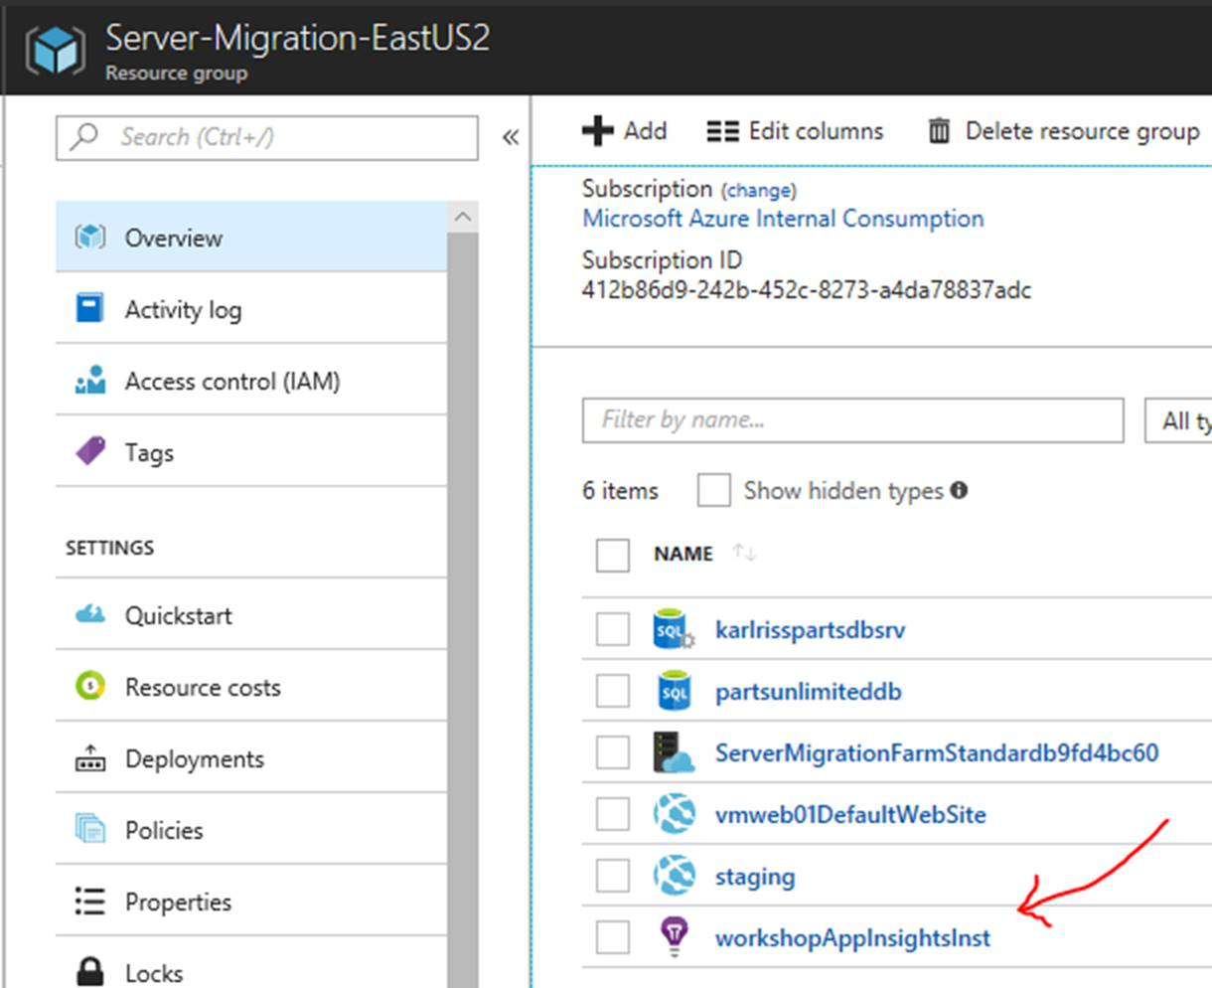

With Application Insights open, scroll down and click the "Getting Started".

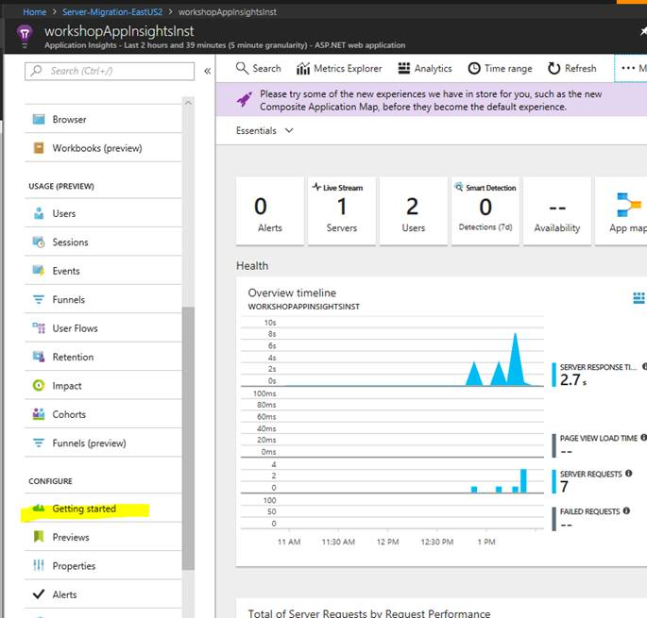

From here, click to monitor client-side operations then copy the JavaScript code.

![Machine generated alternative text:
Home > Server-Migration-EasWS2 > workshopAppInsightsInst - Getting started > Client application monitoring and diagr•is 
'0 workshopAppInsightslnst - Getting started 
Application Insights 
Search (Ctn +0 
Workbooks (preview) 
USAGE (PREVIEW) 
Sessions 
Q nts 
Funnels 
User Flows 
@ Impact 
Cohorts 
Funnels (preview) 
CONFIGURE 
Getting started 
Properties 
Alerts 
Smart Detection settings 
c 
Features * pricing 
Data volume management 
What is Application Insights? 
Application Insights is an extensible analytics service that monitors the 
clients, server and dependencies of your live web application. Detect, 
triage and diagnose performance issues and failures in the clients, 
server or dependencies of pur application. Write own events, 
metrics and traces for even more detailed usage analysis and 
diagnostic power. Application Insights is designed for developers, to 
help you continuously improve the availability, performance and 
usability of your app. 
What can Application Insights do? 
MONITOR AND DIAGNOSE SERVER SIDE APPLICATION 
Detect server side performance issues and failures. Diagnose with 
correlated exceptions, dependency calls and pur application traces. 
MONITOR AND DIAGNOSE CLIENT SIDE APPLICATION 
Add our JavaScript snippet to analyze usage patterns and to detect 
and diagnose client side performance issues and failures. 
ENRICH TELEMETRY WITH CUSTOM METRICS AND EVENTS 
How many red apples were sold today? How many users clicked the 
•Try-Now" button? How good is the new feature? 
Client application monitoring and diagnosis 
Client side telemetry 
Detect and diagnose performance issues and failures in web pages. Understand how your 
application is being used. 
• See correlated client side, server side and custom telemetry, in the context of a user session, 
all in one place. 
• Set up alerts on the client side metrics collected by default or custom metrics reported using 
the JavaScript SDK. 
• Slice and dice client side metrics alongside server and custom telemetry to trace the causes 
of performance issues and failures. 
Leam more 
Application insights client side monitoring 
Privacy statement [4 
Guidance 
Easy to get started. Simply paste the following into your master page 
To collect end-user usage analytics about your application, 
insert the following script into each page you want to track. 
Place this code immediately before the closing </head> tag, 
and before any other scripts. Your first data will appear 
automatically in just a few seconds. 
(script type="text/javascript"> 
var applnsights=window.applnsightsl Ifunction(a){ 
function b=arguments;c.queue.push(func 
instrumentationKey : " c81fee8f -2653-4c87-b76e-738c3287c88c " 
wi ndow. applnsights=applnsights , applnsights. queue&&e-—=applnsights](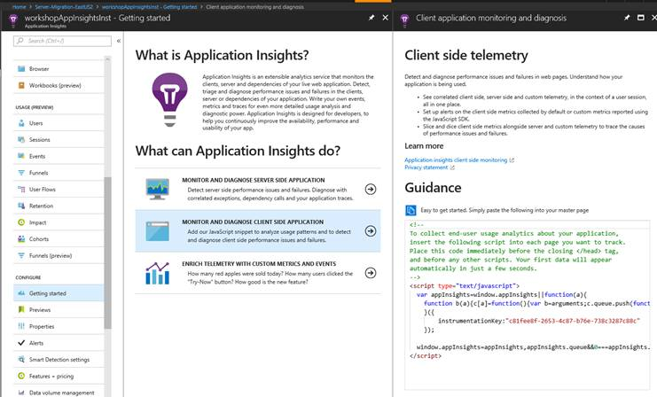)

Go back to Visual Studio and replace the commented Application Insights script with the script from the portal.  When done, you code should look like the following

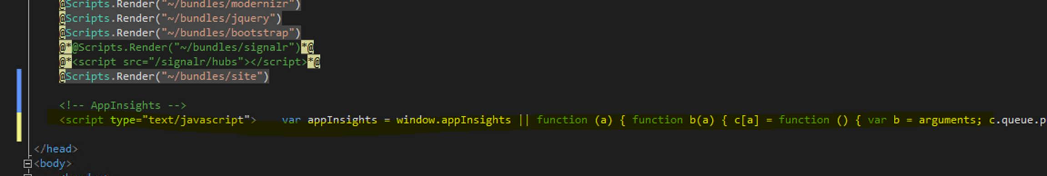

If you want, you can rerun the application to ensure it works correctly.

**Note**: There are other areas where you can add telemetry.  Some of this code has been commented out if you want to add it.

**Note:** This project is .NET Framework 4.5.1.  More capabilities light up if you change the target framework to at least .NET Framework 4.6.

#### Task 4: Implement the Custom Event Telemetry Provider

A custom Event Telemetry Provider has been written, but the implementation needs to be uncommented before it can be used. Navigate to the **Utils** folder and edit the **TelemetryProvider.cs** file by uncommenting the code and add to the top of the class “**using Microsoft.ApplicationInsights;**”. This provider wraps the Azure Application Insights SDK TelemetryClient and is used to record custom events such as messages, traces, and exceptions. Its use can be found in the **OrdersController.cs** or **ShoppingCartController.cs** classes.

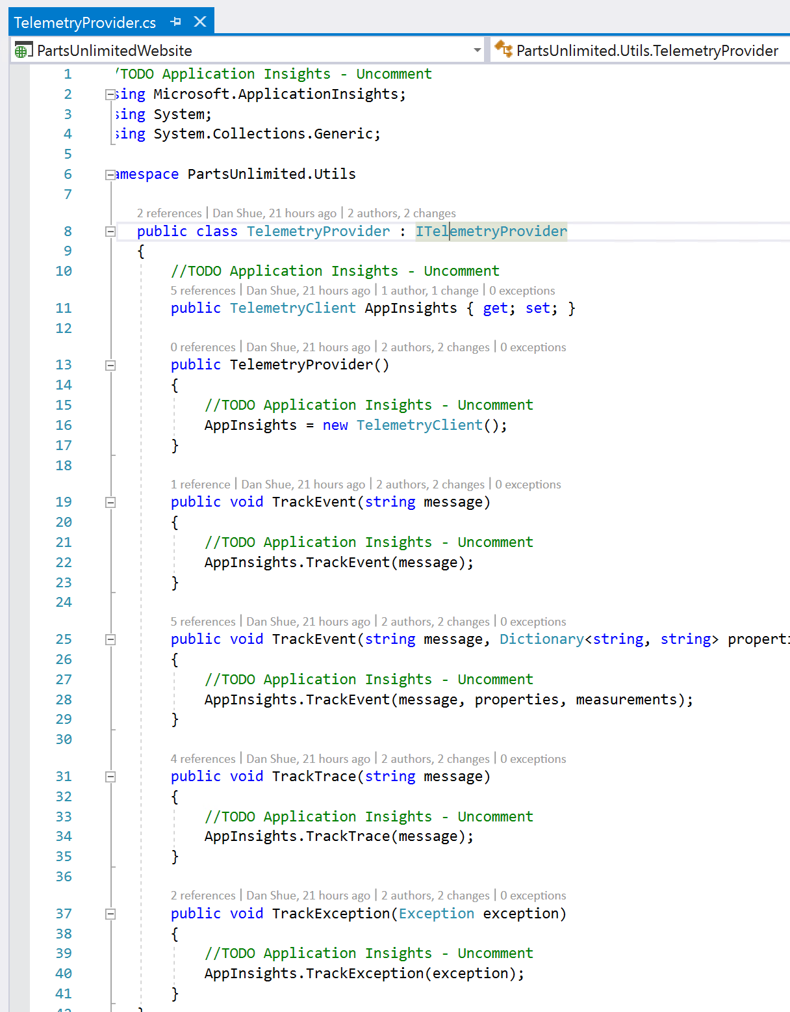

#### Task 5: Push your code to production

With everything running locally, time to push our changes to production.

In Visual Studio, go to the team explorer, then go to changes.

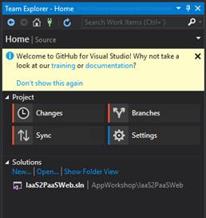

Add a comment and then commit and push

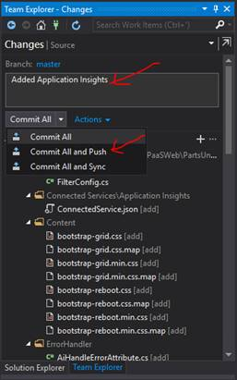

After a few moments you should get a success dialog

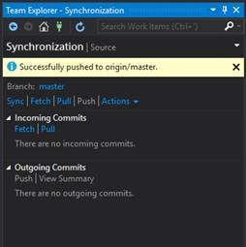

You shouldn't have to do anything at this point, the build and release will automatically kick off.

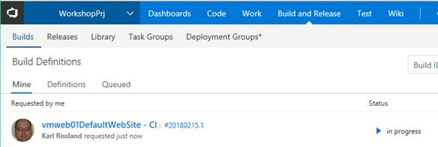

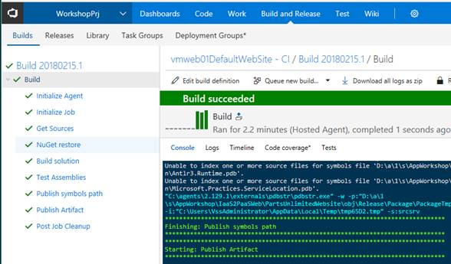

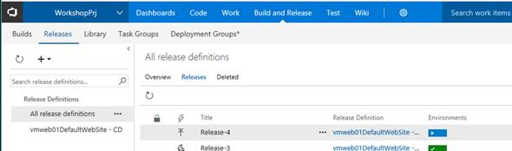

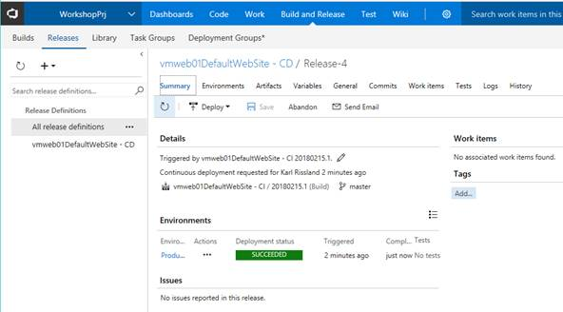

Before moving to the next step, open a browser and navigate to the site. Verify that your release was successful by viewing the source code in the browser to ensure the Application Insights key was deployed to the Web Application in Azure. You can do this by viewing the HTML source code and look for Application Insights instrumentation key in the <head /> block. Move around the site to generate data that will be used in the next activity.

#### Task 5: Review the data

Go back to your resource group and open Application Insights.



Now let’s create a dashboard for this application. Click on the **Application Dashboard** link.

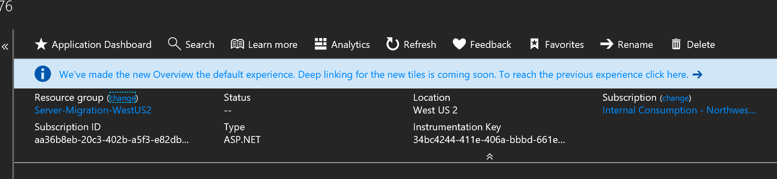

This will give us some core information around Usage, Reliability, Responsiveness, and the Browser.

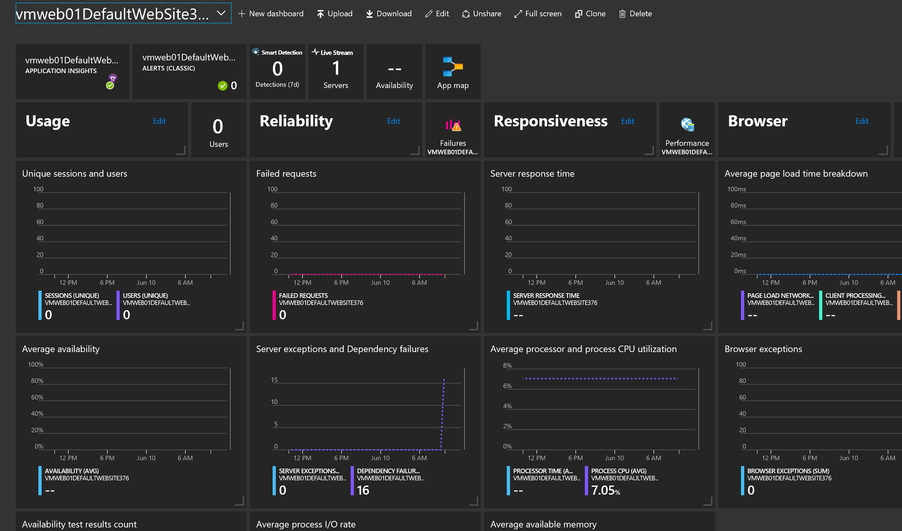

Click the **App Map**

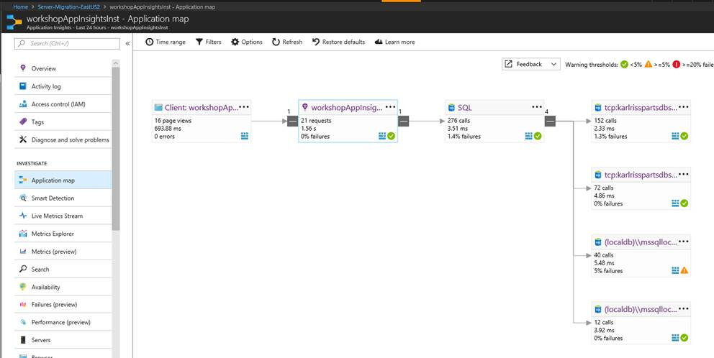

#### Task 6: Web Test

Now we want to monitor the web application from different locations and get a better understanding of what other users in different regions are experiencing. Under the Investigate pane, click on **Availability**. This will bring up a new blade that will allow you to add the new test. Click on **Add Test**.

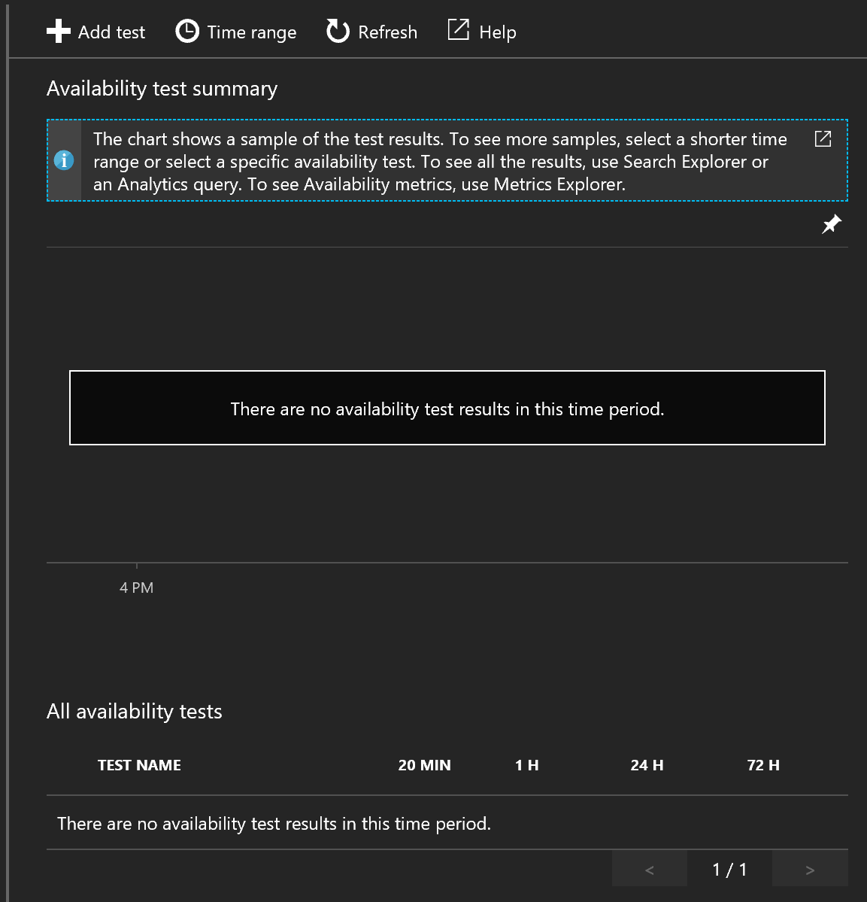

Type “Monitor Application” for the “Test Name” and click on the **Test Locations** and choose where you would like the application to be monitored.

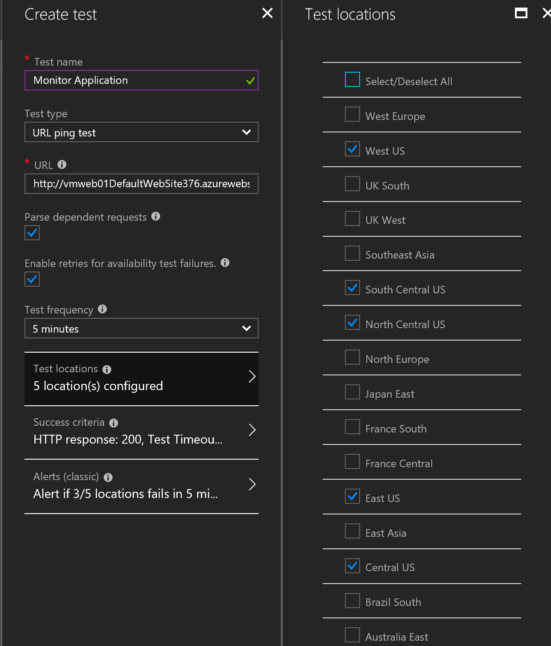

At this point, we’re only going to do a simple **URL ping test** to verify that we’re getting a HTTP 200 returned from the application.

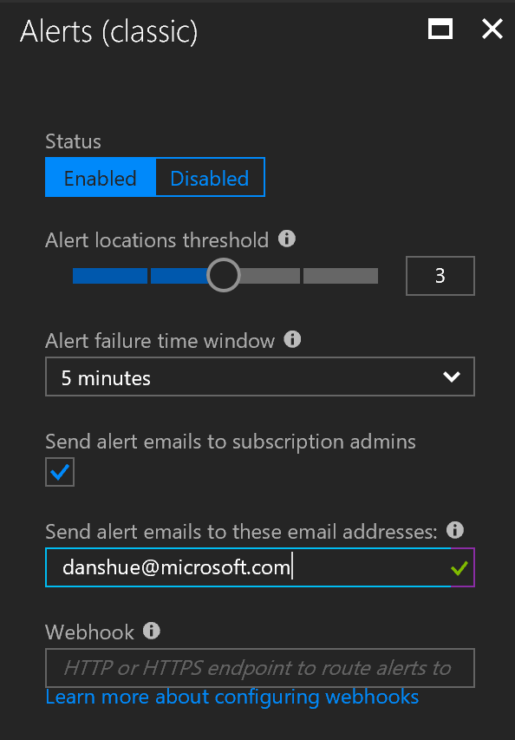

Last, before we create this new test, we want to set how we will be alerting if we do get something other than a HTTP 200 response. In the “send alerts emails to these email address” textbox, type in your email address. At this time, no Webhook will be called and this can be left blank. We done, click OK to continue.

**Note**: There are many alerts possible and Azure Application Insights is integrated with Azure Monitor.

Click **Create** to create the test.

In a few minutes, the Availability Test Summary will be updated, and you will see test results from the of the locations you’ve chosen.

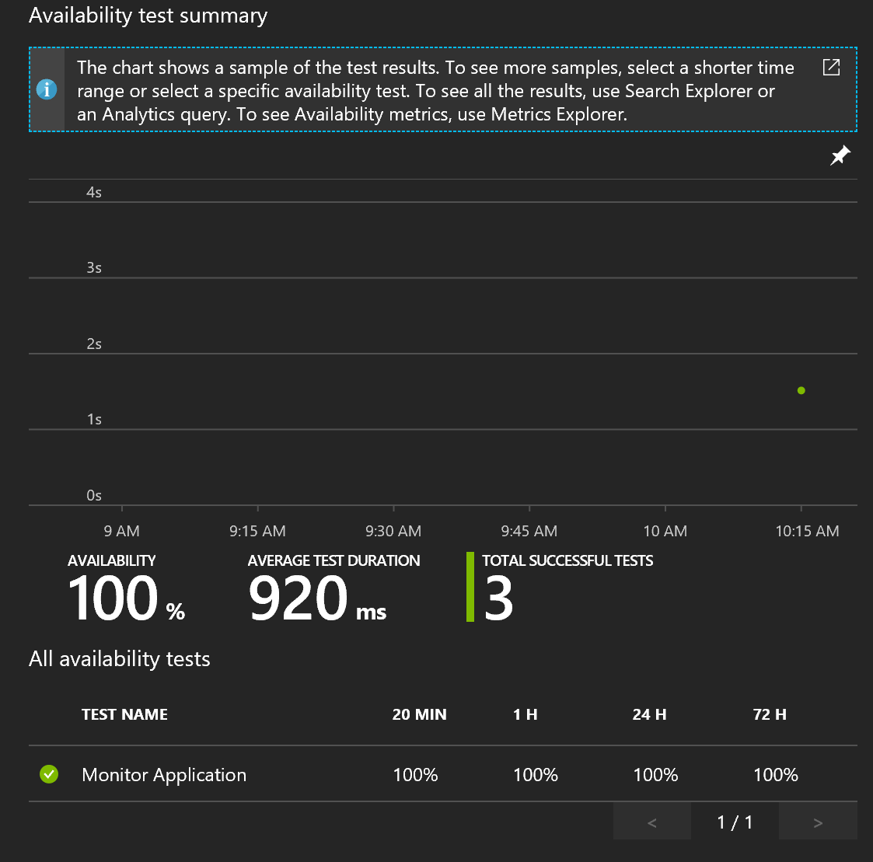

## Exercise 4: Optimize and Protect Azure Web Application

Duration: 45 minutes

While the default settings for deploying web application may work in many situations, we want to examine our Azure App Service Web Application and ensure its secure, optimized, and able to meet the demands of our customers. We will use the Azure portal to configure the ensure backups, logging is enabled, and the application is sized and can scale as need.

This lab will demonstrate how to safe guard and protect your application and make it available by:

* Resource Group cannot be deleted by creating a lock
* Configure backups are setup with 120-day retention
* Ensure the average response time is < 2 seconds
* Configure alerts exist for CPU < 90 secs
* Configure diagnostics and exception logging is configured
* Ensure the average CPU < 20%
* Verify that there’s 35 GB free space available
* Scale up to a premium hosting model with > 3GB RAM available

Azure App Service services keeps you informed about the state of your application. It provides the ability to safe guard the application by performing automatic backups, provides a consolidate method for collection information about your application, has the ability of scaling up/down and notifying you when it does.

#### Help references

|  |  |
| --- | --- |
| Web Site Backup | <https://docs.microsoft.com/en-us/azure/app-service/web-sites-backup> |
| Auto Scaling | <https://docs.microsoft.com/en-us/azure/architecture/best-practices/auto-scaling> |

#### Prerequisites

To complete this task, you should have provisioned the Parts Unlimited IaaS and PaaS environments and have a working CI/CD process and have installed & configure Azure Application Insights. You have logged in and have configured Visual Studio and able to modify code.

#### Task 1: Configure Backups

We need to “start right” by getting the backups going before we move forward with too much code changes. Backups will be stored in defined Azure storage account as ZIP files and contain an XML manifest of the ZIP contents. SQL databases will be stored in a BACPAC file that can be imported.

**Note**: Although the ZIP file and BACPAC file can be accessed, altering any of the files will invalided the backup.

Navigation to the web application in the Azure Portal. Navigate to the “**Backups**” under the settings section. Click the **Configure** link.

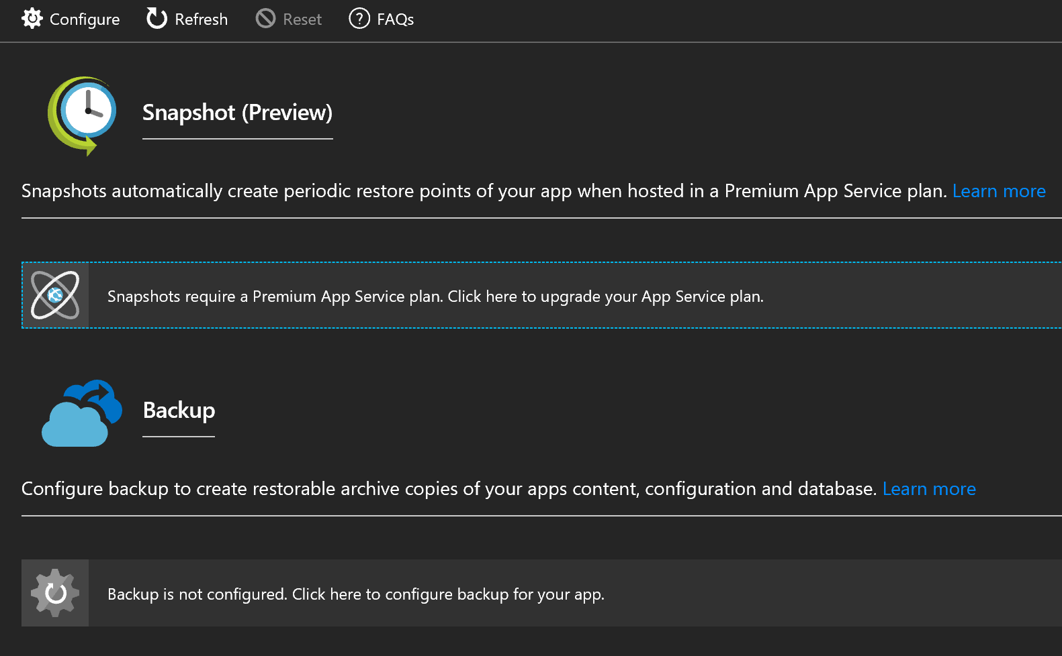

If we had a Premium App Service Plan, we would be able to run Snapshots. Since we’re running a Standard account, we’ll configure our back up to be performed when the traffic and volume is the lowest.

#### Task 2: Configure Storage Account for Backups

We need to define which Azure BLOB storage account to be used for backups. Since we don’t have an account, we’ll create one. Click “Storage not configured” and then on the Storage accounts pane, click the **+Storage Account** to create a new storage account.

For ease of use, type of same name you use for the application as the name of the storage account. Since this is just a backup account, keep the default **Standard** for Performance and select the same “Location” for the region where the application is being hosted. For Replication, change the setting over to “Geo-redundant storage (GRS)”. Click **OK** and it will take a few moments to provision the new storage account.

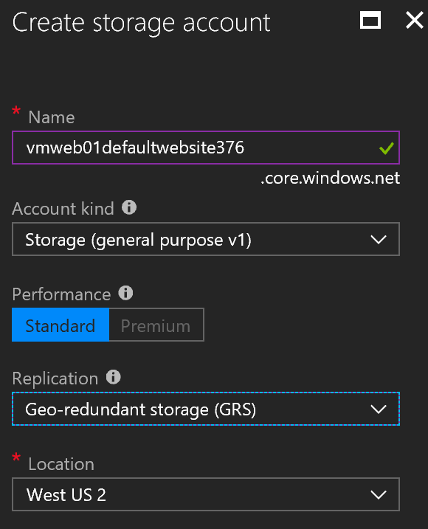

Once provisioned, select the new storage account from the list. Next, we need to define where the backup will be written. Click **+Container** and type in the name of the container, such as ‘backup’. The name must be lowercase, at least 3 characters long and no more than 63 in length. Each hypen must be followed by a non-hypen character. We don’t want the container/backups accessible externally, so make sure Public Access level is set to Private, No anonymouse access.

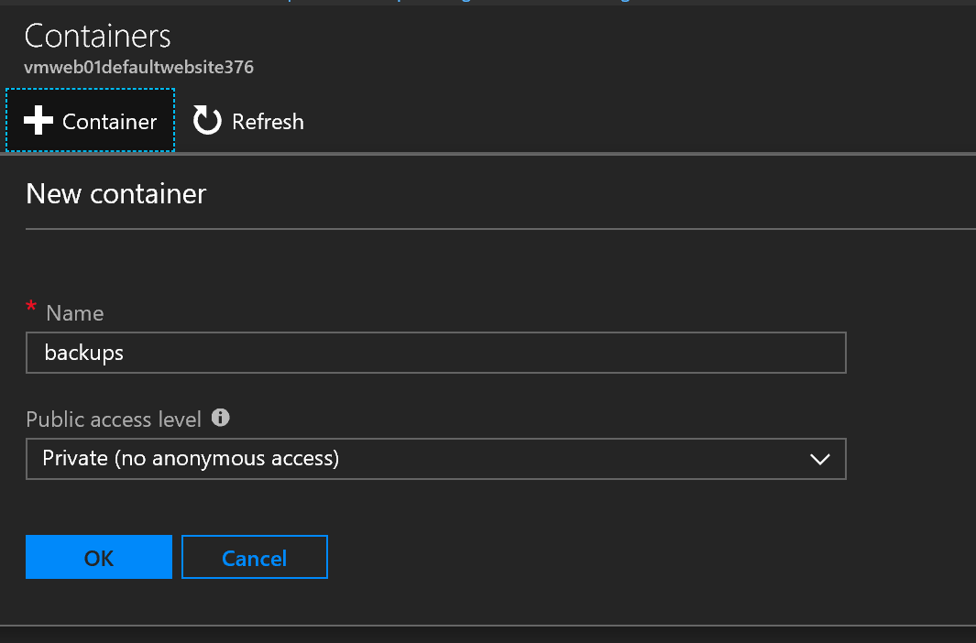

Click **OK** and the in the Containers list, click on the container to use and click **Select** to pick the container that will be used for the backups.

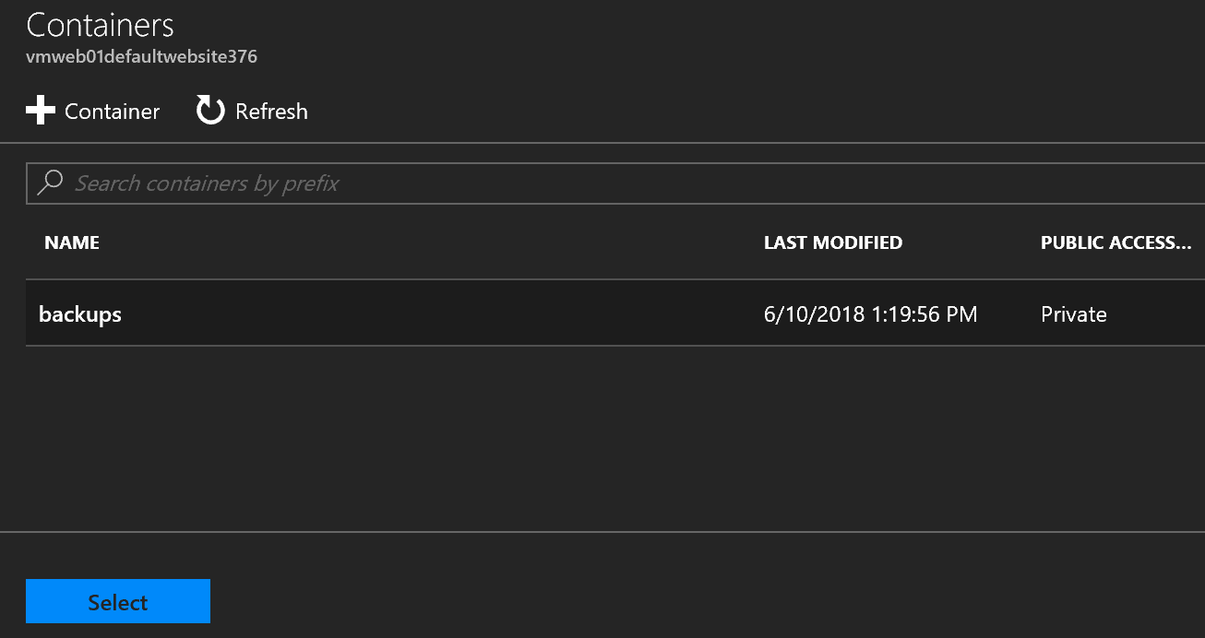

Now that our Storage Account and Container has been selected, validate you have the right setting on the Backup Configuration pane.

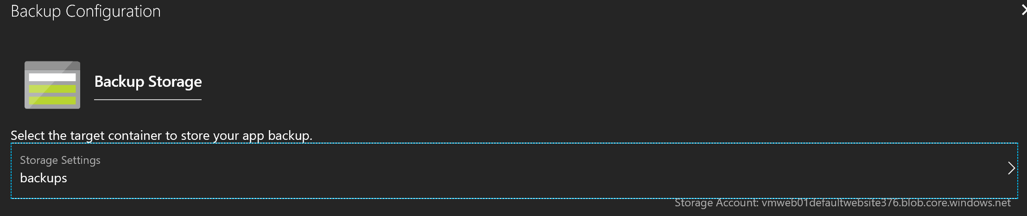

#### Task 3: Schedule Backup

Next, since we want the backup to be performed nightly, we need to turn on the scheduled backups by clicking “Scheduled backup” to “On”.

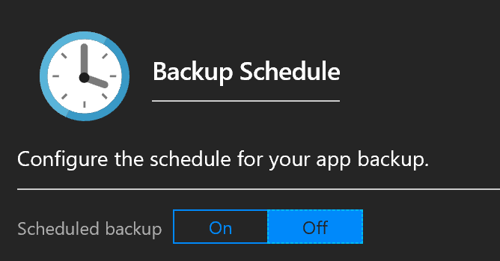

The next steps are to define how often we want to perform the back up and how many days we want to retain the backups. We only need to back up daily, so select “1” for Days. We want our backup to kick off at 3:00 AM, type in 3:00 AM. We backups from the last 120 days, type that in the Retention area.

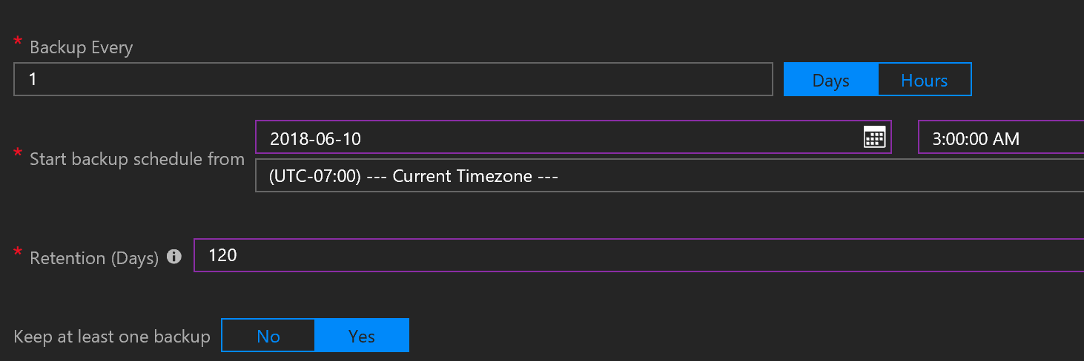

#### Task 4: Backup Database

Azure App Service has detected a database in use, so we’ll want to include that in the back up as well. Click the **Include** checkmark to also have it backed it. Database backups are available for SQL Database, Azure Database for MySQL (Preview), Azure Database for PostgreSQL (Preview), and MySQL in-app.

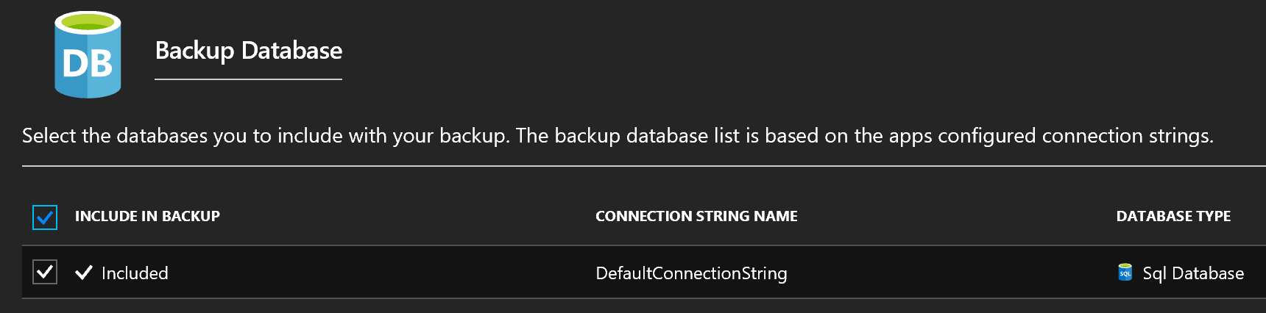

Validate the backup settings on more time and when you’ve confirmed everything meets your organizations policies, click **Save**.

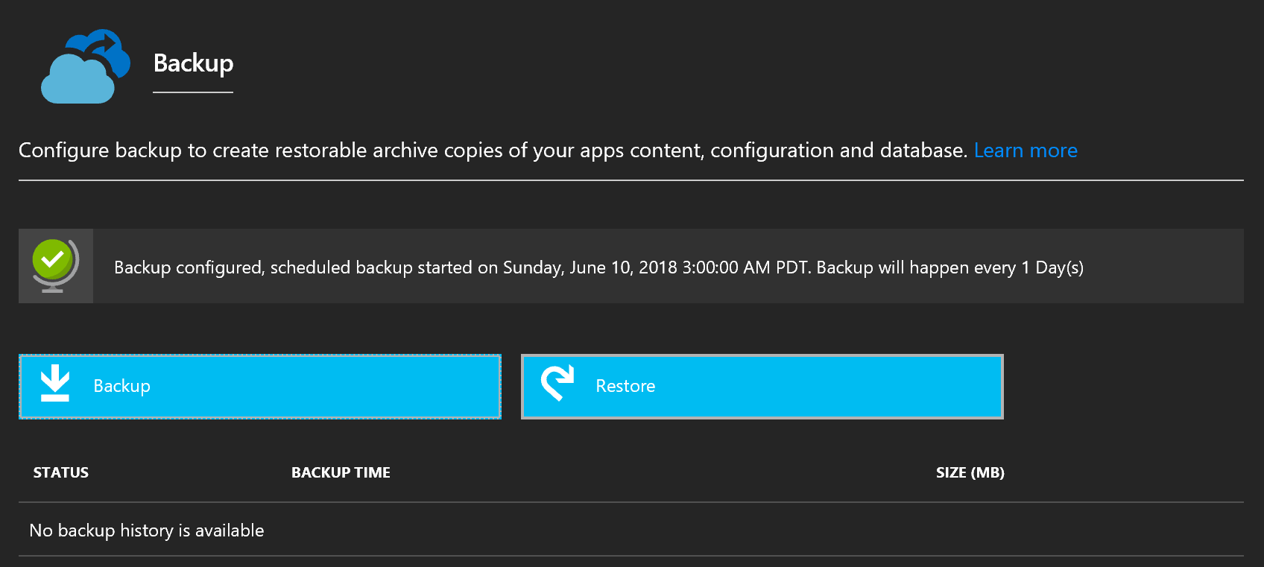

Once the backup is defined, Azure will automatically preform its first backup. It may take some time for the backup to appear, it depends on the size of the application and database. For our application, this should take only a few minutes to appear.

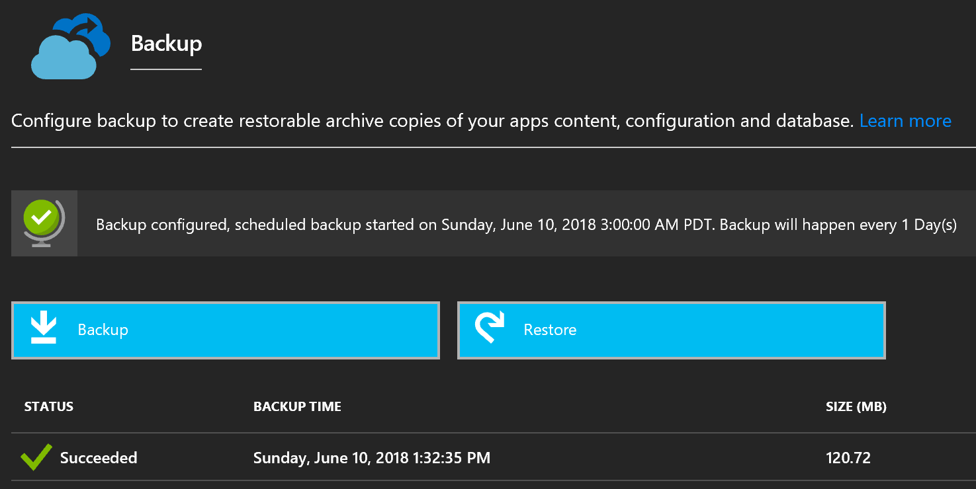

Once a backup has completed, we can use the Azure Portal to navigate to the Container in the Storage Account and see the LOG, XML manifest, and ZIP file containing the files.

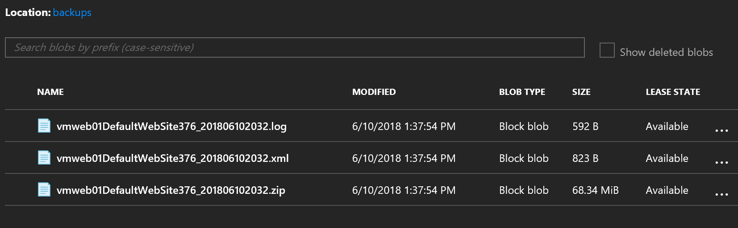

###### Partial Backups

You can also configure Partial backups if you would like to exclude data to limit how much you’re backing up such as logs and image files. 10 GB is the max size available for backups currently.

###### Restore Backup

This is the same page you’ll come to Restore a previous backup.

###### Automate Backup

Like many services in Azure, Application Service backups can also be automated with scripts using either the Azure CLI or Azure PowerShell.

#### Task 5: Viewing Health by Reviewing the Response Time and Errors

Navigate to the Application in the Azure Portal. The Overview section gives you essential information about how your application is performing such the Average Response Time, number of Requests, Data In/Out, and Http 5xx. What is the average Response Time for the application?

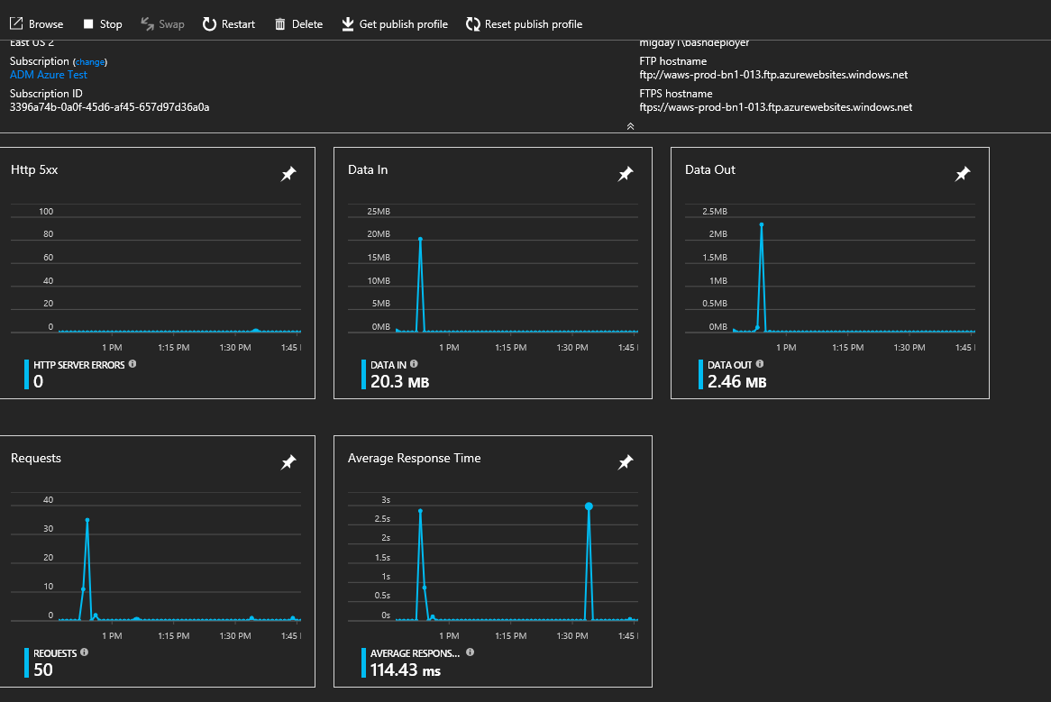

#### Task 6: Setting Alerts

Now you’ve seen basic performance information, let’s setup an early warning system. Under the **Monitoring** section for the Web App, click **Alerts (Classic).** This allows Azure to notify you when certain conditions are of your resources are reached.

We want to create an alert when the CPU raises beyond 70% for a period and be notified. Click **+Add alert metric (classic).** This as a new rule that will be trigged when the condition is reached. Type the name of the rule such as **High Average CPU**, next set the metric to CPU Time, set the threshold to 70, check the email owners, and type in your email address.

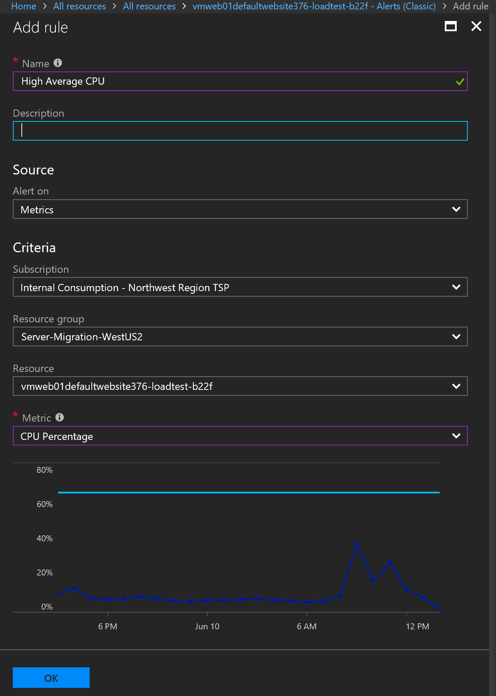

#### Task 7: Configuration App Diagnostics

Once we have the alerting and monitoring in place, we want to be able to record issues as the arise. To enable diagnostics, under the Monitoring section, click on **Diagnostics Logs**. Turn on Application Logging (Filesystem) and Application Logging (Blob), select the level of logging to **Error** for both**.**

**Note**: To view the Stream Log, logs must be written to local storage.

Next, we select the Storage Account you previously created for backups, create a new container called **app-logs** and select it.

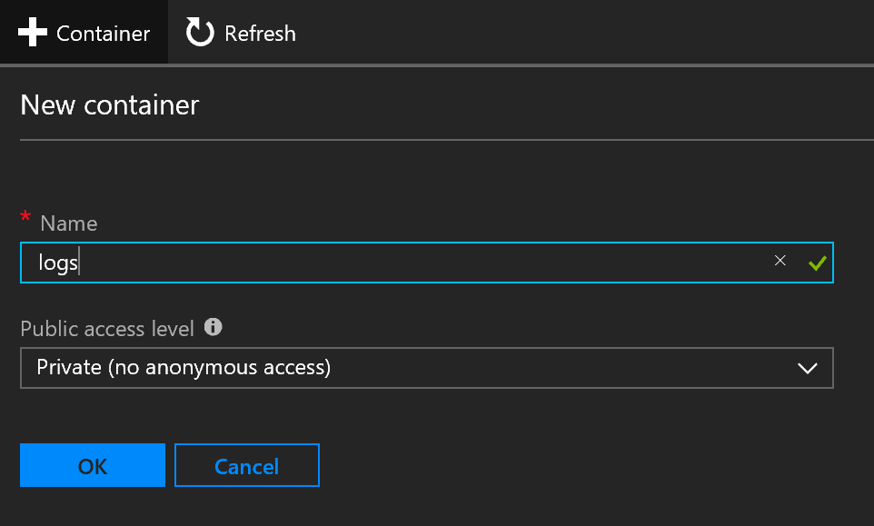

Create another new container called **web-server-logs** and turn on **storage** for the Web server logging.

**Note**: Make sure each container has its access set to private (no anonymous access).

For each log setting, set the retention period (days) to 120.

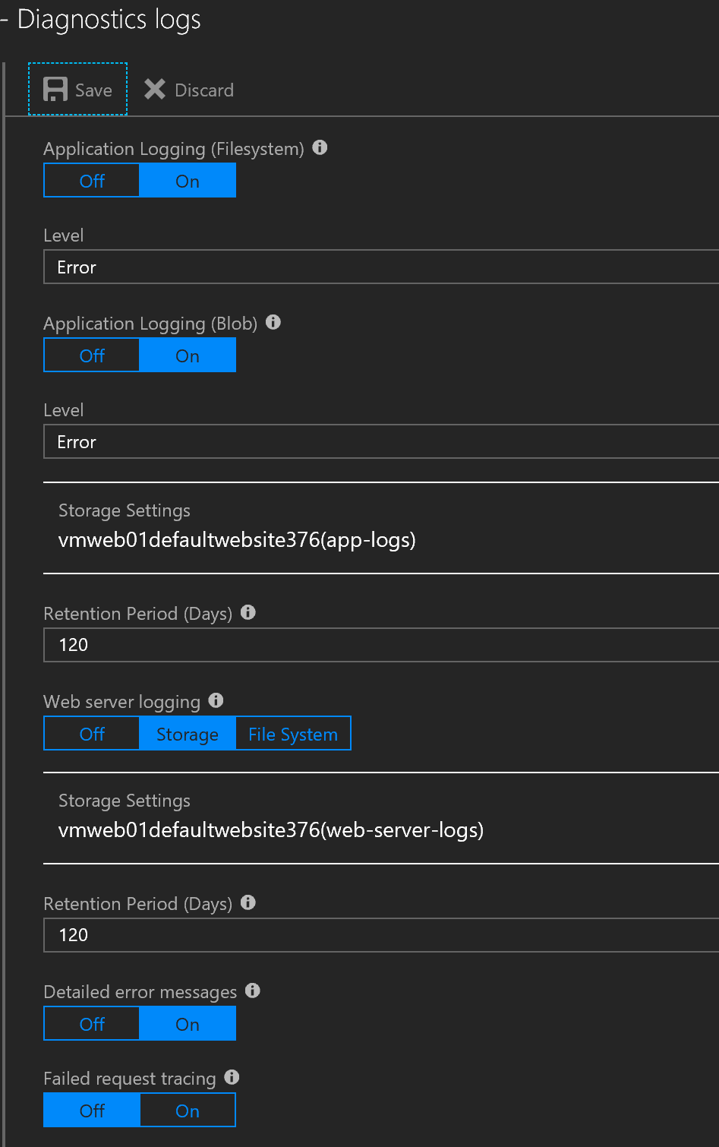

When everything is all set, click **Save**.

#### Task 8: Viewing Application CPU/Memory

We need to ensure that we’re “ok” right now. From a CPU/Mem standpoint.

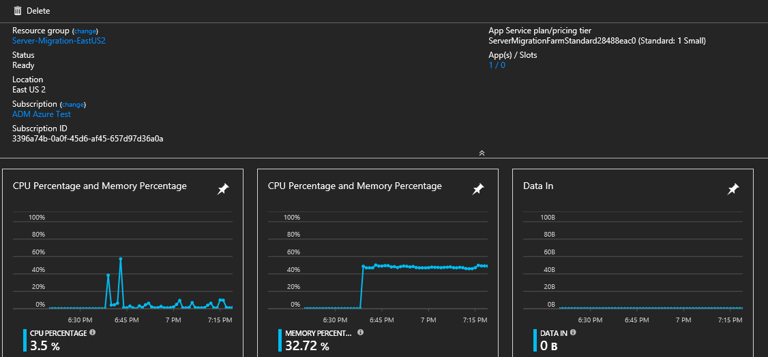

#### Task 9: Viewing Disk space

It’s important that we have room to grow. On the navigation, under the App Service Plan, click on Quotas.

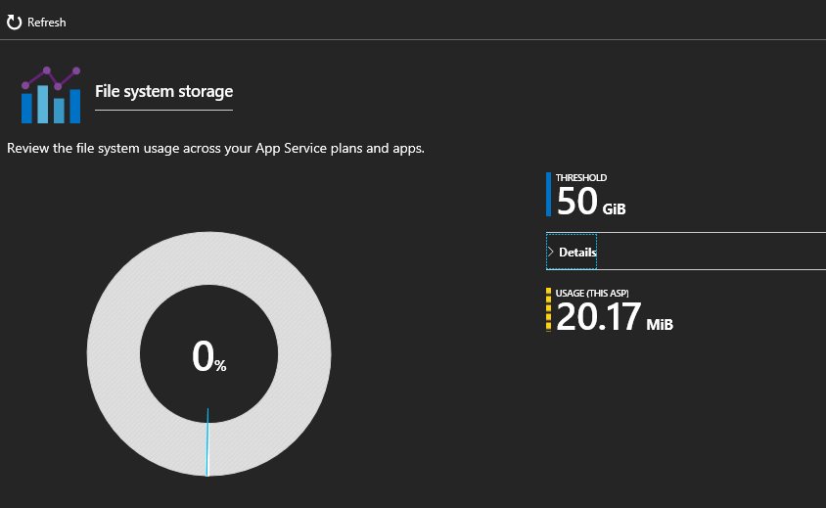

#### Task 10: Configuring Auto Scale Up

We know that the site runs poorly on a single CPU box. Let’s fix that first. Navigate to the App Service Plan and **Scale Up** the application to at least to a P2 instance.

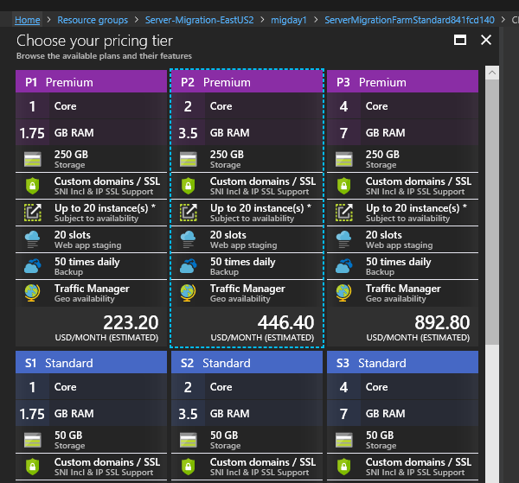

#### Task 11: Creating an Auto Scaling Out

An advantage to running in Azure is auto-scaling the application up and down based off the demand. In this lab, we’re going to create an auto scale rule to handle peak loads.

In the search dialog in the Azure Portal, type ‘Monitor’ to navigate to the Azure Monitor Service.

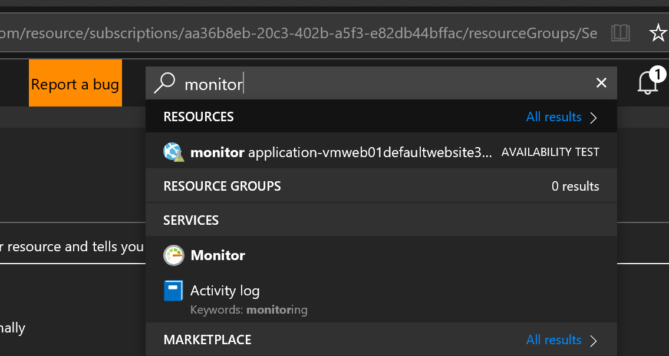

Under the Settings section, click on **AutoScale**. From the list of services, select the App Plan to enable.

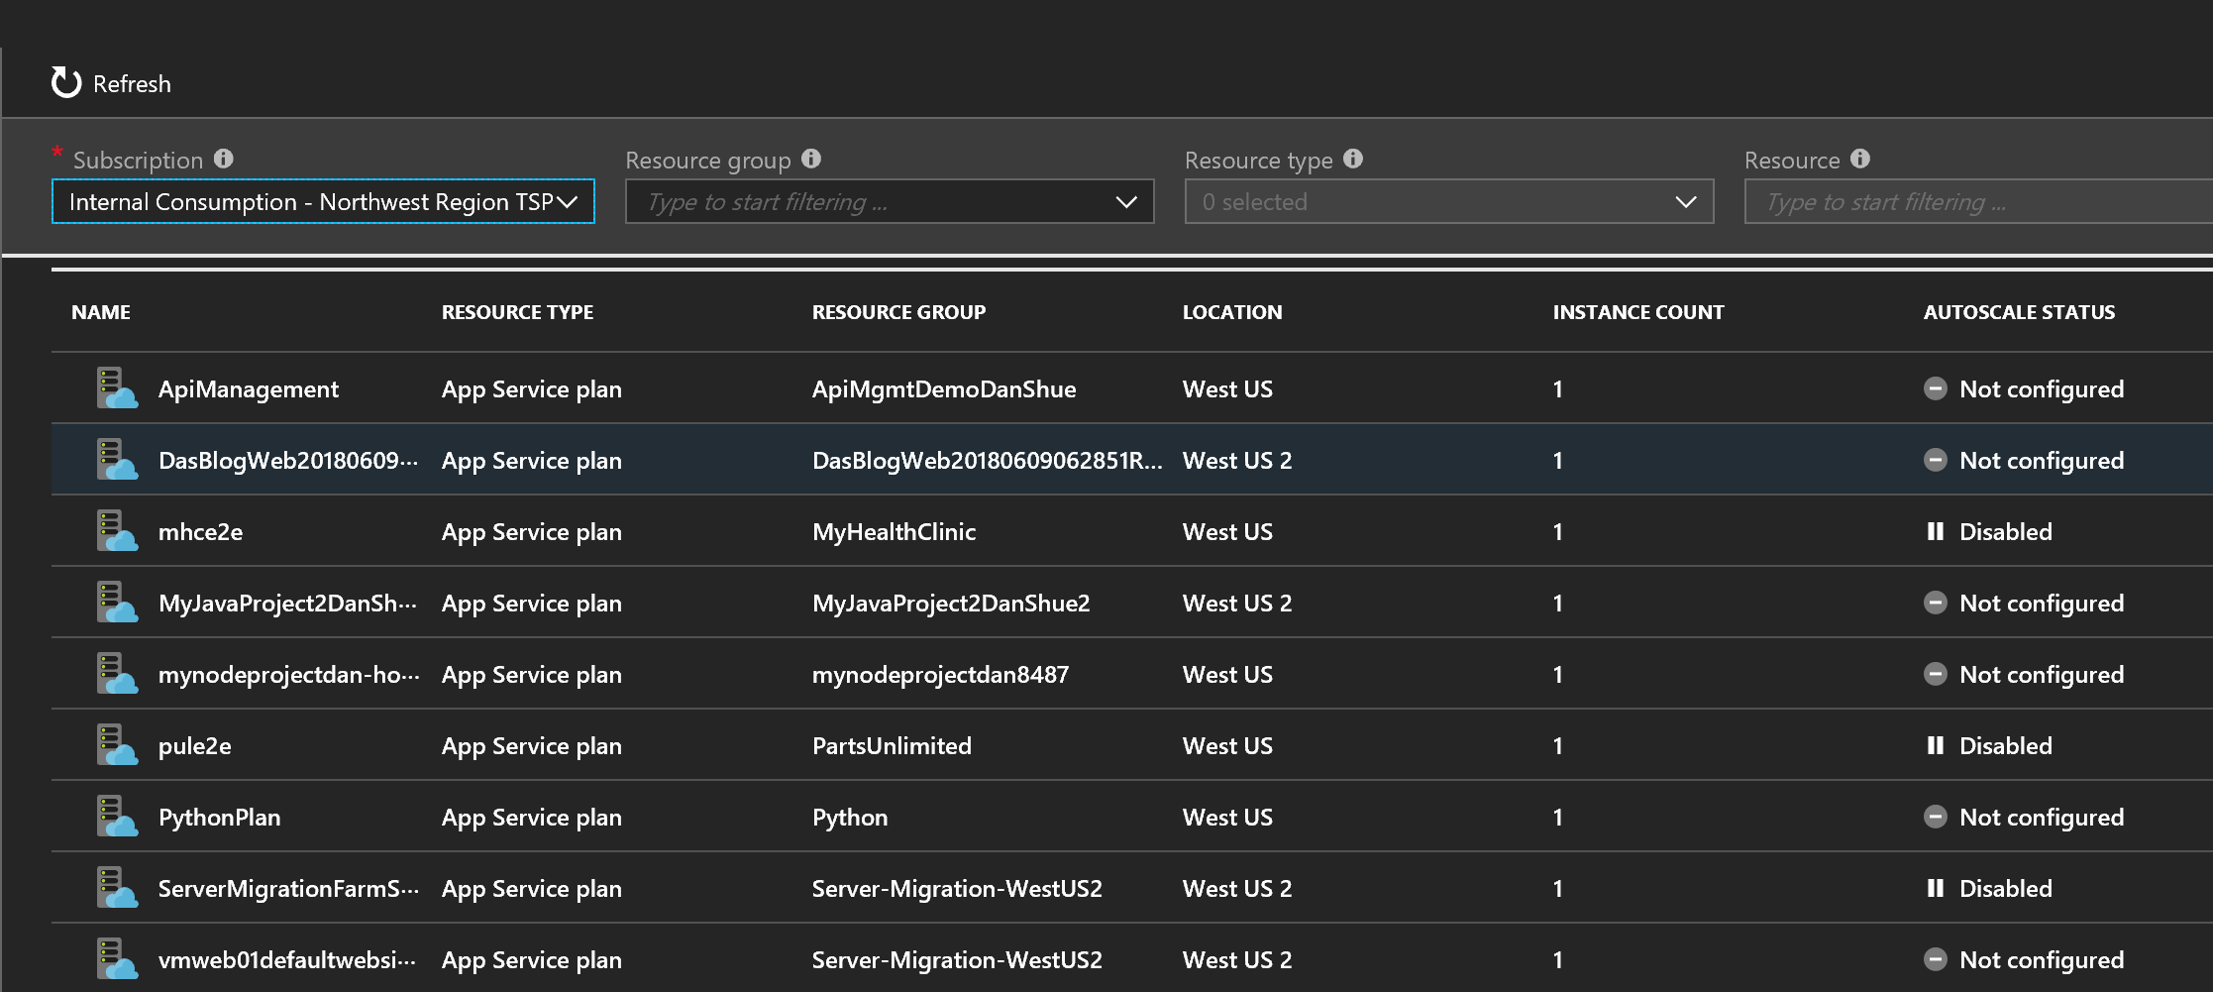

Verify you have the correct **App Plan** and click **Enable** auto scale.

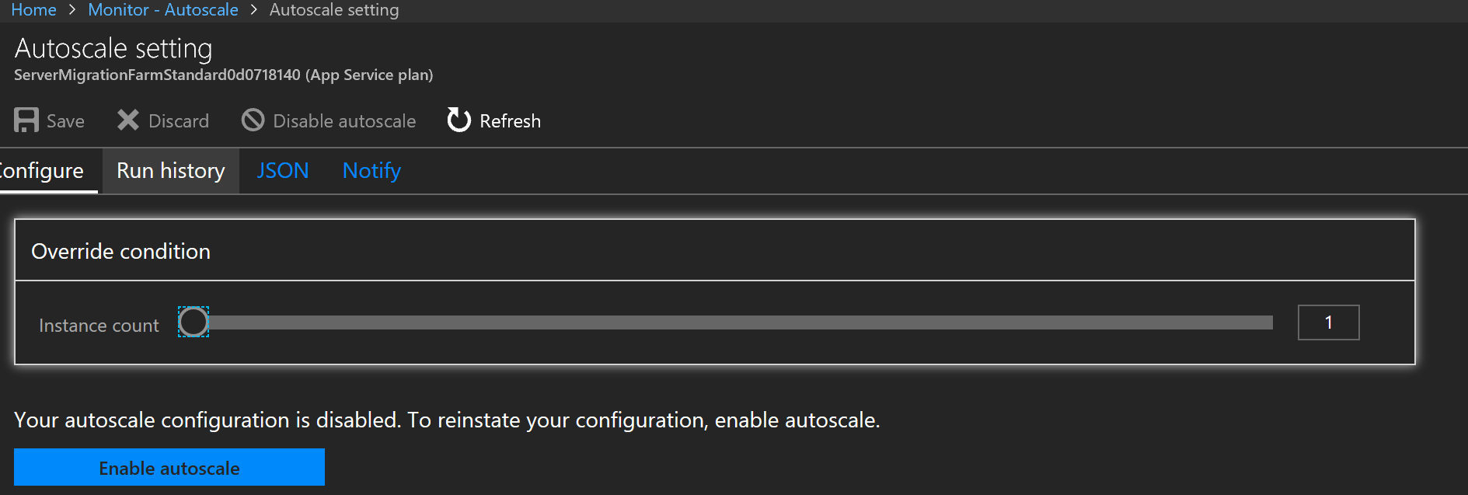

Next, set the rules for which the application will scale out and scale back in.

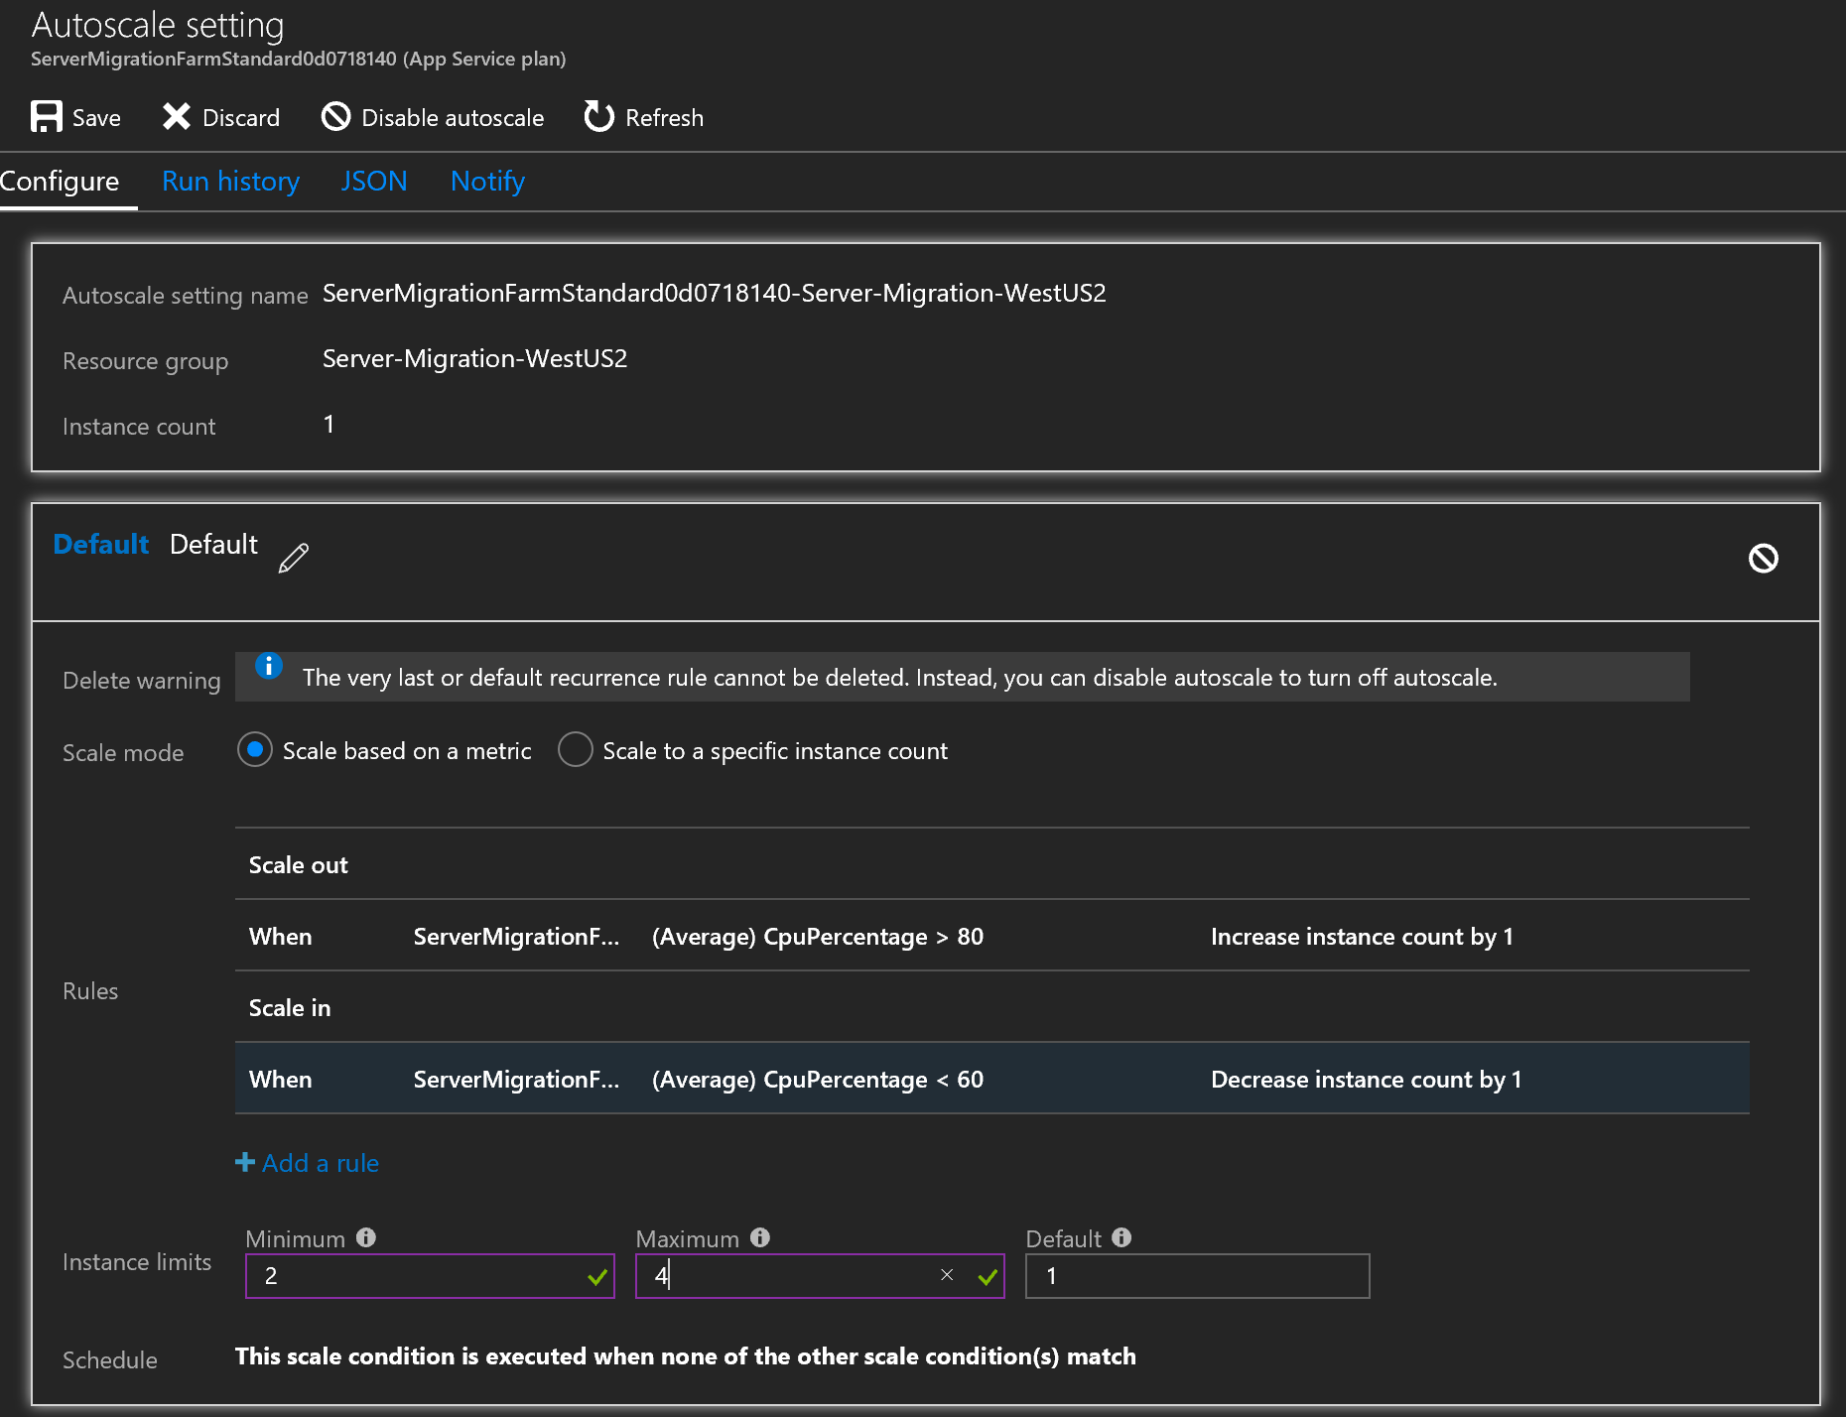

Save the changes

#### Task 12: Prepare for scaling in another region

Are you getting heavy traffic from another region or want to improve the high available of your application? Now that we have a Premium App Plan, we can clone the application and all its settings into a new App Service Plan. That plan can be in the same Resource Group or a new Resource Group.

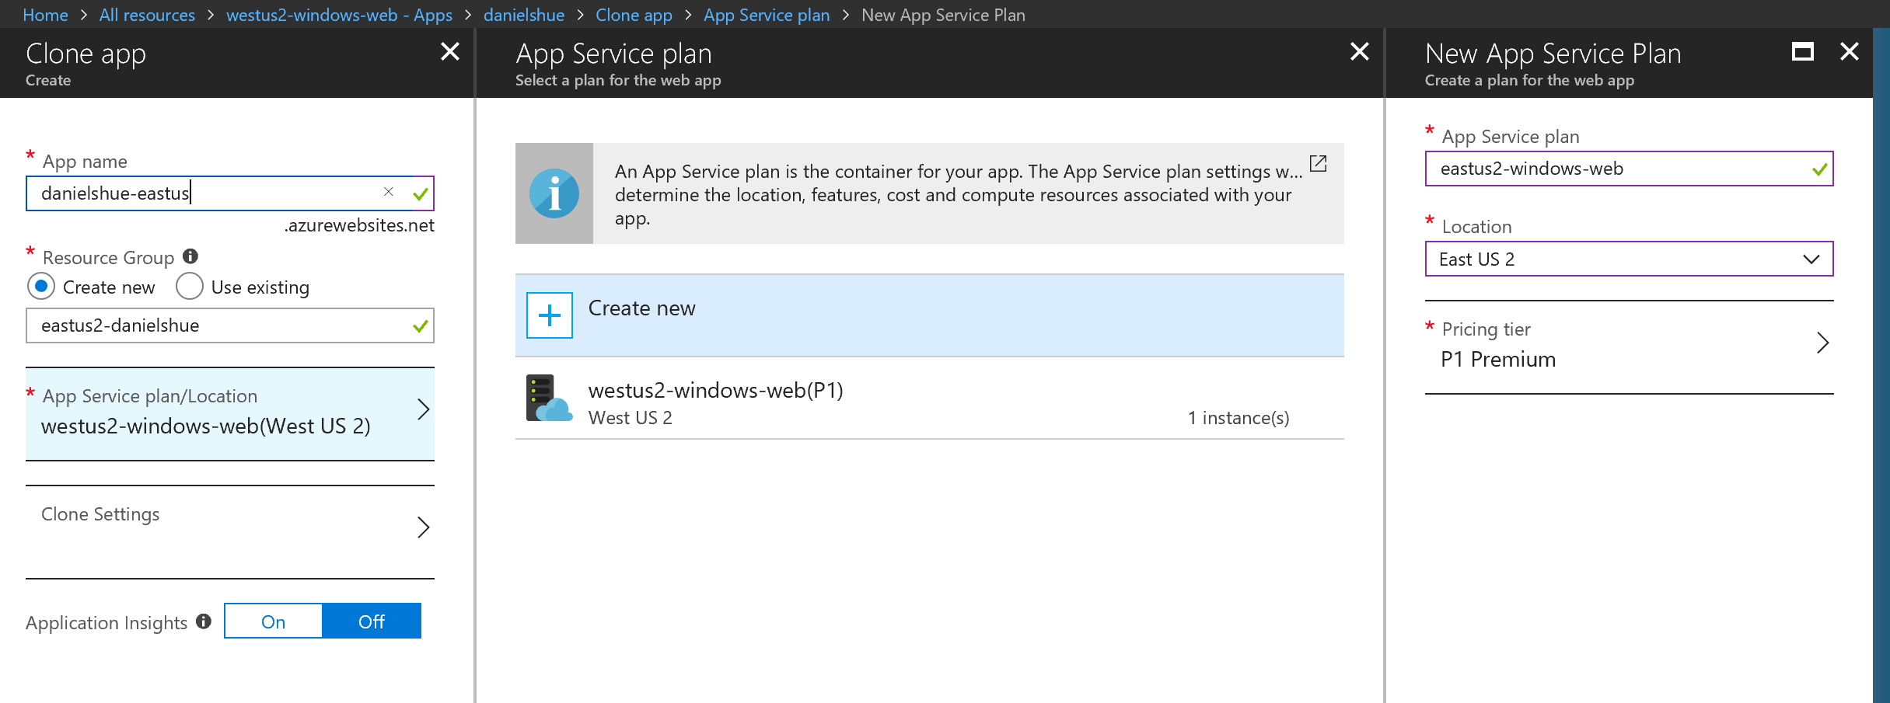

Once you’ve set up a new App Service Plan and Resource Group, now it’s time to set the Clone Settings.

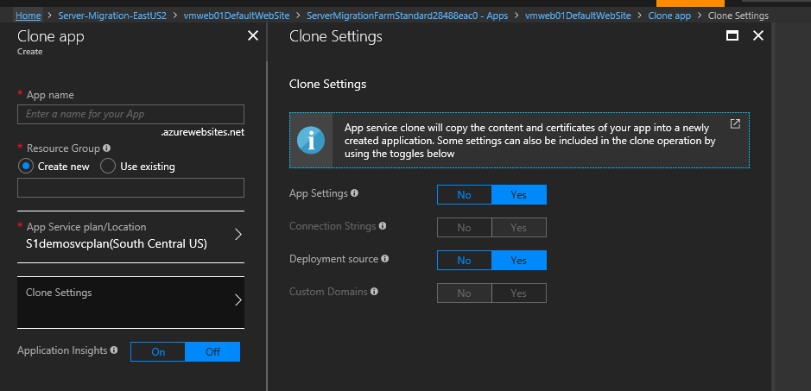

#### Task 13: Viewing Resource Health and History

Now we want to see the overall health history of our resource. Perhaps there was an event that happen that made the application slow to respond or simply want to make sure everything is going already. Navigate to **Resource Health** under the Support + Troubleshooting section. Here you can the current available and the last health events over the last two weeks for the application.

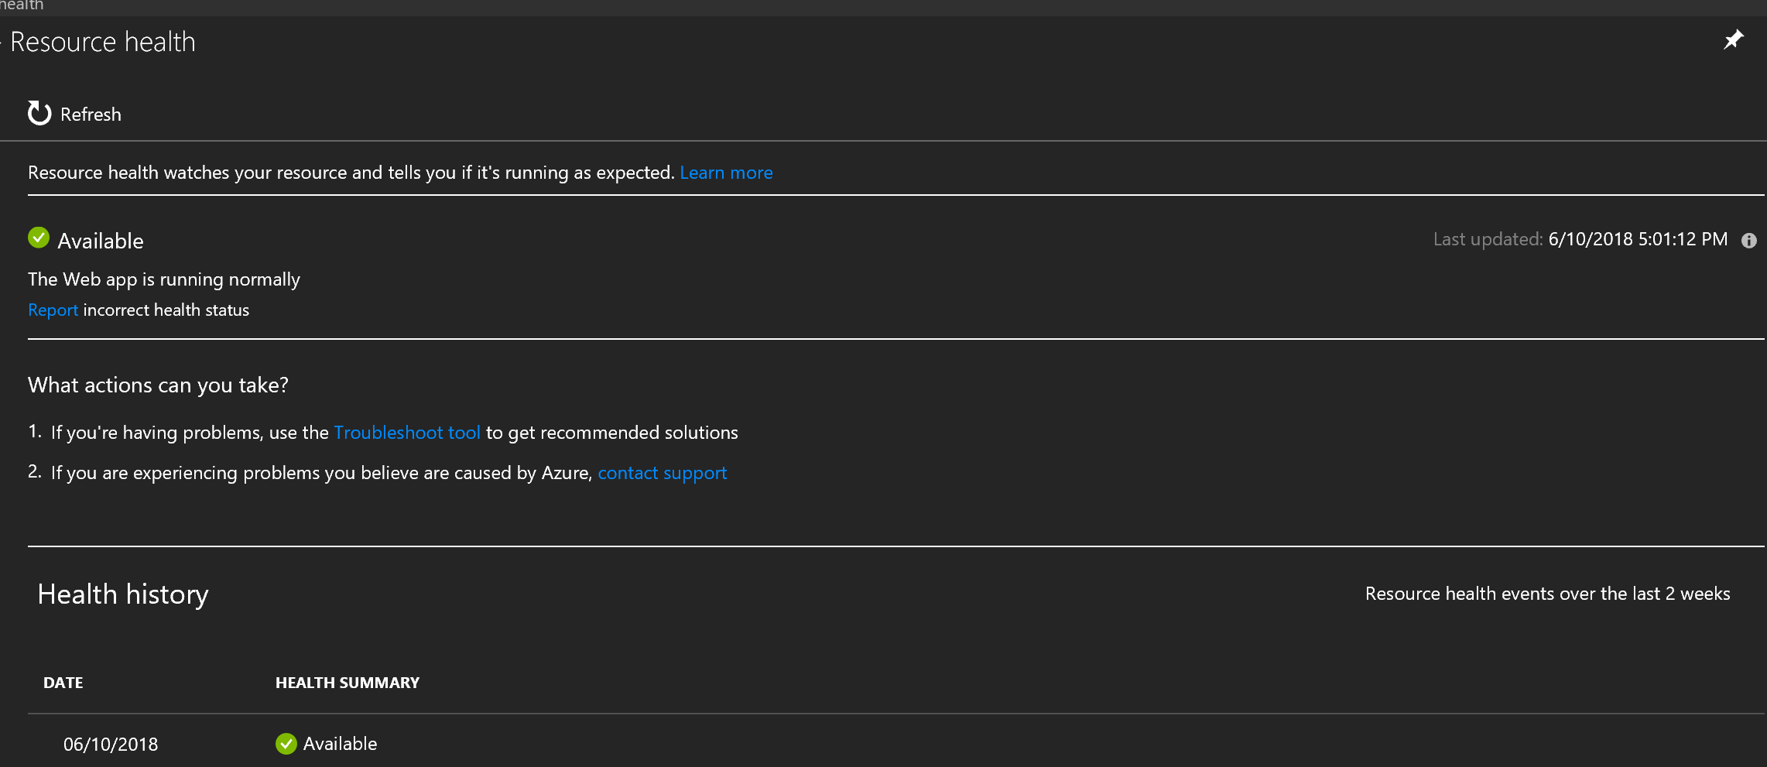

#### Task 14: View Auto Scale Run History

To view the history on how often the web application is scaling up / down, click on the **Run History** link.

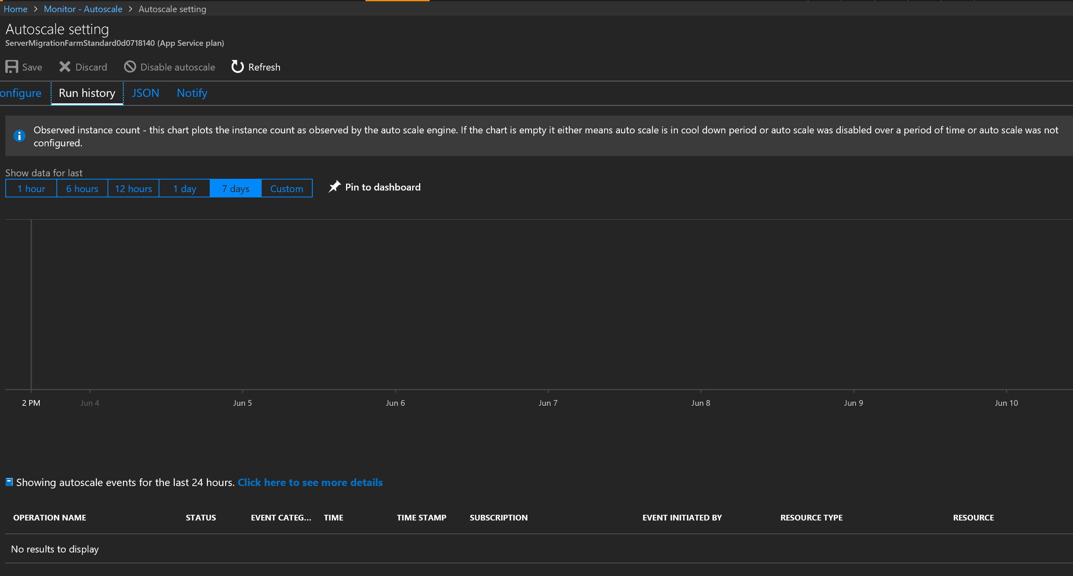

#### Task 15: Setting up auto scaling notifications

If you want to be notified how when the application is scaled up / down, Navigate to Notify.

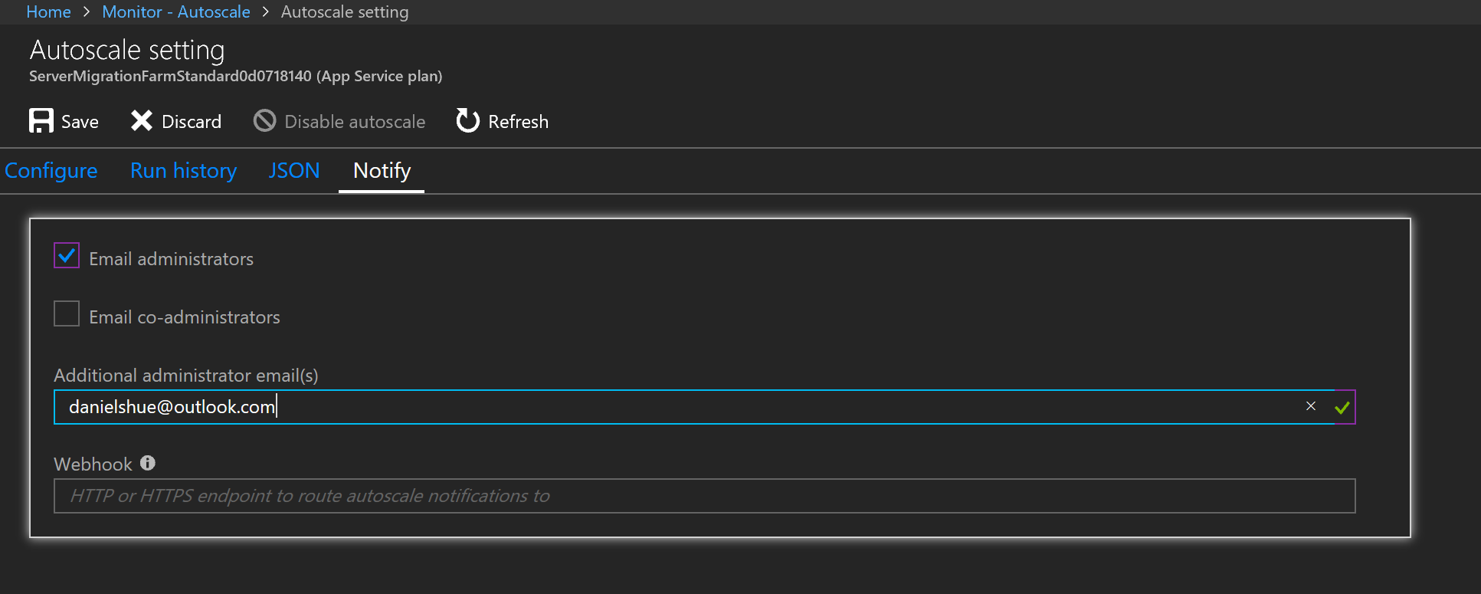

## Exercise 5: Optimize and Secure Azure SQL Database

Duration: 45 minutes

While the default settings for deploying SQL database may work in many situations, we want to examine the database and ensure its secure, optimized, and able to meet the demands of our customers. We will use the Azure portal to configure the ensure tuned, diagnostics is enabled, and the database is sized and can scale as need.

This exercise will demonstrate how to safe guard and protect your database and make it available by:

* Database DTU utilization is < 20%
* >= 3000 DTUs are available for the database
* Database is accessible only from Azure (not externally)
* Database is failover-ready to another region (without app code change)
* Threat Detection is enabled
* Automatic Tuning is enabled
* Diagnostics are enabled
* Alerts anytime DTU usage is > 60%
* Database vulnerabilities are automatically discovered

#### Help references

|  |  |
| --- | --- |
| SQL Azure | <https://docs.microsoft.com/en-us/azure/sql-database/> |
| Resource Group Locking | https://docs.microsoft.com/en-us/azure/azure-resource-manager/resource-group-lock-resources |
| Transparent data encryption for SQL database and Data Warehouse | <https://docs.microsoft.com/en-us/sql/relational-databases/security/encryption/transparent-data-encryption-azure-sql?view=azuresqldb-current> |
| Advanced Threat Protection for Azure SQL Database | <https://docs.microsoft.com/en-us/azure/sql-database/sql-advanced-threat-protection> |
| Firewall & virtual network rules | <https://docs.microsoft.com/en-us/azure/sql-database/sql-database-vnet-service-endpoint-rule-overview> |
| Database Transaction Unit (DTU) | https://docs.microsoft.com/en-us/azure/sql-database/sql-database-what-is-a-dtu |
| Failover Groups and active geo-replication | https://docs.microsoft.com/en-us/azure/sql-database/sql-database-geo-replication-overview |

#### Prerequisites

To complete this task, you should have provisioned the Parts Unlimited IaaS and PaaS environments and have a working CI/CD process. You will use the Developer Workstation deployed as part of the IaaS environment for your development work.

#### Task 1: Resource Locking

We want to make sure than nobody accidentally deletes this footprint. Unlike role-based access control, you use management locks to apply a restriction across all users and roles. There are two settings: **CanNotDelete** and **ReadOnly**. Locks are only limited to the management of the resource itself, not the function of the resource. For example, a ReadOnly lock on a SQL Database prevents you from deleting or modifying the database, but does not prevent you from creating, updating, or deleting data in the database. Only **Owner** and **User Access Administrator** can create or delete management locks.

Navigate to the SQL Server database in the Azure Portal. In the Settings blade for the SQL server database, select **Locks**.

**Note**: Locks can be applied at a resource, resource group, or subscription that you wish to lock.

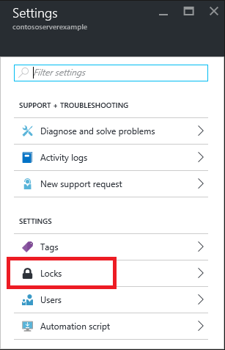

Next, in the Management locks, click on **Add**. If you want to create a lock at the parent level, select the parent. The currently selected resource inherits the lock from the parent. For example, you can lock the resource group to apply a lock to all its resources.

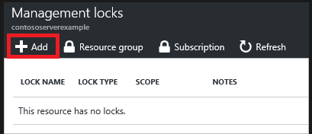

Give the lock a name and lock level.

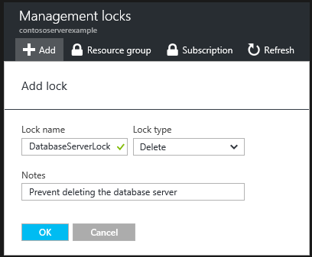

To delete the lock, select the ellipsis and **Delete** from the available options

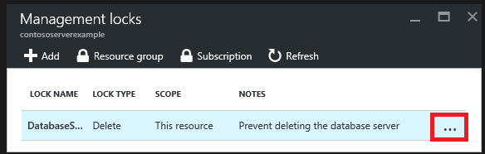

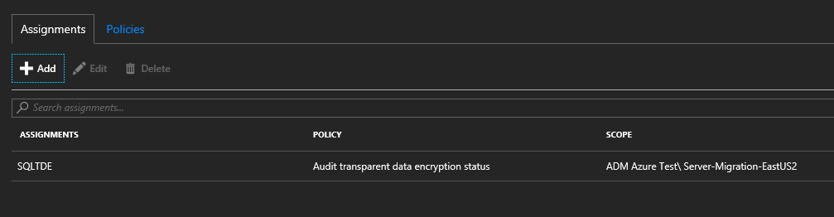

#### Task 2: Enable Transparent Data Encryption

If we have sensitive data, we can encrypt the data without impacting the application. Transparent data encryption encrypts your database, backups, and logs at rest without any changes to your application. For newer databases, this service is automatically turned on. You may need to be manually enabled for older databases.

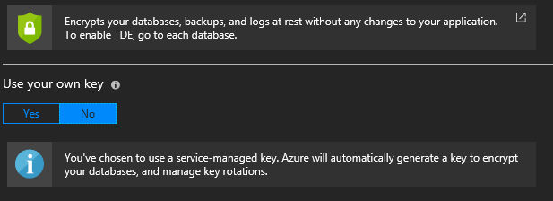

If you want to supply your own key (BYOK), you can store it on Azure Key Vault.

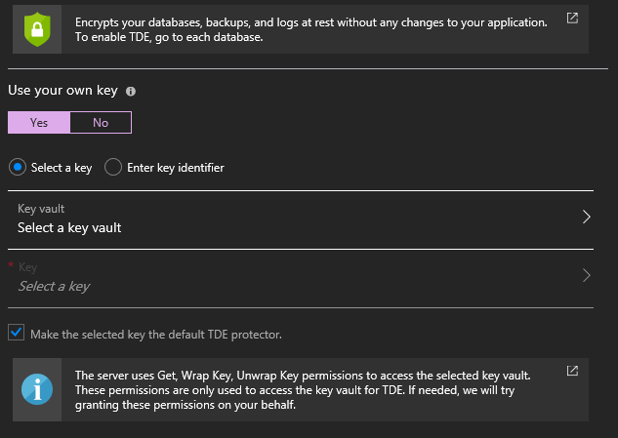

#### Task 3: Scale Up Database Performance

When our database was migrated, only a Standard S0, 10 DTUs, 250 GB database was provisioned, the minimum DTUs for a Standard subscription. We need to scale out our database to at least 100 DTUs or Standard S3: 100 DTUs, 250 GB database configuration. In the blade for your database, click on the **Configure** section and slide the DTU slider to 100, then click **Apply**.

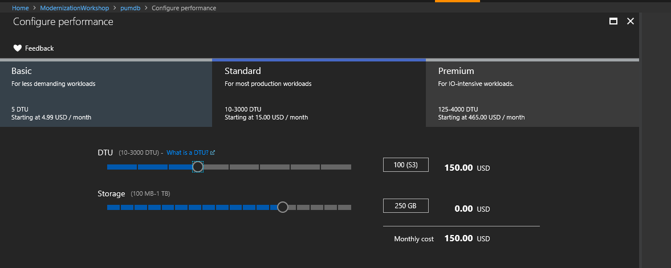

#### Task 4: Configure Firewall and virtual networks

Under the **Security** blade, navigate to **Firewalls and virtual networks.** We want to seal off any access from anyone except us. To allow access to Azure services, click on **ON**.

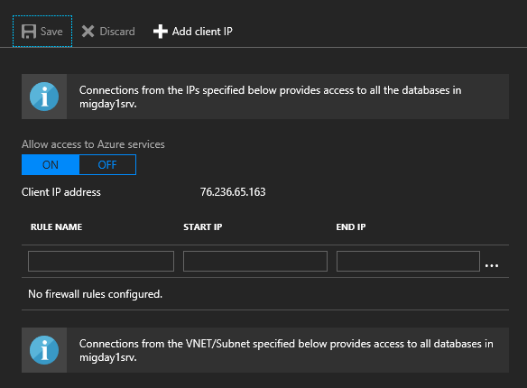

#### Task 5: Threat Detection and Vulnerability Assessment

We want to help protect our database sever again threats. This service includes Threat Detection, Data Discovery & Classification, and Vulnerability Assessment. There is a small fee per server/month to run this service. Enable these settings by navigating to the Security section in the SQL Server blade and select **Advanced Threat Protection**.

In the storage details section, select the same storage account used for the web application.

**Note**: For performance purposes, consider using a different storage account in the same region as the database, but different from other services.

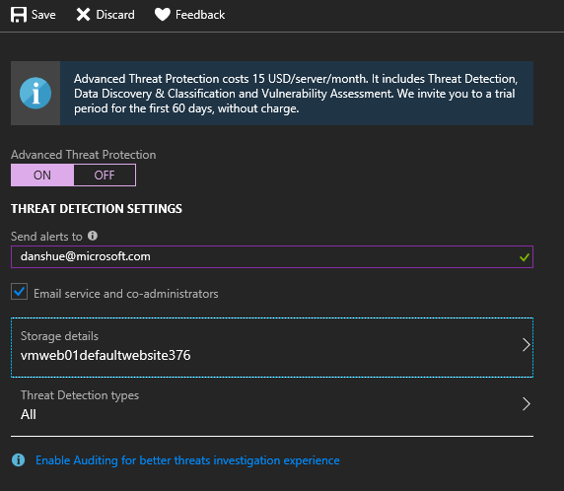

#### Task 6: Turn on SQL Server Auditing

Navigate to the SQL Server. Located under the Security section, click on Auditing. In this section we will enable the SQL Server. Specify which Storage Account you want the logs to be exported too and click on **Save.**

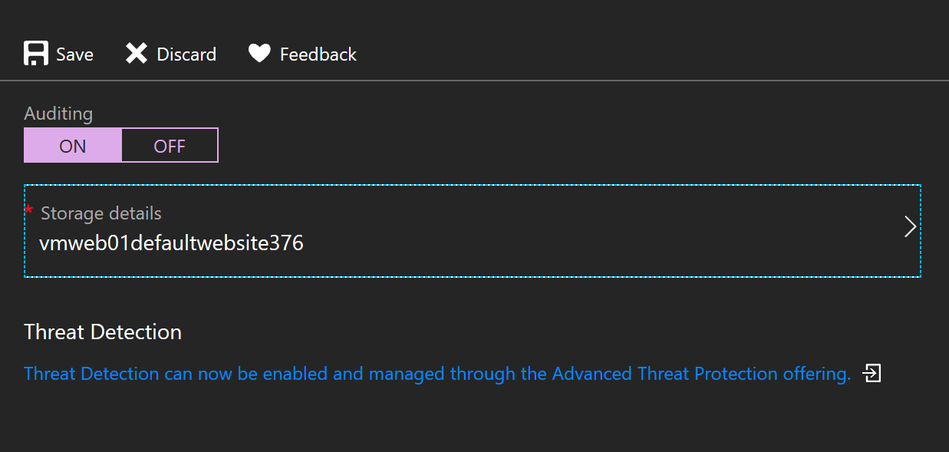

#### Task 7: Automatic Tuning

In the SQL Server blade, select **Support+Troubleshooting** section. Azure SQL Database has built-in intelligence to automatically tune your databases to optimize performance. At the server level, you can enable the Azure defaults. You can set the inherit state or force to be applied or off for your database. Click on **Azure defaults** and click **Apply.**

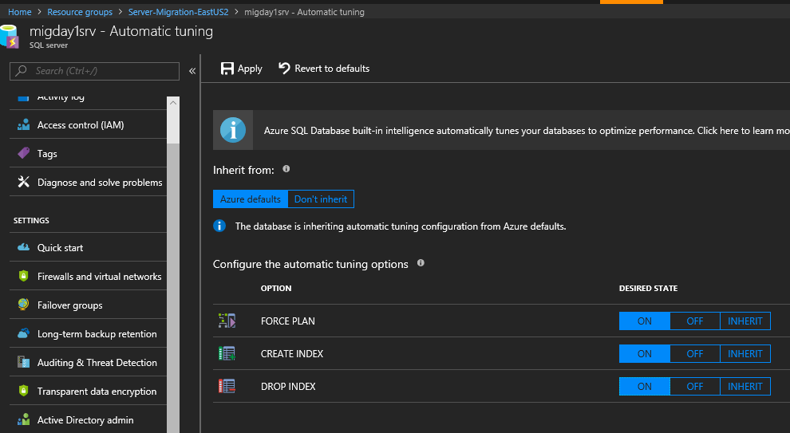

#### Task 8: Enable Database Diagnostics

If we need to troubleshoot or get a better understanding of what’s going on with our database and server, be sure to turn on the Database diagnostics. In the blade, navigate to the database you want Diagnostics turn on and click **Turn on Diagnostics**.

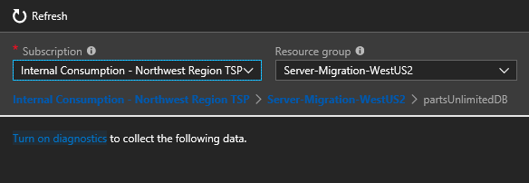

Next, to identify the diagnostics, type in the name. such as the name and location of the database. If you want the logs to be saved to Archived to a Storage Account, select the existing storage account. Next, toggle the retention days you want to keep each log. **Note**: you have the option to send the logs to Log Analytics or Stream to event hub.

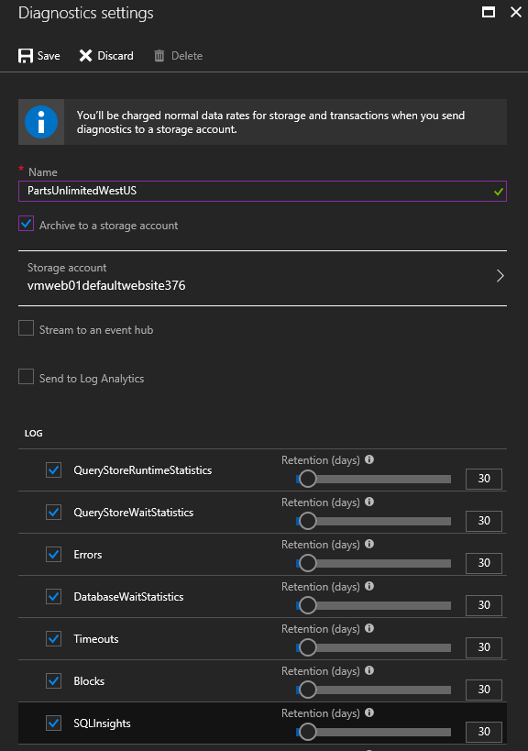

#### Task 9: Configure Long-term backup retention for database

SQL Database automatically creates database backup and uses Azure read-access geo redundant storage (RA-GRS) to provide geo redundancy. These backups are created automatically and at no additional cost. You don’t need to do anything to make it happen. SQL backup create full, differential, and transaction log backups for Point-in-time restore (PITR). The transaction log backups generally every 5-10 minutes, depending on the performance level and database activity. Logs are kept based off the DTI purchased vCore-based purchasing model. You can change the default retention using either REST API or PowerShell. The default values are 7, 14, 21, 28 or 35 days.

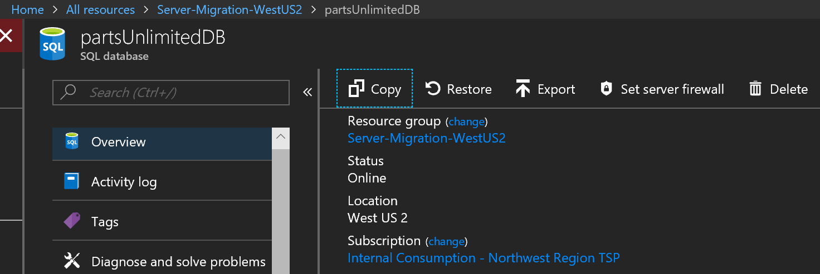

Our business requirements us to have 120 days back up, therefore, we need to configure the Long-term backup retention. Navigation to the SQL Server and under the Settings section, click on **Long-term backup retention.** Select the **PartsUnlimitedDB** from the available databases. In the Configure Policies, click **Weekly Backups**, type **120** for the length and change the drown down interval to **Days**. When done, click **Apply.**

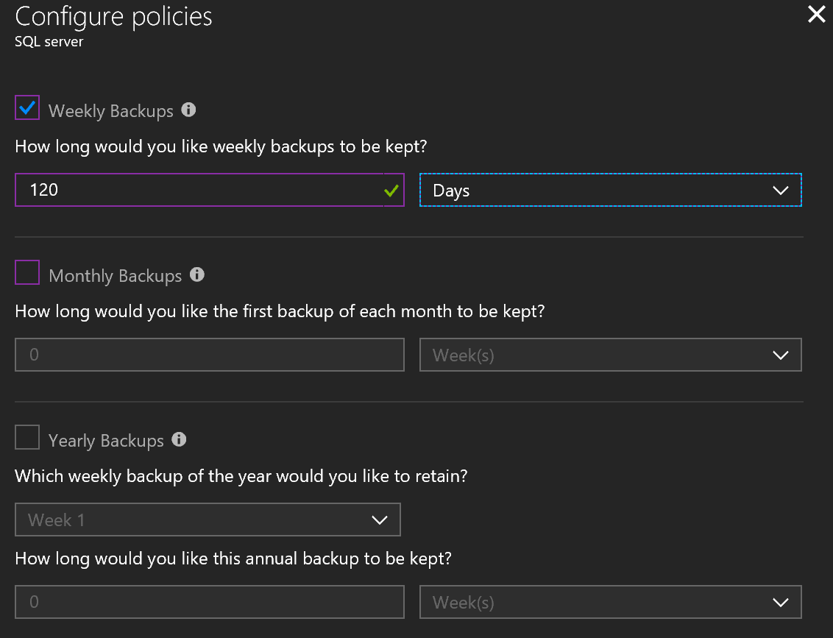

## Exercise 6: Optimize Entire Web Application Performance with Content Distributed Network (CDN)

Duration: 30 minutes

As the improvements have been rolling out to the Parts Unlimited site, marketing has been ramping up its advertising causing an uptick in traffic. While this is exactly what the company wants, it has caused some latency issues. Improvements need to be made to the Parts Unlimited site to reduce latency and improve end user experience. This must be done quickly as there are additional marketing campaigns on the horizon.

To solve the performance issues as quickly as possible, we are going to implement a Content Delivery Network for our site. It has been decided that the entire site will be cached with CDN.

* Create a CDN endpoint to Web App
* Configure for correct behavior of when using Query String
* Change for even faster performance by adding compression

With Azure CDN you have a choice of different CDN providers. Configuring the service is quick, usually around a few minutes, and billing is based on use as opposed to a contract.

#### Help references

|  |  |
| --- | --- |
| Azure CDN | <https://azure.microsoft.com/en-us/services/cdn/> |
| CDN Overview | <https://docs.microsoft.com/en-us/azure/cdn/cdn-overview> |
| Creating a new Endpoint | <https://docs.microsoft.com/en-us/azure/cdn/cdn-create-new-endpoint> |

#### Prerequisites

To complete this task, you should have provisioned the Parts Unlimited IaaS and PaaS environments and have a working CI/CD process. You will use the Developer Workstation deployed as part of the IaaS environment for your development work.

#### Task 1: Configure CDN for the whole web application

Using the **Networking** tab in the **Web App** blade and clicking on the **Configure Azure CDN for your app** link:

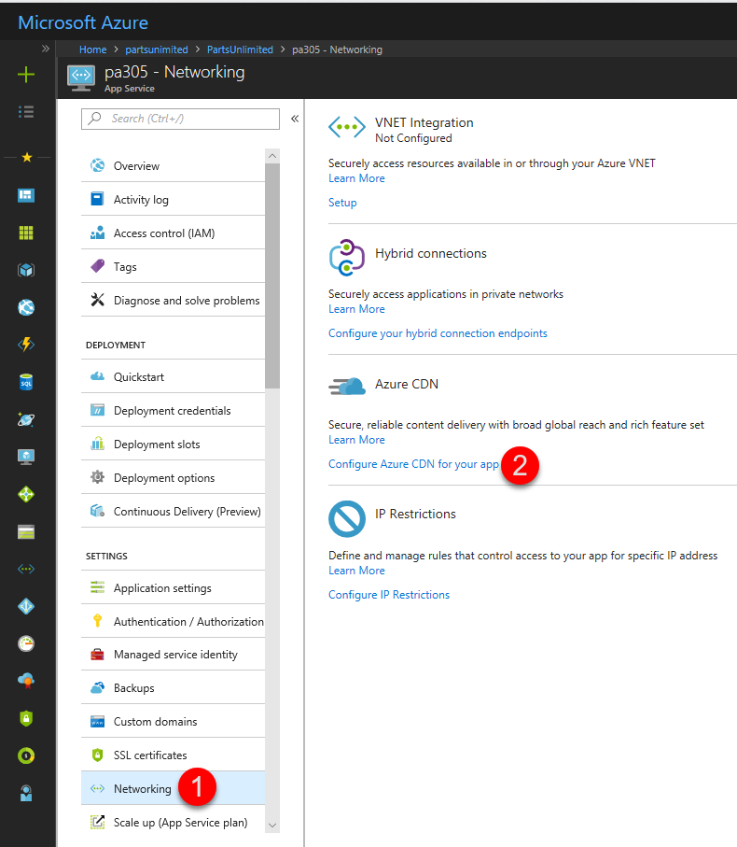

Fill out the form to create a new **CDN Profile** and **CDN Endpoint** for the app:

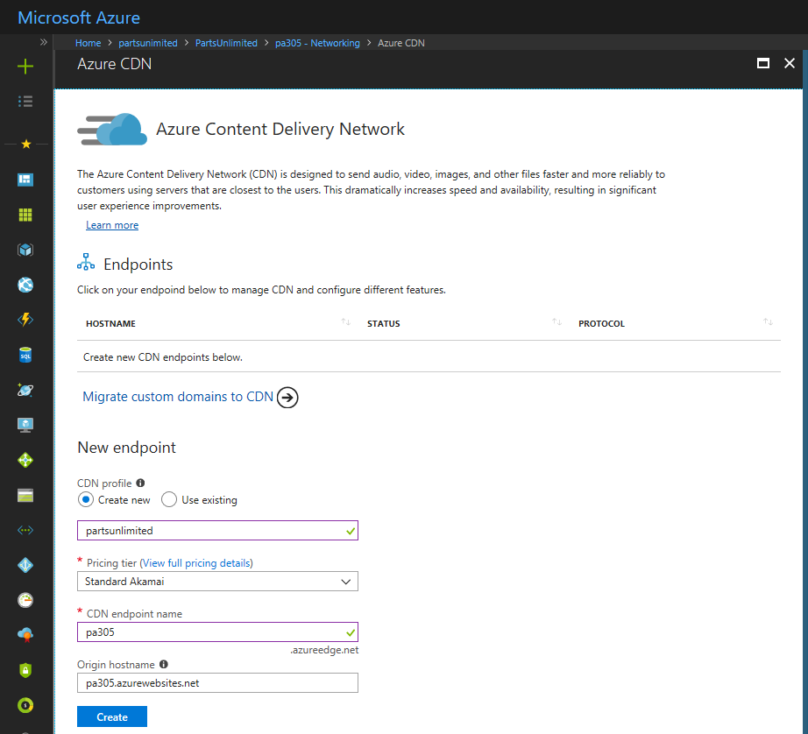

After services are created, browse the website in the edge URL to make sure it is working.

Navigate through the product categories and notice that the same page is being displayed for all categories, must be a problem with the query string parameters, let's fix that.

#### Task 2: Configure Caching Rules

Click on the **CDN Endpoint** in the portal and then on the **Caching Rules** property to see what is available. We can see there is a global rule for **Query String caching behavior**, which is set to be ignored. To fix the problem, change it to **Cache every unique URL**.

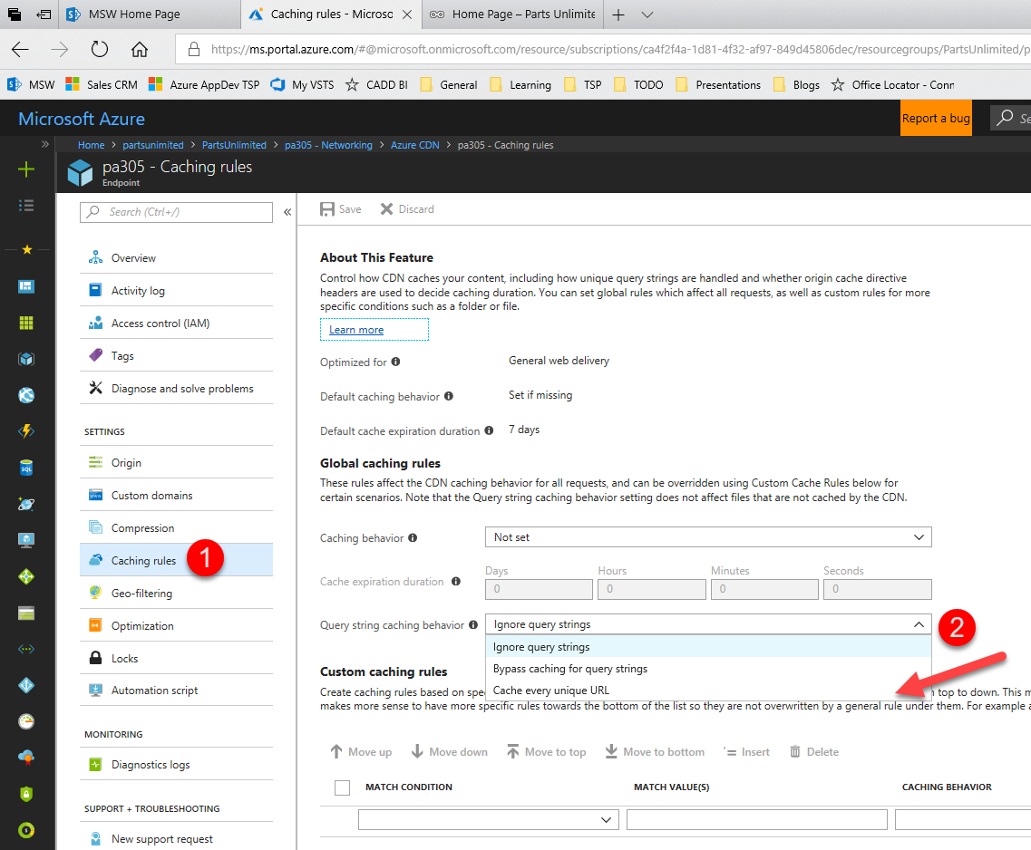

Next, under the custom caching rules, set up a new rule to exclude the shopping cart. For the Match Condition, choose **Url Path,** Matching Value(s), type **/Shopping Cart**, and **Caching Behavior,** choose **Bypass Cache.** When you’re done, click **Save**.

Now browse the website on the edge URL and do a fresh reload on the category product pages and the problem should be fixed now, any subsequent visits will be faster because data is cached in the CDN for all pages.

#### Task 3: Improve performance by adding compression

We can improve the CDN performance even further with compression rules for some types of files, specially text. Click on the **Compression** property, enable it, and click **Save**, additional MIME types can be added if desired:

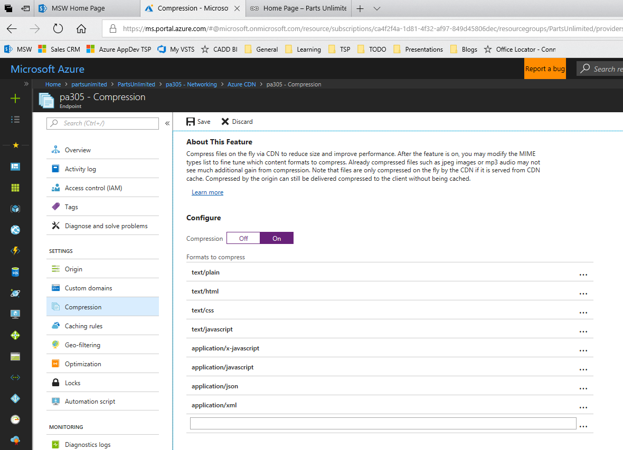

Now browse the website after these changes and load time should be faster!

Custom CDN usage could be added only for portions of the site if this approach is not desirable. In addition, custom domain and SSL certificates can be added to an CDN endpoint.

## Exercise 7: Optimize Partial Web Application Performance with Content Distributed Network (CDN)

Duration: 45 minutes

In the previous CDN exercise, we showed how you can turn on CDN for the whole entire site. However, for some sites with special content such as large files (e.g. large documents, video, etc.), we may want to optimize the delivery for that specific type of content. This lab will show you how to take a directory where your content in stored offload that content to a CDN.

* Create Resource Group & Storage Account
* Create a CDN Profile
* Create a CDN Endpoint
* ouPublish Content: Copy images to storage account
* Change code to use CDN
* Explore additional features

#### Prerequisites

To complete this task, you should have provisioned the Parts Unlimited IaaS and PaaS environments and have a working CI/CD process. You will use the Developer Workstation deployed as part of the IaaS environment for your development work.

#### Task 1: Create a Resource Group & Storage Account

**Note:** If you already created a Storage Group for the web app logs, you can skip this step. If you already created a CDN Profile in the previous lab, you can also skip this step and go to **Add CDN Endpoint**.

Create a resource group called CDN to place all the resources to be used for the Content Delivery Network. In the Azure Portal, click to add a resource and look for Storage Account:

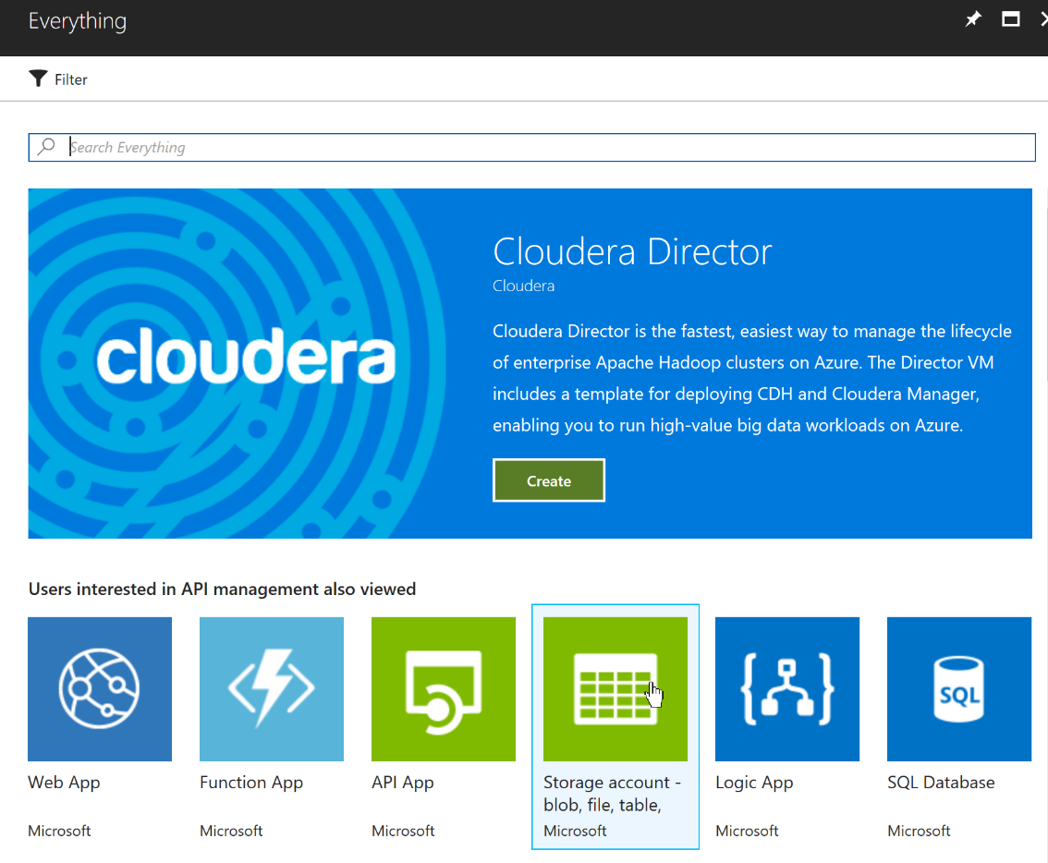

Click on the create button to start:

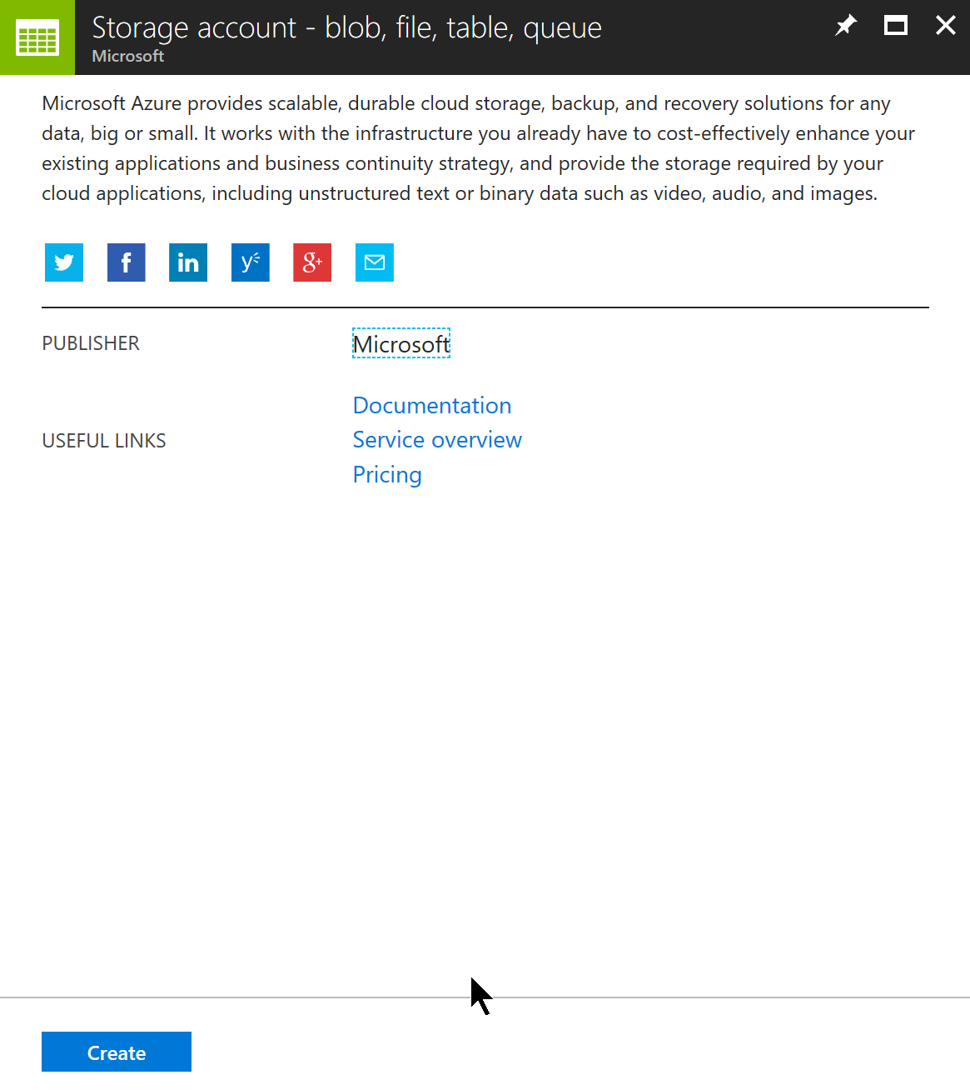

Enter a name for the storage account, select resource manager for deployment model & storage V2 for kind, select standard performance and LRS for replication, Hot for tier and disabled for secure transfer required and select the resource group where to create:

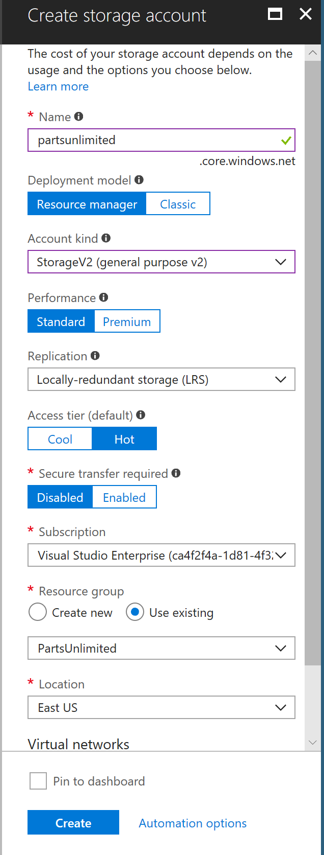

#### Task 2: Provision

In the Azure Portal, click to add a resource and select the "Web + Mobile" area and "CDN" should be immediately available:

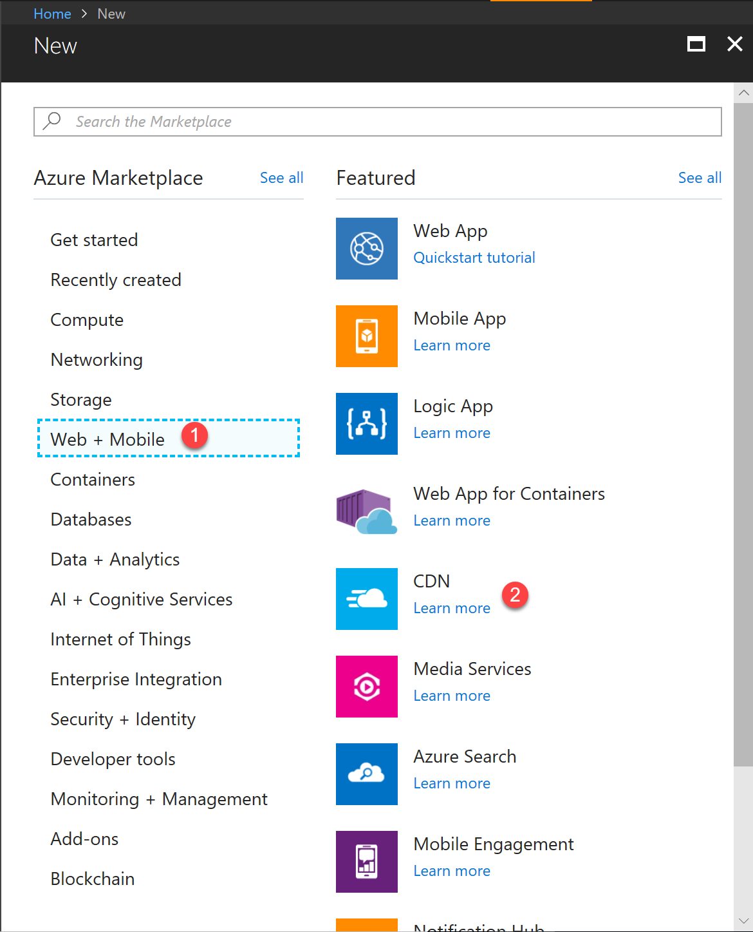

Enter a name for the profile, select a resource group and

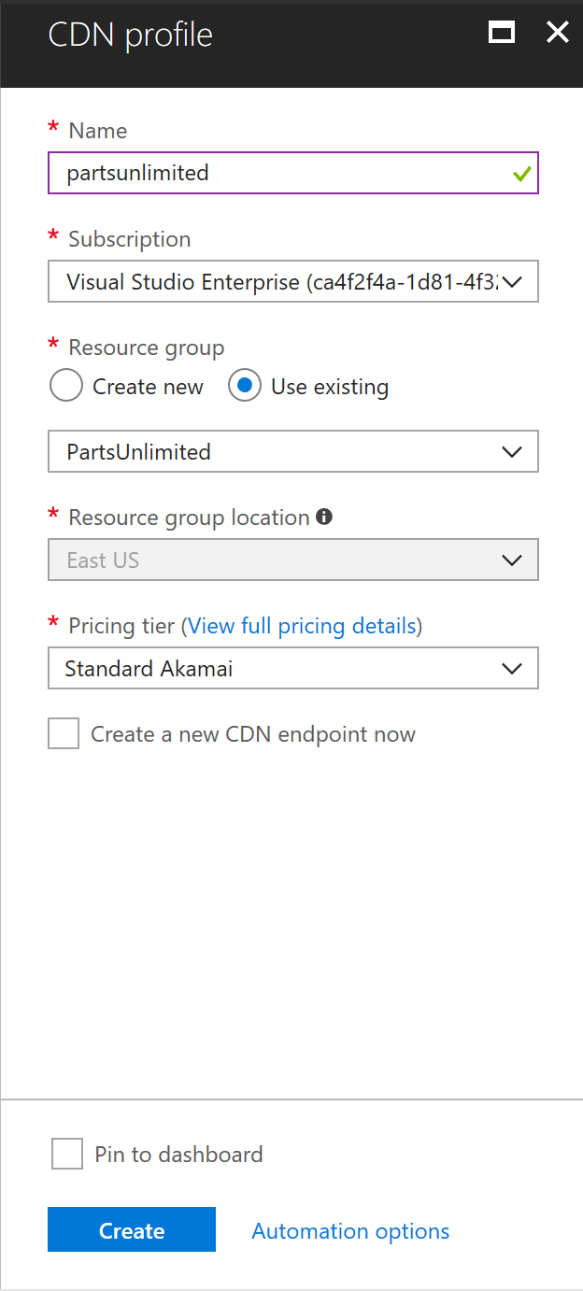

#### Task 3: Add a CDN Endpoint

After the CDN profile is created, you should be able to see the CDN resource and click on the **Add Endpoint** link:

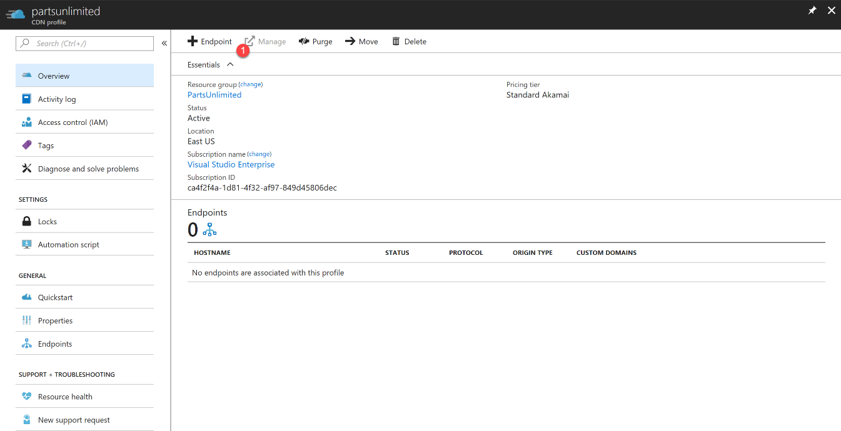

In the dropdown, notice the available options for **Optimized for**…. Enter "{web-host}-images" name for the endpoint, select Storage as origin and click on Add:

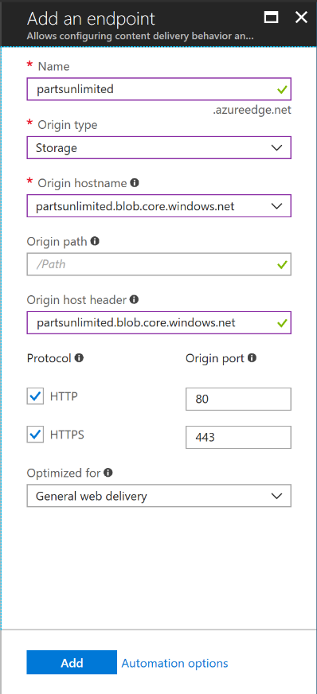

#### Task 4: Copy images to storage account

Use the Azure Storage Explorer in the Portal or [download it](https://azure.microsoft.com/en-us/features/storage-explorer/) to connect to the storage account previously created:

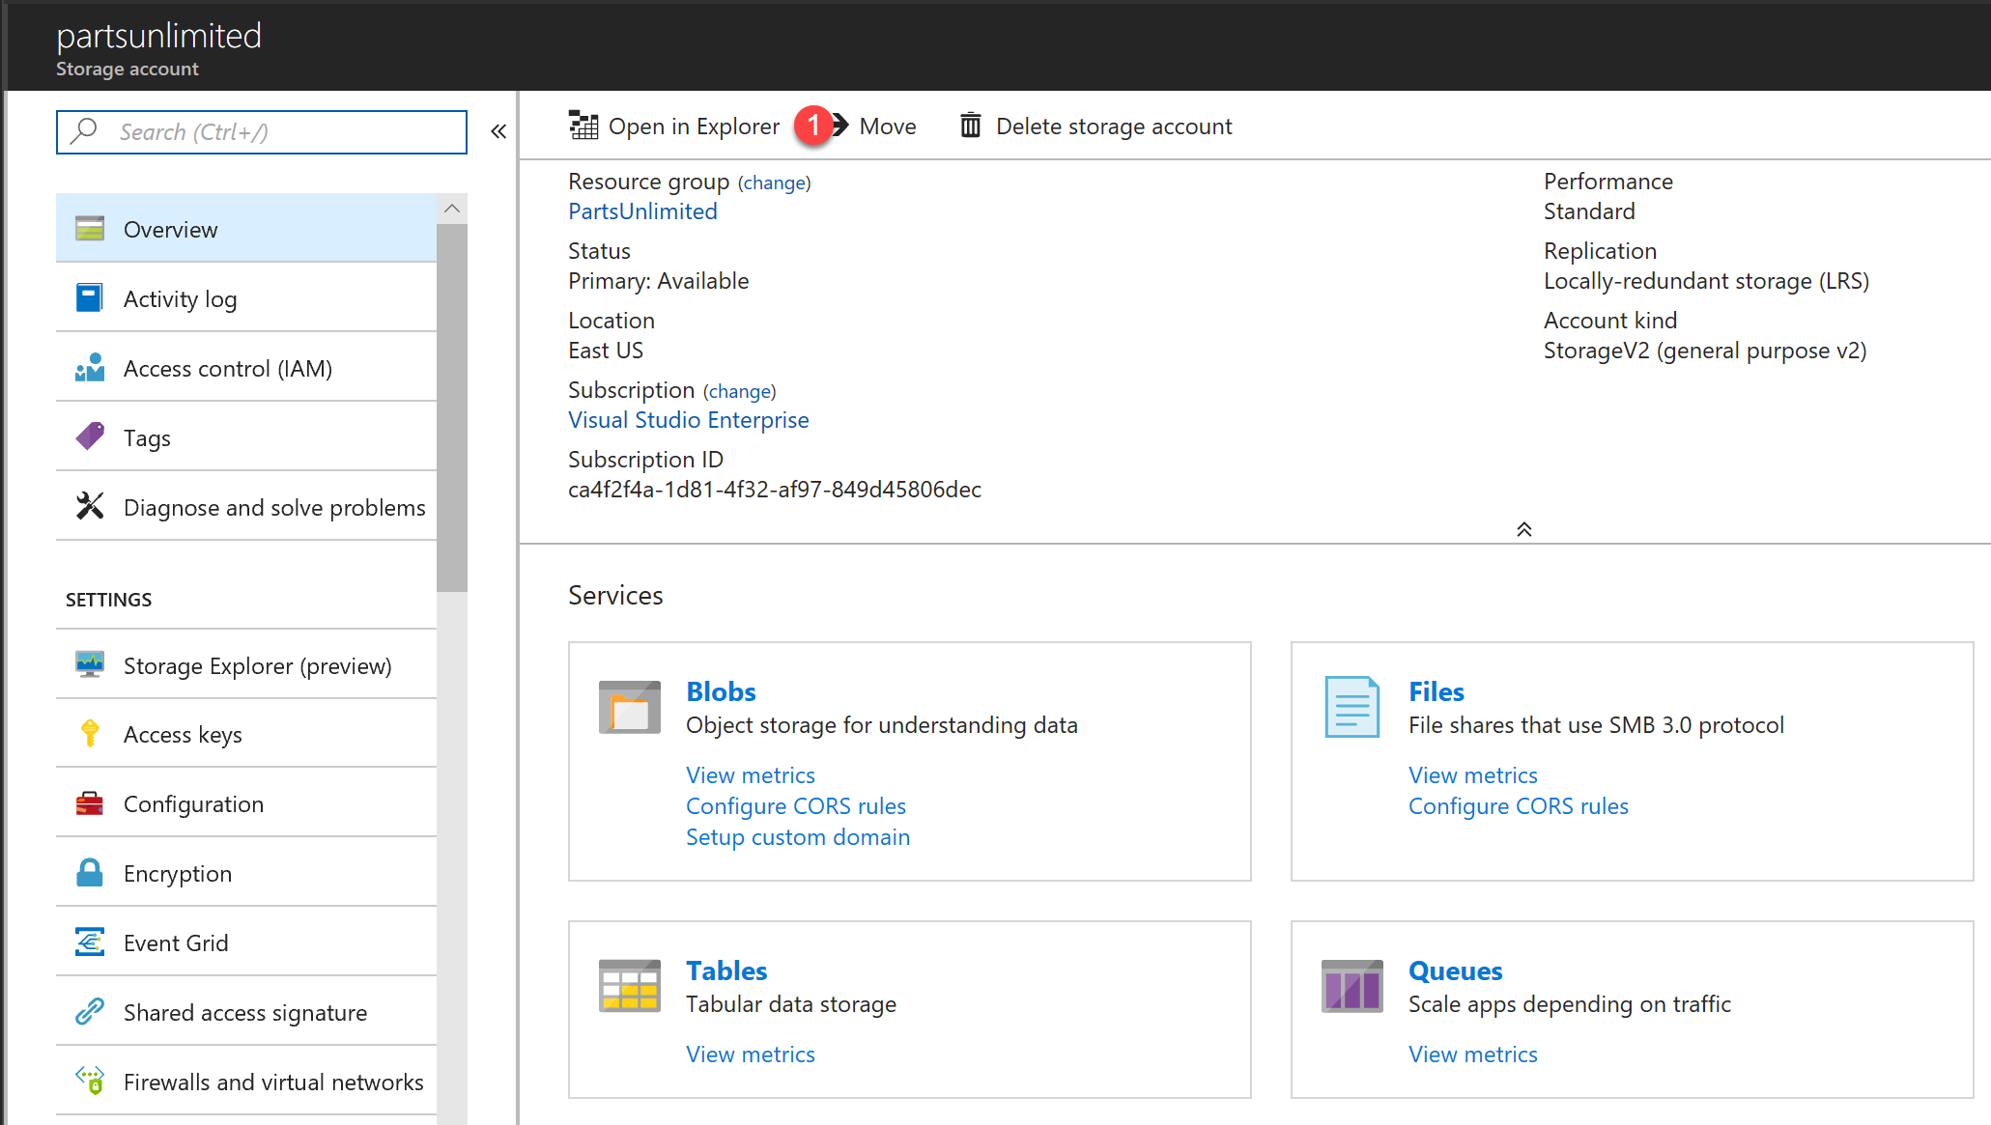

After authenticating and locating the storage account in the Storage Explorer, create an "images" Blob container:

If you’re using the Portal’s Storage explorer, Set the permission to "Public read access for blobs only" to allow them to be accessible.

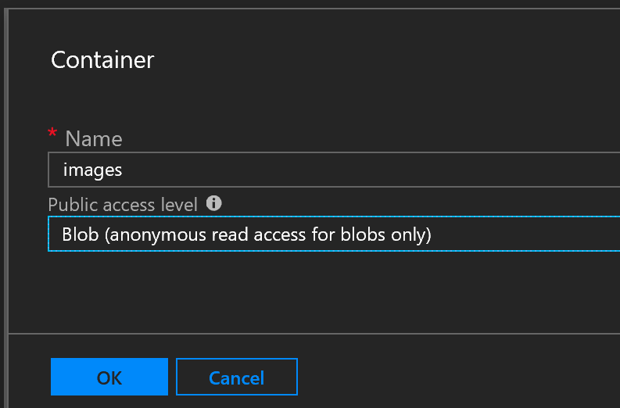

If you’re using the Microsoft Azure Storage Explorer for Windows:

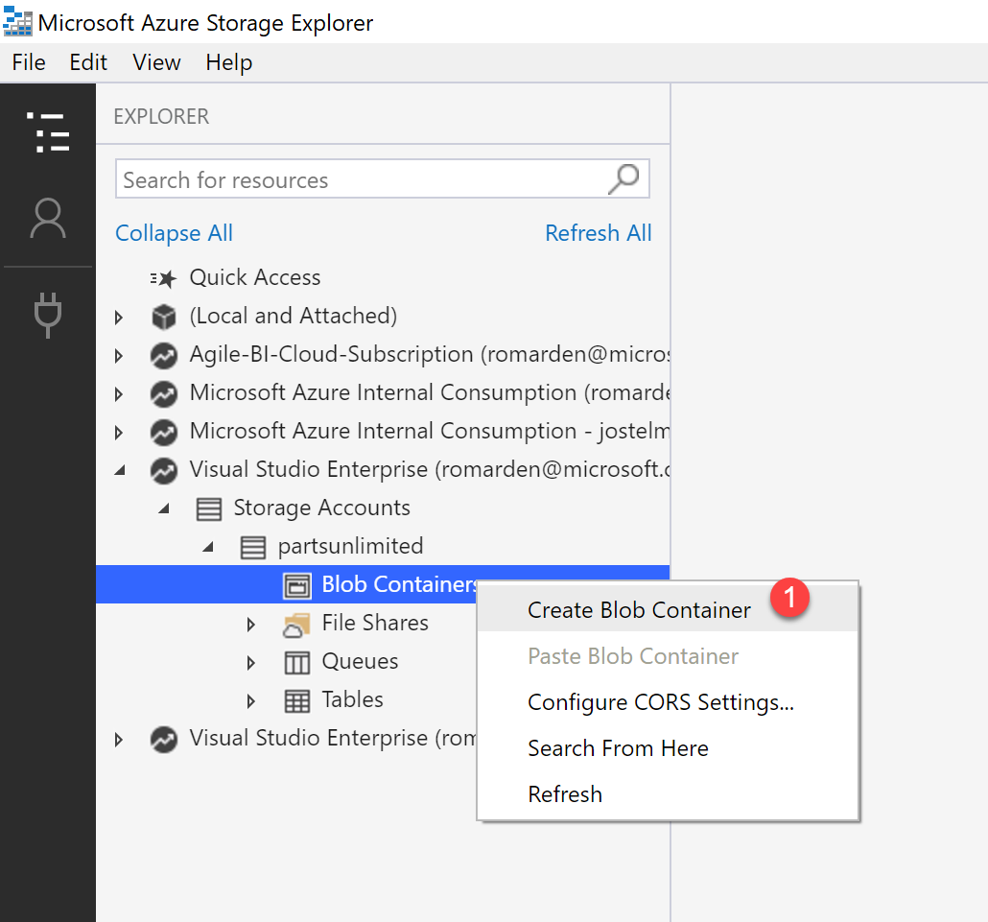

Change the "Public Access Level" for the "images" container:

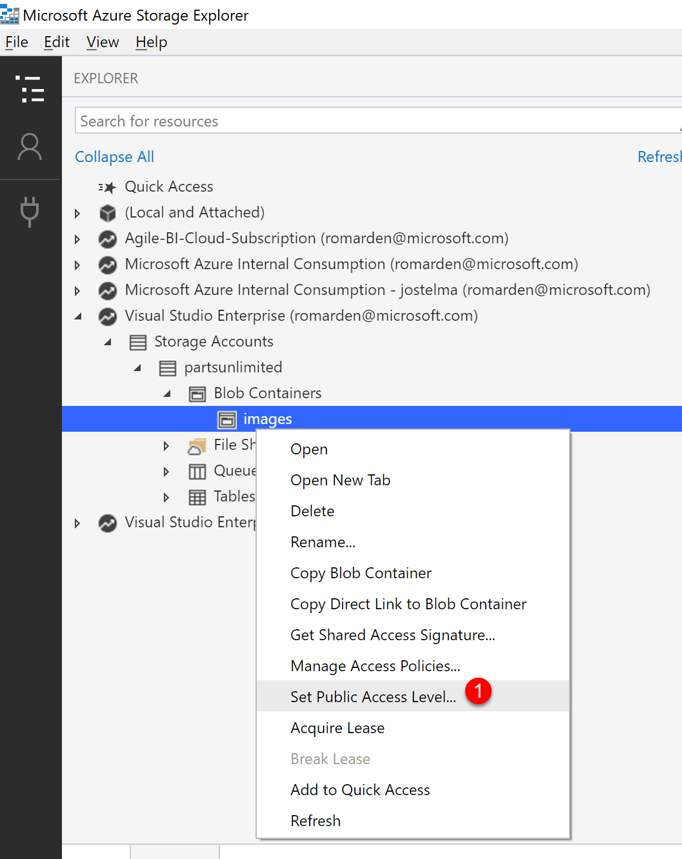

Set the permission to "Public read access for blobs only" to allow them to be accessible:

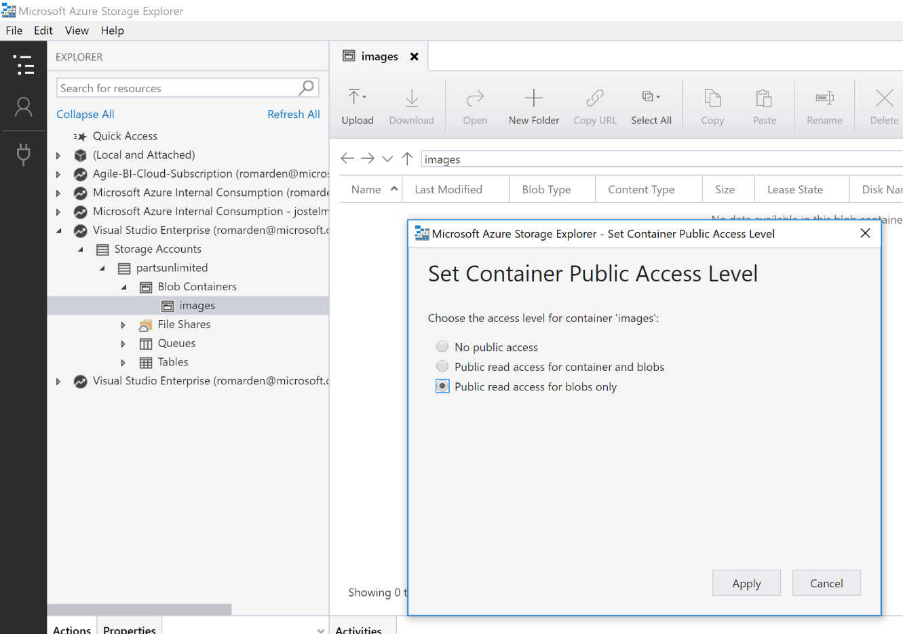

Then proceed to copy all the files in the "/images" folder inside of the PartsUnlimitedWebsite

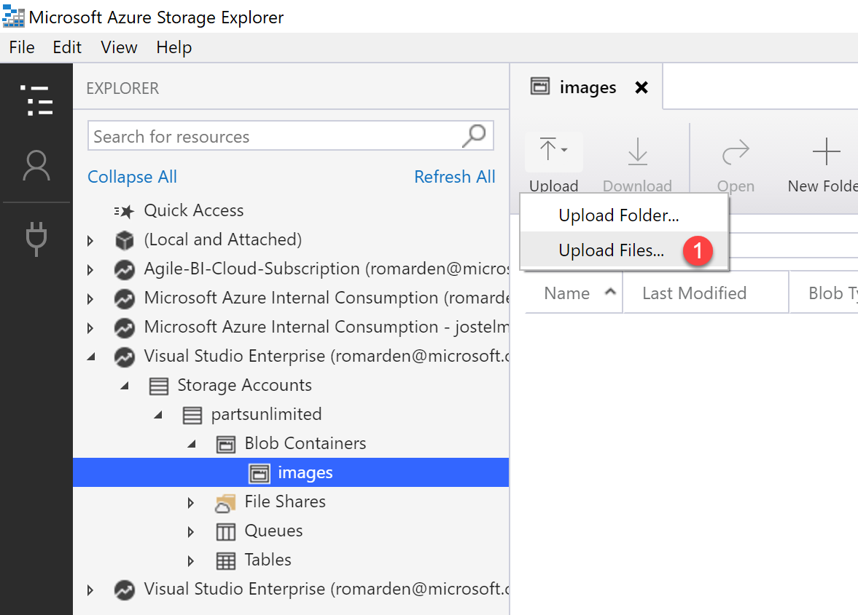

You can test now by requesting in a browser the URL of the endpoint + /images/ + any of the file names and the image should be displayed:

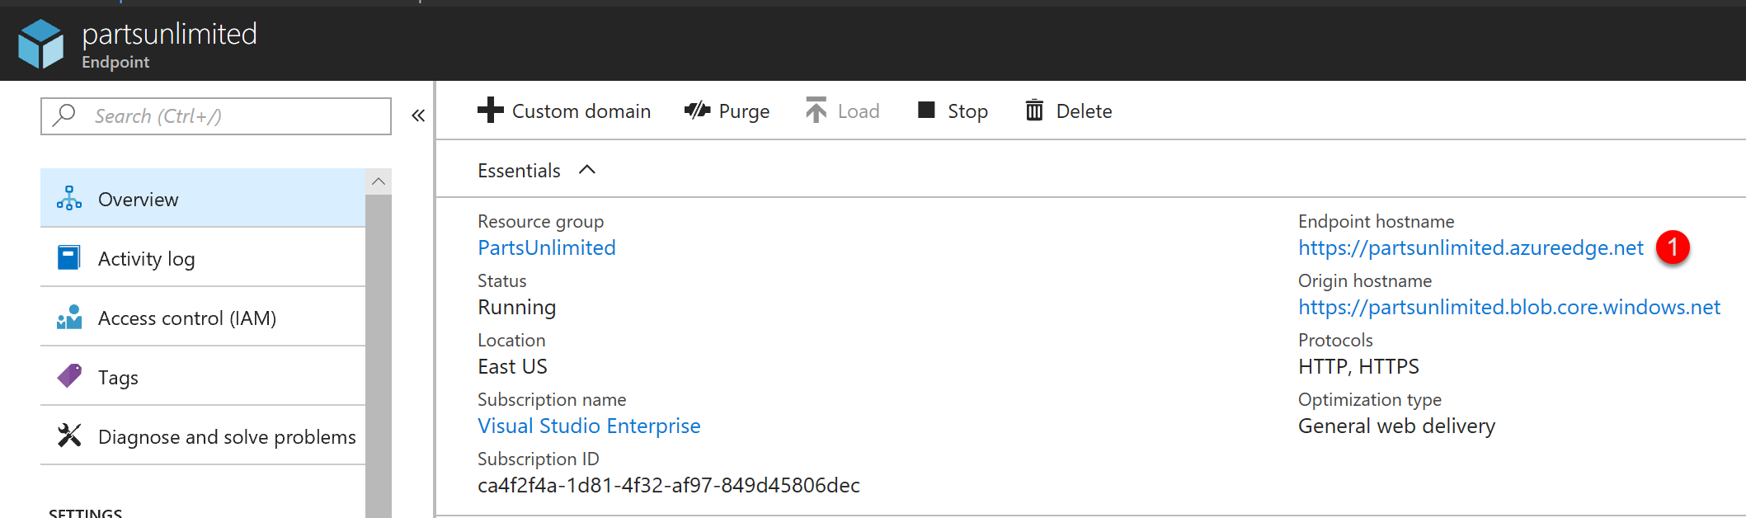

#### Task 5: Integrate into web application

We now need to add an Application Setting to use as source for the images, say we call it CDNUrl, add it to the web.config file with no value:

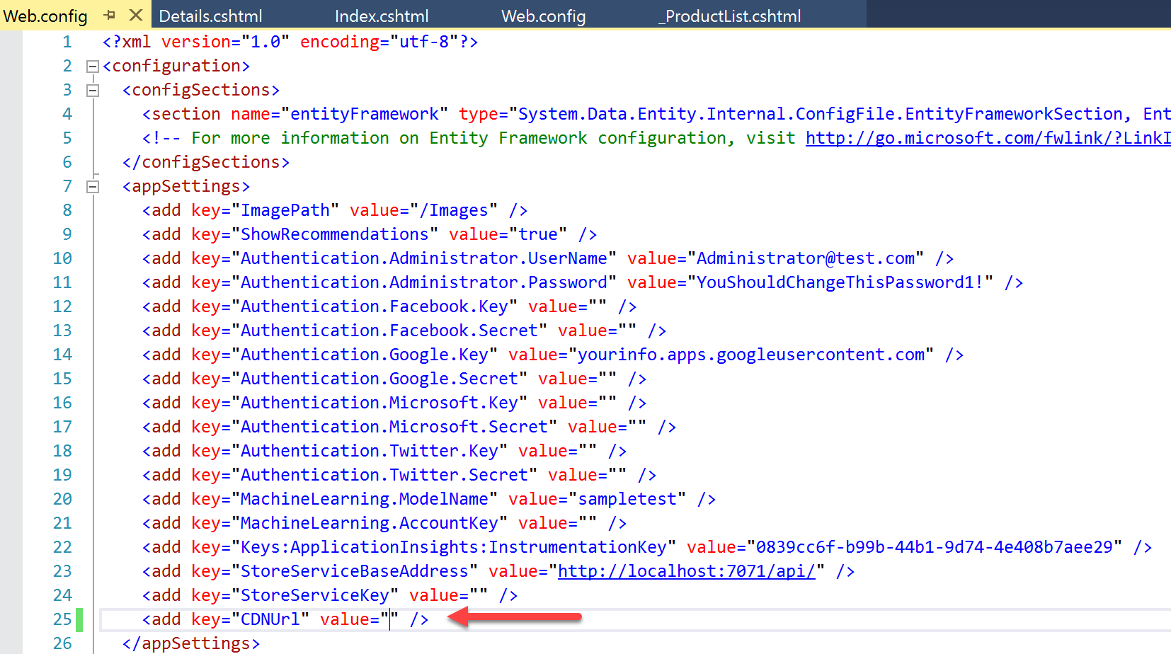

Adding it without value will ensure the changes we are introducing do not change the behavior of the application. Now to make it easier to use, we already have a **ConfigurationHelpers** class in the project, so we can add the **PartsUnlimited.Utils** namespace in the **Views/web.config** file to make it easier to use in our views. This will shorten using this class in all places where we need it.

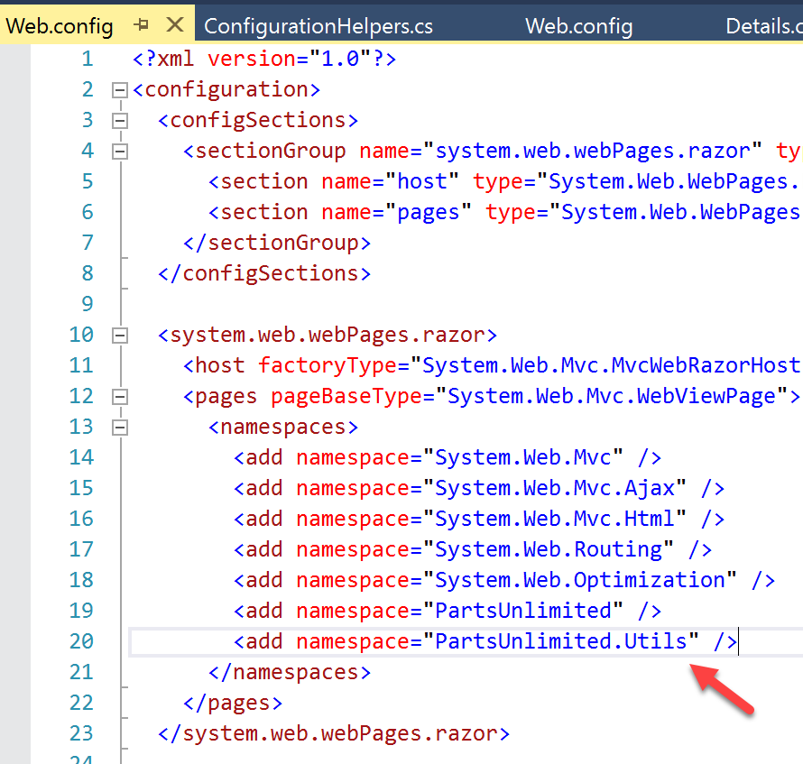

Now let's find the views that need to use the CDN for images, say we only concentrate on the product images, so find the pattern **images/@** in the **PartsUnlimitedWebsite** project:

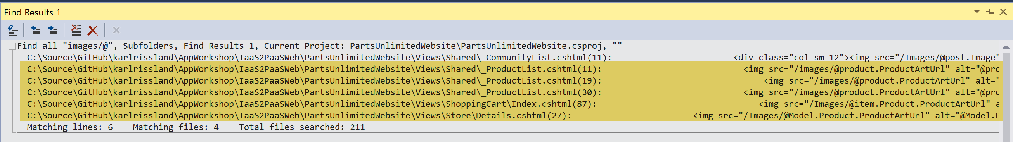

We can see in the results that 3 of the files are related to showing product images, we need to change those to use the **CDNUrl** setting, the quickest way would be to simply using the **ConfigurationHelpers.GetString** method, like the following screenshot shows in the **Views/Store/Details.cshtml** file:

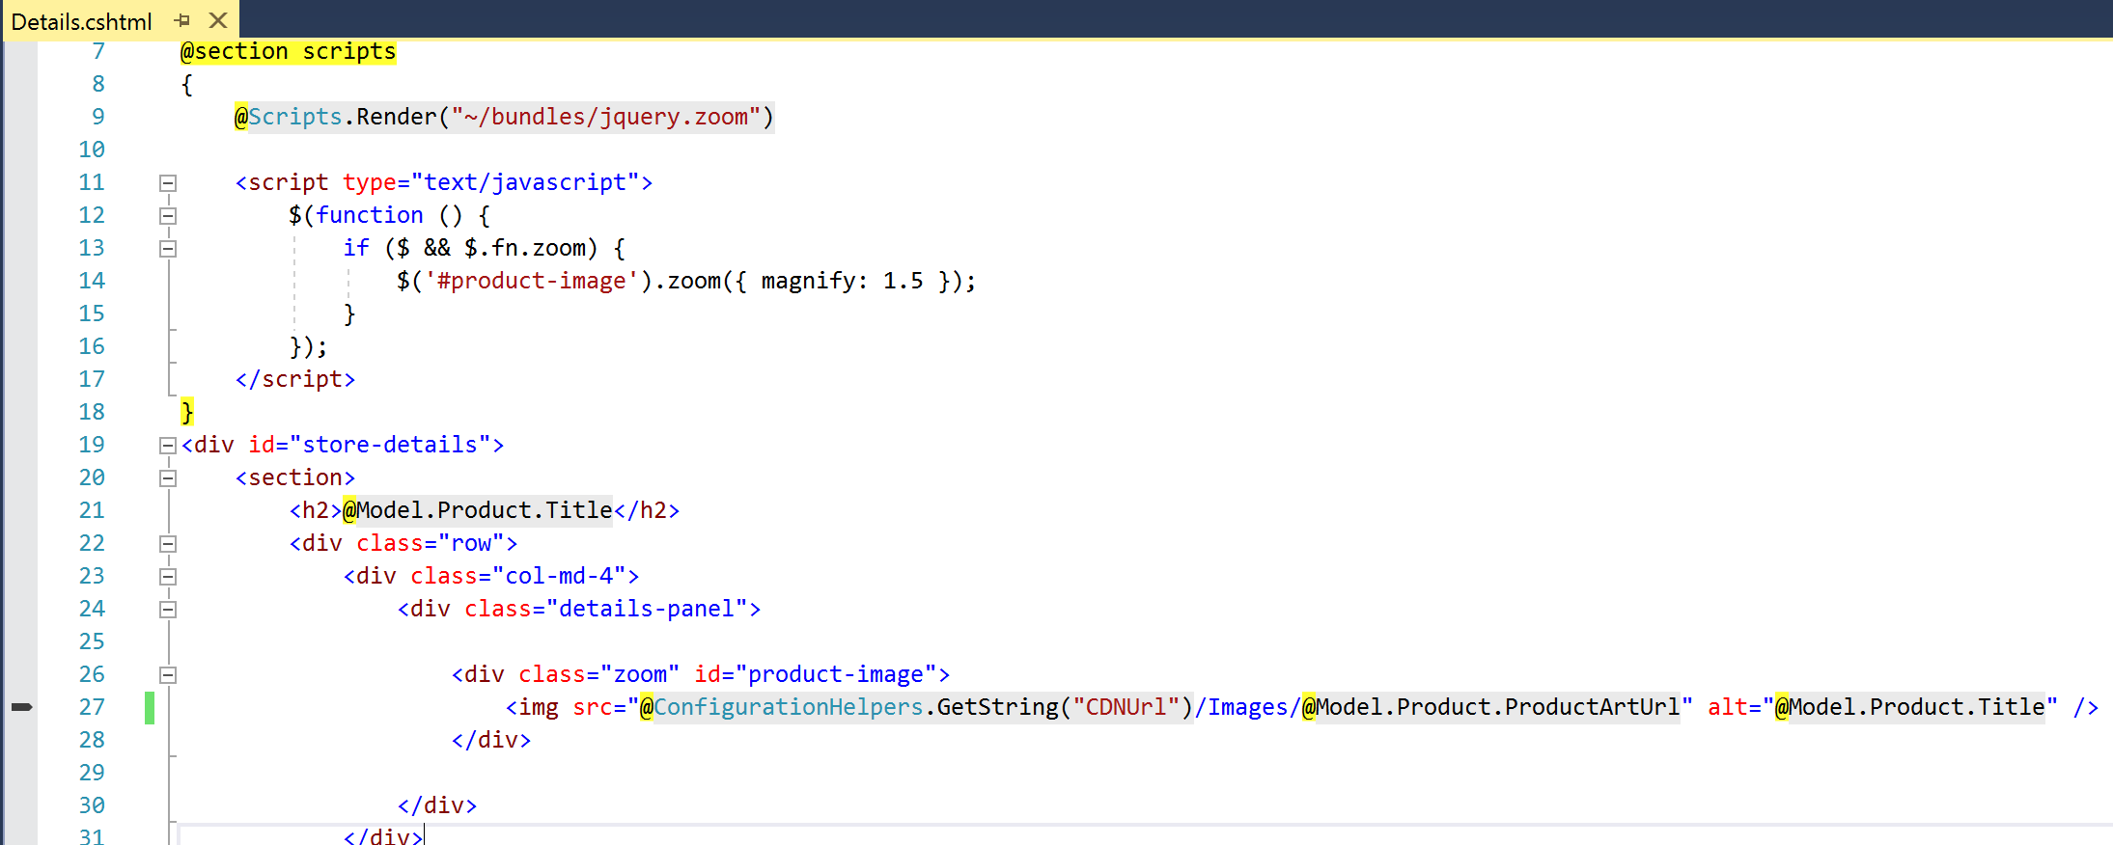

Add the @**ConfigurationHelpers.GetString("CDNUrl")** to all 3 files and test the application to make sure all images are still displayed correctly.

Now add the value of the **CDNUrl** application setting using the name of the endpoint from the Azure Portal:



Now test the application with the product images being served via CDN.

At this point the product images could be removed from the project or marked with build action to **None** and avoid them being included in the build artifacts.

The deployment of the images to the storage account could also be automated using:

**CLI**  
az storage blob upload-batch

**PowerShell**

Set-AzureStorageBlobContent

[https://docs.microsoft.com/en-us/powershell/module/azure.storage/Set-AzureStorageBlobContent?view=azurermps-5.3.0](mhtml:file://C:\Users\danshue\Desktop\Workshop\AppMigrationAndModernizationWorkshopPresenter.mht!https://docs.microsoft.com/en-us/powershell/module/azure.storage/Set-AzureStorageBlobContent?view=azurermps-5.3.0)

Add a comment to your change set and commit/sync your changes, which will start a CI/CD.

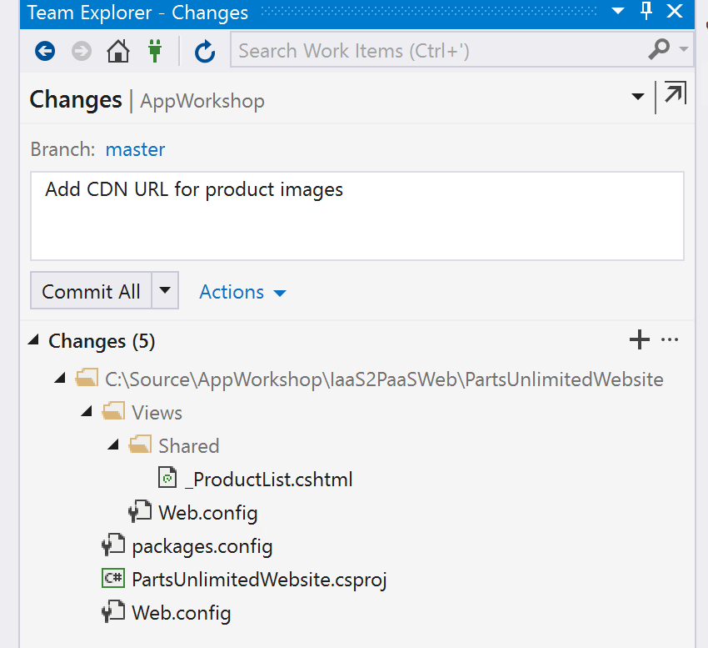

#### Task 6: Explore Enhancements

* Restrict access by country
* Compression
* Caching rules
* Purge

## Exercise 8: Increase Application / Database Performance with Redis Cache

Duration: 60 minutes

It has come to the businesses attention that customers are experiencing slow.

* Provision the Azure Redis service
* Improve session state by using Redis as Session State Provider
* Speed up output by using Redis as Output Cache Provider
* Reduce database usage by using Redis as Data Cache

#### Help references

|  |  |
| --- | --- |
| Redis Cache Quick Start | <https://docs.microsoft.com/en-us/azure/redis-cache/cache-dotnet-how-to-use-azure-redis-cache> |
| No Cache Anti Pattern | https://docs.microsoft.com/en-us/azure/architecture/antipatterns/no-caching/ |

#### Prerequisites

To complete this task, you should have provisioned the Parts Unlimited IaaS and PaaS environments and have a working CI/CD process. You will use the Developer Workstation deployed as part of the IaaS environment for your development work.

#### Task 1: Provisioning the Redis Cache Service

Create a new Redis Cache service to use with the Parts Unlimited Website. Click to create a new resource and search for **Redis Cache**, once found highlight and click on the **Create** button:

![Machine generated alternative text:
MSW 
Redis Cache - Microsoft 
Sales CRM 
https:// 
red Menultem Blade/selectedMenultem d81-4f32-af97-84gd4f 
Azure AppDevTSP O MyVSTS + CADD 
General 
Learning 
PUBLISHER 
Microsoft 
CloudHub Technologies 
Cognosys Inc. 
Cognosys Inc. 
Heimdall Data 
Heimdall Data 
Alachisoft 
Heimdall Data 
Alachisoft 
TODO 
Microsoft Azure 
Home > PartsUnIimitedRedis > Everything > Redis Cache 
Everything 
Redis cache 
Results 
Redis Cache 
Redis 3.0 on Ubuntu 
Redis on Ubuntu 16.04 L TS 
Redis4.O on Ubuntu 
Hardened Redis on CentCentOS 7.3 
Redis 3.2 on Ubuntu 
Hardened Redis on Ubuntu 14.04 LTS-Basic LIC 
Heimdall Data Premium Edition (Per Hour) 
Heimdall Data Enterprise Edition (Per Hour) 
NCache Community 4.8 Server 
Heimdall Data Developer Edition 
NCache Community 4.9 Server 
Related to your search v 
Website * SQL * Redis Cache 
Azure Cosmos DB 
(preview) 
n 
Blogs Office Locator - Conr 
Presentations 
Report a bug 
Redis Cache 
p Search resources, sewices, and docs 
CATEGORY 
Da tabases 
Compute 
Compute 
Compute 
Compute 
Compute 
Compute 
Compute 
Compute 
Compute 
Compute 
Compute 
Database as a service for MongoD3 
Microsoft Azure Redis Cache is based on the popular ppe!-' soprge Redis Cache. It gives users access 
to a secure, dedicated Redis Cache, managed by Microsoft. Users get the best of both worlds, the 
rich Redis feature set and ecosystem, and reliable hosting and monitoring from Microsoft. 
Microsoft Azure Redis Cache is available in the follcnving tiers: 
• Basic— Single node, multiple sizes, ideal for development/test and non-critical workloads. 
The basic tier has no SLA 
• Standard — A replicated cache in a two node Primary/Secondary configuration managed by 
Microsoft, with a high availability SLA. 
Premium - The new Premium tier includes all the Standard-tier features and more, such as 
better performance compared to Basic or Standard-tier Caches, bigger workloads, data 
persistence, and enhanced network security. 
Microsoft Azure Redis Cache helps your application stay responsive even as user load increases. It 
does so by leveraging the low latency, high-throughput capabilities of the Redis engine. This 
separate distributed cache layer allows your data tier to scale independently for more efficient use of 
compute resources in your application layer. 
102.28K 
128.35K 
liéo.63, ](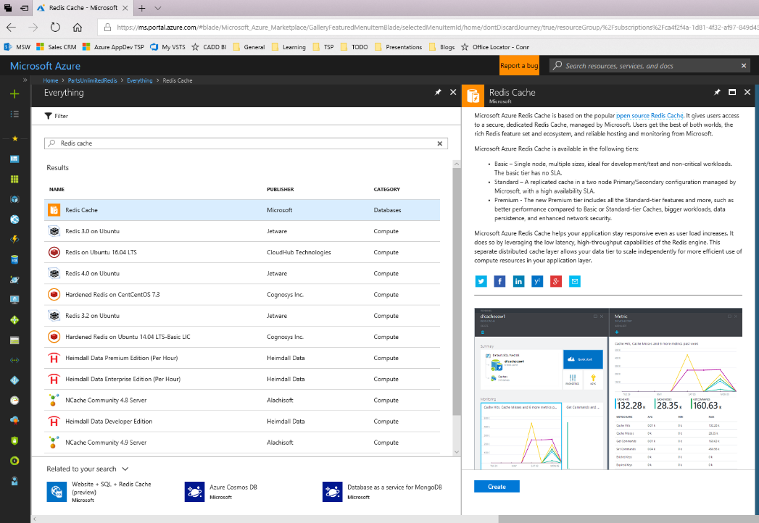)

Provide the values to create the service, provide name (use your web application name), resource group, and choose the same region where your web application is located. Select "Standard C0" for pricing tier and click **Create**.

**Note**: Notice the differences in the pricing tier, networking features, clustering capabilities, size, SLA, connectivity limits, etc.

![Machine generated alternative text:
Choose your pricing tie X -+- v 
MSW 
Sales CRM 
https:// 
ms.portal.azure.com/#createnvlicrosoft.cache 
Azure AppDevTSP O MyVSTS + CADD 
General 
Learning 
TODO 
Presentations 
n 
Blogs 
Office 
Microsoft Azure 
Home > PartsUnIimitedRedis > Everything > Redis Cache > New RedisCache > Choose your pricing tier 
New Redis Cache 
* DNS name 
partsunlimited 
S ubscription 
X 
Choose your pricing tier 
uailable 
Recommended I View all 
.redis.cache.windows.net 
PI 
6 
Premium 
Cache 
Replication 
Moderate network ba... 
All Standard features 
Data Persistence 
Virtual Network 
Redis Cluster 
99.9% 
412.92 
13 
Premium 
Cache 
Replication 
Moderate network ba... 
All Standard features 
Data Persistence 
Virtual Network 
Redis Cluster 
99.9% 
825.84 
P3 
26 
Visual Studio Enterprise - romarden 
Resource group O 
o 
Create new use existing 
PartsUnIimitedRedis 
East US 
Pricing tier (View full pricing details) 
Standard CI (I G8 Cache, Replication) 
(PREVIEW) Availability zone 
Requires Premium tier 
RES's Cluster O 
Requires Premium tier 
RES's oersistence O 
Requires Premium tier 
Requires Premium tier 
Unblock port 6379 (not SSL encrypted) 
Pin to dashboard 
Automation options 
Premium 
Cache 
Replication 
High network bandwi.„ 
All Standard features 
Data Persistence 
Virtual Network 
Redis Cluster 
99.9% 
1,650.94 
LISO/MONTH (ESTIMATED) PER SH_ . 
LISO/MONTH (ESTIMATED) PER SH_ . 
LISO/MONTH (ESTIMATED) PER SH_ . 
P4 
53 
Premium 
Cache 
Replication 
Highest network ban„. 
All Standard features 
Data Persistence 
Virtual Network 
Redis Cluster 
99.9% 
3,303.36 
LISO/MONTH (ESTIMATED) PER SH_ . 
C2 
2.5 
Standard 
Cache 
CO 
250 
6 
Standard 
MB Cache 
Replication 
Low network bandwi... 
Shared infrastructure 
Up to 256 connections 
Configure Redis (key„. 
99.9% 
40.92 
usD'MONTH (ESTIMATED) 
Standard 
Cache 
Cl 
13 
Standard 
Cache 
Replication 
Low network bandwi... 
Dedicated service 
Up to 1,000 connectio... 
Configure Redis (key„. 
99.9% 
102.67 
usD'MONTH (ESTIMATED) 
Standard 
Cache ](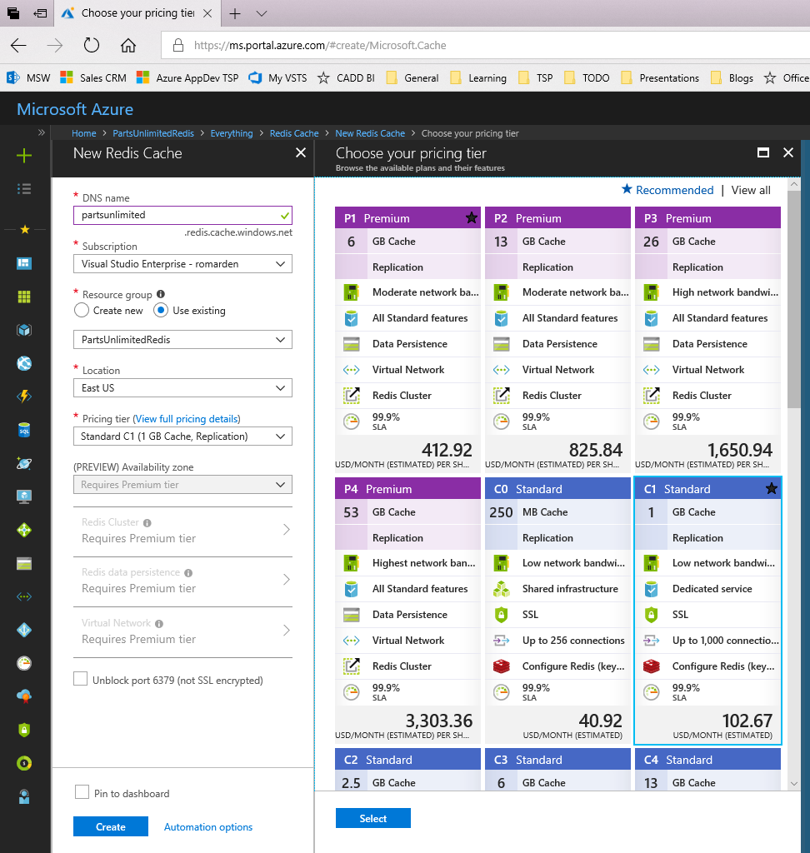)

Navigate to the resource and click on the **Access Keys** property to get the primary key which we will need later to establish connectivity to the Redis Cache:

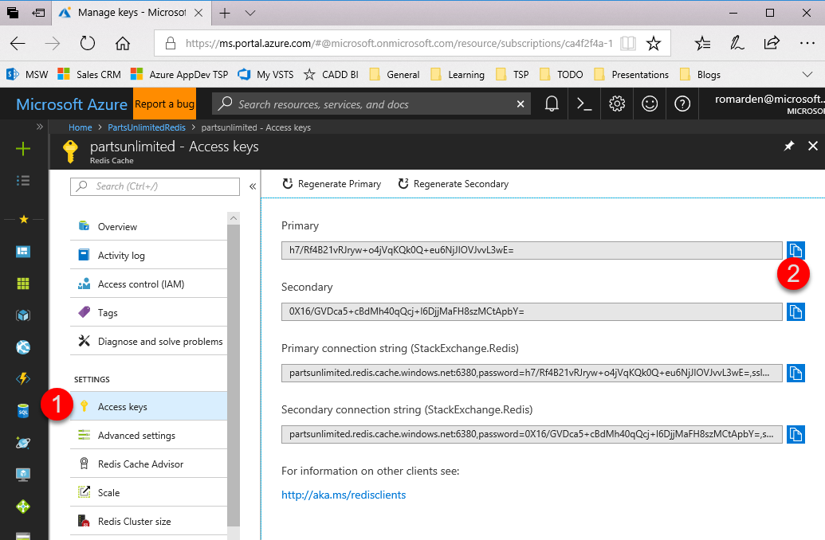

#### Task 2: Improve Session Performance

Remote into the vmdev01 using the User Name and Password used when creating the environment.



**Note**:

Default Admin: sysadmin

Default Password: Password$123





Note: Upgrade Framework to .NET 4.5.2

Install the NuGet package **Microsoft.Web.RedisSessionStateProvider** in the **PartsUnlimitedWebsite** project.

Modify the **Web.config** to add a new connection string replacing the [SERVER\_NAME] and [KEY] values.

|  |
| --- |
| <add name="RedisCacheConnectionString"  connectionString="[SERVER\_NAME].redis.cache.windows.net:6380,password=[KEY],ssl=True,abortConnect=False" /> |

Add the following section in the **Web.config** file, within the **system.web** element. If the sessionState node already exist, replace it with the following which uses that connection string:

|  |
| --- |
| <sessionState mode="Custom" customProvider="MySessionStateStore">  <providers>  <add type = "Microsoft.Web.Redis.RedisSessionStateProvider"  name = "MySessionStateStore"  connectionString = "RedisCacheConnectionString"/>  </providers>  </sessionState> |

**Note**: Use the connection string method to be able to be able to change the values at runtime without deploying your code.

After the changes, run locally to verify everything has been configured correctly by simply navigate to the Shopping Cart on the website, add a few items to the cart, then check the statistics on the Redis Cache:

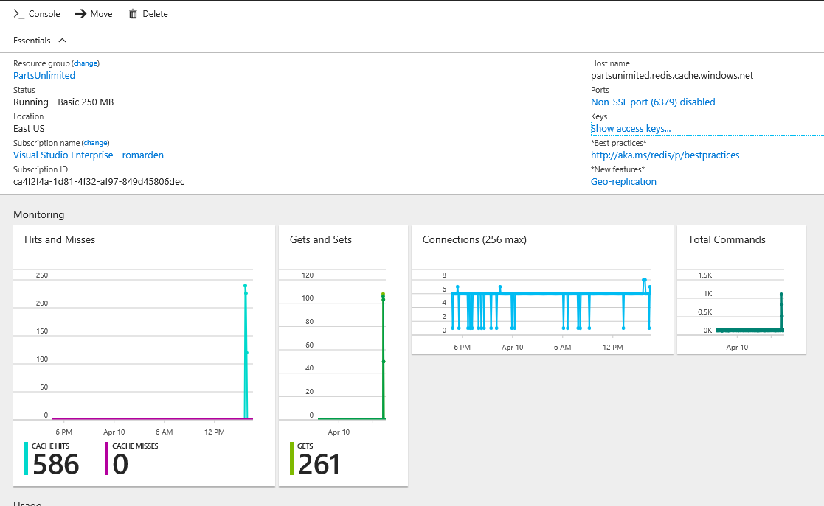

To prove this works, scale out to 2 instances, repeat adding some products to the cart. Scale down and keep doing the same actions on the site and everything should work without any data being lost.

#### Task 4: Speed Up Output and Reduce Memory Footprint

The next thing we want to do is reduce the memory footprint and speed up the output when customers browse the store front. While we have some performance gains by adding a CDN across the site, we also can make further improvements by making some minor changes to our code based specific to the store.

Install the NuGet package **Microsoft.Web.RedisOutputCacheProvider** in the **PartsUnlimitedWebsite** project.

Second, add the following section in the **Web.config** file, within the **system.web** element:

|  |
| --- |
| <caching>       <outputCache defaultProvider="MyStoreRedisOutputCache">         <providers>           <add name="MyRedisOutputCache" type="Microsoft.Web.Redis.RedisOutputCacheProvider" host="REDIS\_HOSTNAME" accessKey="PRIMARY\_KEY" ssl="true" />         </providers>       </outputCache>     </caching> |

Third, modify the **Controllers\StoreController.cs** file to add the following attributes in the Browse and Details functions:

|  |
| --- |
| [OutputCache(Duration = 30, VaryByParam = "\*")] public ActionResult Browse(int categoryId) …  [OutputCache(Duration = 30, VaryByParam = "id")] public ActionResult Details(int id) |

Notice the first one will cache the output taking into accounts all the parameters, the second one will do it only for the id parameter.

You can verify by adding a breakpoint inside the methods and visiting a product in the website, the first time you visit the page the code will hit the breakpoint, subsequent visits to the page will not.

#### Task 5: Reducing database utilization

This next section, we will demonstrate how to reduce the amount of database utilization by using Redis as a custom caching provider. This will require some custom code.

If not already installed, install the NuGet package **StackExchange.Redis.StrongName** in the **PartsUnlimitedWebsite** project.

Right-Click on the PartsUnlintedWebSite project name in Solution Explorer. Select **Manage NuGet Packages…** from the available options. From the NuGet Manager screen on the Browse tab, search for **StackExchange.Redis.StrongName** and **Install** the latest version.

Create a new C# file in the **Utils** folder called **RedisHelper.cs** and copy the contents below into that new file.

|  |
| --- |
| using Newtonsoft.Json;  using StackExchange.Redis;  using System;  using System.Collections.Generic;  using System.Configuration;  using System.IO;  using System.Runtime.Serialization.Formatters.Binary;  namespace PartsUnlimited.Utils  {  static class RedisHelper  {  private static JsonSerializerSettings serializerSettings;  static RedisHelper()  {  serializerSettings = new JsonSerializerSettings  {  ReferenceLoopHandling = ReferenceLoopHandling.Ignore  };  }  private static Lazy<ConnectionMultiplexer> lazyConnection = new Lazy<ConnectionMultiplexer>(() =>  {  string redisHost = ConfigurationManager.AppSettings["RedisCacheConnectionString"];  return ConnectionMultiplexer.Connect(redisHost);  });  public static ConnectionMultiplexer Connection  {  get  {  return lazyConnection.Value;  }  }  public static T Get<T>(string key)  {  var r = Connection.GetDatabase().StringGet(key);  return Deserialize<T>(r);  }  public static List<T> GetList<T>(string key)  {  return Get<List<T>>(key);  }  public static void SetList<T>(string key, List<T> list)  {  Set(key, list);  }  public static void Set(string key, object value)  {  Connection.GetDatabase().StringSet(key, Serialize(value));  }  static string Serialize(object o)  {  if (o == null)  {  return null;  }  return JsonConvert.SerializeObject(o, serializerSettings);  }  static T Deserialize<T>(string value)  {  if (value == null)  {  return default(T);  }  return JsonConvert.DeserializeObject<T>(value, serializerSettings);  }  }  } |

We now need to ensure our models can be serialized, which is required by Redis. Navigate to the Models folder and add **[Serializable]** attribute to the top of the **Product.cs** and **Category.cs**:

|  |
| --- |
| namespace PartsUnlimited.Models {     [Serializable]     public class Product     { |

Note: The system assembly also needs to be referenced, add “using System;” before the namespace.

|  |
| --- |
| using System;  namespace PartsUnlimited.Models {     [Serializable]     public class Category     { |

Modify the **HomeController.cs** to use Redis instead of the MemoryCache:

|  |
| --- |
| public ActionResult Index() {     // Get most popular products     var topSellingProducts = Utils.RedisHelper.GetList<Product>("topselling");     if (topSellingProducts == null)     {         topSellingProducts = GetTopSellingProducts(4);         Utils.RedisHelper.SetList("topselling", topSellingProducts);     }       var newProducts = Utils.RedisHelper.GetList<Product>("newarrivals");     if (newProducts == null)     {         newProducts = GetNewProducts(4);         Utils.RedisHelper.SetList("newarrivals", newProducts);     }       var viewModel = new HomeViewModel     {         NewProducts = newProducts,         TopSellingProducts = topSellingProducts,         CommunityPosts = GetCommunityPosts()     };       return View(viewModel); } |

Validate our changes by adding a breakpoint on the first line of the Index() function in the HomeController.cs and run the website locally. A call to the **GetTopSellingProducts** and **GetNewProducts** should be made only the first time the page loads.

If everything works as expected, then comment and commit/sync your code into VSTS.

## Exercise 9: Improve Quality & Performance of Search with Azure Search

Duration: 30 minutes

It has come to the businesses attention that customers are not able to find what they are looking for easily. After some investigation it was determined that the existing search capabilities were not adequate and needed to be updated. To improve the application’s search capability as quickly as possible, with as little code as possible, while ensuring the ability to support the sites growing traffic, Azure Search will be implemented.

* Go to the Azure Portal
* Look at the Parts Unlimited DB config
* Add Azure Search
* Create a branch
* Modify the application to use Azure Search
* Test Local
* Commit and push to release
* Test in production

#### Help references

|  |  |
| --- | --- |
| Azure Search | <https://docs.microsoft.com/en-us/azure/search/> |

#### Prerequisites

To complete this task, you should have provisioned the Parts Unlimited IaaS and PaaS environments and have a working CI/CD process. You will use the Developer Workstation deployed as part of the IaaS environment for your development work.

#### Task 1: Create Azure Search Service

Current search is based on SQL queries and prone to bad results. Doing a search like "jumper" or "leads" will return a product match like the following:

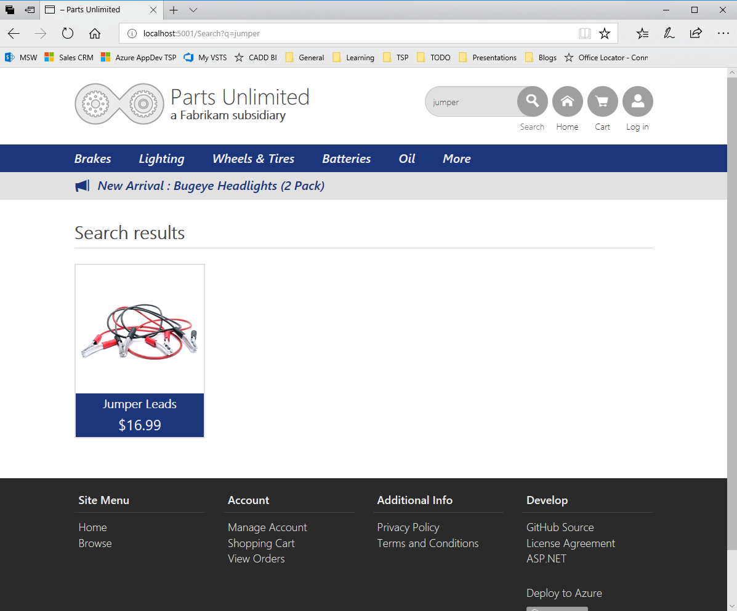

Clicking on the Product, we can see a lot more text that could be searched for:

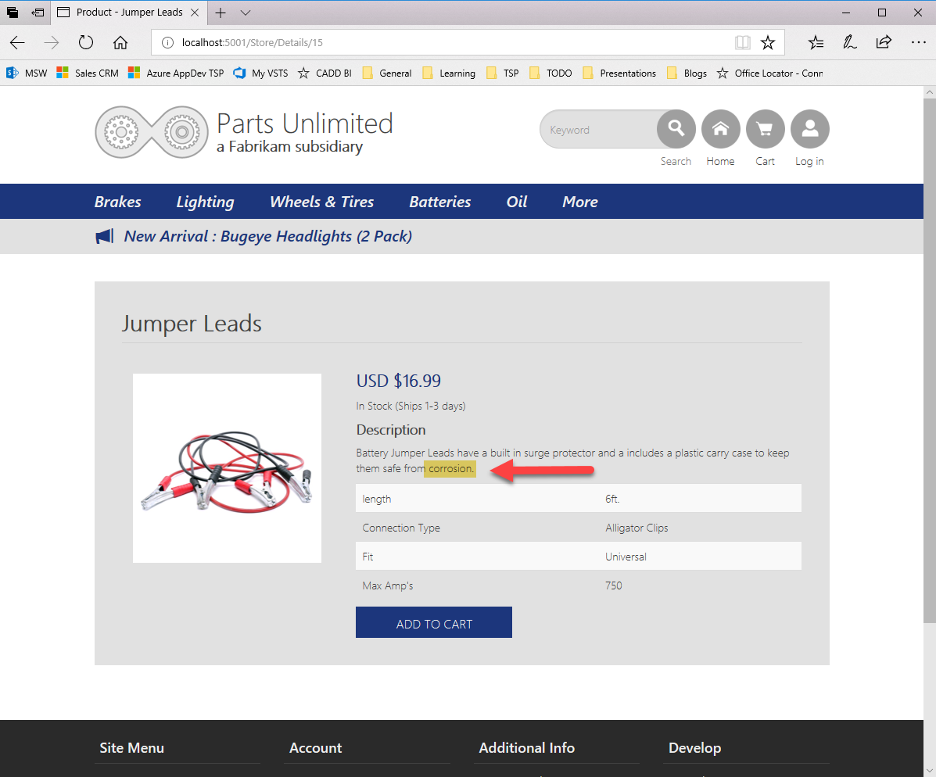

But doing a search on text within the Product's description or details, like "corrosion" would not return any matches:

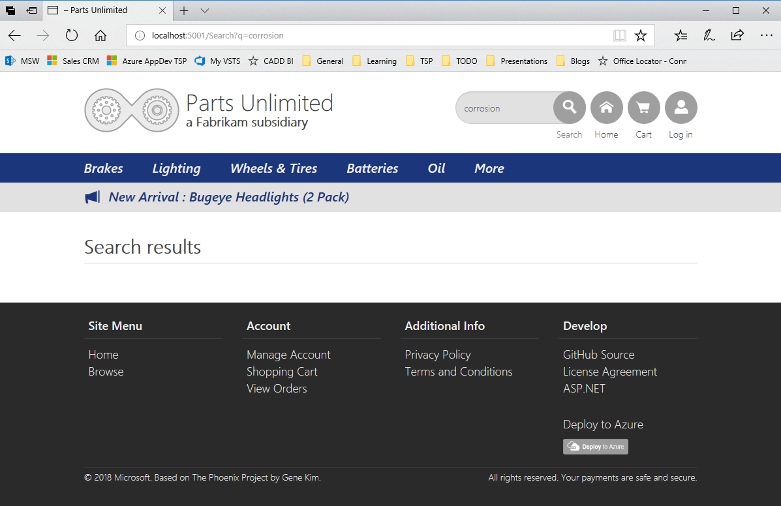

In the Azure Portal, create a new instance of **Azure Search**:

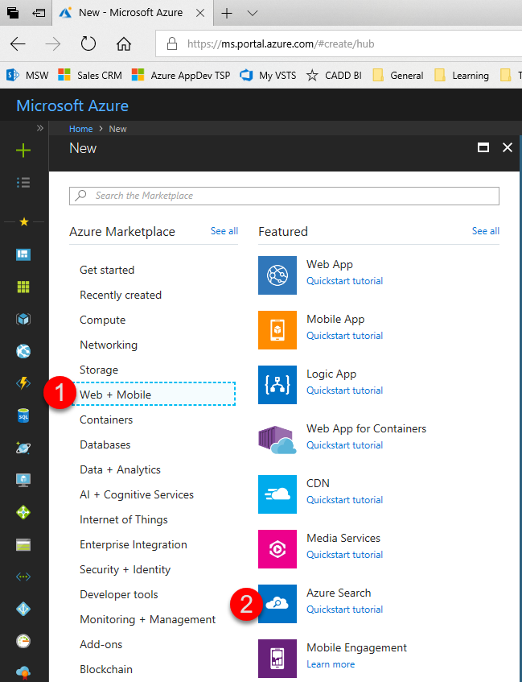

Enter the **name** and **resource group** for the service and click create:

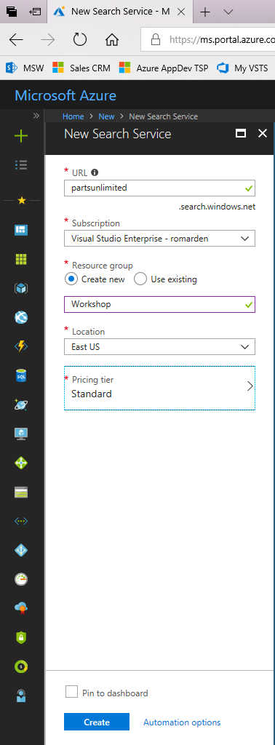

#### Task 2: Configure Azure Search

After the service is created, we must proceed to create an index and populate it with data. To start this process, we will take advantage of the existing database and use the **Import Data** wizard:

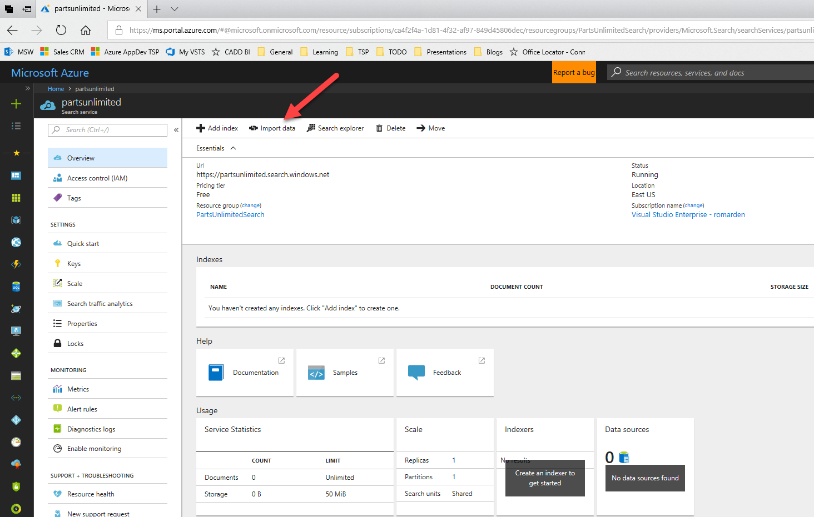

Provide the details for a data source, selecting the type of source, in our case **Azure SQL Database** and providing the connection string values and selecting the **Table/View** of **Products**: For the name, since this is a unique value, type in the host name associated with the application. After typing the name, select the partsUnlimitedDB for the database, UserId, and Password, click on **Test connection** in order to verify the credentials are correct.

**Note**: Use the same name for the database that you used when you created the environment. Note, you may also need to change the login to [username]@hostname.

Default DB Login Name: workshopServiceAcc

Default DB User Name: workshopServiceAcc

Default DB User Password: P2ssw0rd

Default Database Name: partsUnlimitedDB

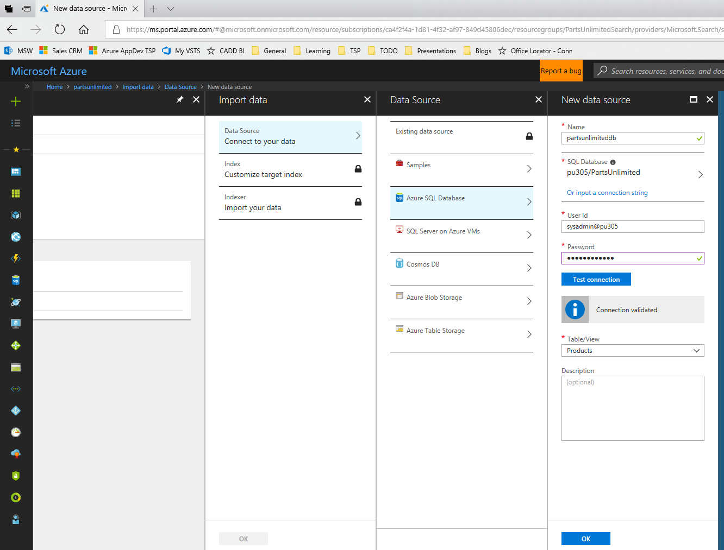

Configure the index, name it **products-index**, select all fields to be retrievable and select as *searchable* **Title**, **Description** and **ProductDetails**:

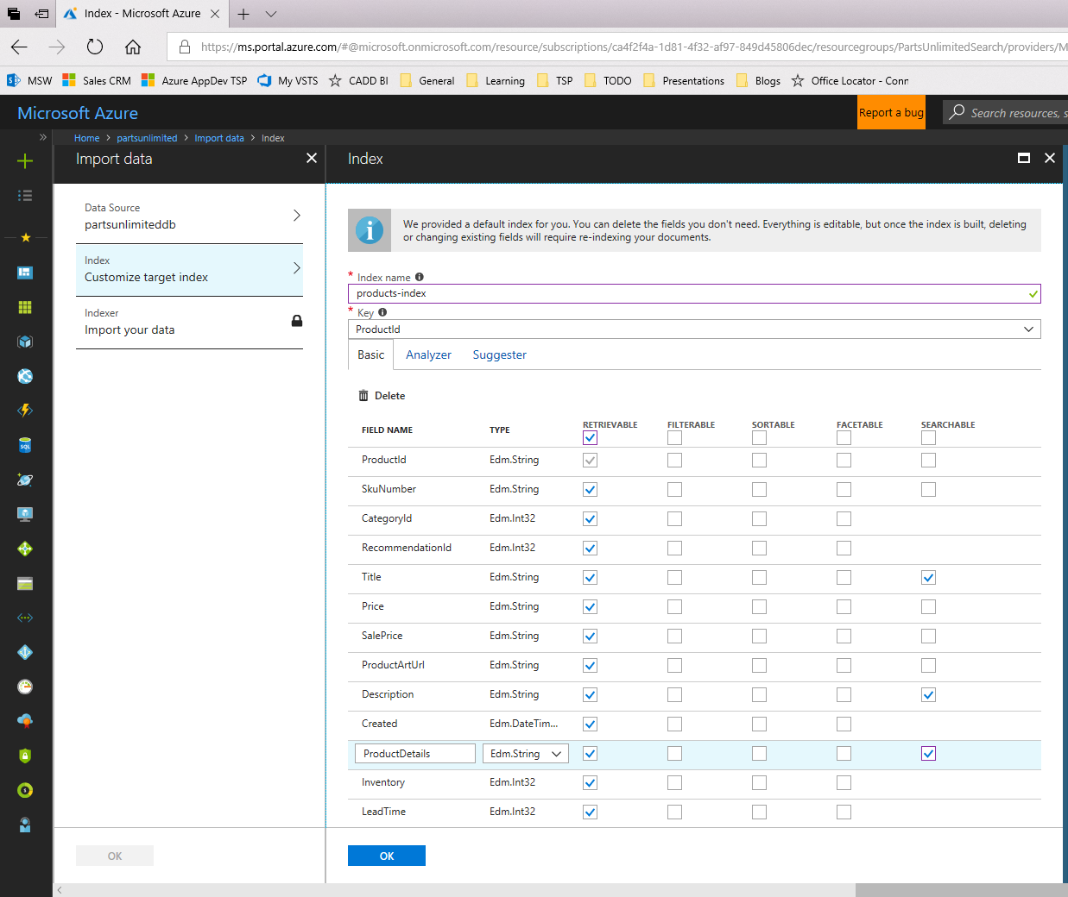

Define the indexer property to update the data in the index, in this case we will select **Once** and click **Ok**. To setup recurring indexer we would need a field to use to track changes, which we don't have now, but adding a field like **UpdatedDate** that is updated every time the product fields are updated would work.

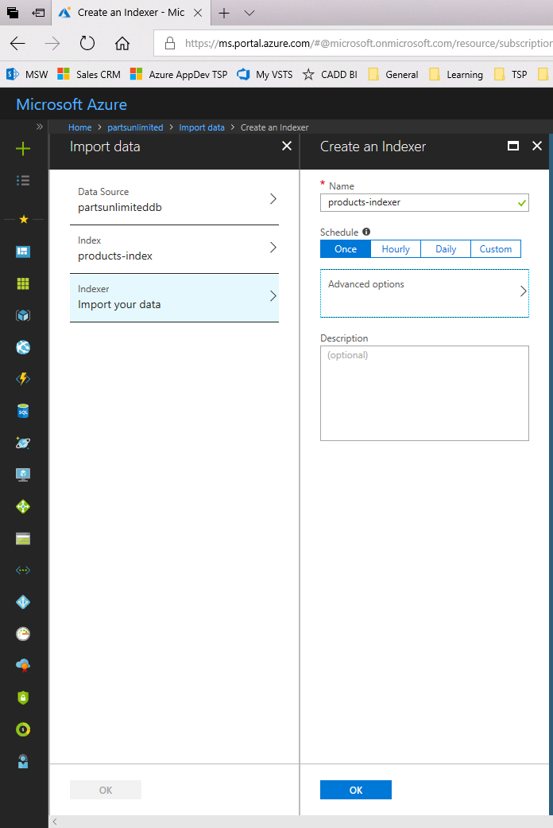

Clicking Ok on the Import Data blade after all details are provided would trigger the indexer to run and it should look like the screenshot below indicating all documents have been indexed.

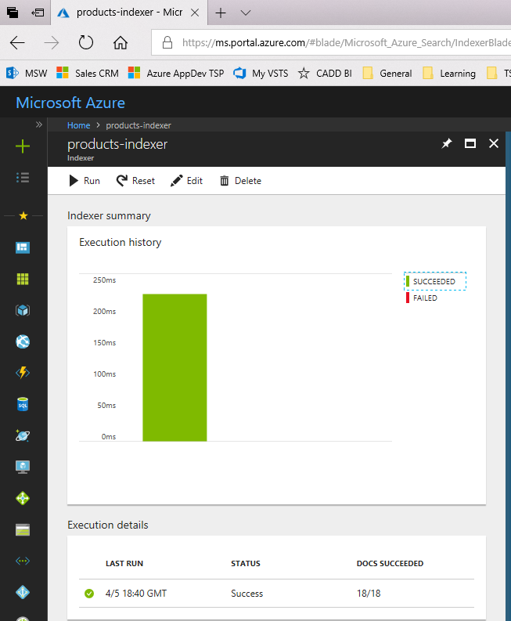

#### Task 3: Integrate search into application

 Remote into the vmdev01 using the User Name and Password used when creating the environment.

**Note**:

Default Admin: sysadmin

Default Password: Password$123



Upgrade the **PartsUnlimitedWebsite** project to target at least the **.Net Framework 4.5.2** to be able to use the Azure Search SDK. This is done via the properties page of the project.

You must add the NuGet package **Microsoft.Azure.Search** that will enable us to code against the Azure Search service. This can be done from the Package Manager Console with the following command:

*Install-Package Microsoft.Azure.Search*

Add some entries in the **Web.config** that will be used to setup the values for integrating with the Azure Search service. The value for the **SearchServiceQueryApiKey** is obtained from the **Azure Search Service/Keys/Manage Search Query** blade.

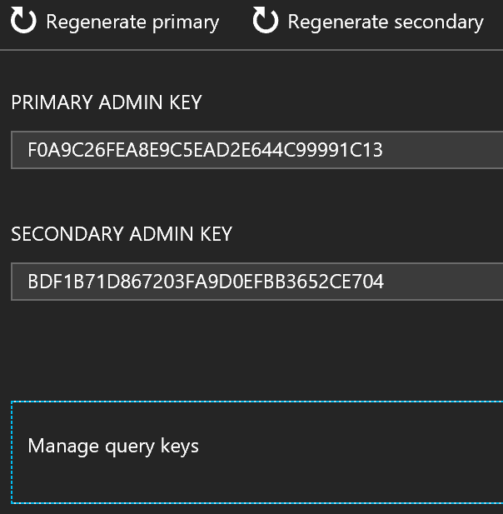

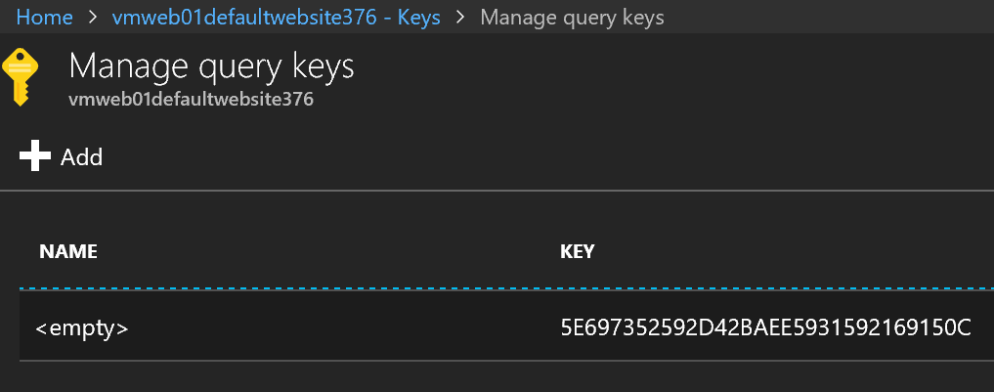

|  |
| --- |
| <add key="SearchServiceName" value="partsunlimited"/>  <add key="SearchServiceQueryApiKey" value="\*\*\*\*\*\*\*\*\*\*\*\*\*"/>  <add key="SearchServiceIndexName" value="products-index"/> |

Add a new class called **AzureIndexProductSearch** in the **ProductSearch** directory:

|  |
| --- |
| using System; using System.Collections.Generic; using System.Data.Entity; using System.Linq; using System.Threading.Tasks;  using Microsoft.Azure.Search; using Microsoft.Azure.Search.Models;  using PartsUnlimited.Models;   namespace PartsUnlimited.ProductSearch {     public class AzureIndexProductSearch : IProductSearch     {         public AzureIndexProductSearch() { }            public async Task<IEnumerable<Product>> Search(string query)         {  List<Product> products = new List<Product>();    try  {  DocumentSearchResult<Product> searchResults;    var parameters = new SearchParameters()  {  Select = new[] { "ProductId", "SkuNumber", "CategoryId", "Title", "Price", "SalePrice", "ProductArtUrl", "Description", "ProductDetails", "Inventory", "LeadTime" }  };    using (var searchClient = CreateSearchIndexClient())                 {                     searchResults = await searchClient.Documents.SearchAsync<Product>(query, parameters);                 }    foreach (var r in searchResults.Results)  {  products.Add(r.Document);  }    return products;  }  catch(Exception ex)  {  //eat it  }    return products;          }    private static SearchIndexClient CreateSearchIndexClient()  {  string searchServiceName = ConfigurationManager.AppSettings["SearchServiceName"];  string queryApiKey = ConfigurationManager.AppSettings["SearchServiceQueryApiKey"];  string indexName = ConfigurationManager.AppSettings["SearchServiceIndexName"];    return new SearchIndexClient(searchServiceName, indexName, new SearchCredentials(queryApiKey));  }    } } |

Replace the class used for the search in the **UnityConfig.cs** file in the **App\_Start** directory:

Replace:

|  |
| --- |
| container.RegisterType<IProductSearch, StringContainsProductSearch>(); |

with:

|  |
| --- |
| container.RegisterType<IProductSearch, AzureIndexProductSearch>(); |

#### Task 4: Verify Search Results

Running the application should allow us to perform the same search as before for "jumper" or "leads" and obtain the same results. However, it is possible now to obtain results by searching by the word "corrosion" and getting as expected the Product with that text in the Description:

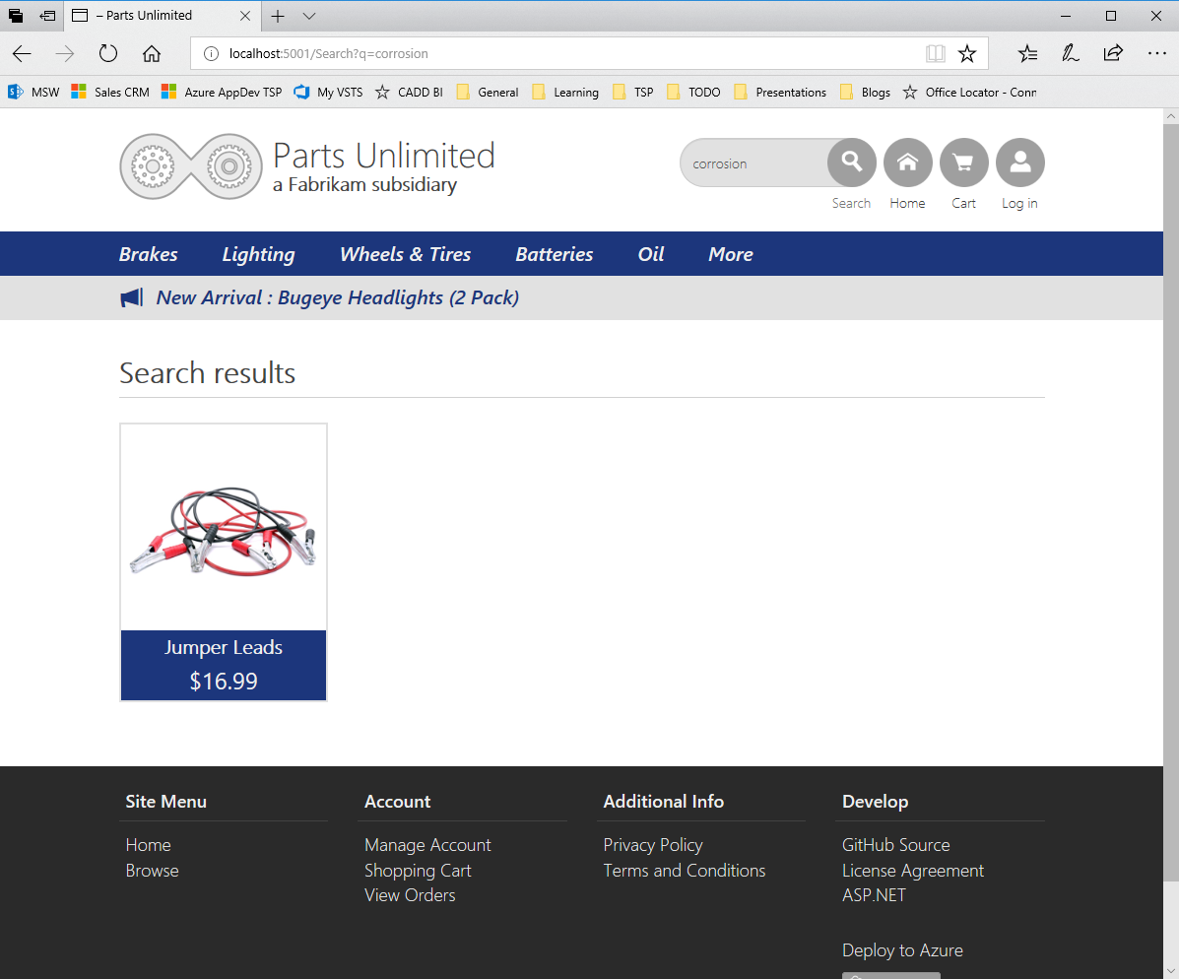

#### Task 5: Commit & Sync Code

When you’re all done verifying the search is working on your local machine, comment, commit, and sync your code. This will kick off the CI/CD. Once VSTS Release Management deploys the code, perform a spot check to verify the changes you’ve made to the search is showing up.

## Exercise 10: Accelerate development and take advantage of serverless using Azure Functions

Duration: 45 minutes

Parts Unlimited has been growing. The business wants to start building relationships with other retailers, so they can sell their product through multiple channels, not just Parts Unlimited.

To get started, the Parts Unlimited site needs to be improved architecturally so portions of its functionality can be reused when integrating with third parties. To accomplish this, the products model will be split into a reusable class. Functions will then be built using this class. Next, the Parts Unlimited website will be modified to use the Azure functions as opposed to accessing the database directly.

#### Help references

|  |  |
| --- | --- |
| Azure Functions | <https://docs.microsoft.com/en-us/azure/azure-functions/> |
| Creating a Function through the Azure Portal | <https://docs.microsoft.com/en-us/azure/azure-functions/functions-create-first-azure-function> |

#### Prerequisites

To complete this task, you should have provisioned the Parts Unlimited IaaS and PaaS environments and have a working CI/CD process. You will use the Developer Workstation deployed as part of the IaaS environment for your development work.

#### Task 1: Refactor

Add a new **PartsUnlimitedModels** Class Library (.Net Framework) project to the Visual Studio solution to move all models classes, make sure to select **.Net Framework 4.5.2**:

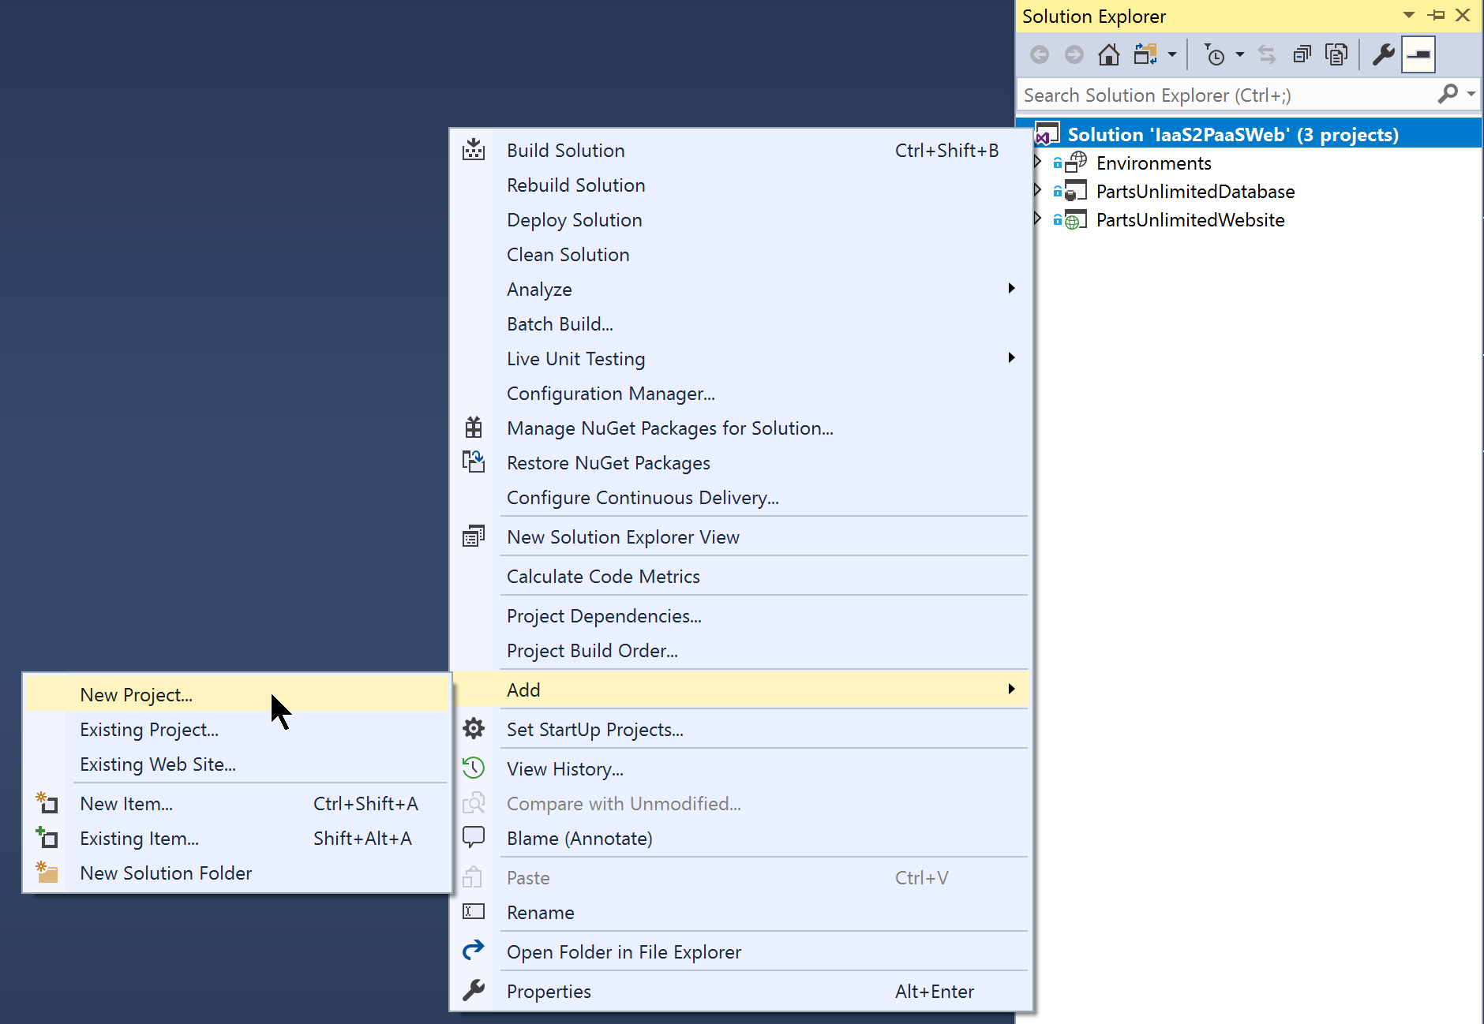

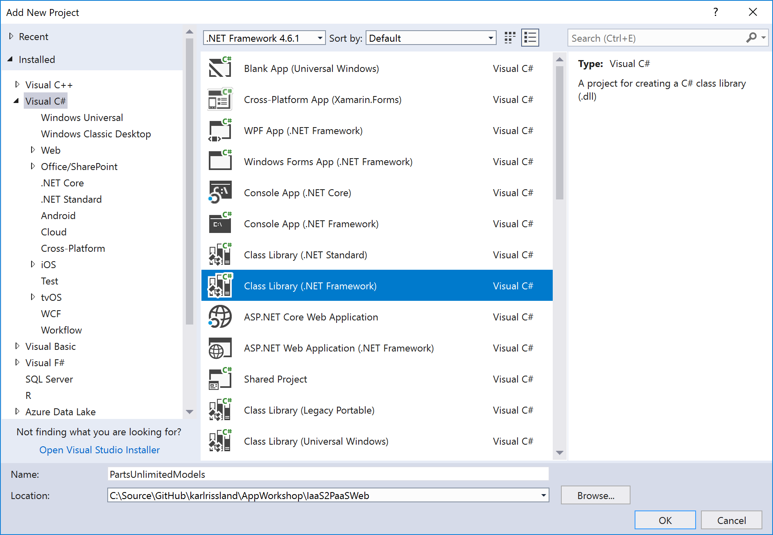

Add the following NuGet packages to the project (Managing NuGet packages in the solution is the fastest way to do this) using the Solution NuGet Package Management option to match the existing versions:

* EntityFramework
* Owin
* Microsoft.Owin
* Microsoft.AspNet.Identity.Owin
* Microsoft.AspNet.Identity.EntityFramework
* Microsoft.AspNet.Mvc

Add an assembly reference to **System.Web:**

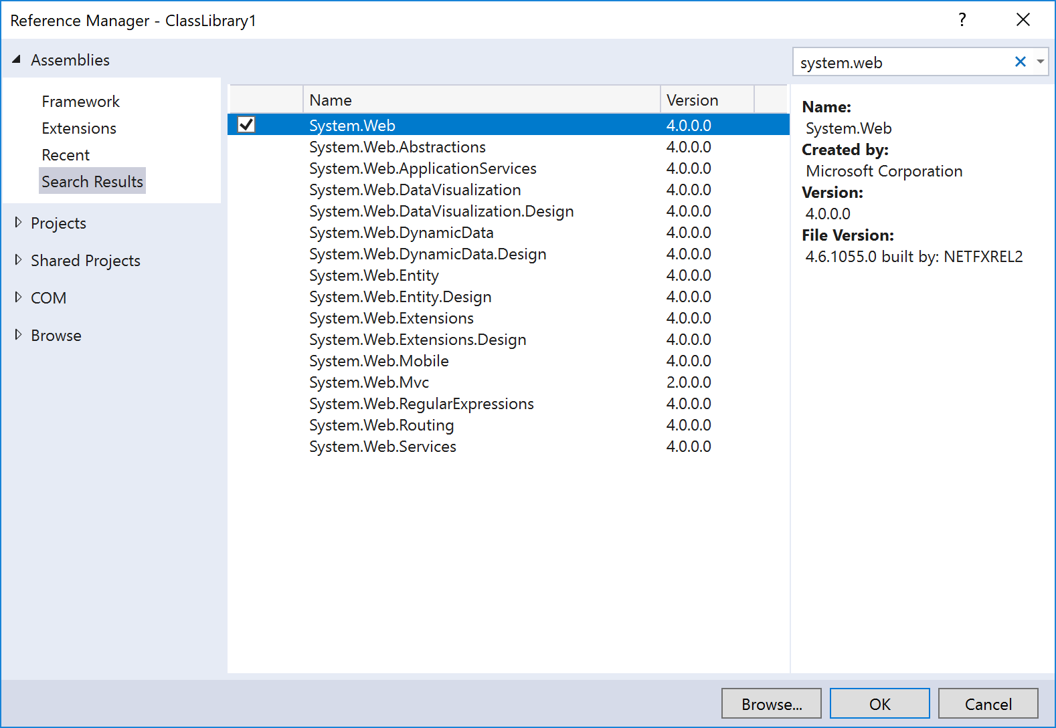

Move the **Models** directory and all files within it to the **PartsUnlimitedModels** project:

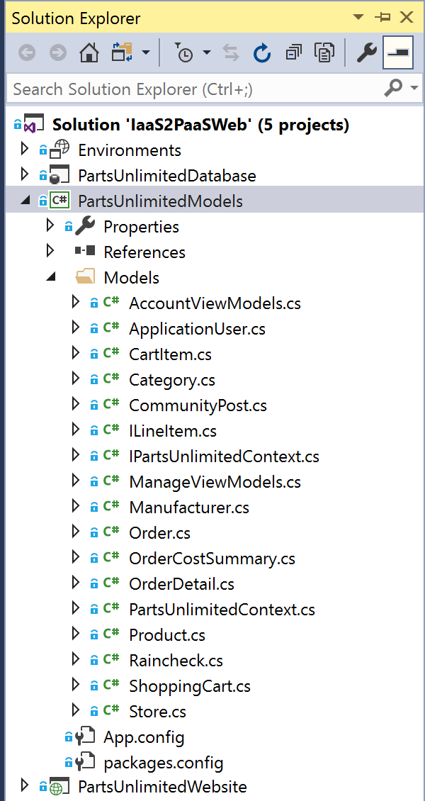

Add a project reference in **PartsUnlimitedWebsite** to **PartsUnlimitedModels** and make sure it still builds successfully:

|  |  |
| --- | --- |
| Machine generated alternative text: Solution Explorer  Search Solution Explorer (Ctrl+,•)  Solution 'laaS2PaaSWeb' (5 projects)  Environments  PartsUnlimitedDatabase  PartsUnlimitedModels  PartsUnlimitedWebsite  Add Reference...  Add Service Reference...  Add Connected Service  Add Analyzer...  Manage NuGet Packages...  Scope to This  New Solution Explorer View  Connected Services  o erties  References  pp_Data  pp Start  reas  In  ontent  ontrollers  onts  ubs  Images  Migrations | Machine generated alternative text: Reference Manager - PartsUnlimitedWebsite  x  Assemblies  projects  Solution  COM  Browse  [3  Name  Environments  PartsUnlimitedDatabase  PartsUnlimitedModels  Path  C:\Source\GitHub\karlr...  C:\Source\GitHub\karlr...  C:\Source\GitHub\karlr...  Search (Ctrl+E)  Name:  Environments |

Build and run the solution to ensure everything compiles and runs okay.

#### Task 2: Modernize

Add a new **Azure Functions** project to the solution called **PartsUnlimitedStoreService** using the **Cloud** templates:

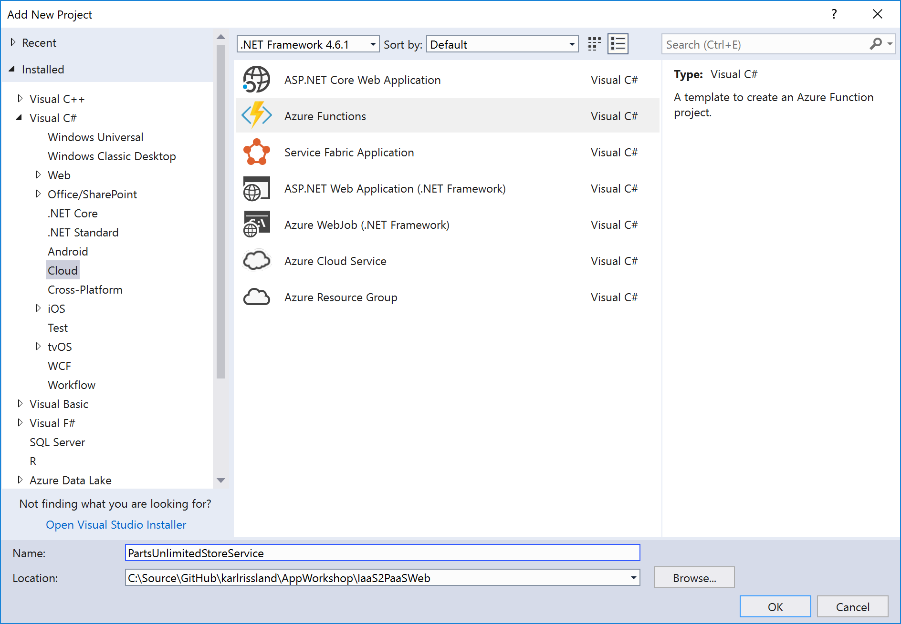

When creating a new Azure Functions project, make sure to change the framework to “Azure Functions v1 (.NET Framework), then click **OK** to continue.

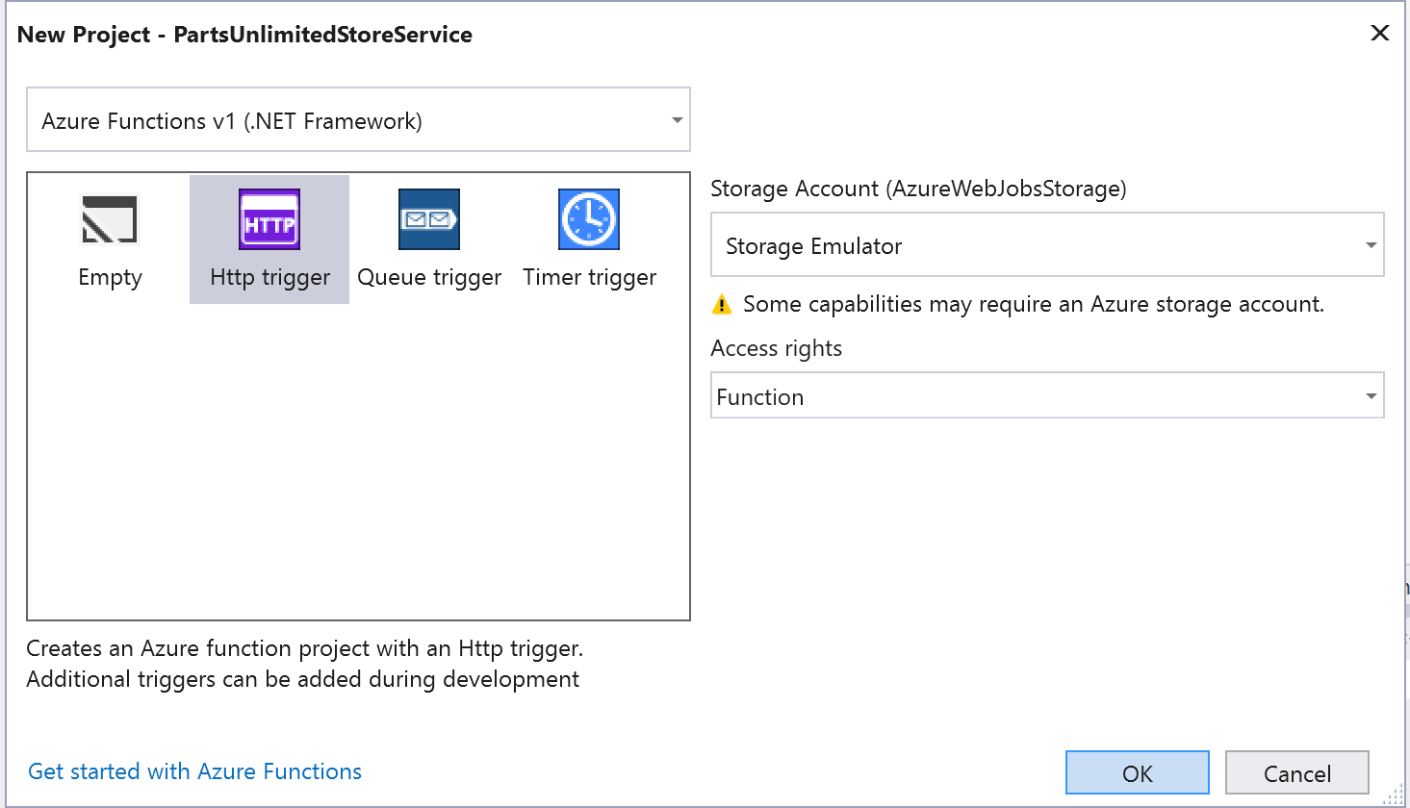

**Note**: Make search the **PartsUnlimitedModels** and **PartsUnlimitedStoreService** projects are both running the same .NET framework version

After the project is created, we’ll create three new Functions. The 3 functions in the Function App: **BrowseCategory**, **GetCategories** & **GetProductDetails** to provide the functionality currently available in the **StoreController** in the **PartsUnlimitedWebsite** project. They should be accessed via URLs in the form **"/api/categories"**, **"/api/categories/{id}"** & **"/api/products/{id}"** respectively.

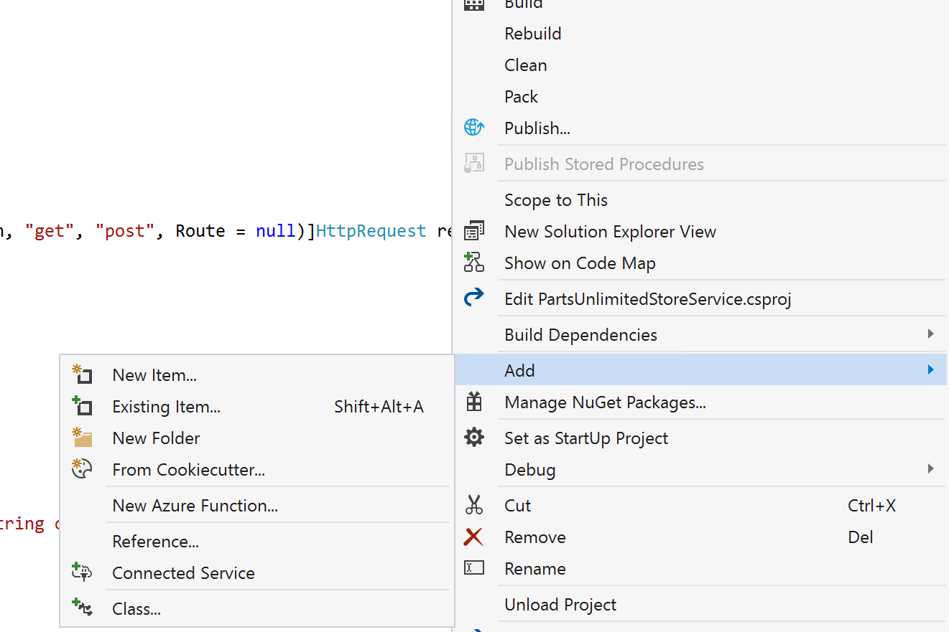

Right click on the new **PartsUnlimitedStoreService** project, choose **Add**, **New Azure Function**.

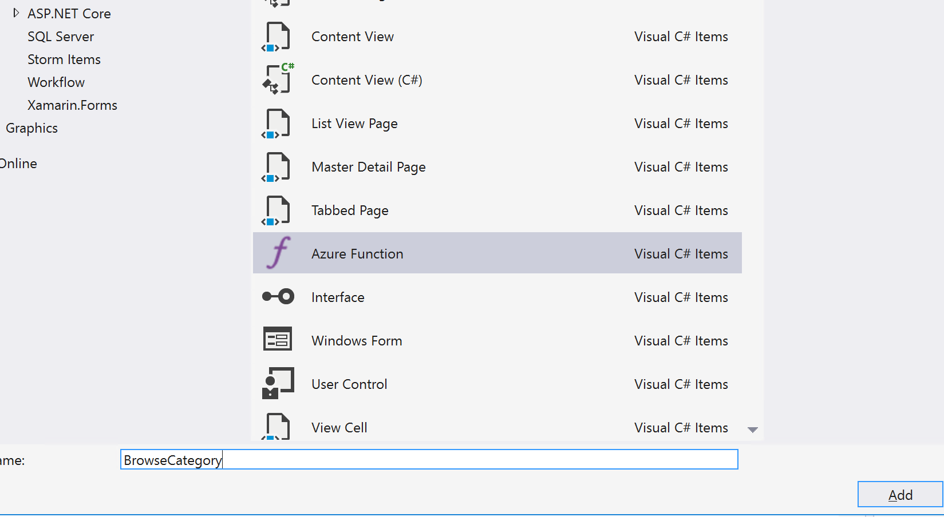

Select the **Http trigger** and the Access Rights as **Function**.

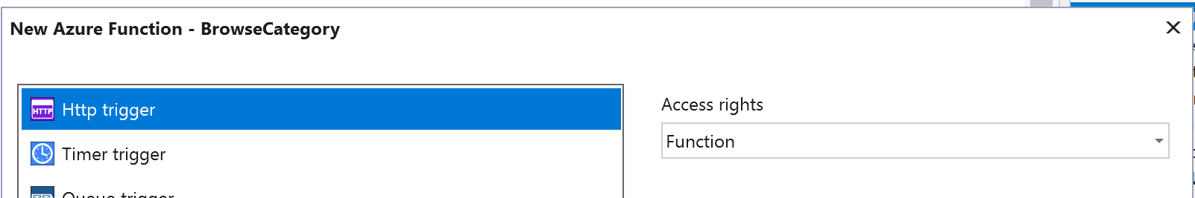

Next, make a reference to our **PartsUnlimitedModels** project:

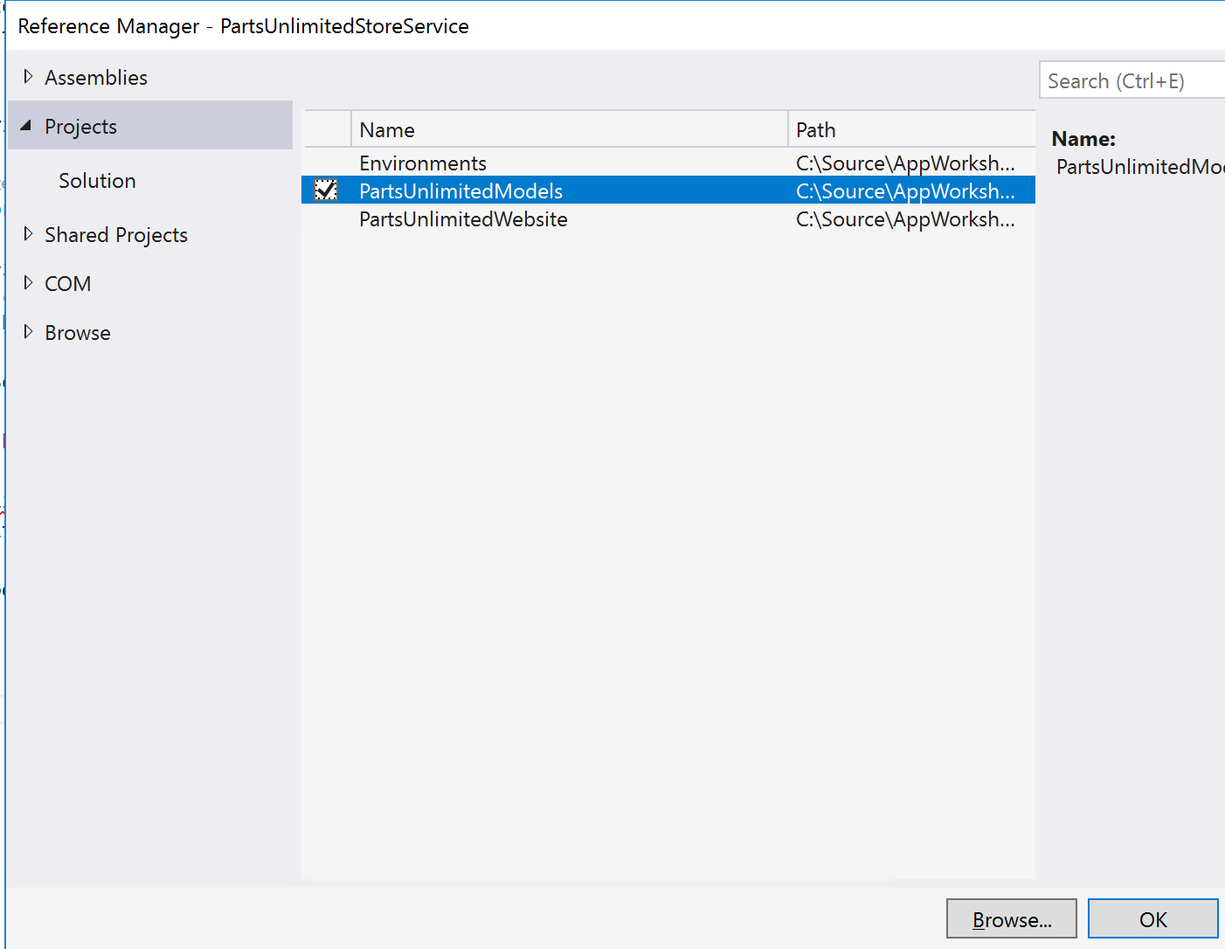

Add a reference to the same version of the **EntityFramework** that you’re using in the web project. In the Solution Explorer, right-click on dependencies and select **Manage NuGet Package.** Click the **Browse** tab and search for EntityFramework.

Notice that for this to work, we will need the connection string to the database available for the Function App to work, which locally can be set in the **local.settings.json** file:

|  |
| --- |
| {   "IsEncrypted": false,   "Values": {     "AzureWebJobsStorage": "UseDevelopmentStorage=true",     "AzureWebJobsDashboard": "UseDevelopmentStorage=true"   },   "ConnectionStrings": {     "DefaultConnectionString": "Server=(localdb)\\mssqllocaldb;Database=PartsUnlimitedWebsite;Integrated Security=True;"   } } |

Create a new class called **GlobalConfiguration.cs** and replace its contents with the snippet below:

###### GlobalConfiguration.cs

|  |
| --- |
| using System.Net.Http; using System.Web.Http;   namespace PartsUnlimitedStoreService {     internal static class GlobalConfiguration     {         internal static void SetConfiguration(HttpRequestMessage req)         {             HttpConfiguration config = req.GetConfiguration();  ((Newtonsoft.Json.Serialization.DefaultContractResolver)config.Formatters.JsonFormatter.SerializerSettings.ContractResolver).IgnoreSerializableAttribute = true;              config.Formatters.JsonFormatter.SerializerSettings.ReferenceLoopHandling = Newtonsoft.Json.ReferenceLoopHandling.Ignore;         }     } } |

Replaces the contents of the GetCategories.cs from below.

Create a new class called **GetCategories.cs** and replace its contents with the snippet below:

###### GetCategories.cs

|  |
| --- |
| using System.Data.Entity; using System.Net; using System.Net.Http; using System.Threading.Tasks; using Microsoft.Azure.WebJobs; using Microsoft.Azure.WebJobs.Extensions.Http; using Microsoft.Azure.WebJobs.Host; using PartsUnlimited.Models;   namespace PartsUnlimitedStoreService {     public static class GetCategories     {         [FunctionName("GetCategories")]         public static async Task<HttpResponseMessage> Run([HttpTrigger(AuthorizationLevel.Anonymous, "get", Route = "categories")]HttpRequestMessage req, TraceWriter log)         {             GlobalConfiguration.SetConfiguration(req);               log.Info("Retrieving Product Categories");               var db = new PartsUnlimitedContext();             var categories = await db.Categories.ToListAsync();               return req.CreateResponse(HttpStatusCode.OK, categories);         }     } } |

Create a new class called **BrowseCategory.cs** and replace its contents with the snippet below:

###### BrowseCategory.cs

|  |
| --- |
| using System.Data.Entity; using System.Net; using System.Net.Http; using System.Threading.Tasks; using Microsoft.Azure.WebJobs; using Microsoft.Azure.WebJobs.Extensions.Http; using Microsoft.Azure.WebJobs.Host; using PartsUnlimited.Models;   namespace PartsUnlimitedStoreService {     public static class BrowseCategory     {         [FunctionName("BrowseCategory")]         public static async Task<HttpResponseMessage> Run([HttpTrigger(AuthorizationLevel.Anonymous, "get", Route = "categories/{id:int}")]HttpRequestMessage req, int? id, TraceWriter log)         {             GlobalConfiguration.SetConfiguration(req);               log.Info($"Get Product Category {id}");               if (!id.HasValue)                 return req.CreateResponse(HttpStatusCode.BadRequest, "Please pass a valid category ID");               var db = new PartsUnlimitedContext();             var genreModel = await db.Categories.Include("Products").SingleAsync(g => g.CategoryId == id.Value);               return req.CreateResponse(HttpStatusCode.OK, genreModel);         }     } } |

Create a new class called **GetProductDetails.cs** and replace its contents with the snippet below:

###### GetProductDetails.cs

|  |
| --- |
| using System.Data.Entity; using System.Net; using System.Net.Http; using System.Threading.Tasks; using Microsoft.Azure.WebJobs; using Microsoft.Azure.WebJobs.Extensions.Http; using Microsoft.Azure.WebJobs.Host; using PartsUnlimited.Models;   namespace PartsUnlimitedStoreService {     public static class GetProductDetails     {         [FunctionName("GetProductDetails")]         public static async Task<HttpResponseMessage> Run([HttpTrigger(AuthorizationLevel.Anonymous, "get", Route = "product/{id:int}")]HttpRequestMessage req, int? id, TraceWriter log)         {             GlobalConfiguration.SetConfiguration(req);               log.Info($"GetProductDetails {id}");               if (!id.HasValue)                 return req.CreateResponse(HttpStatusCode.BadRequest, "Please pass a valid product id");               var db = new PartsUnlimitedContext();             var product = await db.Products.SingleAsync(a => a.ProductId == id.Value);               return req.CreateResponse(HttpStatusCode.OK, product);         }     } } |

The function can now be tested locally using an Http Client like Postman or any other of your choice. To test, right-click on **PartsUnlimitedStoreService** as click on **Set as Startup Project**.

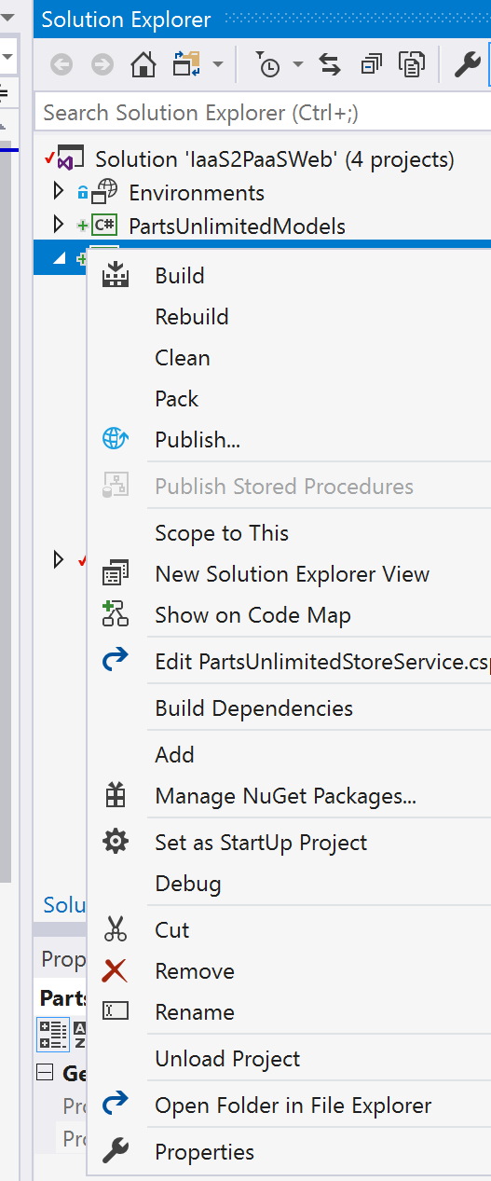

If prompted to install the Azure Function CLI tools, click **Yes**.

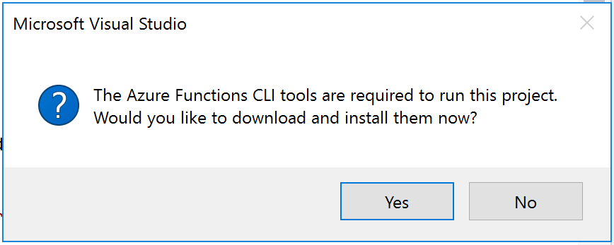

After a moment, you’ll see a command window appear running func.exe. Note the URLs

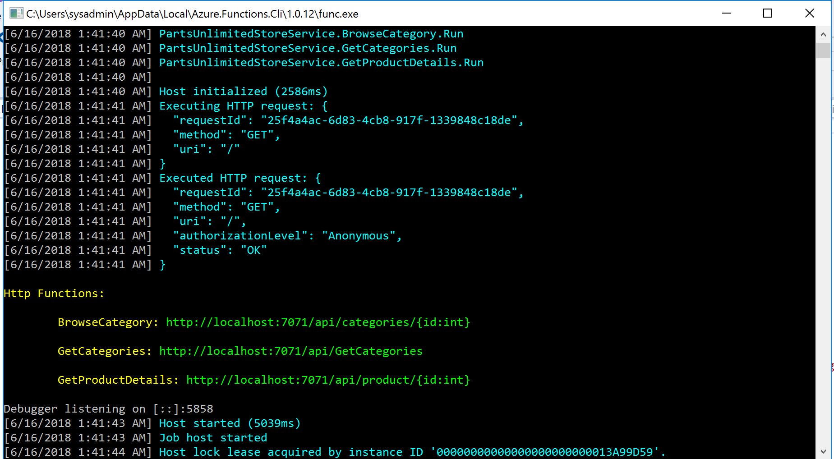

Run Postman from the Desktop and issue a GET against the **GetCategories** /api/GetCategories

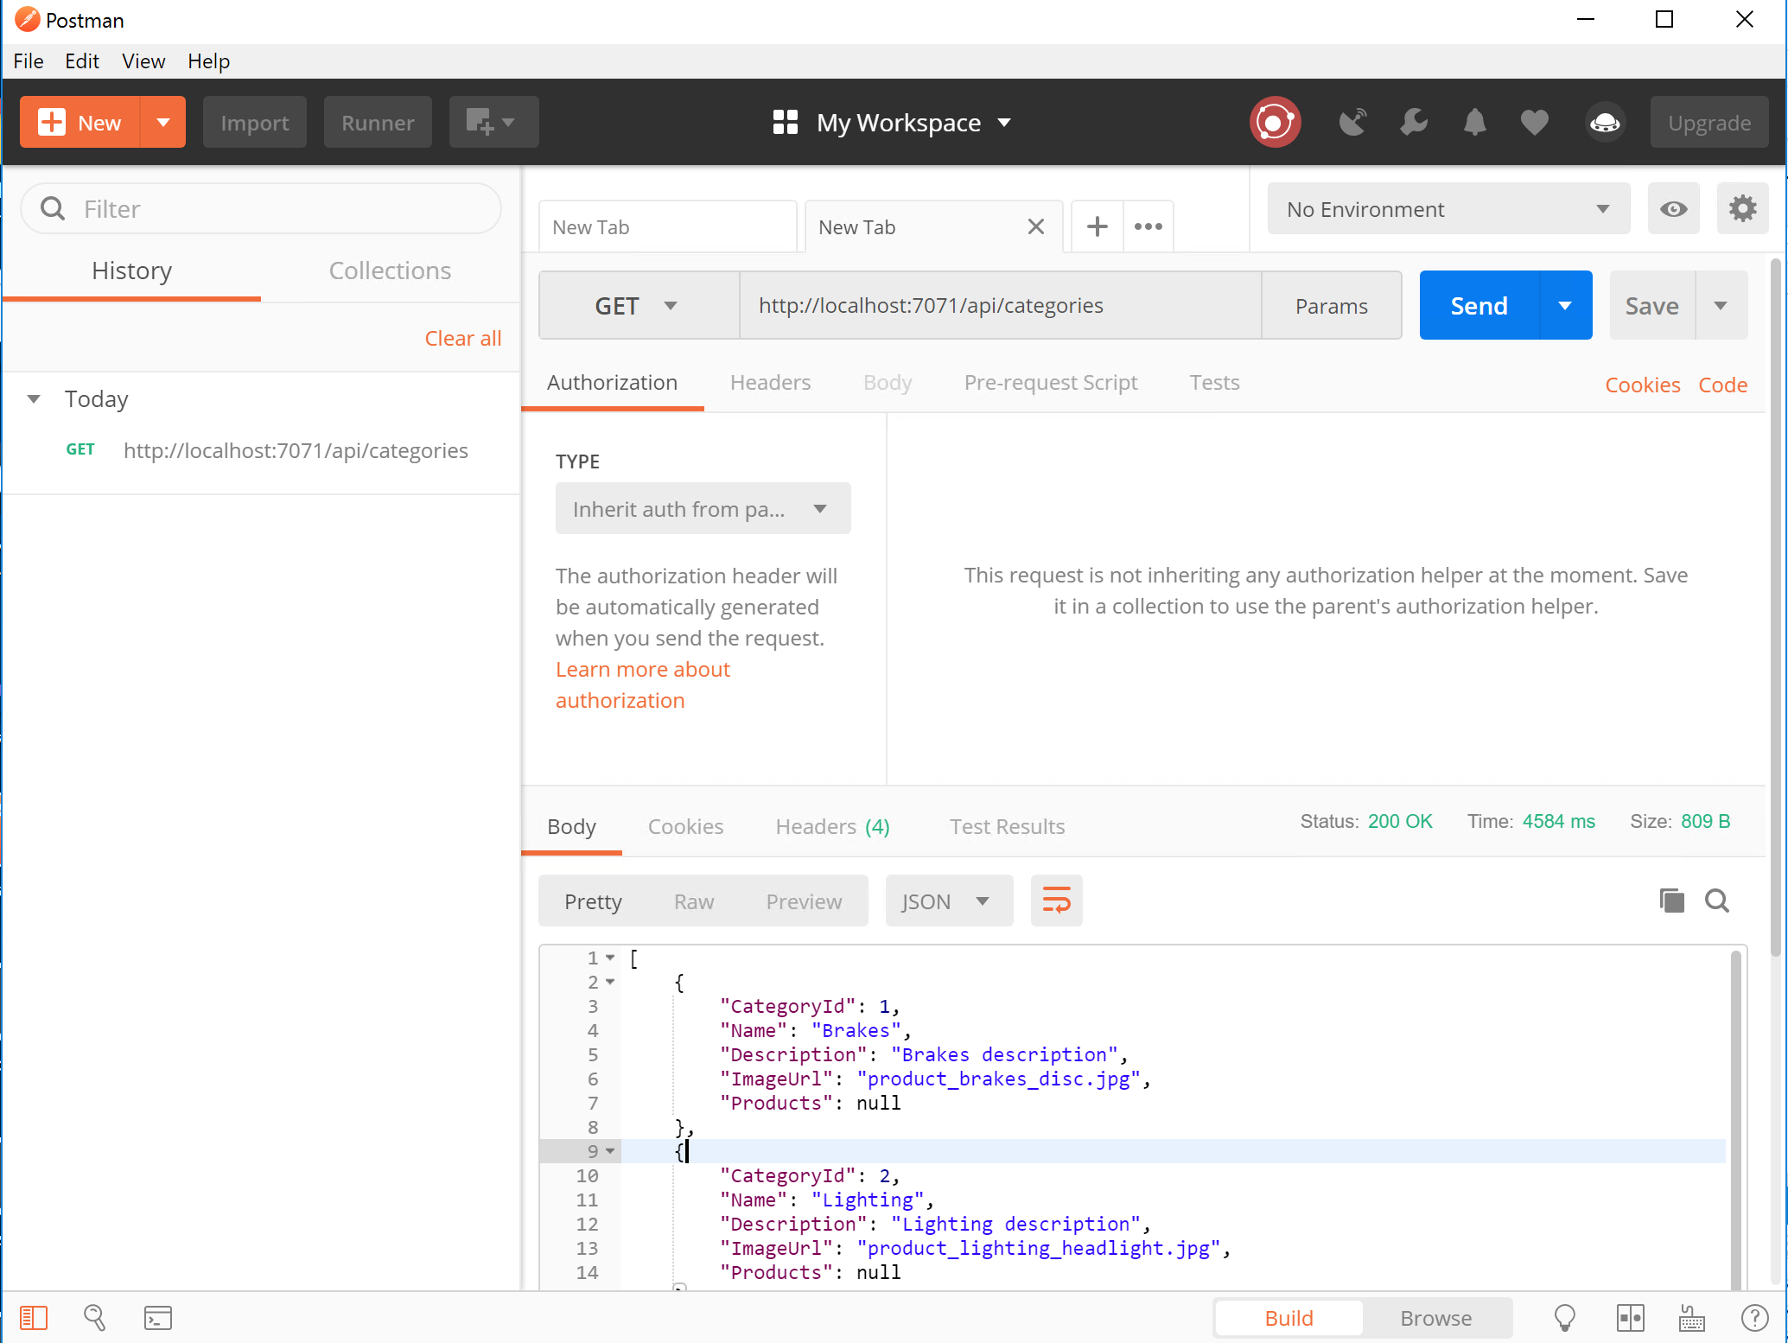

#### Task 3: Integrate

Replace the code in **StoreController.cs** in the **PartsUnlimitedWebsite** project to retrieve data from the Function App by making a REST call to the appropriate endpoint.

**Tip**: Using a utility class like **System.Net.Http.HttpClient** makes it easy to implement the calls and writing a generic method convenient for reusability.

The URL of the Function App should be defined in the **Web.config** to easily change it during deployment and if a key is to be used for access control should be also in configuration. Add the following two lines to the <appSettings> section, replacing the value of the StoreServiceBaseAddress with your local instance.

|  |
| --- |
| <add key="StoreServiceBaseAddress" value="http://localhost:7071/api/" />  <add key="StoreServiceKey" value="" /> |

Next add to the bottom of the **StoreController.cs** method:

|  |
| --- |
| private static async Task<T> GetFromStoreService<T>(string path) {     using (var client = new HttpClient())     {  // https://stackoverflow.com/questions/46223078/c-sharp-httpclient-an-existing-connection-was-forcibly-closed-by-the-remote-host  // C# 4.6 still defaults to only SSL3/TLS 1.0 even though TLS 1.1 and 1.2 are supported.  // If this is the cause of the issue, you can manually add TLS 1.1 and 1.2  ServicePointManager.SecurityProtocol |= SecurityProtocolType.Tls11 | SecurityProtocolType.Tls12;          var baseAddress = ConfigurationManager.AppSettings["StoreServiceBaseAddress"];         var key = ConfigurationManager.AppSettings["StoreServiceKey"];           client.DefaultRequestHeaders.Accept.Clear();         client.DefaultRequestHeaders.Accept.Add(new MediaTypeWithQualityHeaderValue("application/json"));           var uri = new Uri(baseAddress + path);           HttpResponseMessage response = await client.GetAsync(uri);         return await response.Content.ReadAsAsync<T>();     } } |

Add the **System.Threading.Tasks**, **System.Collections.Generic, System.Net.Http, and System.Net.Http.Headers**, **System.Net**; reference to the top of the class. Then replace the Intex(), Browse(int), Details(int) methods with the ones below. Notice the public methods in the class can be implemented in an asynchronous way and simpler:

|  |
| --- |
| using System.Threading.Tasks;  using System.Collections.Generic;  using System.Net.Http;  using System.Net.Http.Headers;  using System.Net;  ….  // // GET: /Store/ public async Task<ActionResult> Index() {     return View(await GetFromStoreService<List<Category>>("categories")); }   // // GET: /Store/Browse?genre=Disco public async Task<ActionResult> Browse(int categoryId) {     return View(await GetFromStoreService<Category>($"categories/{categoryId}")); }   public async Task<ActionResult> Details(int id) {     var productCacheKey = string.Format("product\_{0}", id);     var product = MemoryCache.Default[productCacheKey] as Product;     if (product == null)     {         product = await GetFromStoreService<Product>($"product/{id}");         //Remove it from cache if not retrieved in last 10 minutes         MemoryCache.Default.Add(productCacheKey, product, new CacheItemPolicy { SlidingExpiration = TimeSpan.FromMinutes(10) });     }       var viewModel = new ProductViewModel     {         Product = product,         ShowRecommendations = ConfigurationHelpers.GetBool("ShowRecommendations")     };       return View(viewModel); } |

Test locally and ensure everything works as expected and no functionality has been affected from the website standpoint.

In Solution Explorer, right-click on the Solution and click **Set Startup Projects**. Select Multiple startup projects and for the action for **PartsUnlimitedStoreService** and **PartsUnlimitedWebsite**, choose **Start**.

Browse the product categories and details of the site and notice the Functions getting executed.

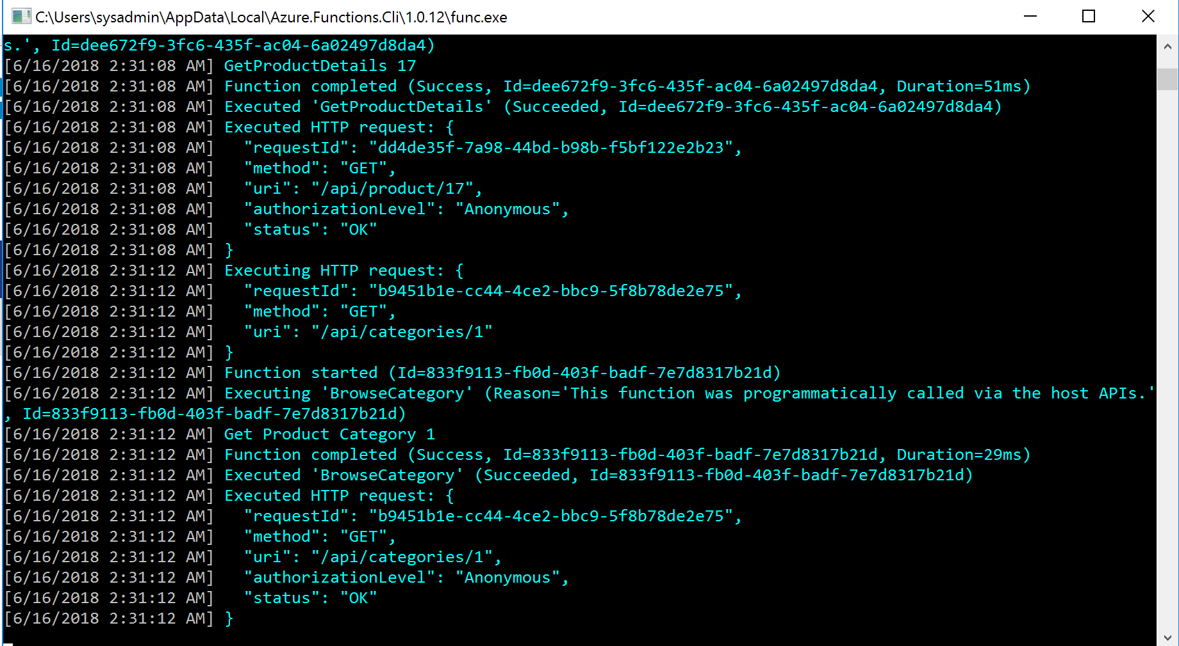

#### Task 4: Publish the Service

Now that we have a working Function App with the website, it is time to deploy to Azure, which can be accomplished using the Publish feature in Visual Studio. Before we continue, we need to update the Azure Functions and Web Jobs Tools in Visual Studio.

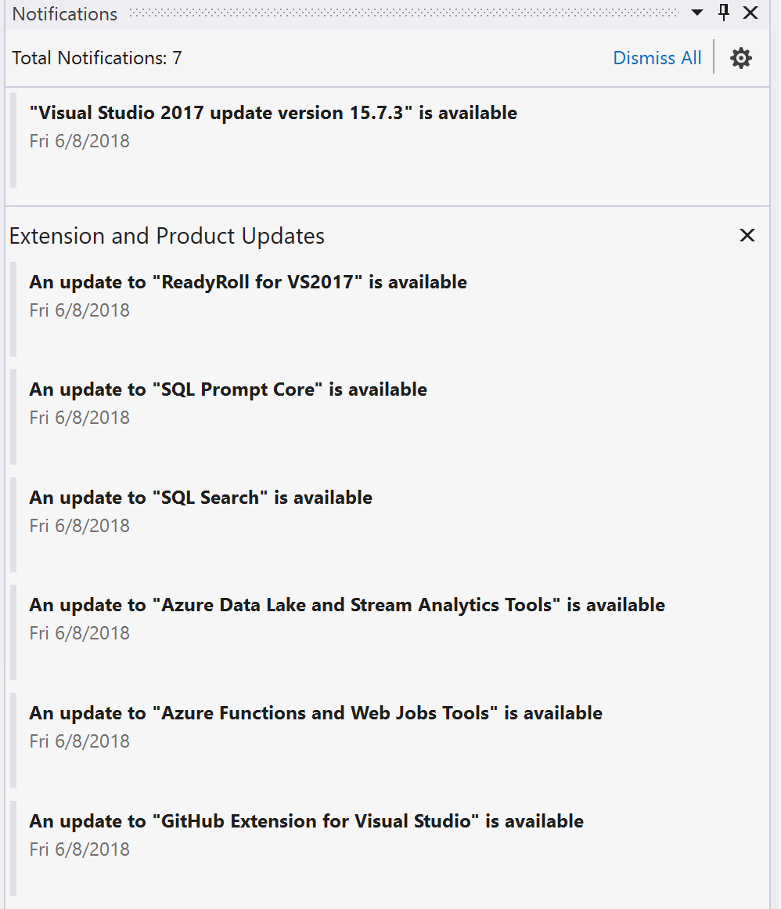

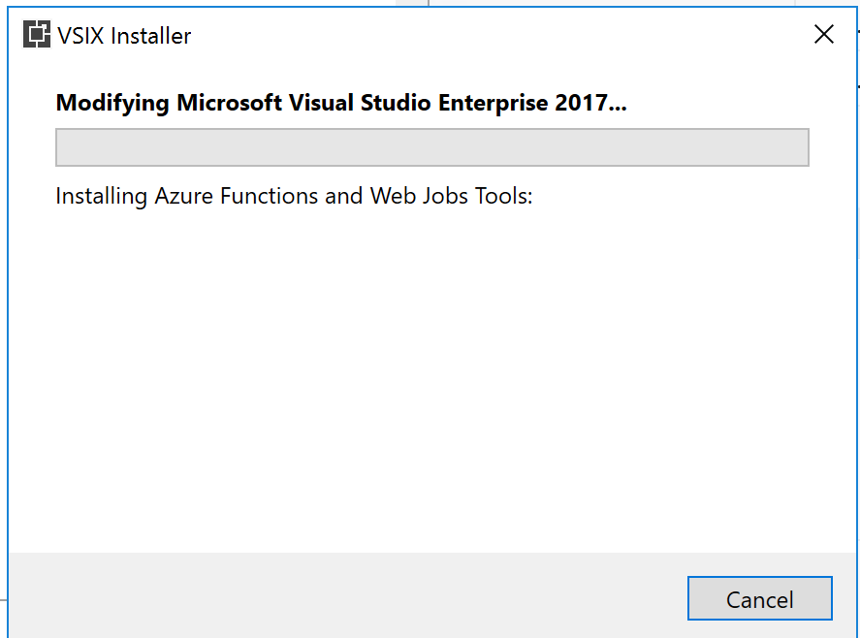

Once Visual Studio has restarted, reload the project and begin publishing.

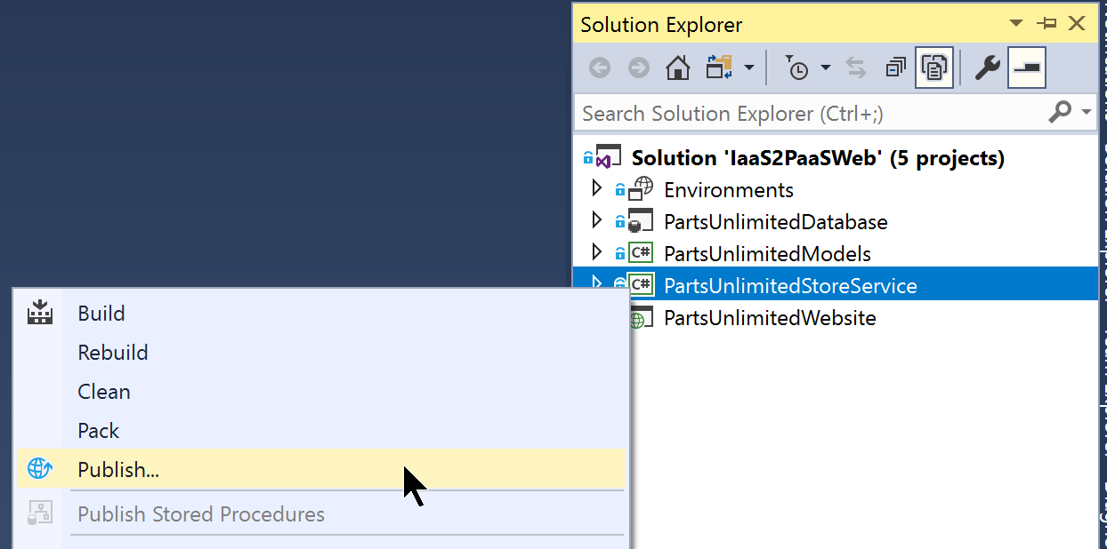

Select the **Function App** target and **Create new** option:

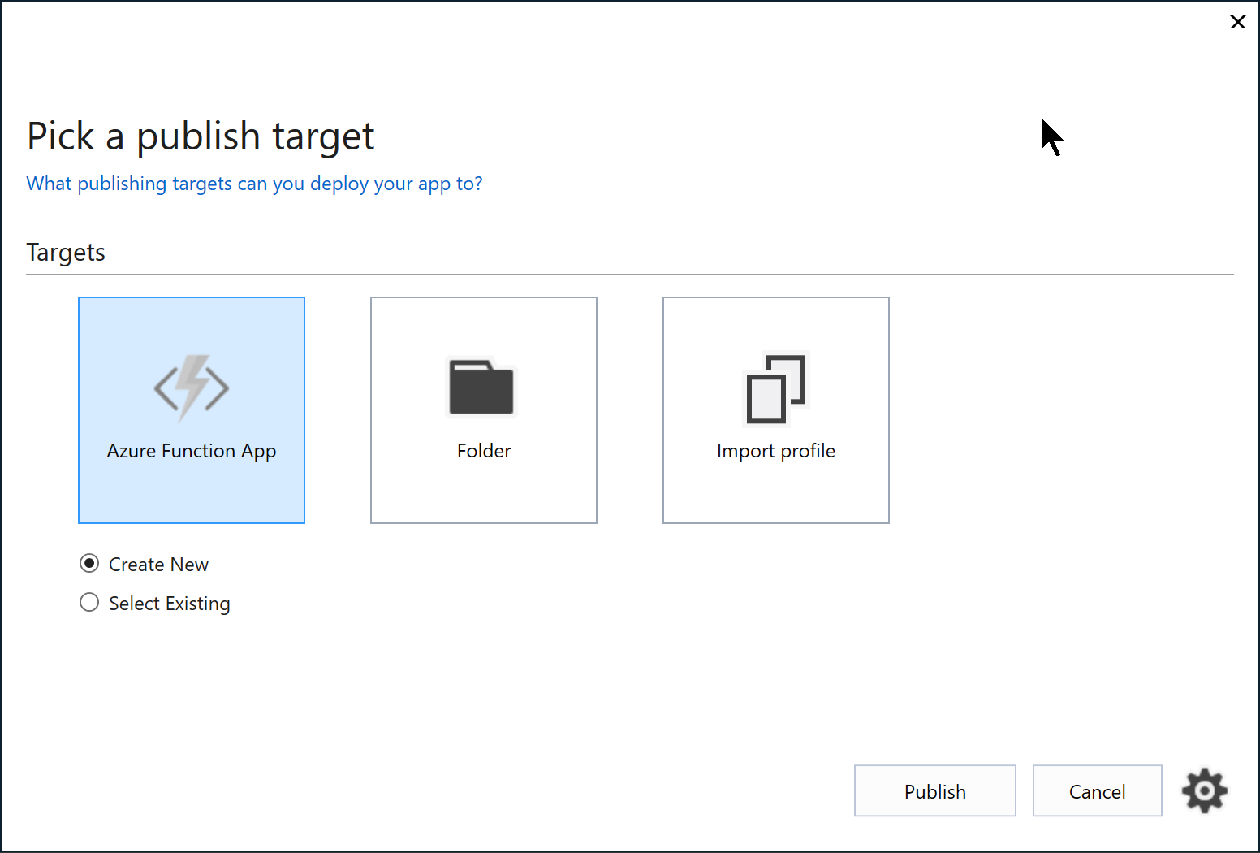

Enter or select the appropriate values for the publish profile, selecting the Consumption for the hosting plan and your existing Storage Account used for the website. You can also choose your existing website to host the Functions.

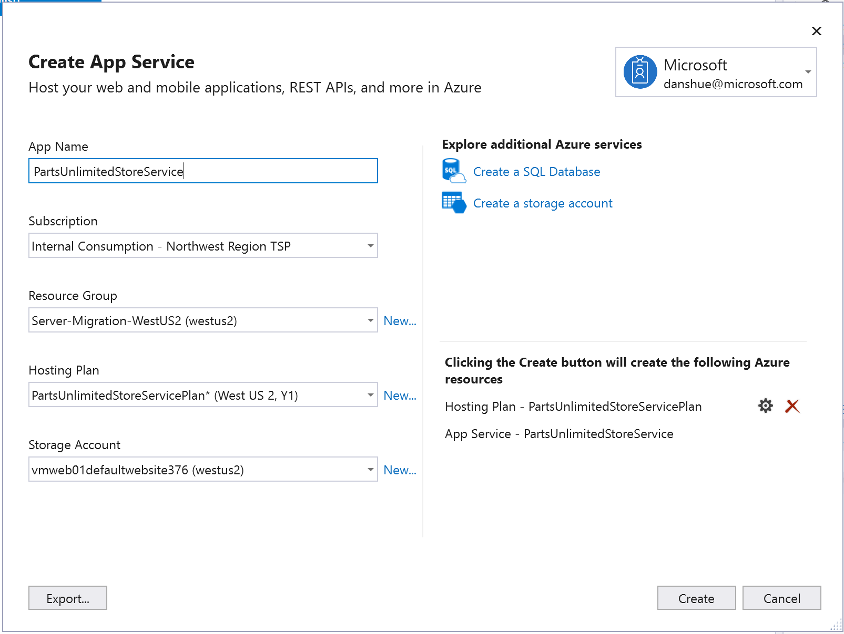

Decide how this function will be hosted. It will either use a Consumption Plan, where Microsoft manages the scaling up/down the infrastructure to support your Function or an existing App Plan to take advantage of infrastructure you’ve already defined. Select your existing Storage Account where you’re storing the Application Log files. After everything is configured, click **Create** to continue.

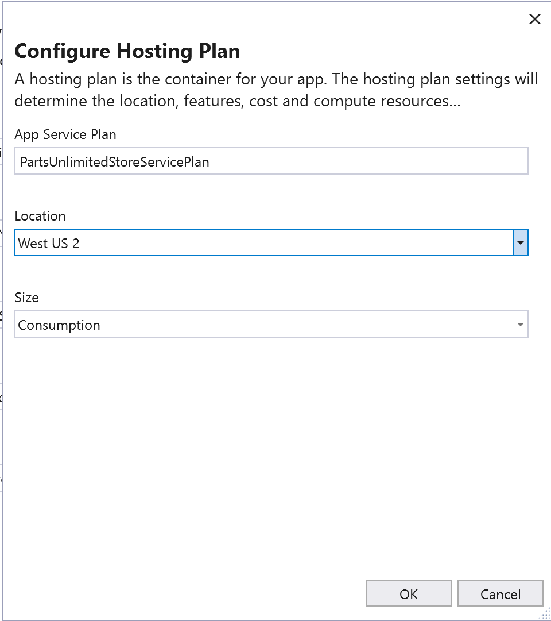

In a few moments, the new enviornment will be configured and the deployment to that will begin.

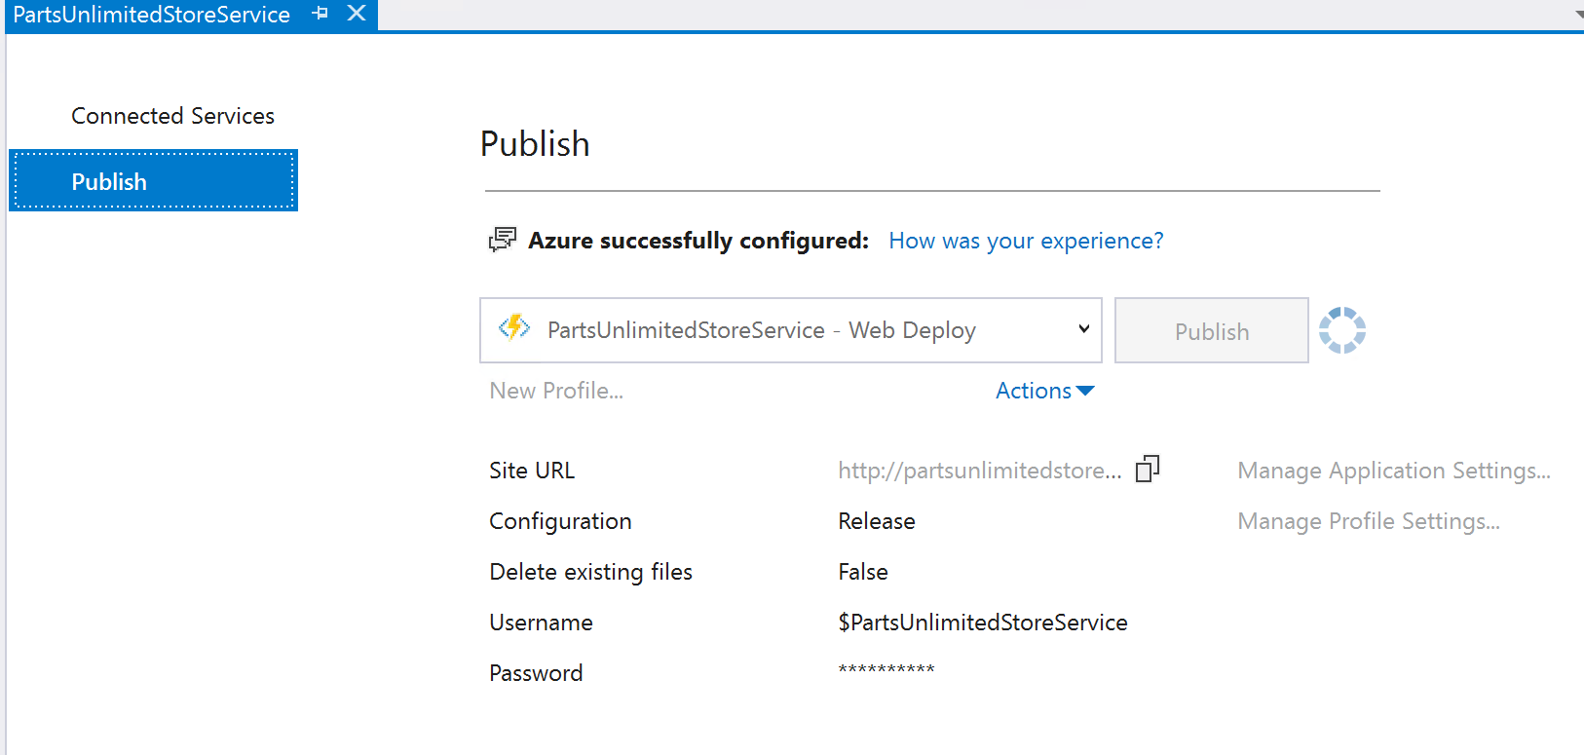

#### Task 5: Configure Function Database Connection

Once the Function is complete, using the Azure Portal, navigate to the newly created Function **App Service**.Notice the Function Icon.



You can navigation to the URL for the Function App to verify the Function has been provisioned correctly.

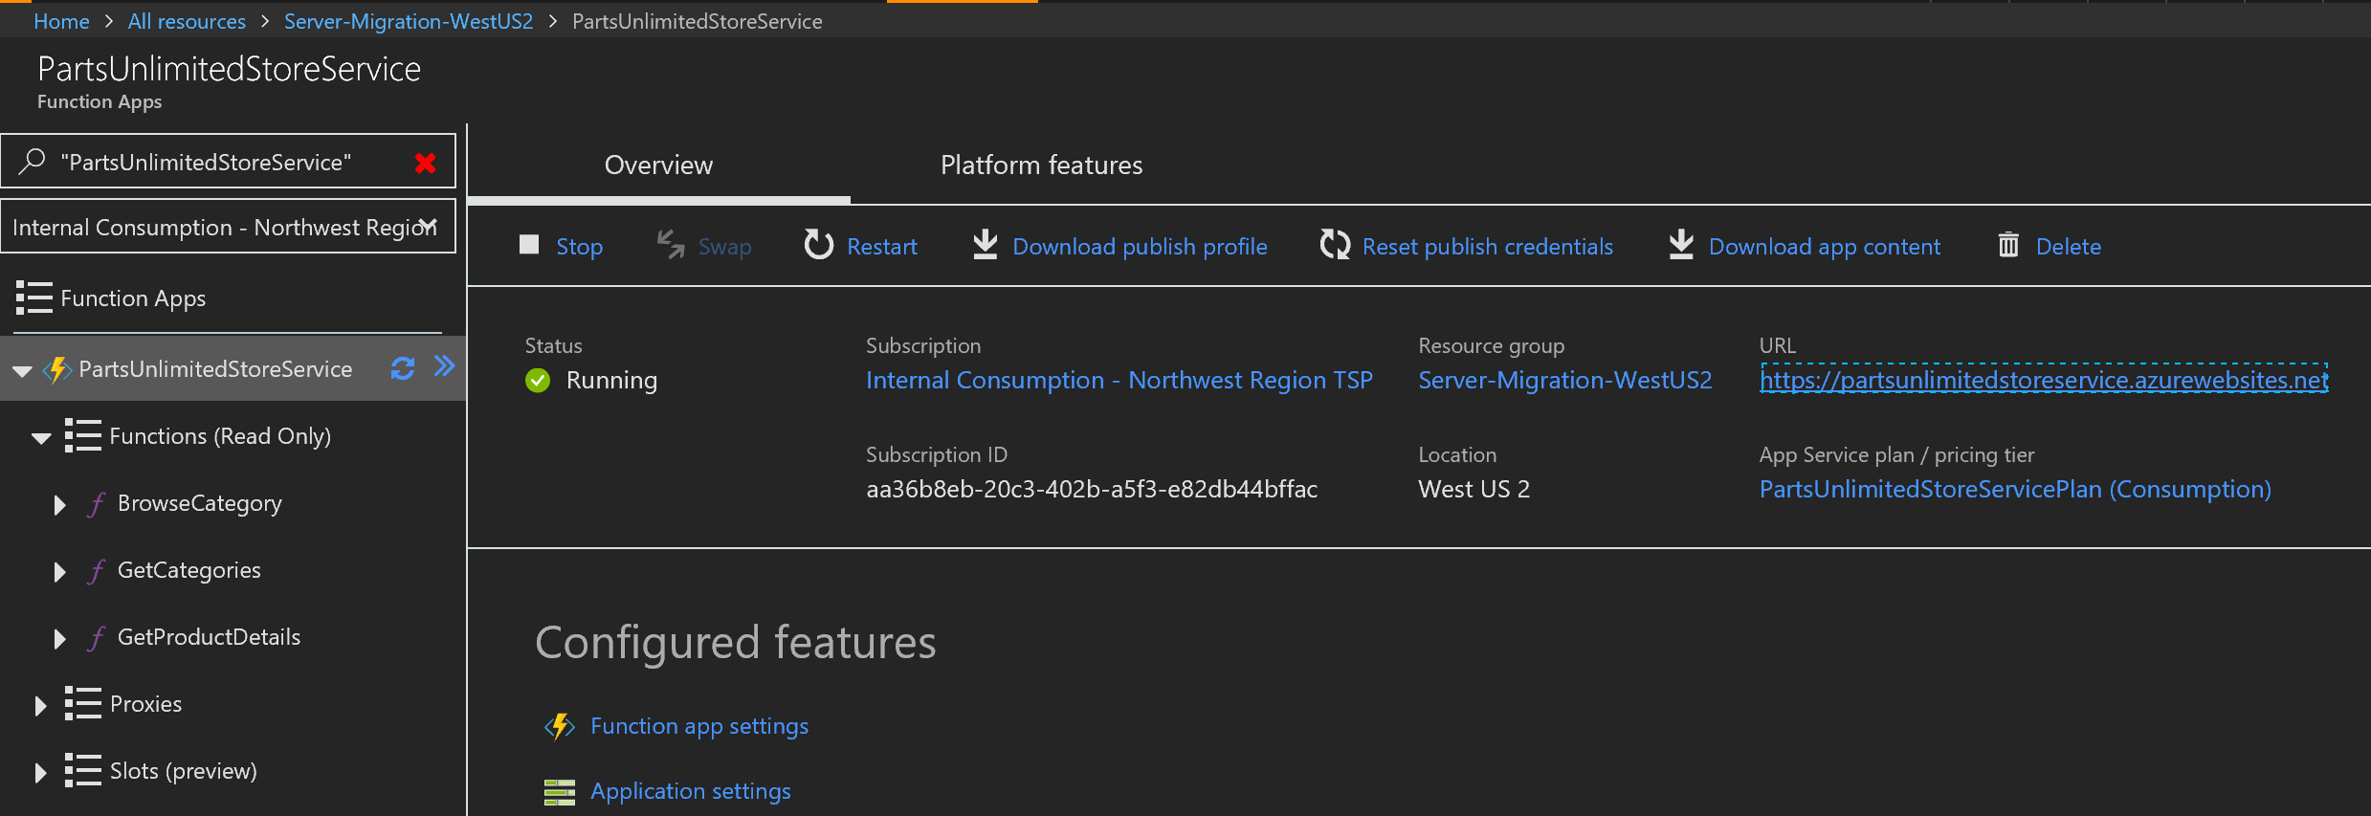

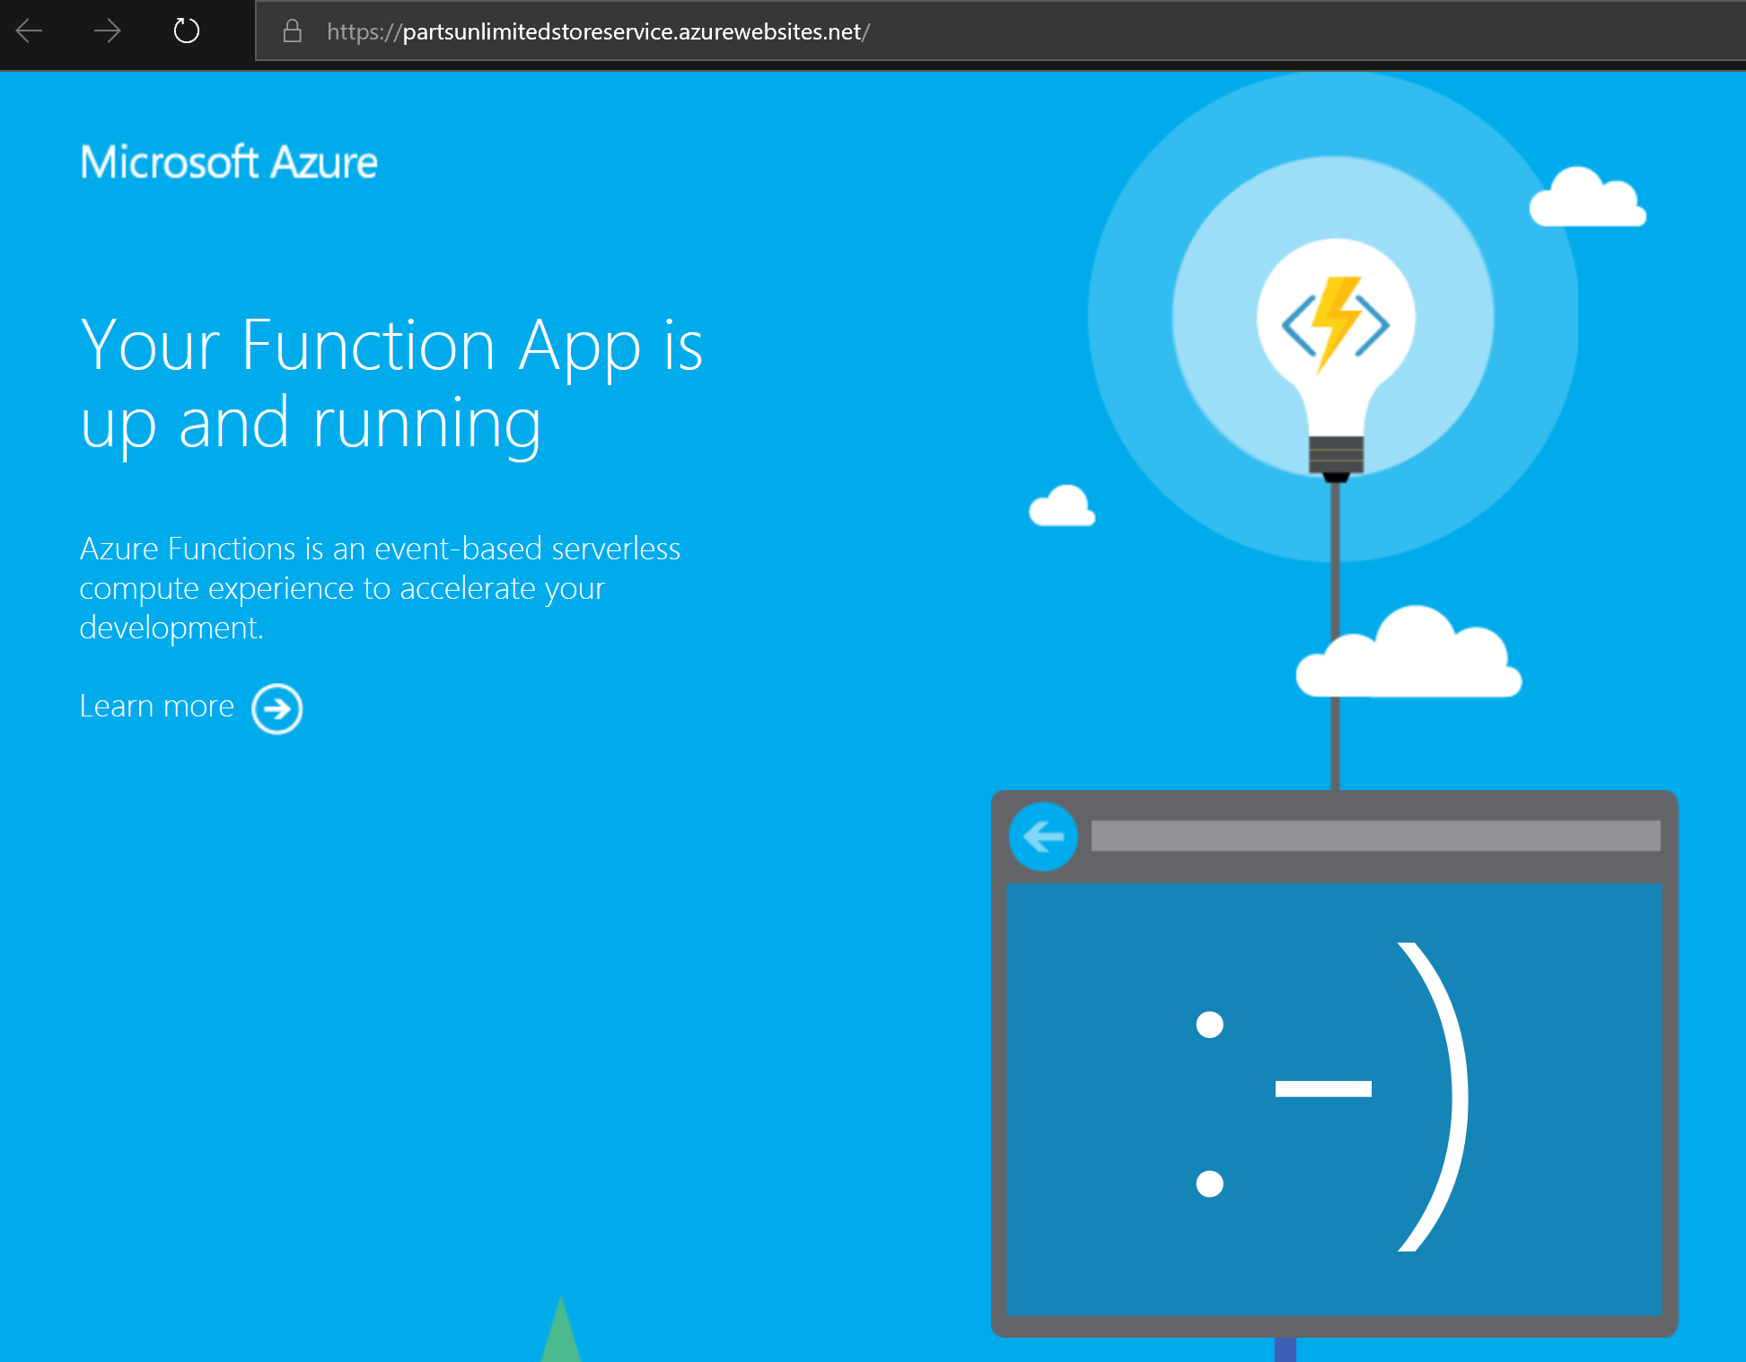

After publishing the Function App, we need to add the required Connection String for the database, which can be done via the Azure portal:

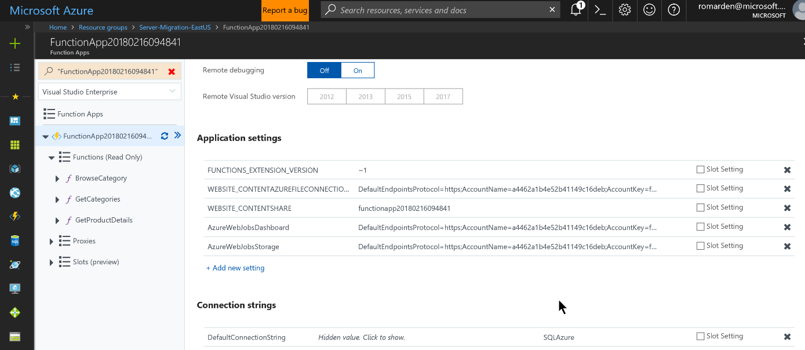

After publishing is completed, publish a new version of the website including the Application Settings for the location and key of the Store Service and test.

**Default Settings**

db Login Name: workshopServiceAcc  
db User Name: workshopServiceAcc  
db User Password: P2ssw0rd

Database Name: partsUnlimitedDB

DefaultConnectionString:

Server=tcp:{server\_name}.database.windows.net,1433;Initial Catalog=partsUnlimitedDB;Persist Security Info=False;User ID={db\_user\_name};Password={db\_user\_password};MultipleActiveResultSets=False;Encrypt=True;TrustServerCertificate=False;Connection Timeout=30;

**Note**: Be sure to the Connection String has a space between User and ID (e.g. “User ID”), otherwise the Entity Framework will throw an exception ‘Keyword not supported: 'userid'’. This is a known issue with the version of Entity Framework being used and has been corrected in a later version.

#### Task 5: Configure Function Application Insights

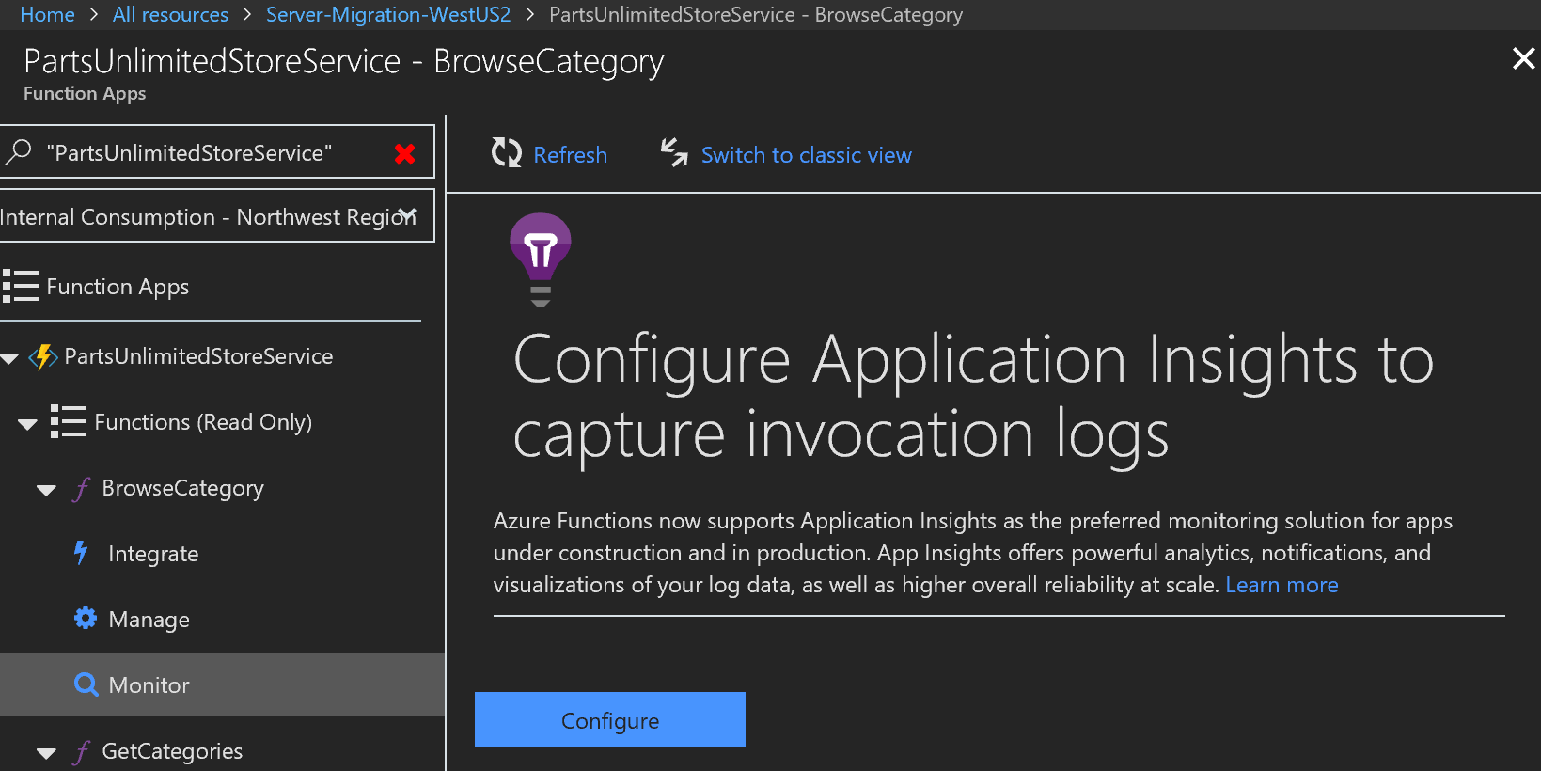

Click **Configure**.

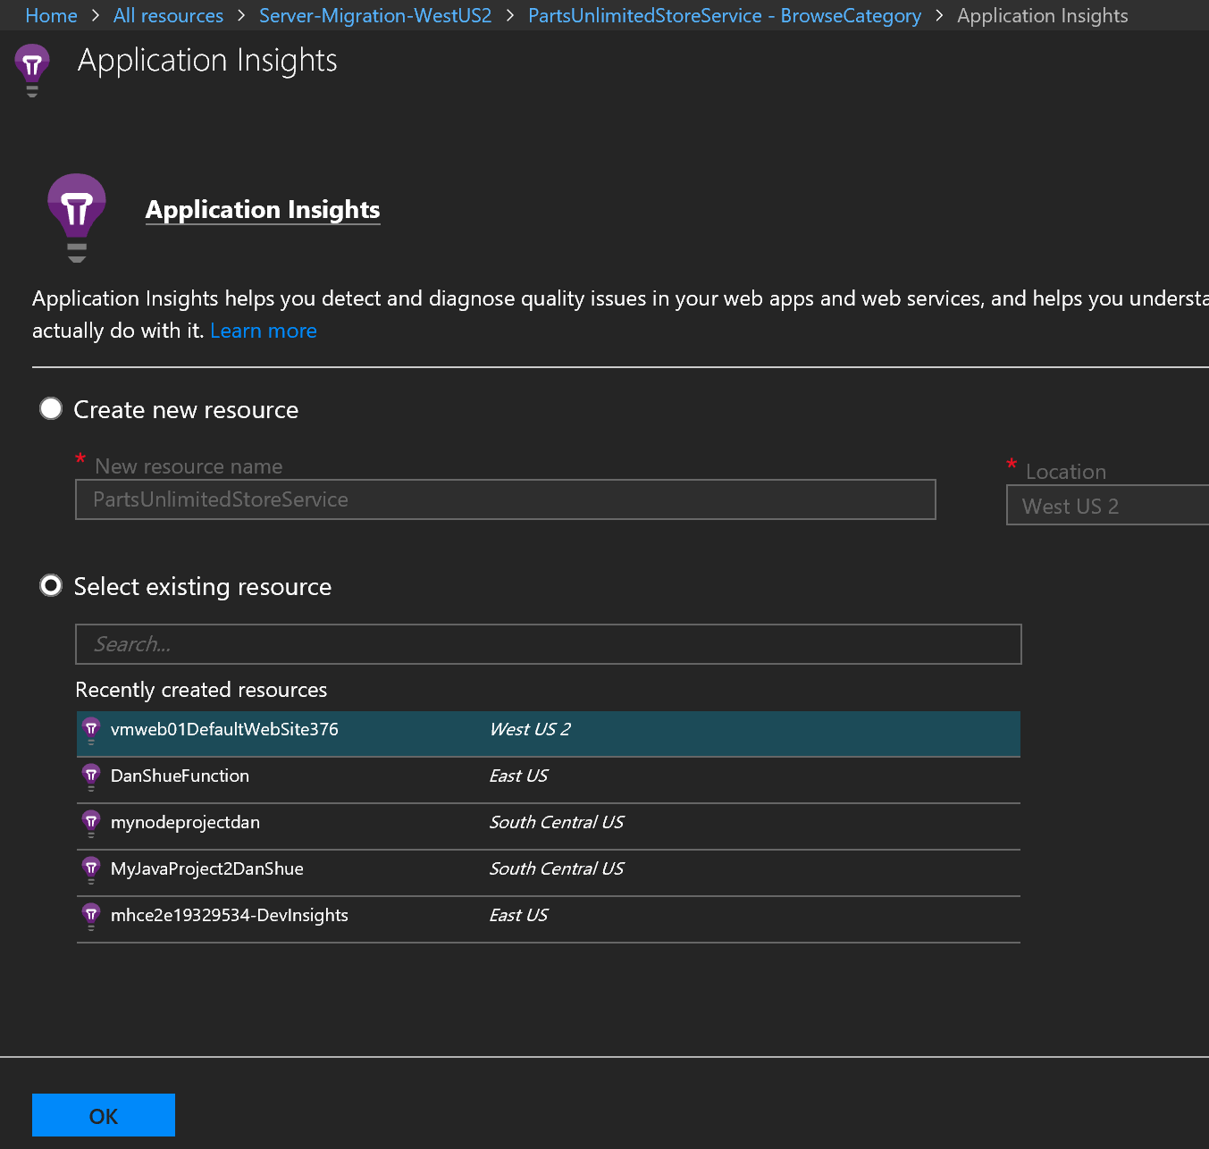

Next, you have a choice to create a new Application Insights instance or select your existing resource. Since we want to see everything in area, we’ll select our existing application and click **OK.** After configuring Application Insights, notice the Live Stream is now available.

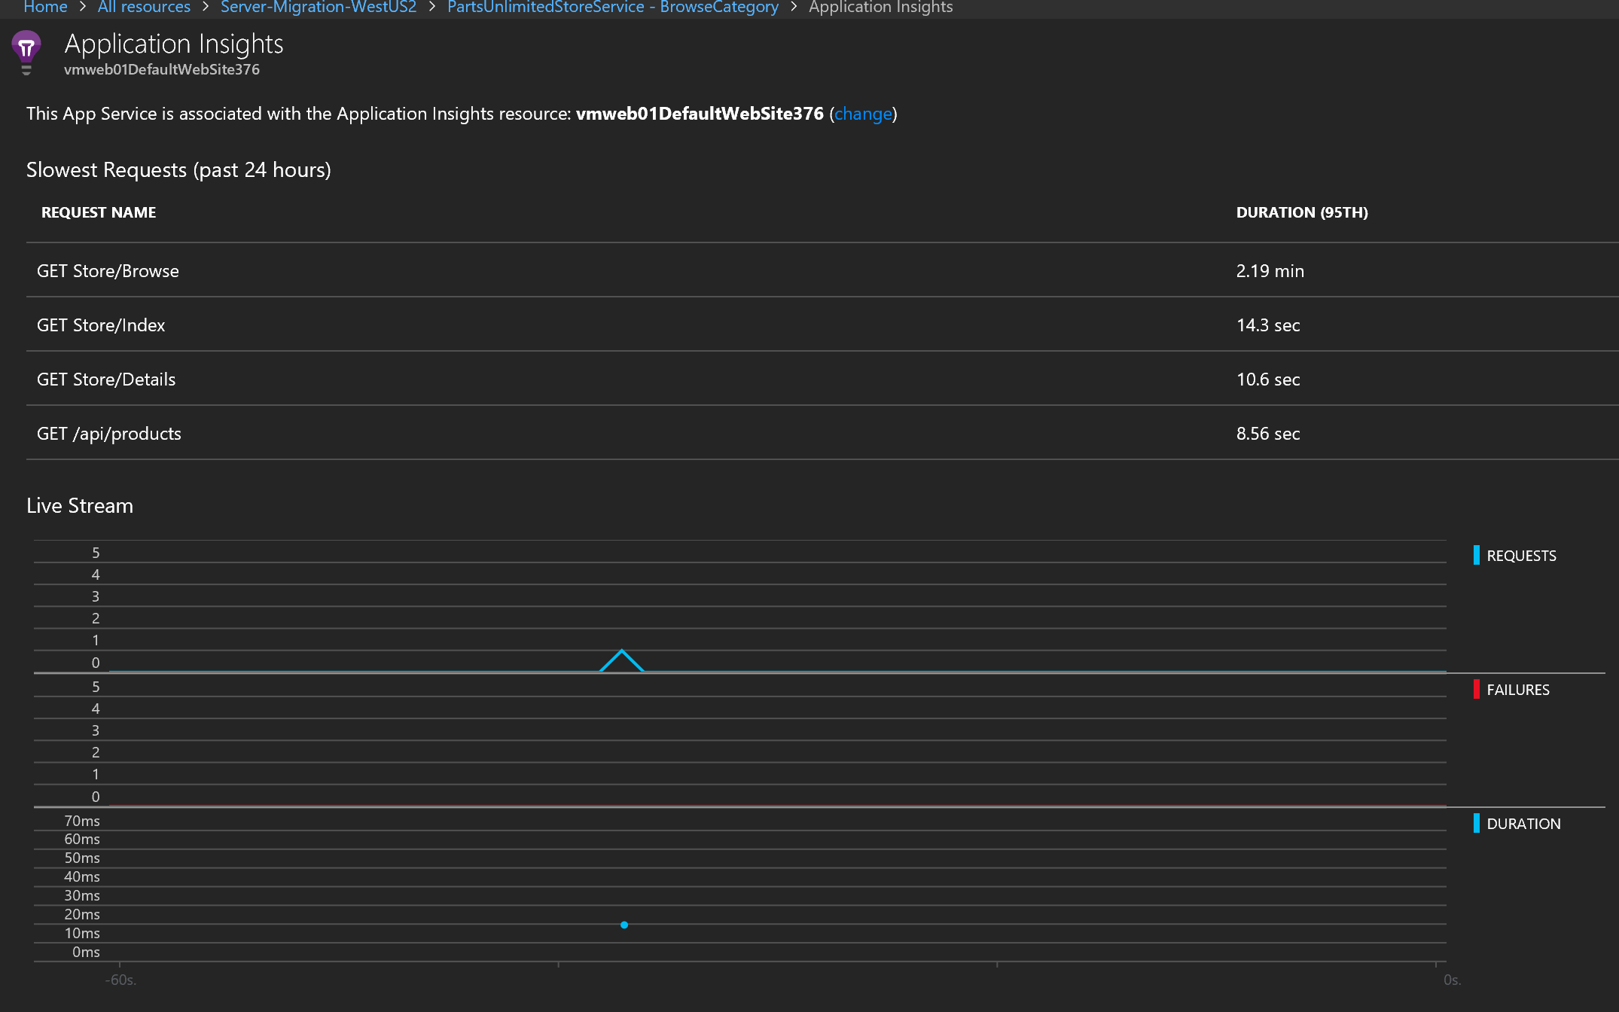

Use Postman to verify that everything the function can communicate with the database and Application Insights in configured correctly.

In Postman, send a Get to the Function Service using the URL (<https://[service_name].azurewebsites.net/api/categories>) and ensure the payload coming back is the json results.

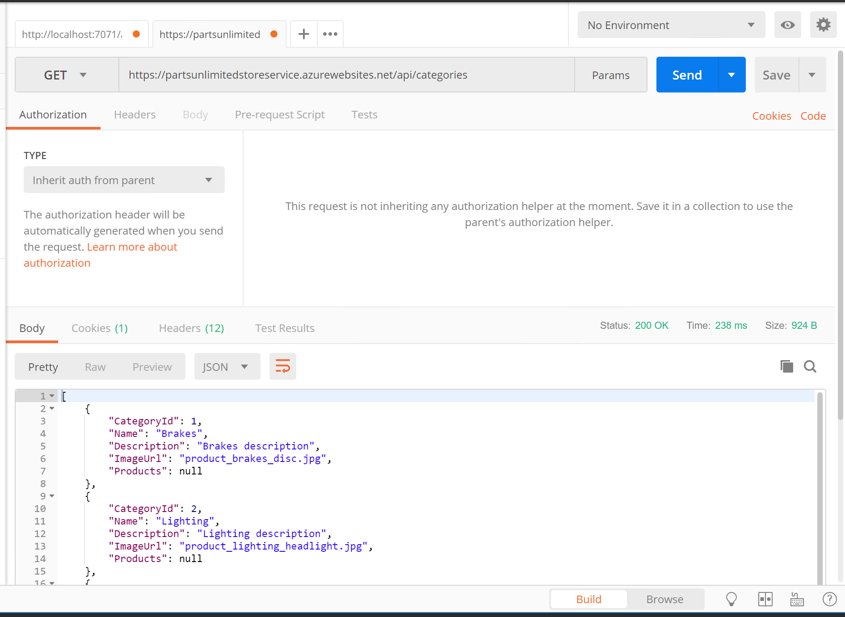

Instead of configuring our web application to use the Function directly, in our next Exercise, we’ll configure our website to go through API Management instead.

#### Task 6: Modify App Service CI/CD Task

The solution file will now produce artifacts for the web application, **PartsUnlimitedWebsite.zip**, and one for the store, **PartsUnlimitedStoreService.zip**. Our current build task will fail since it can’t deploy multiple ZIP files to the service, therefore, we need to specify the correct file. Navigate to your VSTS instance, to Releases, and modify the App Service deployment task to have the correct file.



## Exercise 11: Monetize your data and services, and open new channels to customers using Azure API Management

Duration: 45 minutes

Now that Parts Unlimited has an API available, the business wants to start building relationships with other retailers, so they can sell their product through multiple channels. We’ve decided to use Azure API Management to expose and manage our API.

#### Help references

|  |  |
| --- | --- |
| API Management | <https://docs.microsoft.com/en-us/azure/api-management/> |

#### Prerequisites

To complete this task, you should have provisioned the Parts Unlimited IaaS and PaaS environments and have a working CI/CD process. You will use the Developer Workstation deployed as part of the IaaS environment for your development work. You have already provisioned the API Management instance in your Azure Subscription.

#### Task 1: Set up new a new API in the Azure Portal

To create a new API in Azure API Management, we will use the OpenAPI definition (Swagger) from our web application.

Add a new API using the Azure Portal:

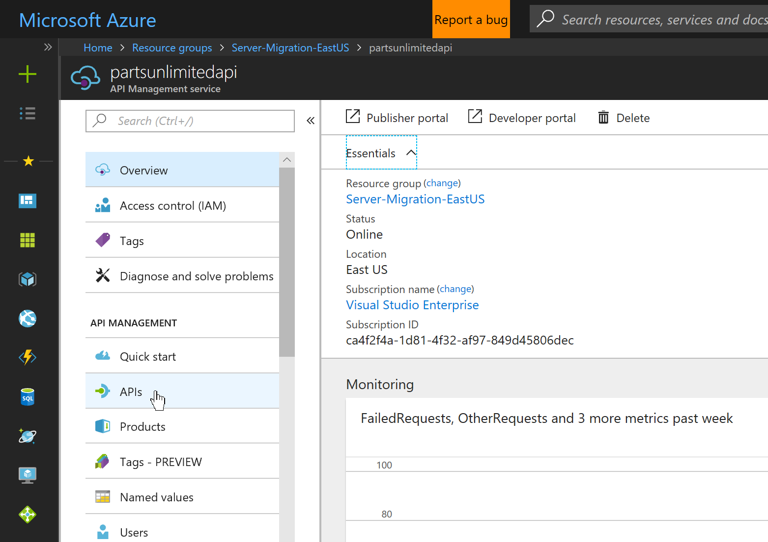

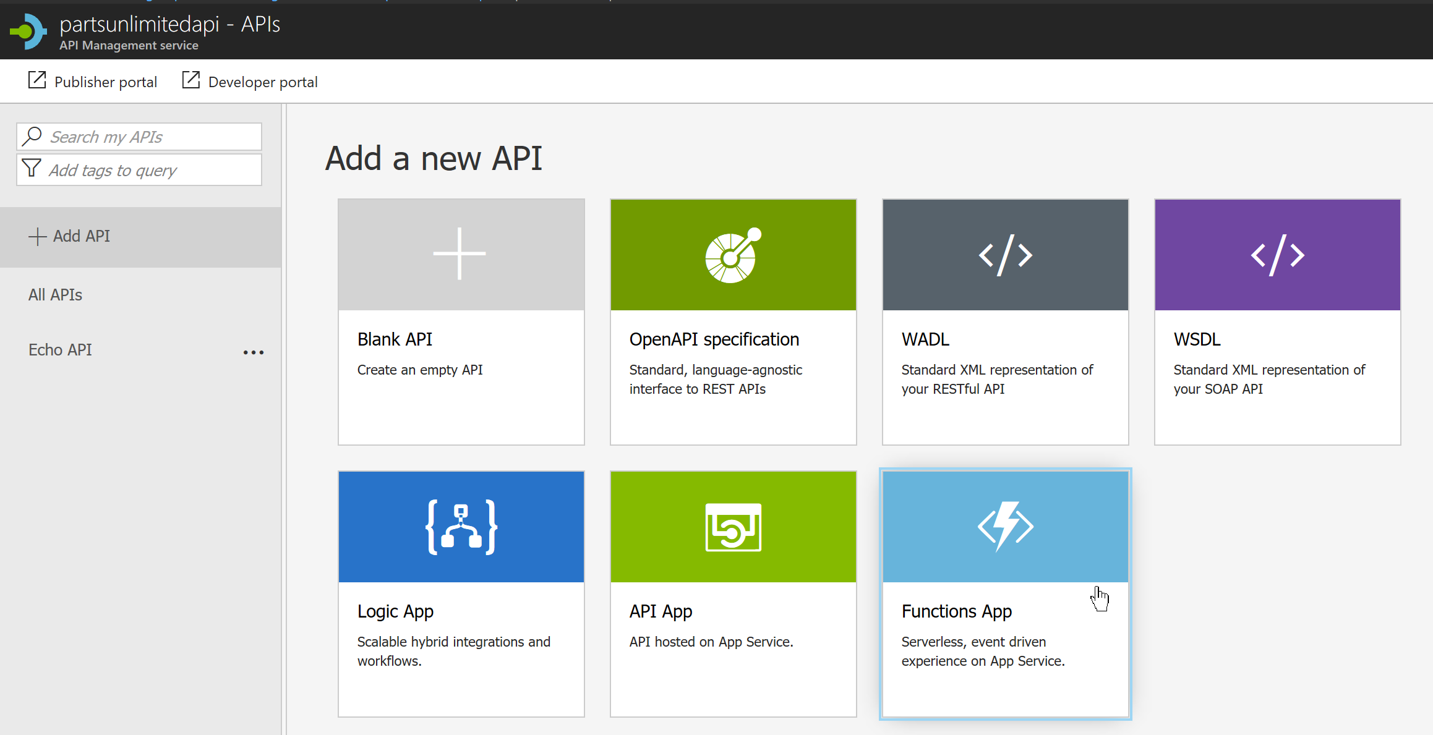

Click **Browse** to select the new function to Add.

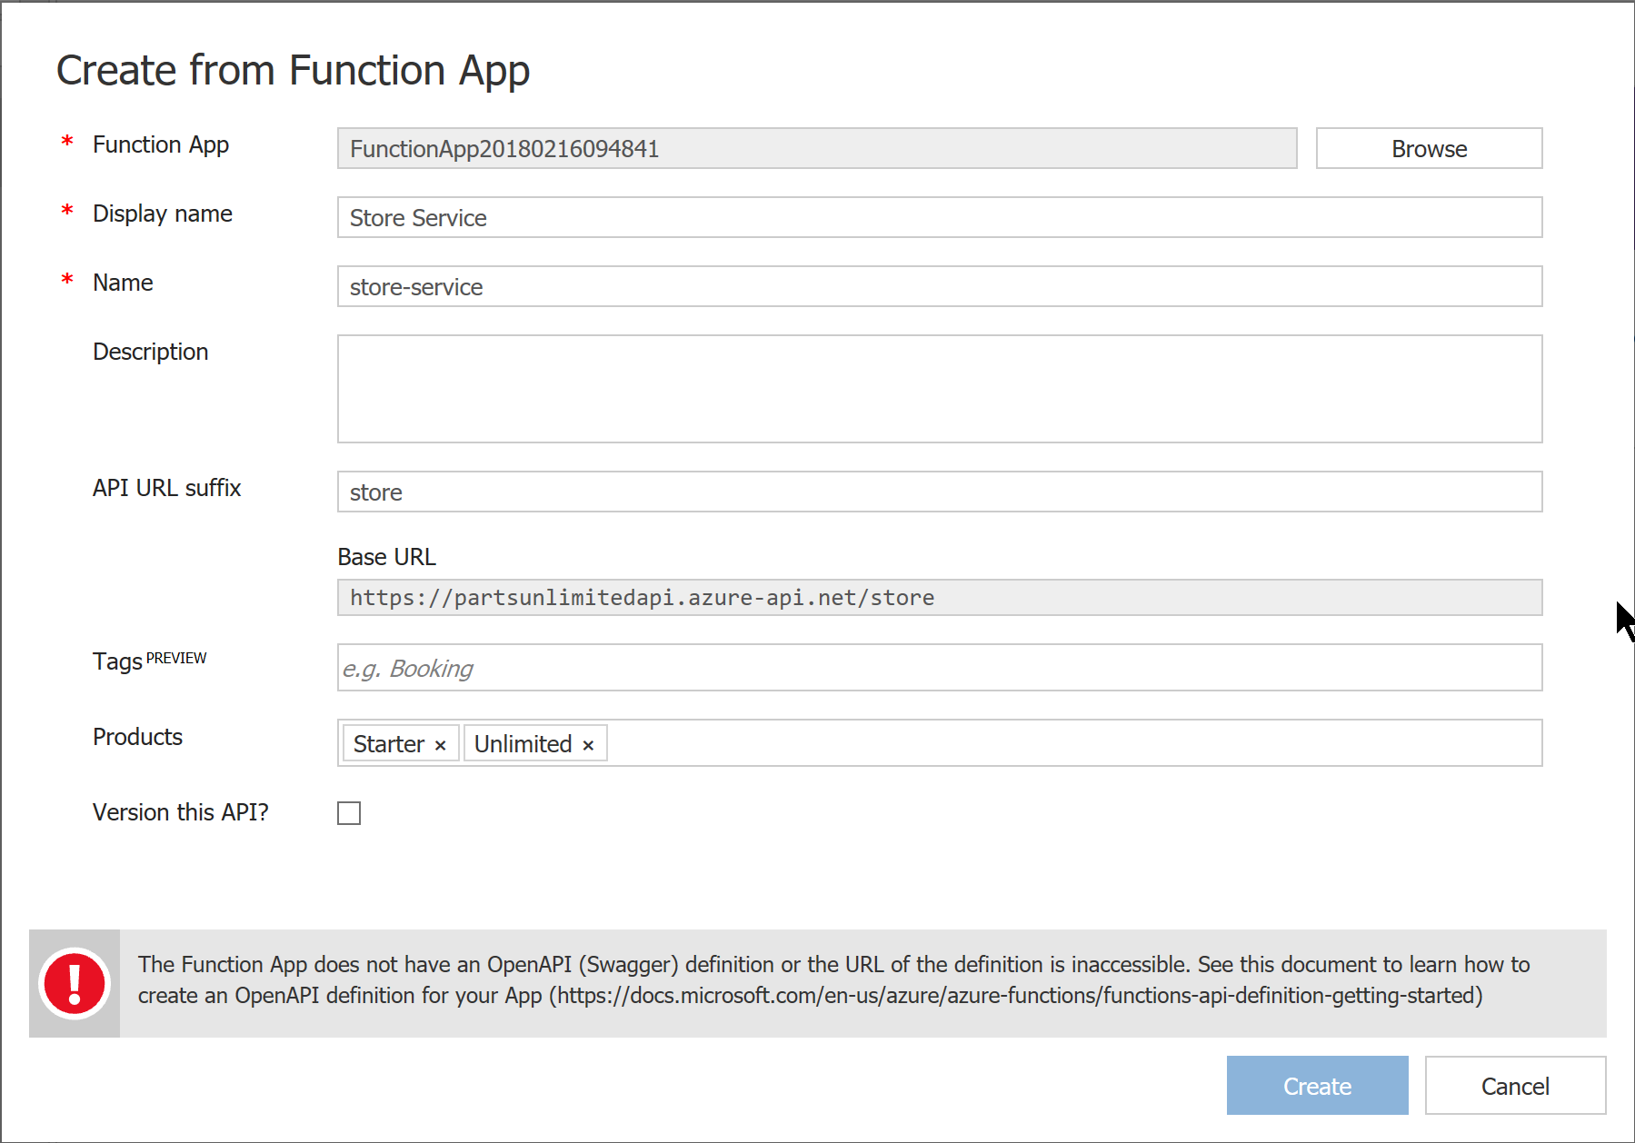

To add an OpenAPI definition, go to the Function App and use the Platform Features tab to add an API definition:

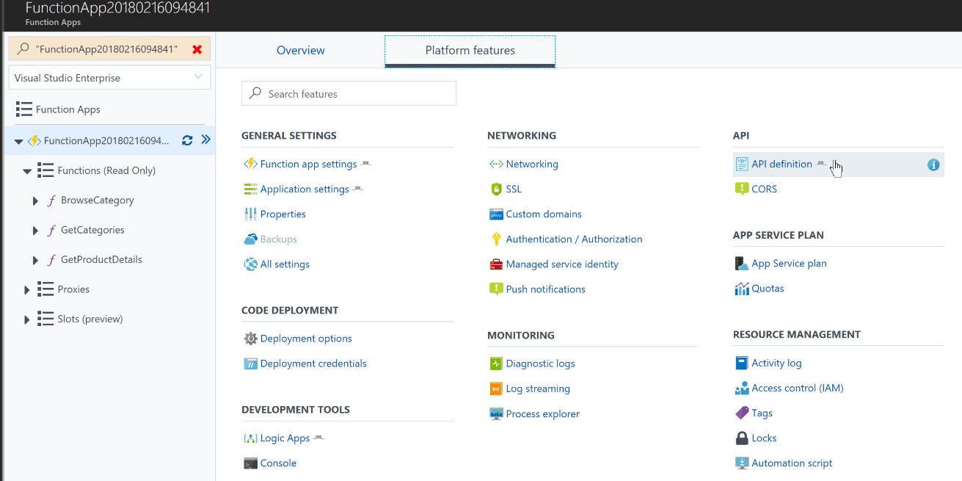

It might fail at first:

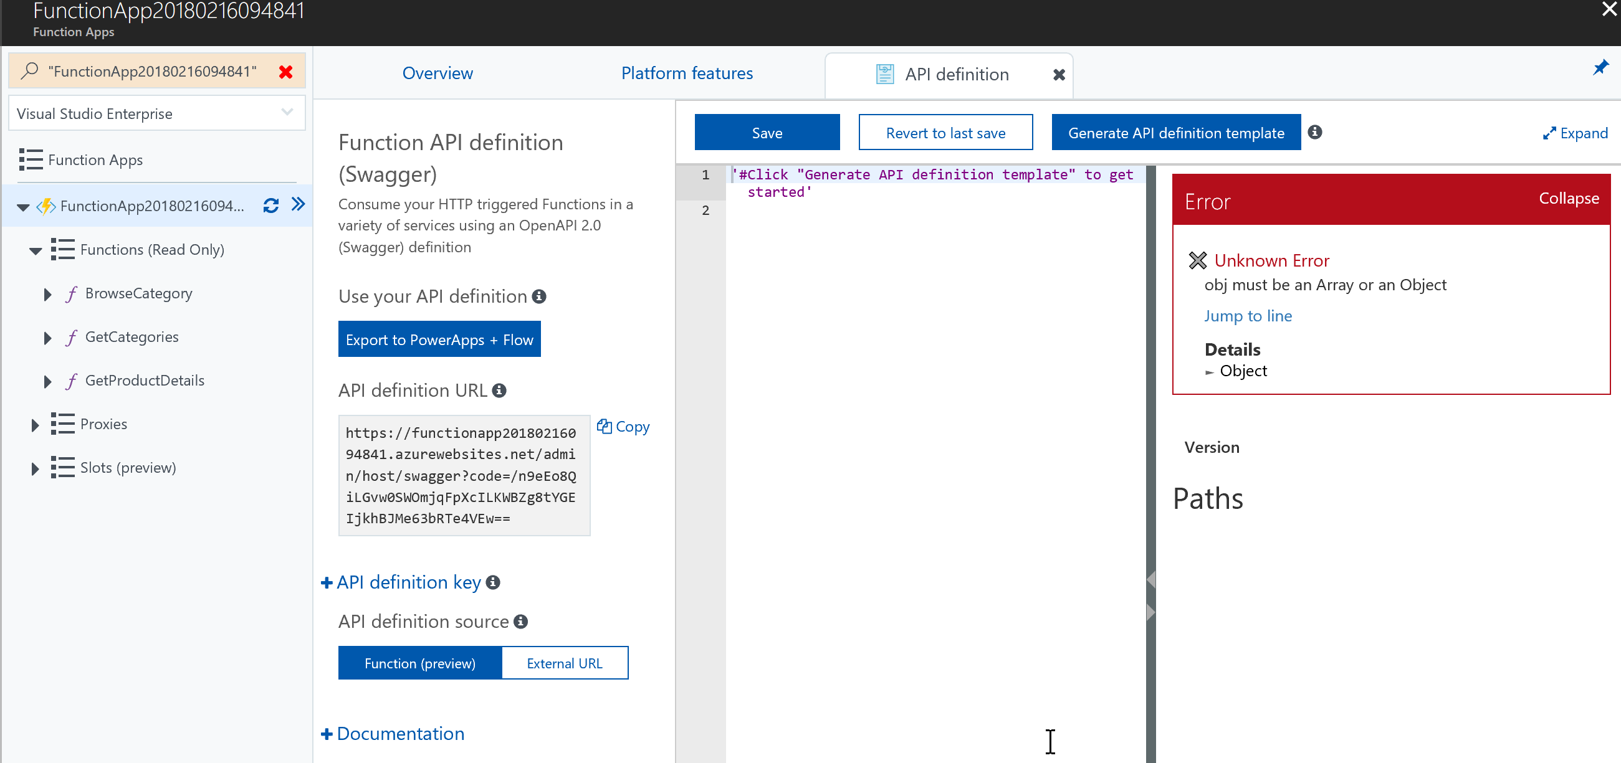

Click on the **Generate API definition template** button to generate it from code and then click the **Save** button:

![Machine generated alternative text:
FunctionApp20180216094841 
Function Apps 
p "FunctionApp20180216094841 " 
Visual Studio Enterprise 
Function Apps 
O FunctionApp20180216094... C 
Functions (Read Only) 
f BrowseCategory 
f GetCategories 
f GetProductDetails 
Proxies 
Slots (preview) 
x 
Overview 
Function API definition 
(Swagger) 
Platform features 
API definition 
Revert to last save 
x 
Generate API definition template 
Save 
• '2.0' 
wagger . 
info: 
title: 
O 
Expanc 
Consume your HTTP triggered Functions in a 
variety of services using an OpenAPl 2.0 
1 
3 
4 
5 
6 
8 
9 
10 
11 
12 
13 
14 
15 
16 
17 
18 
19 
20 
21 
22 
23 
24 
25 • 
26 
27 
28 
29 
30 • 
31 
32 
33 
34 
35 • 
36 
38 
39 
40 
41 
42 
43 
44 
functionapp20180216Ø94841 
. azurewebsites . net 
version: I.e. 0 
host: functionapp2Ø180216094841. azurewebsites 
. net 
basePath: / 
schemes : 
- https 
- http 
paths: 
' /api/categories/{id}' : 
get : 
operationld : 
' /api/categories/{id}/get ' 
produces: [ ) 
consumes: [ ) 
parameters : 
name: id 
in: path 
required : 
true 
type: integer 
description: 
Replace with Operation Object 
#http : / / swagger . io/ specification 
/#operationObject 
responses: 
'200': 
description: Success operation 
security : 
apikeyQuery: [ ] 
/api/ categories : 
get : 
operationld: /api/categories/get 
produces: [ ) 
consumes: [ ) 
parameters : 
description: 
Replace with Operation Object 
#http : / / swagger . io/ specification 
/#operationObject 
functionapp20180216094841 .az 
(Swagger) definition 
Use your API definition O 
Export to PowerApps + Flow 
API definition URL O 
https : / /functionapp2018Ø216Ø 
94841. azurewebsites . net/ admi 
n/ host/ 
iLGvwOSWOmjqFpXc1LKWBZg8tYGE 
+ API definition key O 
API definition source O 
Copy 
Version 1.0.0 
Security 
apikeyQuery (API Key) 
Name 
In 
Paths 
/api/categories/{id} 
Authenticate 
code 
query 
Function (preview) 
+ Documentation 
External URL 
GET /api/categories/{id} 
Description 
Replace with Operation Object 
#http://swagger.io/specification/#operationObje 
ct 
Parameters 
Name Located in 
responses: 
'200': 
description : 
security : 
apikeyQue ry : 
' /api/product/{id} ' : 
get : 
operationld : 
Required 
Yes 
Schema 
Success operation 
id 
path 
Responses 
' /api/product/ 
Code 
Description ](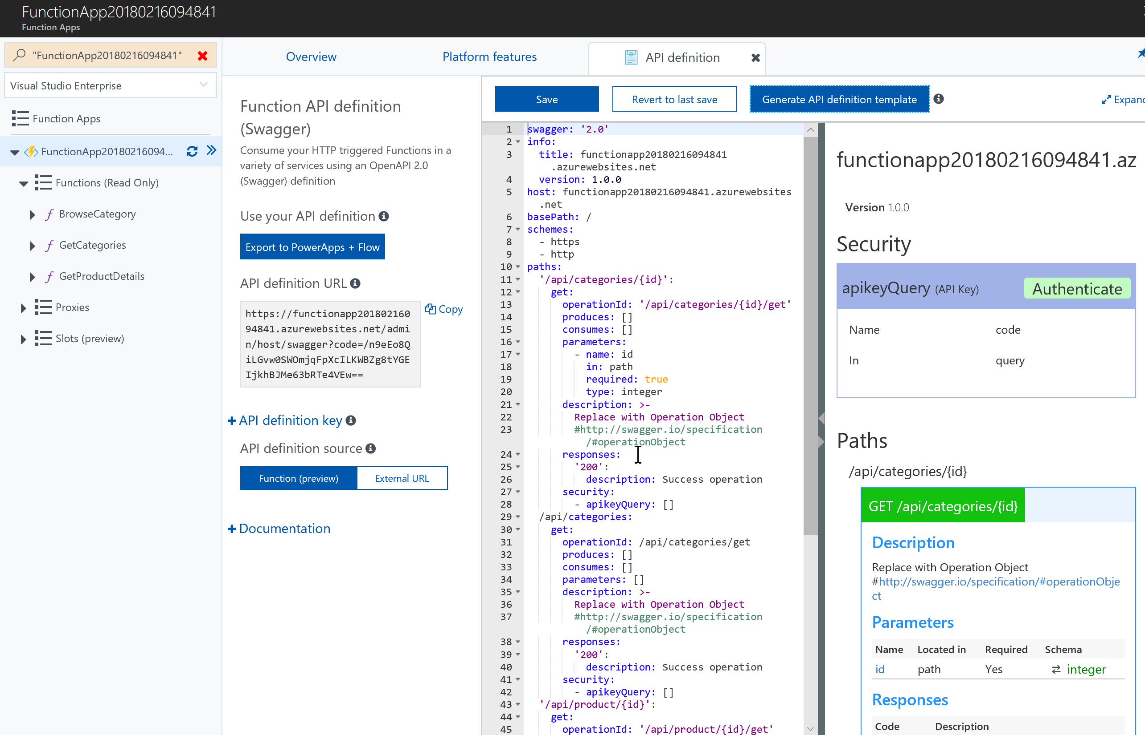)

The auto generated API definition is not complete and contains a few placeholders that should be edited manually, for simplicity use **- application/json** as value for the **produces** and **consumes** attributes, add descriptions and remove the security related attributes.

With exception of the HOST attribute (make sure to use hostname), the swagger should look like the following:

|  |
| --- |
| swagger: '2.0'  info:  title: Parts Unlimited Store Service  version: 1.0.0  host: partsunlimitedstoreservice.azurewebsites.net  basePath: /  schemes:  - https  - http  paths:  '/api/categories/{id}':  get:  operationId: '/api/categories/{id}/get'  produces: [application/json]  consumes: [application/json]  parameters:  - name: id  in: path  required: true  type: integer  description: >-  Get the specific category based off the specific id  #http://swagger.io/specification/#operationObject  responses:  '200':  description: Success operation  /api/categories:  get:  operationId: /api/categories/get  produces: [application/json]  consumes: [application/json]  parameters: []  description: >-  Get all available categories  #http://swagger.io/specification/#operationObject  responses:  '200':  description: Success operation  '/api/product/{id}':  get:  operationId: '/api/product/{id}/get'  produces: [application/json]  consumes: [application/json]  parameters:  - name: id  in: path  required: true  type: integer  description: >-  Get the spoecific product based off the specific id  #http://swagger.io/specification/#operationObject  responses:  '200':  description: Success operation  definitions: {} |

Now add the API to API Management as attempted before and the error should not be present anymore, make sure to only add the **Unlimited** product:

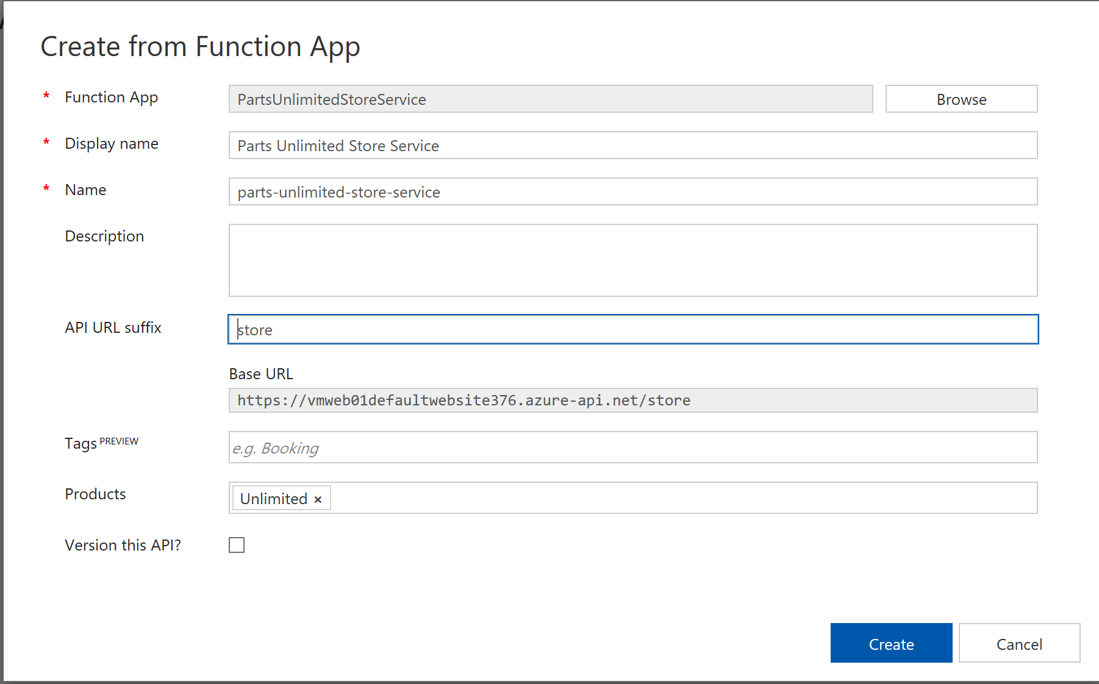

After your selections, click **Create**.

You can now test each of the methods of API in API Management, like the following test with get categories:

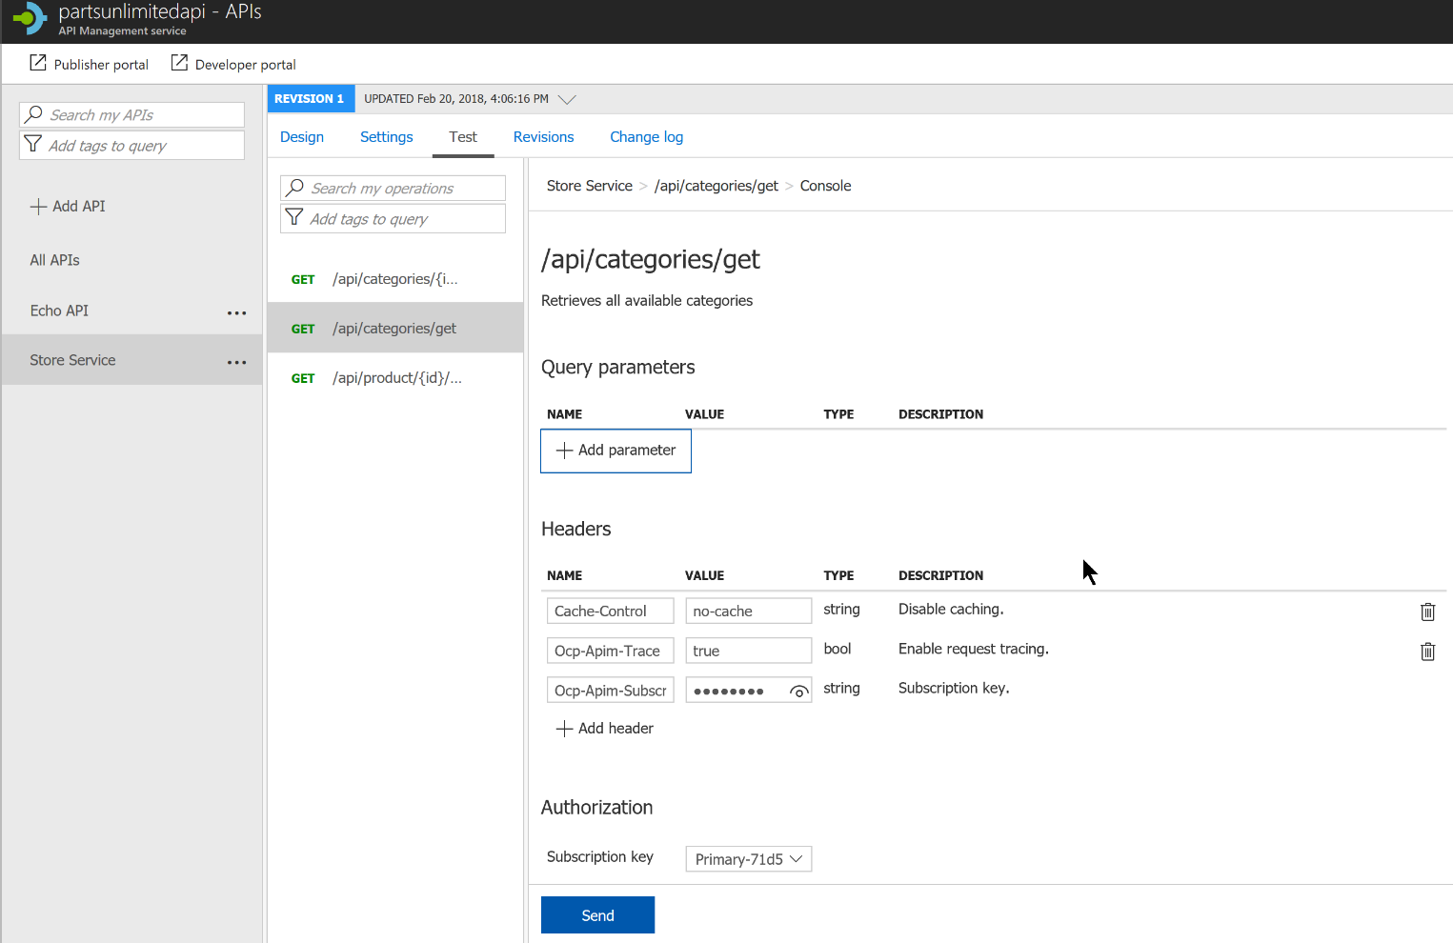

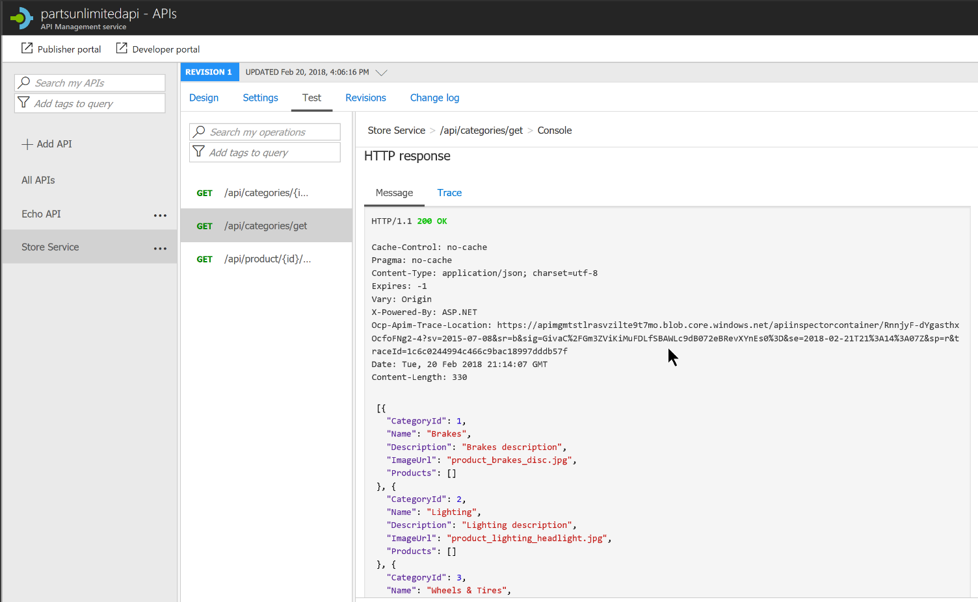

Update the web project GetFromStoreService method to pass the StoreServiceKey value in the HTTP header request. Change the StoreServiceBaseAddress in the AppSetting section of the **Web.Config**.

Run the project locally and if everything works, then commit and push your code to the repository. After the build has complete.

|  |
| --- |
| private static async Task<T> GetFromStoreService<T>(string path) {     using (var client = new HttpClient())     {  // https://stackoverflow.com/questions/46223078/c-sharp-httpclient-an-existing-connection-was-forcibly-closed-by-the-remote-host  // C# 4.6 still defaults to only SSL3/TLS 1.0 even though TLS 1.1 and 1.2 are supported.  // If this is the cause of the issue, you can manually add TLS 1.1 and 1.2  ServicePointManager.SecurityProtocol |= SecurityProtocolType.Tls11 | SecurityProtocolType.Tls12;          var baseAddress = ConfigurationManager.AppSettings["StoreServiceBaseAddress"];         var key = ConfigurationManager.AppSettings["StoreServiceKey"];           client.DefaultRequestHeaders.Accept.Clear();         client.DefaultRequestHeaders.Accept.Add(new MediaTypeWithQualityHeaderValue("application/json"));  client.DefaultRequestHeaders.Add("Ocp-Apim-Subscription-Key", key);          var uri = new Uri(baseAddress + path);           HttpResponseMessage response = await client.GetAsync(uri);         return await response.Content.ReadAsAsync<T>();     } } |

#### Task 3: Enable Application Insights

Now that the API is set, we want to further monitor application performance and be able to easily trace down exceptions when this occurs. Configure Application Insights by navigating to the Application Insights (preview). In the stop, **Select Application Insights** and pick the web application subscription. This will mark settings as **Enabled** and automatically insert the instrumentation key, click on **Save**.

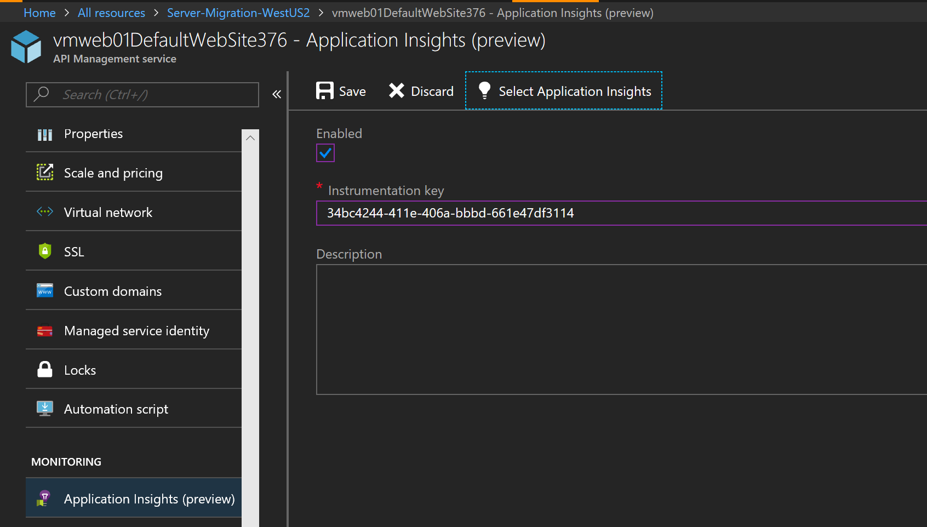

After the site has been deployed, explore the live site. Navigate back to the Azure Portal and explore Application Insight. Look at the different dependencies being called Database, Function, and API Management.

#### Task 4: Explore the API Management (APIM) Developer Portal

From the APIM resource in the Azure Portal, click on the link to the Developer Portal:

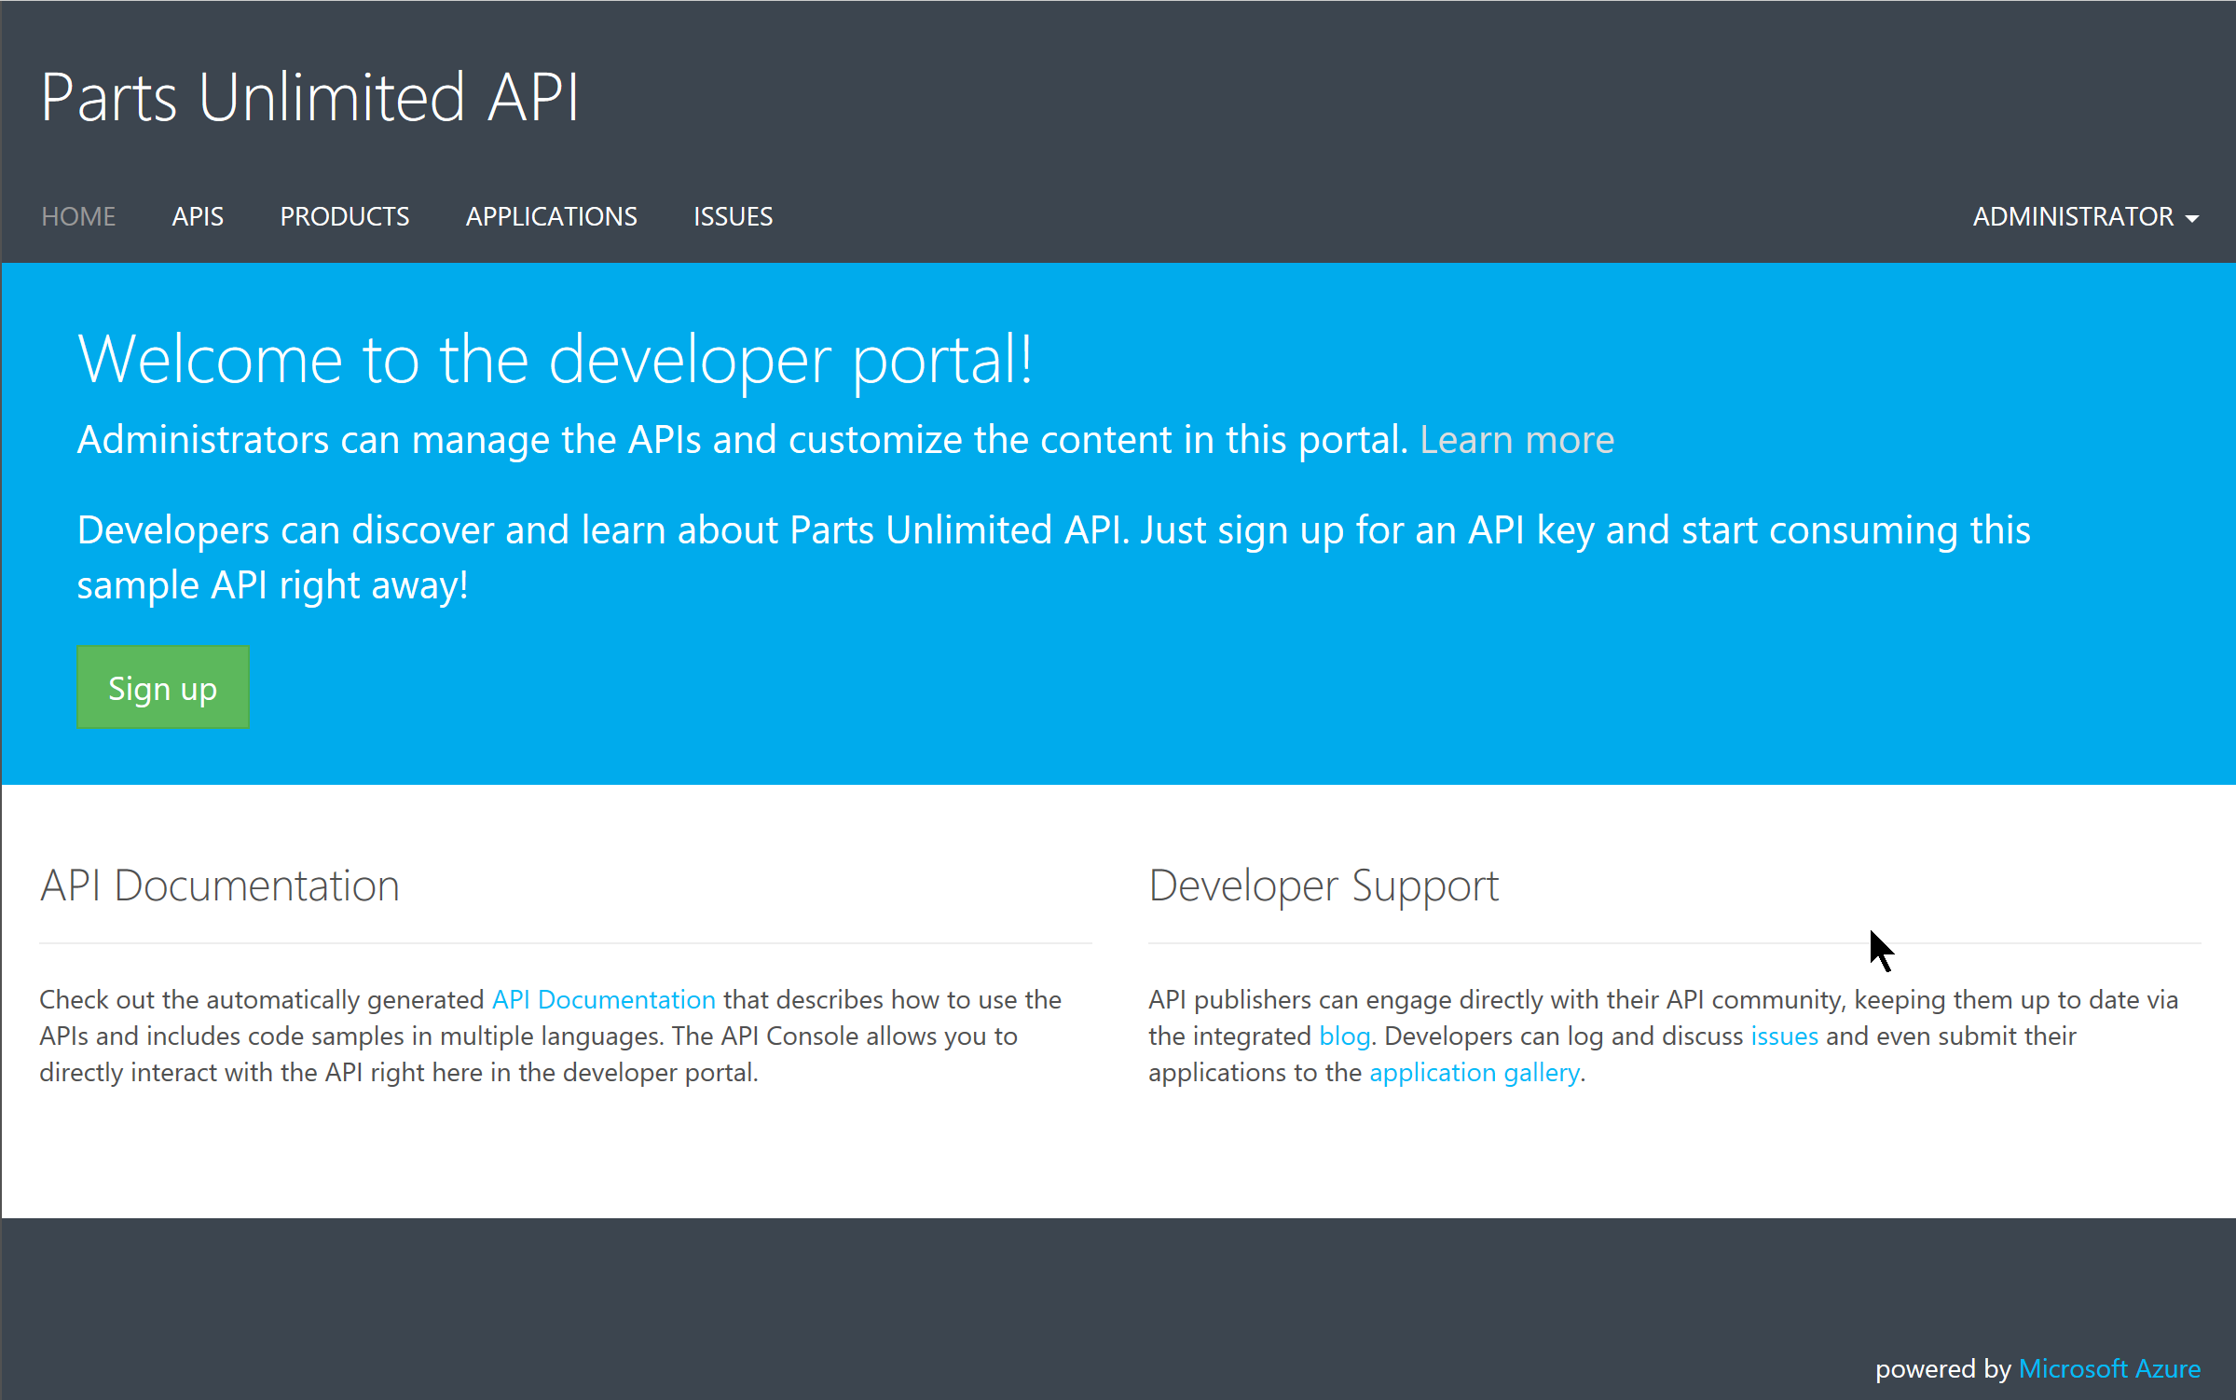

Here you can sign up for access to the API, browse through API definitions and test them, check the products and applications available.

Here you will also have the possibility to customize styles for the look and feel of the developer portal:

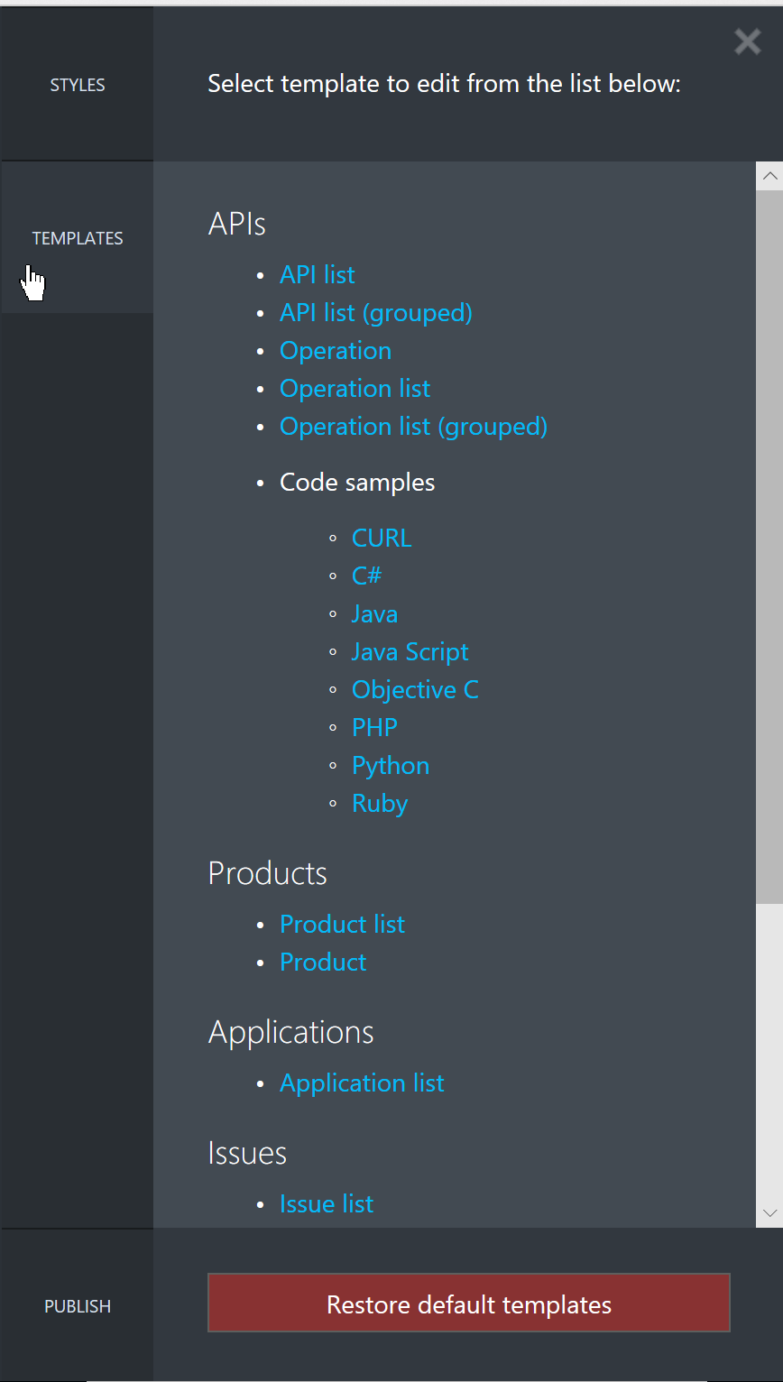

## After the hands-on workshop

Duration: 10 minutes

In this exercise, attendees will deprovision any Azure resources that were created in support of the lab.

#### Task 1: Delete the Resource Group in which you placed your Azure resources.

1. From the Portal, navigate to the blade of your Resource Group and click Delete in the command bar at the top
2. Confirm the deletion by re-typing the resource group name and clicking Delete

You should follow all steps provided *after* attending the hands-on lab.